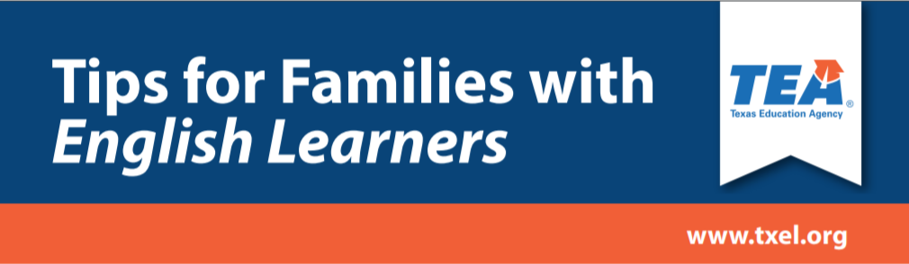

Social Media Campaign

Tips for Families with English Learners

The Texas Education Agency (TEA) English Learner Support Division, has launched Tips for Families with English Learners social media campaign to support Texas families with English learners at home. Families can visit the Parents and Families page on txel.org for resources and support for their child during school closures caused by COVID-19 in eight different languages. The website also provides families contact information to internet providers.

Once families go to the website, they will be able to find educational resource links organized by elementary, middle, and high school. The website also provides links to COVID-19 information to assist in reducing anxiety the family may be feeling during this time.

Please see below for the social media wording in English and Spanish. You will find the social media images in the accompanying Tips for Families with English Learners file.

Message in English:
“Click here to learn how to help your child with school in a few easy steps from home.”

Message in Spanish:

“Haga clic aquí para aprender cómo ayudar a su hijo(a) con la escuela con unos sencillos pasos desde su hogar.”

