2022 Log In and Learn More
Sample Social Media Posts
This sample content is intended for both Twitter and Facebook. We encourage you to include any relevant hashtags related to your district, and to keep posts under the suggested 280-character limit on both platforms to increase engagement.
Social Media Blurb/Post | Social Media Image
Learning isn’t just for students. Parents can Log In and Learn More about their child’s academic progress during the 2021–22 school year. Visit TexasAssessment.gov to access STAAR scores, learning tools, and other valuable resources. | 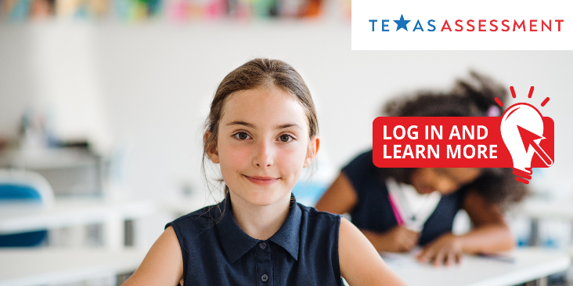
Curious where your children stand academically? Log in to TexasAssessment.gov and access detailed information about their performance during the 2021–22 school year. STAAR results can help you learn if your child is on track in key subject areas.
Help prepare your child for the new school year. Log In and Learn More (TexasAssessment.gov) about your child’s STAAR results, and access resources to support their future academic progress. | 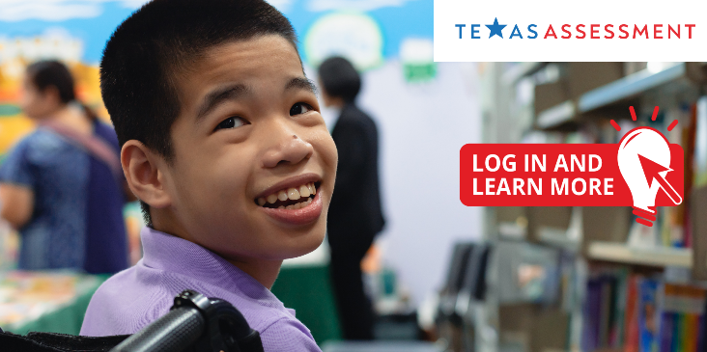
Texas parents, we encourage you to Log In and Learn More about your child’s STAAR results. Visit TexasAssessment.gov to access test results and resources, including each STAAR question and answer, along with your child’s answers.

Gain access to a personalized snapshot of your child’s academic progress this year by logging into TexasAssessment.gov. This website provides STAAR results and resources designed to help you ensure your child is well prepared as they progress to the next grade level.

Suggested hashtags: #LogInLearnMore, #learningtogether, #TXED

