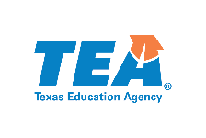
School Librarian Standards Advisory Committee Nomination Form

Nominee Information

Name

School District

ESC Region

Name of Current School, University or Program

Email

Years of Relevant Experience

List of current and valid educator certifications (specific grade, content, etc.)

Ethnicity

Race

Gender

Have you previously served on any TEA Advisory Committees?

Role-Related Information

- Describe your background and professional experience in a school district, college/university, and/or educator preparation program.

- List your most recent student achievement/proficiency data, at the classroom or campus level.

- Please explain why you want to participate in School Librarian standards development. What skills and qualifications are particularly suited to this work?

- What resources, professional development, and texts do you use to inform you on best practices in library services?

