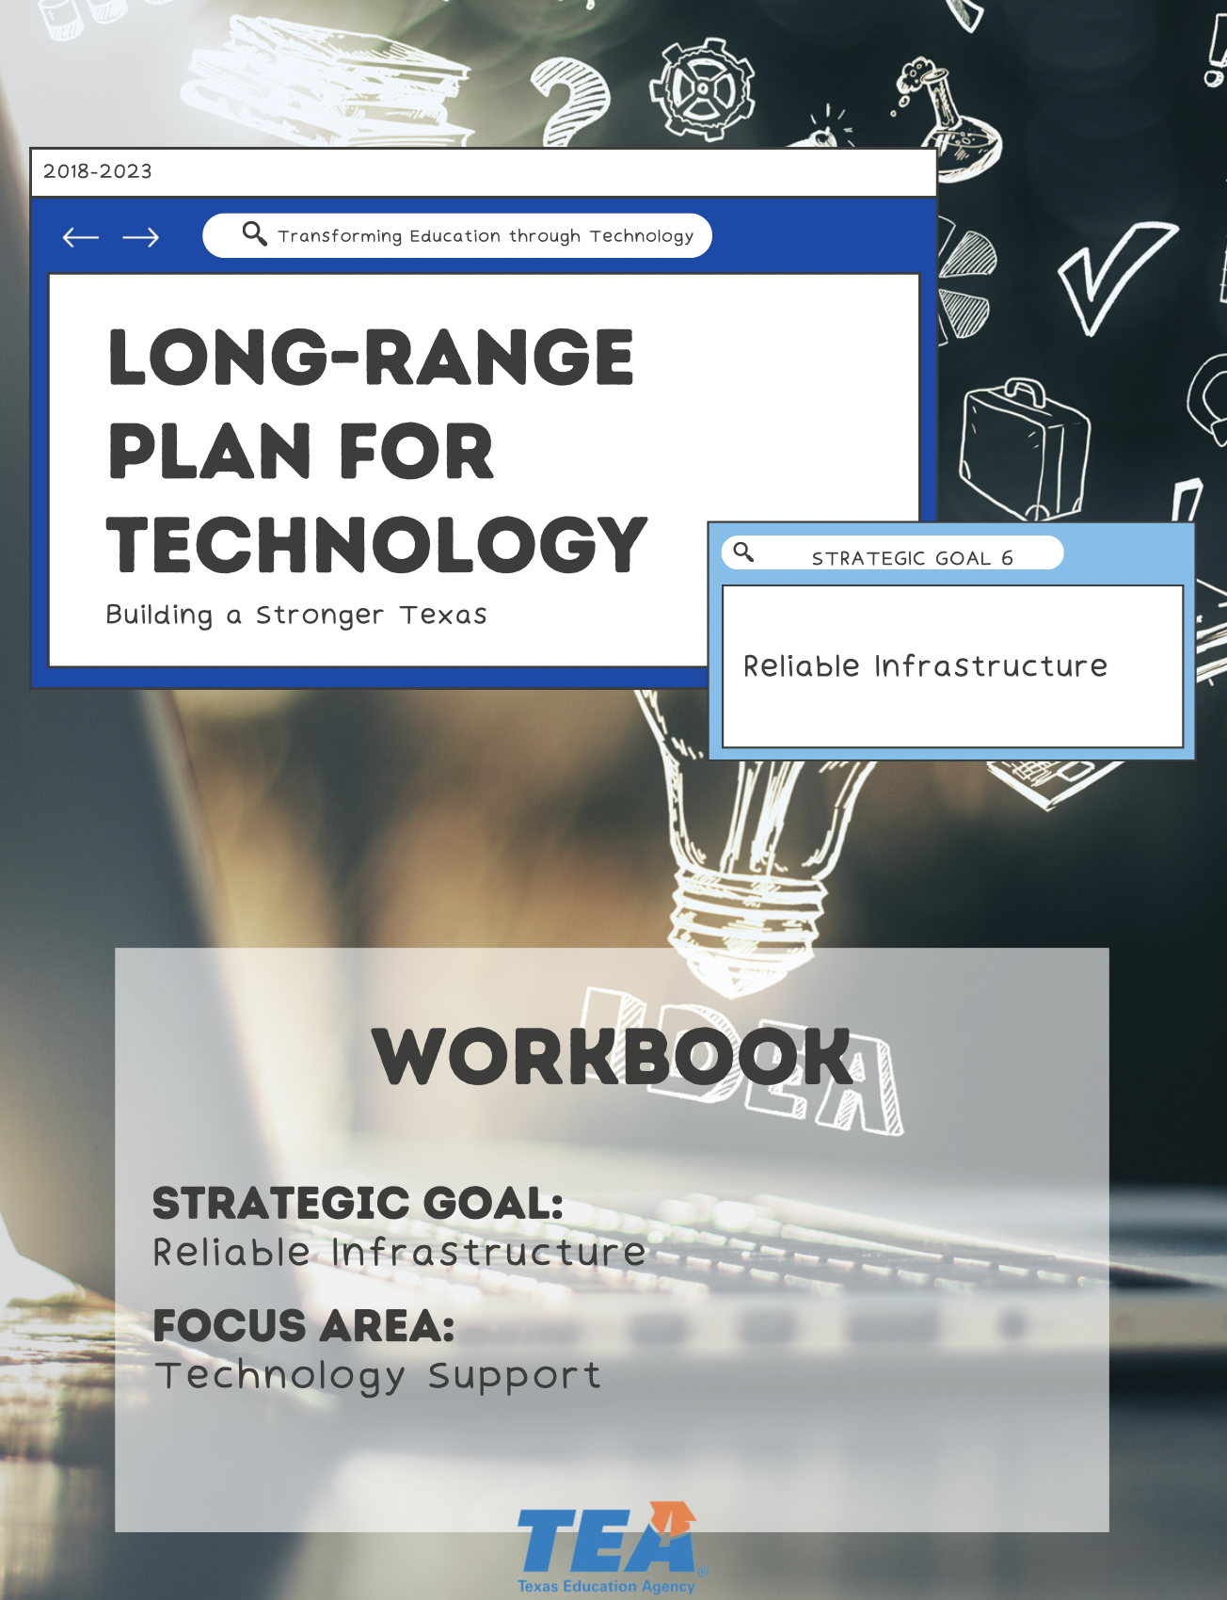

1. Take Note & Reflect:
Reflect on your district. How often is the tech support need underestimated and learning time lost?

1. Take Note & Reflect:
What do tech support teams currently look like in your district?

2. Take Note & Reflect:
Does the help desk in your district standardize intake, track workload, and automate functions?

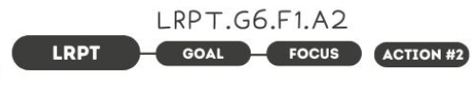

1. Take Note & Reflect:
Define device-as-a-service as it relates to your district. How could this service improve your district?

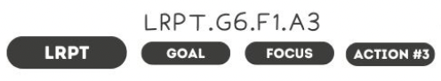

1. Take Note & Reflect:
Reflect on what your district is currently doing to design learning spaces. What needs to change or be updated to make this practice most effective?

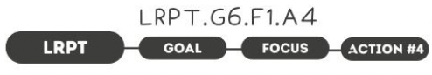

1. Take Note & Reflect:
What is your district currently doing to invest in professional development for tech support staff? Is this sustainable?

2. Take Note & Reflect:
How is PD staying current with expertise, trends, and risks? What is your current target for technical PD for training? Is it to the minimum suggested total of 80 hours?

1. Take Note & Reflect:
Is your district addressing technology staff salaries to be competitive with the industry standards? What are the processes in place to ensure you hire and retain qualified technical staff?

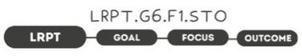

1. Take Note & Reflect:
What would be the indicators of better student and teacher interaction and experience with tech?

1. Take Note & Reflect:
What are the markers of a qualified, competent technical workforce?

1. Take Note & Reflect:
Write a short summary statement for this focus area. How would you summarize what you've done and what you need to do for this focus area based on your work so far?

