ECSE Home Learning Information

Parent/Guardians,

During this unprecedented time of school closures, it is important that your child continue to follow a daily routine. To help support you and your child during this time, I will be providing weekly activities for you to do with your child at home. I know that life is very different right now and understand that not everyone has the same resources, time or flexible schedules for “at-home” learning. However, if you have some time, please take a moment to look over the information and activities I have provided for your child. These will be very helpful in continuing your child’s learning while learning at home.

Since you know your child best, please also consider what your child can handle during this unfamiliar time. Your child’s age and/or abilities will influence how long they will be able to sit and focus on an activity. Many young children do not stay focused on one activity for longer than 10-15 minutes (sometimes less!). Please use these activities as a guide and use your best judgement to make it work for your child and your schedule.

Thank you for all you do for your child!!
Enjoy this time with your kiddo(s) & family and practice healthy hygiene routines!!
Please feel free to contact me for any questions or concerns!!
I am HAPPY TO HELP!

Teacher Name - ECSE Teacher
Email address
Virtual Office Hours: Tuesday-Friday 1 - 2:30 PM

Creating a Schedule at Home
Most children function best when their day is predictable, therefore creating a daily home schedule will be very important during this time. Since most children will be ready to learn at different times during the day, I have provided a sample schedule with flexible times.
Activity | Time Frame | Notes
Morning Routine | 30-45 minutes | wake up, potty, get dressed, breakfast, brush teeth
Choice time (free play) | 1 hour | Blocks, Pretend play, etc. Playing with your child and modeling language is a great learning opportunity. If you cannot play with your child due to other responsibilities, any other family member in the house can support this time as well.
Virtual Circle Time | 15 minutes | Watch Mrs. Fowler lead our daily circle time (include link/directions here)
Sensory Play | 30 minutes | Play-doh, sand, water beads, kinetic sand, beans, pasta, shaving cream, home-made slime, etc
Learning time | 15 minutes | See weekly activities
Lunch | 30 minutes | Remaining seated and focused on eating is an important skill. Ask child to describe the food colors, and textures for added language development
Outside time | 1 hour | Enjoy the sunshine!
Virtual story time | 15 minutes | Watch Mrs. Fowler read a story, aloud!
Rest time | 1-2 hours | Resting is important for growth and development.
Snack | 15 minutes | This is a good opportunity to practice requesting.
Fine Motor time | 15 minutes | See weekly activities
Choice time (outside time or free play) | 1 hour | Enjoy the sunshine!
Learning time | 15 minutes | See weekly activities
Evening routine | 1-2 hours | Dinner, bath time, brush teeth, storytime.
Visuals
We use visuals in our classroom everyday. This includes a visual schedule as well as procedural visuals (for example - going potty, washing hands, what to do in the cafeteria, etc). Below are some visuals to utilize at home. Please let me know if you have any questions on how to begin using this type of schedule with your child.
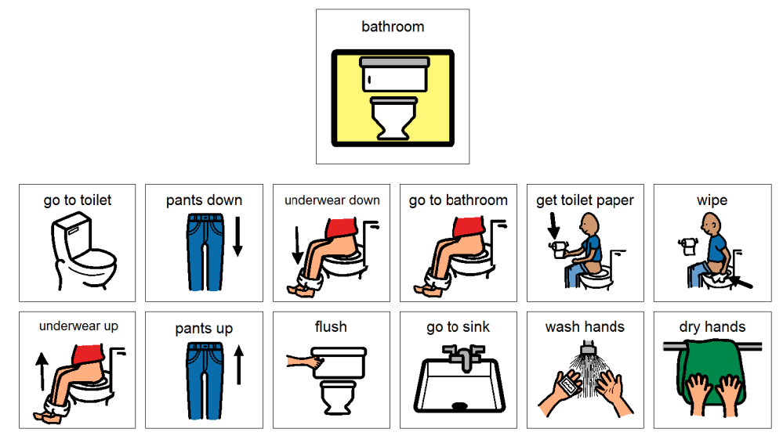
Morning Routine

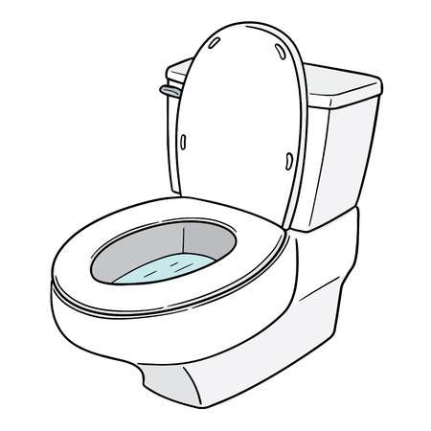  Potty | Get Dressed | 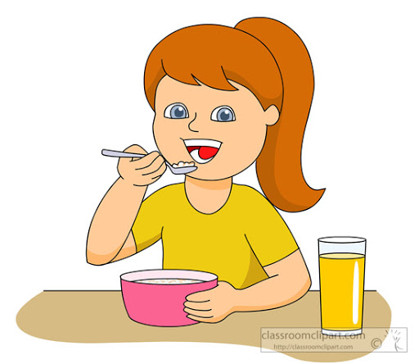  Eat breakfast | Brush Teeth
Here are some schedule cards to go along with the sample schedule provided above if you would like to implement a visual schedule at home. Cut them apart to use.

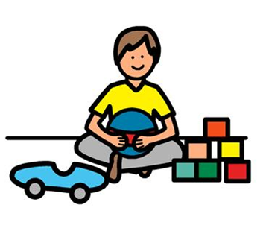  Choice Time | Circle Time | 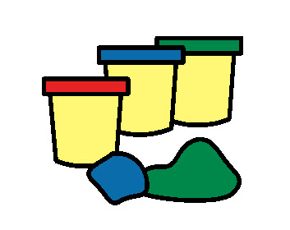  Sensory Play | Learning TIme
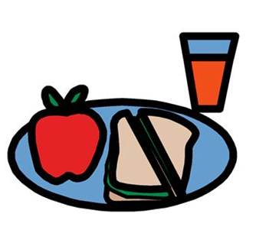  Lunch | Outside Time | Storytime | 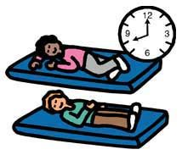  Naptime
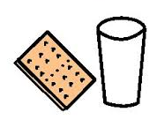  Snack | Fine Motor | Learning Time | Outside Time
Choice Time | Sensory Play | Potty | Potty

Evening Routine
Dinner | Bath Time | Brush Teeth | Storytime | Bed time

We use “First, Then” language the classroom all day, every day. This language helps your child understand that there is something preferred coming after something that might be less preferred. For example - “First potty, then snack”; “First work, then play-doh”.

Potty Training at Home

STUDENT has been working hard on potty training at school! PLEASE continue to work on this skill while at home.. Here are some tips to help make potty training successful at home:

- Establish a schedule or routine. At school STUDENT sits on the potty every 45 minutes to an hour.
- Utilize the visuals on the previous pages.
- Use “First, Then” language. If your child fusses and does not want to sit on the potty, provide a preferred activity with “First, Then” language.
“First potty, then gummy”
- Get excited! When your child goes potty - CELEBRATE! And make it a big deal about it. At school we clap and cheer and sing “I’m a big kid now”.
- Be consistent. Accidents are bound to happen, but consistency is key to successful potty training.

Language at Home

It is very important to continue to focus on language during our time away from school. For STUDENT this will include modeling social language and labeling objects. Here are some examples:

“I want the ____.”
“Do you have to go potty?” “I have to go potty.”
“I see the ____.”
“It’s time to wash our hands. First we get the soap, then we turn on the water…..”

You can also reinforce simple signs for communication.
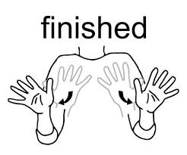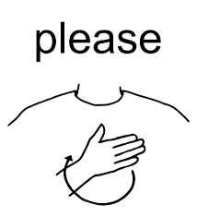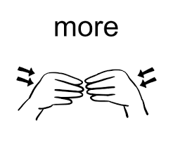
Another good place to start is during asking/requesting events. Encourage STUDENT to follow a set sentence stem when asking for or requesting an item:
“Can I please have a ……..”
“Can I please go to the …….”

You will likely have to model this for your childand then have them repeat each part of the sentence stem after you.

Remember I am here to support you during this time! Please reach out if you have specific questions or if you would like me to model this for you.
Reading to Your Child

Reading to your child is the most important thing you can do, if you are able to.. Reading to your child has a very positive impact on your child’s vocabulary. The more words they hear - the more words they know! Reading to your child also helps their ability to stay focused and interested on a task.

Tips for making “Read Alouds” fun and exciting for your child:

- Let your child pick the book - if they are interested they are more likely to stay focused
- Let them help turn the pages - this increases focus and attention and is helpful for their fine motor skills
- Use funny voices
- Create a fun reading space in your house, if possible.
- Act out the story with or for your child

ECSE Home Learning Activities
Week Of: March 30 Student: ________

**Please note that these activities are meant to be done WITH your child. Your child is still learning how to be an independent learner. The same activities will be done each day with a slight variation. Please read the notes for each activity to see how they will vary from day to day.

MONDAY
- VIRTUAL CIRCLE TIME
  - I will email this link daily

- LEARNING TIME #1
  - Find 5 objects around your house (canned foods, stuffed animals, blocks, etc) and model counting the 5 objects for STUDENT. Be sure to touch each object as your count. Then prompt STuDENT to count the objects. Afterwards say “I have 5 ___”. Have Rebecca repeat you.
  - Repeat this activity for 2 more sets of 5 objects.

- VIRTUAL STORY TIME:
  - I will email this link daily

- FINE MOTOR:
  - Scoop transfer activity
    - You will need two small bowls. Fill one with beans, rice, sand…..anything that can be easily scooped. Leave the second bowl empty.
    - Give STUDENT a spoon and model how to scoop the contents out of one bowl and fill the second bowl.
    - Encourage your child to hold the bowl steady with her nondominant hand while scooping and pouring.
    - Repeat this activity several times.

- LEARNING TIME #2:
  - Using the alphabet chart, sing the ABC’s with STUDENT while touching each letter on the alphabet chart. You may have to model this or do hand over hand support.
  - Using the uppercase letter flash cards, pick 5 letters and have your child match them to the alphabet chart. **Pick 5 different letters each day.
- Read at least two books to your child each day, when possible. Remember, siblings and other family members can do this too!

TUESDAY
- VIRTUAL CIRCLE TIME
  - I will email this link daily

- LEARNING TIME #1
  - Cut out the colored circles for the sorting activity.
  - Have STUDENT name each color.
  - Place one of each color in a row then have STUDENT match the remaining circles.
  - When your child is finished prompt them to say “I sorted by color”.
  - Ask - Where are the red circles? Where are the blue circles? Where are the yellow circles? Where are the green circles? Where are the orange circles?

- VIRTUAL STORY TIME:
  - I will email this link daily

- FINE MOTOR:
  - Stringing beads
    - Items that can be used as string: shoe lace, plastic straw, pipe cleaner, spaghetti noodle, yarn, etc
    - Items that can be used as beads: pasta, a plastic straw cut into pieces
    - Have STUDENT put as least 5 “beads” on a string

- LEARNING TIME #2:
  - Using the alphabet chart, sing the ABC’s with STUDENT while touching each letter on the alphabet chart. You may have to model this or do hand over hand support.
  - Using the uppercase letter flash cards, pick 5 letters and have them match them to the alphabet chart. **Pick 5 different letters each day.
- Read at least two books to your child each day, when possible. Remember, siblings and other family members can do this too!

Color Sorting Activity - Tuesday

WEDNESDAY
- VIRTUAL CIRCLE TIME
  - I will email this link daily

- LEARNING TIME #1
  - Cut out the shapes for the sorting activity.
  - Have STUDENT name each shape.
  - Place one of each shape in a row then have STUDENT match the remaining shapes.
  - When your child is finished prompt them to say “I sorted by shape”.
  - Ask - Where are the circles? Where are squares? Where are the triangles? Where are the rectangles?

- VIRTUAL STORY TIME:
  - I will email this link daily

- FINE MOTOR:
  - Cutting
    - Use the cutting template in this packet to practice cutting
    - Some things to remember when cutting:
      - The thumb should be pointed up
      - Fingers and thumb should go “open, close, open, close”
      - Cutting is a two-handed skill. The non-dominant hand that is holding the paper is important too!
      - You may have to provide hand over hand support to help STUDENT..

- LEARNING TIME #2:
  - Using the alphabet chart, sing the ABC’s with STUDENT while touching each letter on the alphabet chart. You may have to model this or do hand over hand support.
  - Using the uppercase letter flash cards, pick 5 letters and have them match them to the alphabet chart. **Pick 5 different letters each day.
- Read at least two books to your child each day, when possible. Remember, siblings and other family members can do this too!

Shape Sorting Activity - Wednesday

Cutting Practice - Wednesday
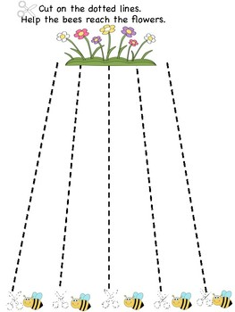

THURSDAY
- VIRTUAL CIRCLE TIME
  - I will email this link daily

- LEARNING TIME #1
  - Cut out the flowers for the sorting activity.
  - Show STUDENT a big flower and say “big flower”. Have STUDENT repeat you.
  - Show STUDENT a little flower and say “little flower” Have STUDENT repeat you.
  - Place one of each size in a row then have STUDENT sort the remaining flowers by size.
  - When your child is finished prompt them to say “I sorted by size”.
  - Ask - Where are the big flowers? Where are the little flowers?

- VIRTUAL STORY TIME:
  - I will email this link daily

- FINE MOTOR:
  - Name writing practice
    - Use the laminated name handwriting template and the dry erase marker to practice writing STUDENT’s name. You will most likely have to helpr with hand over hand support.
    - Be sure to say the letters of their name as you help write them.

- LEARNING TIME #2:
  - Using the alphabet chart, sing the ABC’s with STUDENT while touching each letter on the alphabet chart. You may have to model this or do hand over hand support.
  - Using the uppercase letter flash cards, pick 5 letters and have her match them to the alphabet chart. **Pick 5 different letters each day.
- Read at least two books to your child each day, when possible. Remember, siblings and other family members can do this too!

Size Sorting Activity - Thursday

FRIDAY
- VIRTUAL CIRCLE TIME
  - I will email this link daily

- LEARNING TIME #1
  - Repeat STUDENT’s favorite sorting activity from the week. OR repeat the activity they had the most trouble with.

- VIRTUAL STORY TIME:
  - I will email this link daily

- FINE MOTOR:
  - Complete one of the optional crafts below, if you have the supplies, OR color the flower coloring page.

- LEARNING TIME #2:
  - Using the alphabet chart, sing the ABC’s with STUDENT while touching each letter on the alphabet chart. You may have to model this or do hand over hand support.
  - Using the uppercase letter flash cards, pick 5 letters and have her match them to the alphabet chart. **Pick 5 different letters each day.
- Read at least two books to your child each day, when possible. Remember, siblings and other family members can do this too!

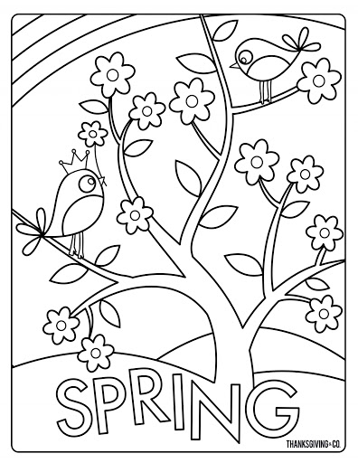
OPTIONAL CRAFT IDEAS TO TRY
Supplies not provided by the teacher - these are just ideas if you have craft supplies available!
If you create any of the crafts - snap a picture and email to your teacher!
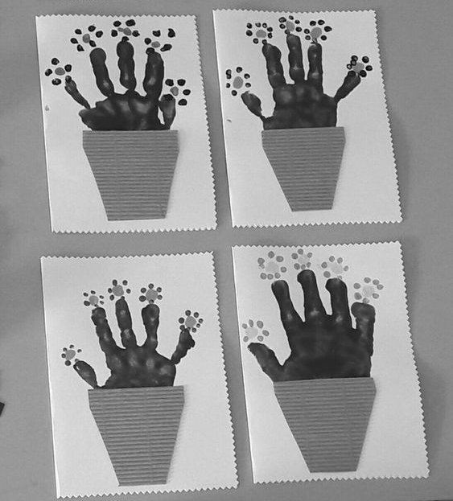
Succulent Hand Painting
Green paint on hand, press on paper
Cut out pot, glue on top
Using Qtip, dip in paint and dab colorful flowers on the ends!

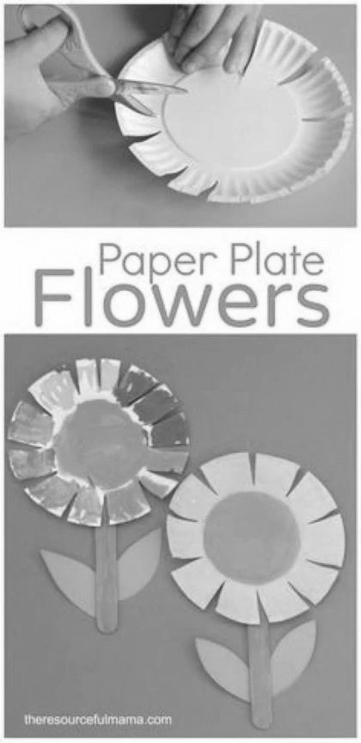
Paper Plate Flower
Cut around edges for petals
Paint each petal
Paint popsicle stick green
Cut out leaves

