



Corrective Action Plan - Quick Reference

How to Use the Corrective Action Plan Form

Enter **District identification** data in the designated area **(1).**

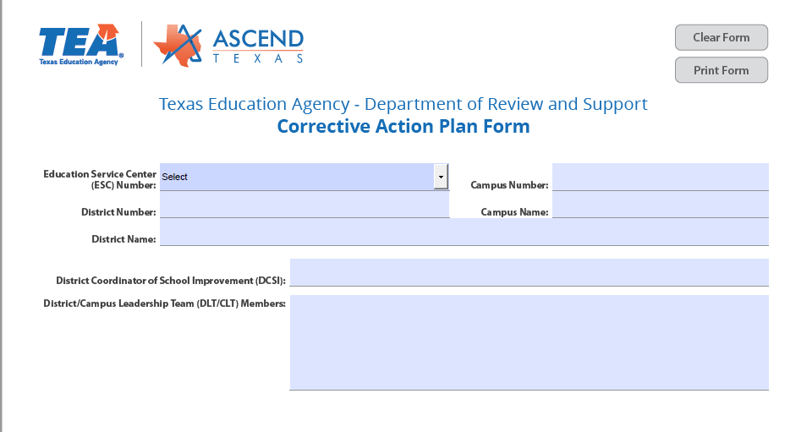

**1.**

The **Source(s) of Noncompliance** should identify the source of the non-compliance citation issued to the LEA **(2).** Select the status of the noncompliance by selecting new, current, or continuing **(3).** Next, enter the date of the notice of noncompliance, this can be found on the top left corner of the notification **(4).** The area of noncompliance is the topic and specific legal reference identified on the LEA notice of noncompliance **(5).**

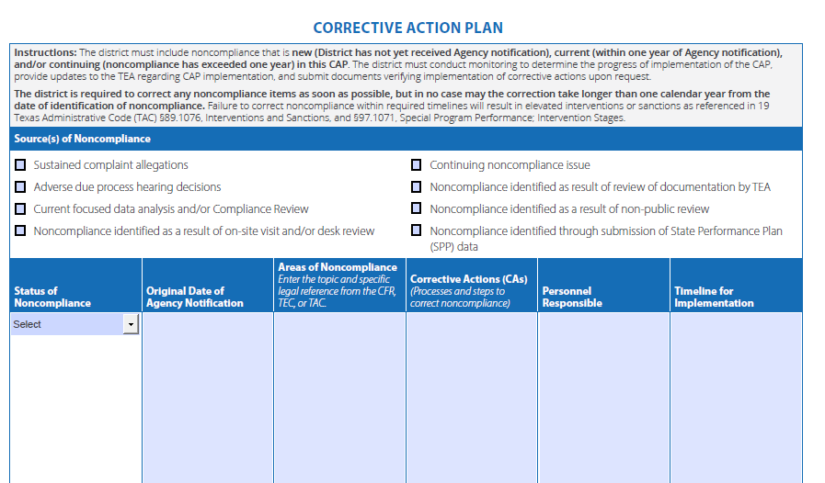

**3.**

**4.**

**5.**

**6.**

**7.**

**8.**

**2.**

Corrective Actions should include all activities the LEA will engage in to correct identified noncompliance **(6).**

* **Examples of this may include:**
  + **Policies, Procedures, and Practices**
    - This should include writing, revising and the development of internal monitoring and review procedures
* **Training and Professional Development** 
  + Provided for staff members and/or pertinent stakeholders
* **Self-Monitoring**
  + This should include a system of programming evaluations to ensure appropriate policy implementation
* **Personnel responsible (7):** This should be the position title(s) of the individuals who will manage the completion of the activity (i.e. general education teacher, special education teacher, instructional specialist, etc.)
* **Timeline for completion (8):** Set a projected completion date for the activity