Vendor Role
Question: How does a vendor get access to TREx? What TREx functionality is available for vendors? Can vendors see confidential data?
Answer: One of the roles made available with the implementation of Phase 2 of the TREx project is the Vendor role. The Vendor role allows student information system (SIS) vendors to validate XML extract files intended for uploads in TREx by their customer schools and districts.
TEASE Access to TREx:
To receive TEASE access to TREx, a vendor should follow the procedures explained on the TEA web site at http://www.tea.state.tx.us/webappaccess/OnlineRequestIntro.htm.
In addition to their name, company name, email address, and other information as indicated on the online request form, vendors should select “Other” as the Organization Type and enter “701603” as the Organization Number.
TEA serves as both the submitting approver and final approver for vendor access, i.e., superintendent approval is not required. The vendor receives two emails from the TEA Computer Access group once the TEASE request is approved.
Validation Process:
Access to TREx by vendors is designed to provide a means to test XML extract files from SIS applications. No other functionality is available to vendors. No other data outside of that within the extract file being tested is available to the vendor thereby ensuring FERPA requirements for student data confidentiality.
Following is an example of the TREx functionality immediately accessed through the vendor role:
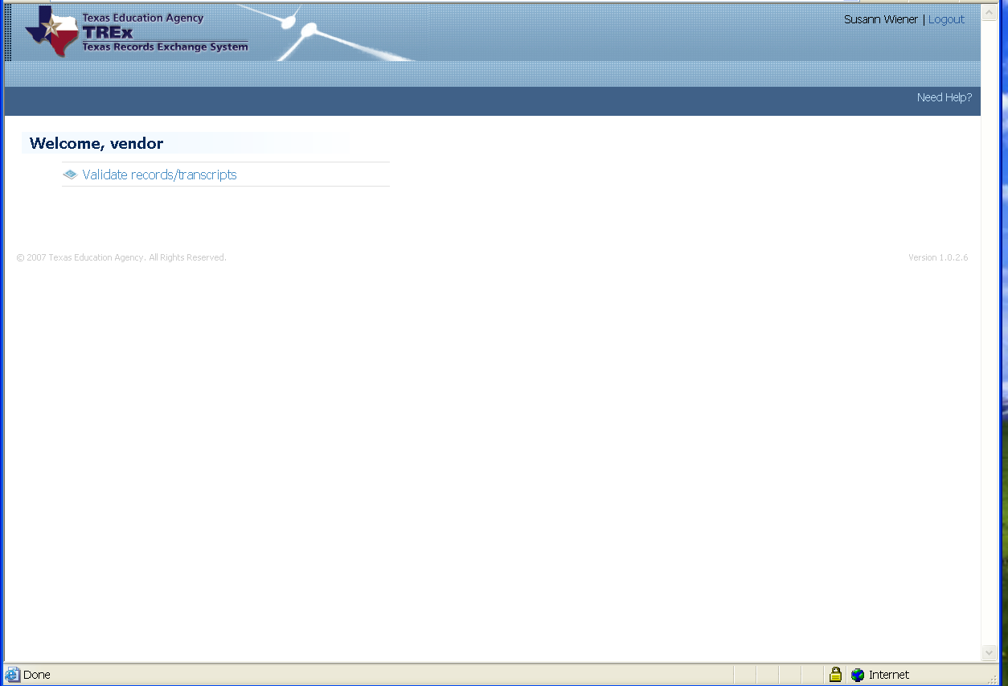
By clicking the Validate Record/Transcript option, the following screen displays:
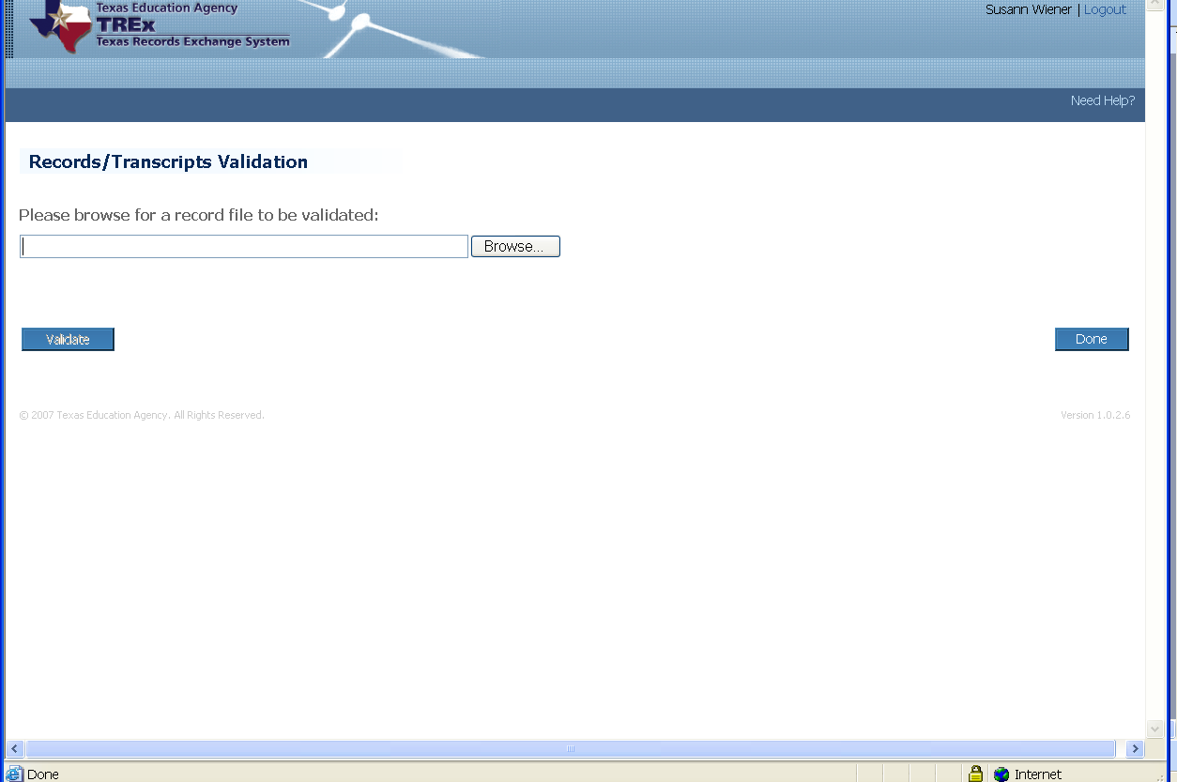
At this point, the vendor browses for the SIS XML extract file stored on their local drive. Once the file name is populated in the field, the vendor clicks the Validate button.
If the extract file passes the XML schema validation, TREx displays a message indicating the upload was successful and a list of data validation warnings.
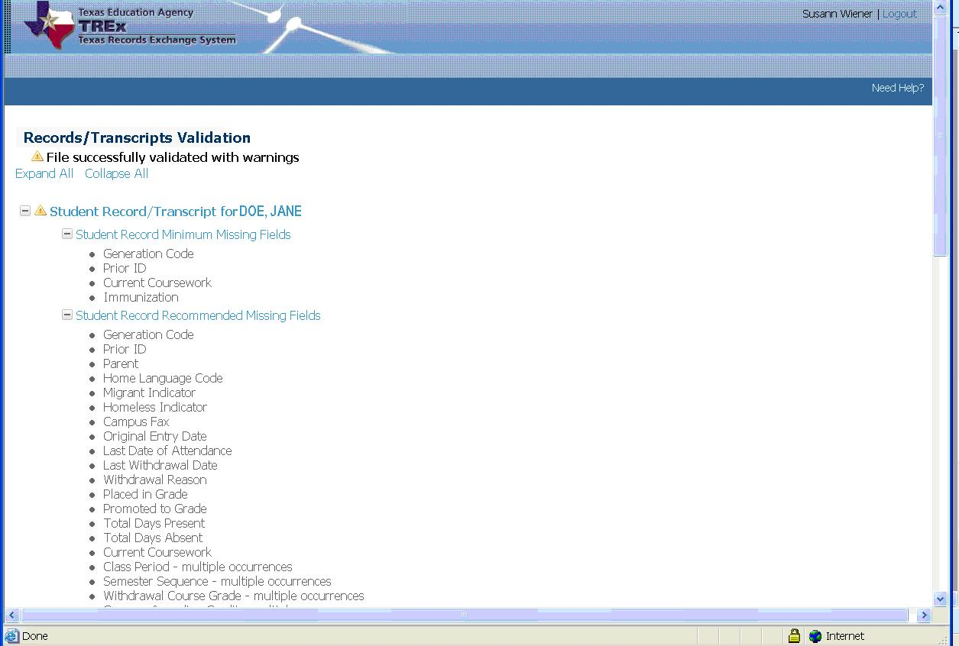
If the extract file does not pass the XML schema validation, TREx displays an error message indicating the upload failed and describing the cause of the failure. An example follows:
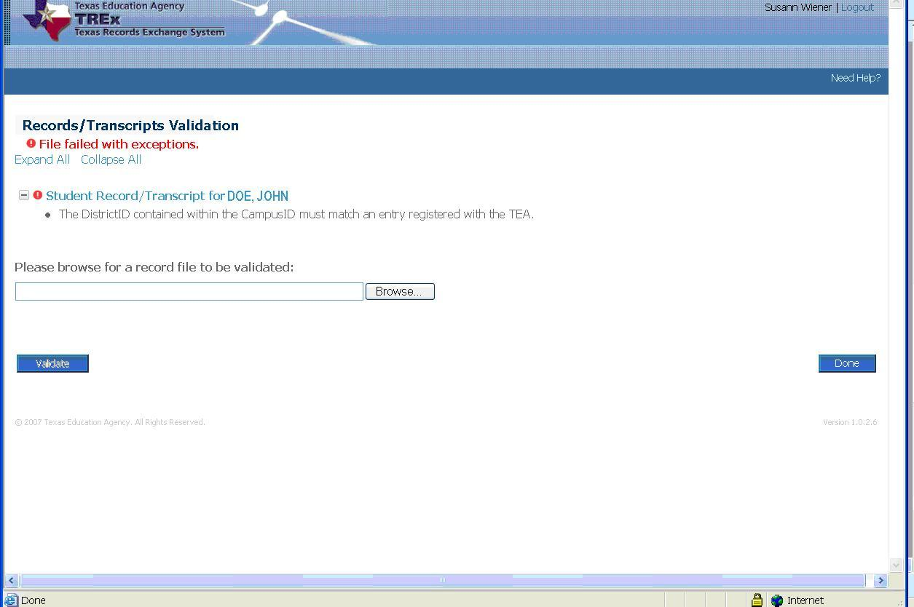
To resolve the issue, the data for the extract file must be correct in the student information system (SIS), extracted through that application’s extract process, and then uploaded into TREx.
For more information, please reference the 2007-2008 TREx Data Standards for information on the following:
- State Minimum and TEA Recommended data elements – Appendix A
- TREx Schema – Appendix B
- TREx XSD Graphical Representation – Appendix C

