Learn More
About Your Child’s School
2023 Sample Social Media Posts for Districts
This sample content is intended for X (formerly Twitter), Instagram and Facebook. We encourage you to include any relevant hashtags related to your district and to keep posts under the suggested 280-character limit on both platforms to increase engagement. These blurbs/posts can also be used as text message content to families.

Social Media or Text Message Blurb/Post | Social Media Image
Option 1: The wait is over – the 2023 school ratings are here. Visit TXschools.gov to see how your child’s school is performing and working towards ensuring every student has the opportunity to succeed.  Option 2: We’re thrilled to announce the release of this year’s school ratings. Check out TXschools.gov for a closer look at how your child’s school is performing and preparing your child for future academic and career success.  Option 3: Texas parents and families, TXschools.gov gives you easy-to-access information you need to understand how your child’s school is performing. Visit today to see your school’s 2023 school rating.  Option 4: Texas parents and families, 2023 ratings are here. Visit TXschools.gov to learn more about your child’s school performance and progress to ensure every student is prepared for the future. | New Images
We are proud of our schools! Visit TXschools.gov to see the rating for your child’s school and discover how your child’s school is preparing them for the next grade level and success after high school. | 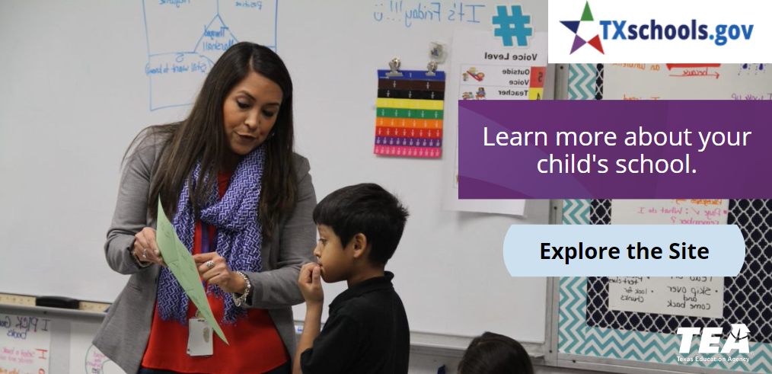
Curious about the 2023 rating for your child’s school? Visit TXschools.gov to learn about how your child’s school is preparing students for the next grade level and success after high school. | 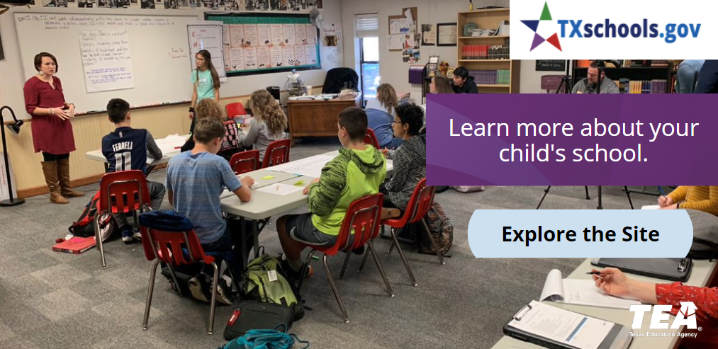
Moving this year? Visit TXschools.gov to find the best school for your child! Just enter an address, city, or zip code to learn more.
Parents and families, we encourage you to visit TXschools.gov to see the rating for your child’s school along with many other offerings at the school!
Gain access to a comprehensive view of your child’s school by visiting TXschools.gov. Learn about how the school is preparing your child for the next grade level and success after high school.
Want to compare your child’s school to others? Use TXschools.gov’s School Comparison Tool.

Copyright © 2023. Texas Education Agency. All Rights Reserved.

