

System of Great Schools Network Application

|  |
| --- |
|  |
|  |
| Application Deadline: March 9, 2021 |



Introduction:

The System of Great Schools (SGS) Network helps public school leaders ensure that more students have access to better schools every year by increasing the number of high-quality, best-fit options. The SGS Strategy is a district-wide problem-solving approach that helps district leaders understand and deliver the schools that families want and need. By implementing the SGS Strategy, the superintendent and their cabinet define ambitious goals and a compelling Theory of Action to call the right play at every campus and ensure that every campus is a high-quality option that best fits student needs. The mission of the SGS Network is to support district leaders as they engage in this district-wide Strategy. SGS Network districts choose to participate in a 4-year program that provides district leaders with strategic advising, professional learning opportunities, tools and resources, and support in applying for grants.

What is a System of Great Schools District?

SGS Network districts vary from rural to urban and are committed to ensuring every student has access to a high-quality, best-fit school. 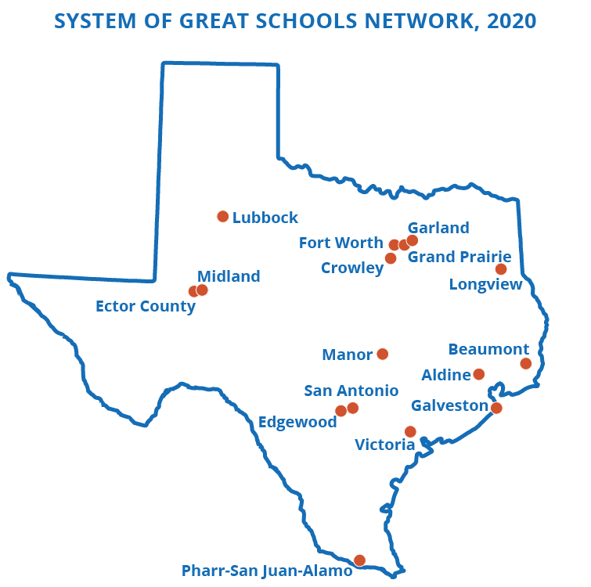The SGS Network consists of sixteen districts enrolling 490,000 students. Through their participation in the Network, they have created 14 Offices of Innovation and created, redesigned, and restarted almost 190 schools. Districts deliver on the promise of enrolling more students in great schools, and their outcomes speak for themselves. Altogether, current SGS Network districts that joined in 2017 have increased A and B seats by 52% and decreased D and F seats by 36%. District highlights include:

* San Antonio ISD increased A and B seats by 467% and decreased D and F seats by 50%. Through SAISD’s 4x increase, more than 10,000 students attend great schools.
* Fort Worth ISD increased A and B seats by 11% and decreased D and F seats by 34%.
* Edgewood ISD increased A and B seats by 47% and decreased D and F seats by 17%.

The SGS team at Texas Education Agency (TEA) supports new members of the SGS Network to continuously improve outcomes for their students. Through the application process, TEA will evaluate:

1. an applicant’s understanding of SGS Strategy’s four levers,
2. an applicant’s willingness to act boldly for all students by identifying areas for growth, and
3. school board and superintendent alignment with the SGS Strategy, especially with the singular goal of increasing a defined number and percent of students in A- and B-rated seats.

SGS Theory of Action:

Districts that join the SGS Network are ready to engage in bold and transformational change aligned to the following Strategy, which is each aligned to a sample deliverable:

*Set the right goal* of providing all students access to a high-quality school that best fits their educational goals and individual needs.

*Conduct an annual portfolio planning process* thatanalyzes school performance, community needs, and parent and family feedback to inform action plans for all schools.

*Take bold action* driven by the annual planning process, including at least one school action per year.

*Empower families* by communicating each child’s options, enrolling them in their desired program, and helping them overcome logistical barriers to attendance.

*Create new organizational structures* to drive new policies and practices that accelerate the success, efficiency, and sustainability of the SGS Strategy.

SGS Network Benefits:

The SGS Network is a dynamic professional learning community of like-minded district leaders throughout the state. SGS Network districts are provided with the following:

* Technical Assistance: Districts are matched with an [Executive Advisor (EA) firm](https://tea.texas.gov/sites/default/files/DSSI%2C%20Approved%20Vendor%20List%2C%202020.pdf), which guides them in understanding, planning, and implementing the SGS Strategy. EA firms are funded at eight days per month in year 1, tapering down to two days per month in year 4.
* Professional Learning Opportunities: The SGS Network offers a robust learning community which gathers for regular workshops and events. Participation is required for Network districts.

|  |  |  |  |
| --- | --- | --- | --- |
| Professional Learning | Frequency | Estimated time commitment | Total annual time commitment |
| Superintendent & Cabinet Convenings | Triannual | 1 day per session | 3 days per year |
| Board Support and Ongoing Coaching | Varied | 2-day initial training & monthly coaching session | 4 - 5 days of training and coaching per year |
| Chief Innovation Officer Workshops | Every other month | 1 day per session and about 4 hours of pre-work | 6 days off-site and 20 - 24 hours of pre-work total |
| SGS Summit | Annual | 2 days (virtual) | 2 days, including 5 - 10 hours of pre-work |
| SGS Network District Visit | Annual | 1 - 2 days per visit (virtual) | 2 - 4 days per year |

* Tools and Resources: Network districts are provided implementation tools such as models, templates, and exemplars that they can adapt to their local context. Additionally, while districts are not guaranteed grants, they strategically access funding to jumpstart their initiatives, including:
  + School Action Fund: Open to eligible *comprehensive* and *targeted* campuses, the School Action Fund can be used for planning and implementation of [*School Actions*](https://centerforschoolactions.squarespace.com/actions), including: redesigning, creating, or restarting a school, or reassigning students to higher quality schools.
  + Texas Partnerships: SB 1882 provides accountability and financial benefits to districts that partner with school operators through a rigorous authorization process. Partnerships may receive additional state funding for the partnership school, and schools with an unacceptable state accountability rating are eligible to receive a two-year exemption from specific accountability interventions.
  + Charter School Program (CSP) Replication and Start-up Grants: Eligible Texas Partnerships may apply for CSP grants to support implementation.

Eligible Applicants:

All Texas districts are eligible to apply. Ideal applicants have over 7,500 students, 10 or more schools, and the desire to pursue system transformation that leads to more high-quality, best-fit schools.

Application Process and Timeline:

|  |  |
| --- | --- |
| **Date** | **Event** |
| **Jan. 27** | **Applications Released:** The application will be available on [the SGS webpage](https://tea.texas.gov/texas-schools/district-initiatives/system-of-great-schools). |
| **Feb. 5, 12, and 19** | **Informational Webinar:** Interested districts may learn more by attending a webinar on February 5th at 2:00 pm, 12th at 1:00 pm, or 19th at 9:30 am. [Please sign up here](https://forms.gle/S7MS7FCVLEo4zTqi8). |
| **Mar. 9** | **Application due:** Please submit applications to [SGS@tea.texas.gov](mailto:SGS@tea.texas.gov). |
| **Mar. 22 - 31** | **Phone Interviews:** TEA staff will conduct phone interviews with District leaders to add context to the written application and make an acceptance decision. |
| **Apr. 7** | **Acceptance:** Accepted applicants will be invited to join the 4-year program. |
| **April 27 - May 14** | **Readiness Assessment:** TEA staff will interview district staff and leaders to help identify the key priorities as the new district begins to implement the SGS Strategy. |
| **Starting June 10** | **EA Firm Match & Onboarding:** New Network districts interview, select, and hold planning kick-off meetings with the EA firm that will support SGS implementation. |

How to Apply:

* Interested applicants may attend an introductory webinar on the dates are listed above.
* Please email completed applications to [SGS@tea.texas.gov](mailto:SGS@tea.texas.gov) by the deadline listed above. Late applications will not be accepted.
* Applications should be in 11-point font, single-spaced, and adhere to word limits. The application should be submitted as a Word or PDF file. There is no file type restriction on addenda.
* Please email [SGS@tea.texas.gov](mailto:SGS@tea.texas.gov) with questions.

System of Great Schools Application:

Page limit: 5 pages total

*Section 1: SGS Preconditions*

*Limit: 500 words*

The SGS team at TEA is seeking districts that have the preconditions needed to succeed in the SGS Network: an *understanding* of the SGS Strategy and the *political will* to implement it.

1. Why does the district want to implement the SGS Strategy? Why is now the right time to join the SGS Network?
2. What are the district’s strategic priorities and how is success for each goal measured?

*Section 2: Managing School Performance*

*Limit: 500 words*

SGS Network districts evaluate the quality of every campus in the District and use that data develop a clear Portfolio Plan, which includes a strategy to improve each campus in the District. The North Star Goal of the District is to increase the number and percent of students in A- and B-rated schools.

1. What data does the district use to make decisions about campuses? How does the district communicate this data to make it actionable for district leaders, campus leaders, and community members?
2. How do the district’s departments and cabinet use performance data to plan support, intervention, or a [*School Action*](https://centerforschoolactions.squarespace.com/actions) at each campus?
3. Does campus performance data inform the district’s strategic plans? If so, please describe how.
4. Which stakeholders and community members are involved in the district’s strategic and long-term plans, especially to start, restart, redesign, and close schools?

*Section 3: Expand Great Options*

*Limit: 750 words*

SGS Network districts expand high quality education options for all students by using all strategies available, including traditional school improvement methods as well as bold [*School Actions*](https://centerforschoolactions.squarespace.com/actions).

1. Has the District created, restarted, redesigned, or closed any schools in the past 2-3 years in order to expand great options available to students? If so, what was the process to execute School Action(s) and who was involved in the process?
2. What is the District’s approach to improving chronically underperforming schools (i.e., schools that are persistently rated comprehensive, targeted, D, F, or IR)?
3. Does the district currently authorize in-district charter partnerships?
   1. If yes, please describe the process for recruiting, vetting, and selecting partners.
   2. If no, please discuss whether the district is willing to explore the possibility of authorizing an in-district charter partnership.

*Section 4: Improve Access to Options*

*Limit: 750 words*

SGS Network districts increase access to high-quality best-fit options and help parents and families know their child’s options, enroll in their desired program, and overcome logistical barriers to attendance.

1. What is the district’s vision for school choice? How is this vision put into practice through policies and processes?
2. How does the district help families find, apply to, and enroll in a campus that best fits each child’s needs? *Please link to any webpages or attach any supporting documents that the district uses to support students and parents.*
3. What support does the District provide to help families to access the right school for their child?

*Section 5: Create New Organizational Structures*

*Limit: 500 words*

SGS Network districts create an Office of Innovation (OOI) to sustain systemic reform. The OOI’s work is guided by the North Star goal of increasing the number and percentage of students in A- and B-rated seats. The OOI leads the district’s efforts to align policies and practices, including those pertaining to budgeting and autonomy, with all four levers of the SGS Strategy.

1. Does the district currently have an Office of Innovation or similar office?
   1. If yes, please describe the roles and responsibilities of this office. Does the leader of this office report directly to the Superintendent and hold a cabinet-level position?
   2. If no, is the district willing to establish an Office of Innovation with a cabinet-level leader who reports directly to the Superintendent?
2. The SGS Strategy requires a balance between campus autonomy and district oversight, which can mean certain decisions are made at the campus level. How does the district determine which decisions are made at the district or campus level? *Please link to any webpages or attach any supporting documents that demonstrate district alignment with this Strategy.*
3. Through [student-based budgeting](https://files.eric.ed.gov/fulltext/ED545128.pdf), SGS Network districts allot discretionary revenue to campus leaders based on student attendance and student needs. This funding model allows districts to increase equity, transparency, and flexibility. Please explain why the district is interested in equipping certain campuses with increased autonomy over campus’ revenue.

*Section 6: Supplemental Questions*

*Limit: 250 words*

1. Who are the key stakeholders and organizations in your community?
2. How do board members and the Superintendent engage these stakeholders to improve academic options for students?

*Section 7: SGS Program Assurances*

By completing this application, the district Superintendent commits to implementing the following:

1. The district commits to conducting an annual Quality Seats Analysis (QSA), which includes academic achievement and growth measures, enrollment and demographic trends, and community input.
2. The district commits to using the QSA to develop an annual portfolio plan that articulates a clear strategy to improve every campus in the district.
3. The district commits to executing at least one [*School Action*](https://centerforschoolactions.squarespace.com/actions) each year, such as creating a new school, restarting a low-performing school, redesigning a district school, or reassigning students to a higher-performing school.
4. The district commits to building a pipeline of school leaders and partner organizations to execute [*School Actions*](https://centerforschoolactions.squarespace.com/actions) that are aligned with district needs.
5. The district commits to launching an annual Call for Quality Schools to announce the needs of the district and rigorously vet internal school leaders and/or external partner organizations and their plans to execute school actions.
6. The district commits to launching an Office of Innovation with a Cabinet-level Chief Innovation Officer (or similar position) who reports to the Superintendent.
7. The district commits to actively participating in all SGS-related professional learning activities, including CIO Workshops, Texas Authorizer Leadership Academy, Superintendent and Cabinet convenings, and the annual SGS Summit.
8. The district commits to developing and implementing equitable enrollment policies and practices.
9. The district commits to increasing equity, transparency, and flexibility through a student-based campus funding model.

*TEA commits to supporting districts in completing all SGS Program Assurances.*

*Section 8: Contact Information*

Please provide the information requested below.

|  |  |
| --- | --- |
| District |  |
| Mailing Address |  |
| Superintendent Name |  |
| Superintendent Email |  |
| Superintendent Phone |  |
| SGS Primary Contact Name |  |
| SGS Primary Contact Email |  |
| SGS Primary Contact Title |  |

_____________________________________ _____________________________

Superintendent Date

_____________________________________ _____________________________

Chief Innovation Officer Date