

System of Great Schools Application

New SGS Districts

|  |
| --- |
|  |
|  |
| Submission Deadline: August 14, 2020 |

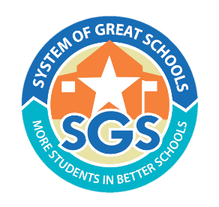

Introduction:

A System of Great Schools strategy is a district-level problem solving approach that seeks to understand school performance and community demands and use that information to make decisions about expanding what works, replacing what doesn’t, and pursuing all possible options. The mission of the System of Great Schools (SGS) network is to support district leaders to ensure that more students attend better schools, every year.

SGS network districts choose to participate in a 4-year cohort-based program that provides district leaders with technical assistance, workshops and convenings, and support in applying for grants and other financial resources. Please see full program description and more details [here.](https://tea.texas.gov/sites/default/files/SGS%2C%20Program%20Description%20for%20New%20Districts%2C%20VF.docx)

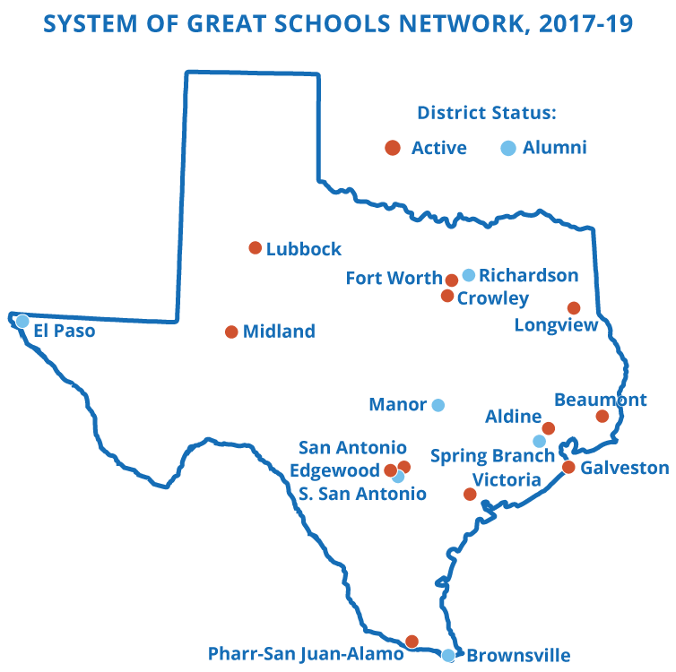What is a System of Great Schools District?

Eighteen districts, enrolling over 500,000 students, have joined the SGS network since its establishment in 2017. SGS districts vary from rural to urban and are committed to ensuring every student has access to a high quality, best fit school.

Active SGS Districts have delivered on this promise, and the outcomes speak for themselves: four of the seven Cohort 1 districts increased the percentage of A/B seats by over 40%.

TEA is committed to supporting all current System of Great Schools districts that remain committed to the SGS strategy.

SGS Theory of Action:

Districts that join the System of Great Schools network are ready to engage in bold and transformational change aligned to the following levers, each aligned to a sample deliverable:

*Set the right goal* of providing all students access to a high-quality school that best fits their educational goals and individual needs.

*Conduct an annual portfolio planning process* thatanalyzes school performance, community needs, and parent feedback to inform action plans for all schools.

*Take bold action* driven by the annual planning process, including at least one school action per year.

*Empower families* by helping parents know their child’s options, enroll in their desired program, and overcome logistical barriers to attendance.

Create organizational structures to drive new policies and practices that accelerate the success, efficiency, and sustainability of the System of Great Schools theory of action.

SGS Network Benefits:

The SGS Network is a dynamic professional learning community of like-minded district leaders throughout the state. SGS Network districts are provided with the following:

* Technical Assistance: Each SGS district is matched with a TEA-vetted organization with deep expertise to support districts in implementing the System of Great Schools theory of action. Technical assistance providers, known as Executive Advisor Firms, are funded at eight days per month in year 1 and tapering down to two days per month in year 4.
* Professional Learning Community: The TEA requires District participation in regular workshops and professional development opportunities, including:

|  |  |  |  |
| --- | --- | --- | --- |
| Event | Frequency | Estimated time commitment | Total annual time commitment |
| Superintendent & Cabinet Convenings | Triannual | 1 day per session | 3 days per year |
| Board Support and Ongoing Coaching | Varied | 2-day initial training & monthly coaching session | 4 - 5 days of training and coaching per year |
| Chief Innovation Officer Workshops | Every other month | 1 day per session and about 4 hours of prework | 6 days off-site and 20 - 24 hours of pre-work total |
| Annual SGS Summit | Annual | 2 days (virtual) | 2 days, including 5 - 10 hours of pre-work |
| SGS Network District Visit | Annual | 1 - 2 days per visit (virtual) | 2 - 4 days per year |

* Access to Grants and Resources: While SGS Districts are not guaranteed state or federal grants, they are strategic about the accessing competitive grants and other funding opportunities to jump start SGS initiatives, including:
  + School Action Fund: Open to eligible *comprehensive* and *targeted* campuses, the School Action Fund can be used for planning and implementation of “school actions:” create a new school, restart a struggling school, and reassign students to a higher-performing school.
  + Texas Partnerships: SB 1882 provides benefits in order to encourage districts to use Texas Partnerships as an action to improve student outcomes. Approved partnerships may receive additional state funding for the partnership school, and schools with an unacceptable state accountability rating are eligible to receive a two-year exemption from specific accountability interventions.
  + Charter School Program (CSP) Replication and Start-up Grants: Eligible Texas Partnerships may apply for CSP grants to support implementation.

# Eligible Applicants:

All interested Texas districts are eligible to apply. Ideal districts have over 7,500 students, 10 or more schools, and the desire to pursue system transformation to create high-quality best-fit schools.

SGS Application Process and Timeline:

* **July 1: Applications Released**
  + The Division of System Support and Innovation (DSSI) will release the application for Districts which are interested in joining the SGS network for the first time. Please note that there are two differentiated applications: one for current SGS Districts interested in continuing in the network and one for districts new to SGS. Applications and more information can be found on [systemofgreatschools.org/apply](http://www.systemofgreatschools.org/apply).
* **August 14: Application due**
  + Districts interested in joining the System of Great Schools Network should apply by submitting the application to [**SGS@tea.texas.gov**](mailto:SGS@tea.texas.gov).
* **September 1 - 11: Phone Interviews**
  + DSSI staff will conduct phone interviews with District leaders to add context to the written application.
* **September 14 - 30: Readiness Assessment**
  + DSSI staff conducts virtual interviews and focus groups with key district stakeholders, including Cabinet members, Board members, principal managers, principals, parents, and students to determine the District’s readiness to pursue the SGS theory of action.
* **October 9: Invitation to Join Network**
  + Accepted applicants will be invited to join the 4-year program via email.
* **October – November: Onboarding for New SGS Districts**
  + Upon selection, districts will vet and select an Executive Advisor Firm that will support SGS implementation. Executive Advisor Firms and the SGS district support team will conduct a phone call with network districts to kick-off the SGS implementation process.
  + SGS Districts set a clear vision for the next four years and District leaders attend the first of the network’s bimonthly CIO Workshops.

How to Submit:

* Applicants must submit proposals via email to [SGS@tea.texas.gov](mailto:SGS@tea.texas.gov) by August 14, 2020.
* Submissions must be in 11-point font and single-spaced. Please adhere to specified limits.
* All required documents should be submitted as either a Word or PDF file.
* Late or incorrectly formatted applications will not be accepted.
* Contact [SGS@tea.texas.gov](mailto:SGS@tea.texas.gov) with questions.

System of Great Schools Application: New Districts

Page limit: 5 pages total

*Section 1: SGS Preconditions*

*Limit: 500 words*

The SGS team is seeking districts that have two necessary conditions to implement specific high-value SGS strategies: understanding of the SGS Strategy and having the political will to get things done.

1. Please explain 2-3 of the district’s strategic priorities and how success on those priorities is measured.
2. Why does your district want to implement an SGS strategy? Why is now the right time to join the SGS Network?
3. Has your district created, restarted, or closed any schools in the past five years to increase access to improved academic options?
   1. If yes, please describe why and how these actions were chosen, what these actions were, when these actions were executed, which stakeholders were involved, and what your leaders learned along the way.
   2. If no, what indicates that your district leaders, such as board members, the superintendent, and cabinet members, are now ready to take bold action?

*Section 2: Managing School Performance*

*Limit: 500 words*

SGS network districts use data to measure the quality of each seat available to children in their community with the goal of increasing the number and percent of seats in A- and B-rated schools.

1. Does campus performance data inform the District’s strategic and long-term plans?
   1. If yes, how does this analysis impact the district’s plans for campus-level interventions and actions? Which stakeholders and community members are involved in strategic and long-term plans, especially to start, restart and close schools?
   2. If no, what steps does the district need to take to gain a clear picture of the district’s overall performance?

*Section 3: Expand Great Options*

*Limit: 1000 words*

SGS network districts take steps to expand high quality education options for all students using all tools available, including traditional school improvement methods as well as bold school actions.

1. Does the District cultivate internal leaders to lead school actions and partner organizations? o If yes, please describe the success of this process or program thus far.
2. Has the District created any new schools in the past 2-3 years? o If yes, what was the process to design and launch this new school?
3. What is the District’s approach to improving chronically underperforming schools (ie, D/F rated or IR-2-4 schools)?
4. Has the district closed any schools in the past 2-3 years? o If yes, how did the District determine this was the right decision for the campus(es)?
5. Does your district currently authorize in-district charter partnerships? o If yes, please describe the process for vetting and selecting that partner. What is the process for recruiting and evaluating non-district organizations?

*Section 4: Improve Access to Options*

*Limit: 500 words*

SGS network districts increase access to school choice options and help parents and families know their child’s options, enroll in their desired program, and overcome logistical barriers to attendance.

1. How do students currently enroll in school in your district?
2. Is there any flexibility for students who don’t want to attend their neighborhood school for whatever reason?
   1. If yes, how does your district currently help parents and families find a campus that best fits their child’s needs and understand the enrollment process?
   2. If no, what are the main barriers to allowing families to choose the right school for their child(ren)?

*Section 5: Create New Organizational Structures*

*Limit: 500 words*

SGS network districts create an Office of Innovation to lead systemic reform and establish policies on staffing, partnerships, campus autonomy, and finances which establish a cycle of continuous improvement.

1. Does the district currently have an Office of Innovation or similar office?
   1. If yes, please describe the roles and responsibilities of this office. Do any members of this office hold a Cabinet-level position?
   2. If no, what is the likelihood of the district starting an Office of Innovation with a cabinet-level position?
2. How does your district currently allocate revenue to each campus each school year? (For example, is this based on the number of staff members assigned to the campus, based on the number and types of students enrolled, or on other considerations?)

*Section 6: Supplemental Questions*

*Limit: 250 words*

1. Who are the key educational stakeholders in the district (i.e., education champions, nonprofit organizations, etc.)? How has your district engaged these stakeholders to drive improved academic options for students?

*Section 7: SGS Program Assurances*

By completing this application, the Superintendent commits to implementing the following SGS initiatives in the District:

1. The District commits to conducting an annual portfolio planning process that analyzes academic performance and community need and demand.
2. The District commits to executing at least one school action each year, including creating a new school, restarting a low-performing school, or reassigning students to a higher-performing school.
3. The District commits to building a pipeline of internal school leaders and external partner organizations to execute school actions aligned with district needs.
4. The District commits to launching an annual Call for Quality Schools to announce the needs of the District and rigorously vet internal school leaders and/or external partner organizations and their plans to execute school actions.
5. The District commits to launching an Office of Innovation with a Cabinet-level Chief Innovation Officer (or similar position.)
6. The District commits to actively participating in all SGS-related professional learning activities, including CIO Bootcamp, Texas Authorizer Leadership Academy, Superintendent and Cabinet convenings, and the annual SGS Summit.
7. The District commits to develop and implement equitable enrollment policies and practices.

*TEA commits to supporting districts in completing all SGS Program Assurances.*

*Section 8: Contact Information*

Please provide the information requested below.

|  |  |
| --- | --- |
| District |  |
| Mailing Address |  |
| Superintendent Name |  |
| Superintendent Email |  |
| Superintendent Phone |  |
| SGS Primary Contact Name |  |
| SGS Primary Contact Email |  |
| SGS Primary Contact Title |  |

_____________________________________ _____________________________

Superintendent Date

_____________________________________ _____________________________

Chief Innovation Officer Date