Instructional Continuity Recommended Check-list for Immediate Action

Purpose of Document:
The document provides a high-level check-list of action items the agency recommends districts take immediately to launch at-home instructional models.

Background:
The agency is developing an instructional continuity framework to support districts in launching and/or enhancing an at-home school to maximize the amount of instructional time for students this school year and support student mastery of grade level standards. Resources will be provided in alignment with the framework to support districts in delivering at-home instruction
Instructional Continuity Framework
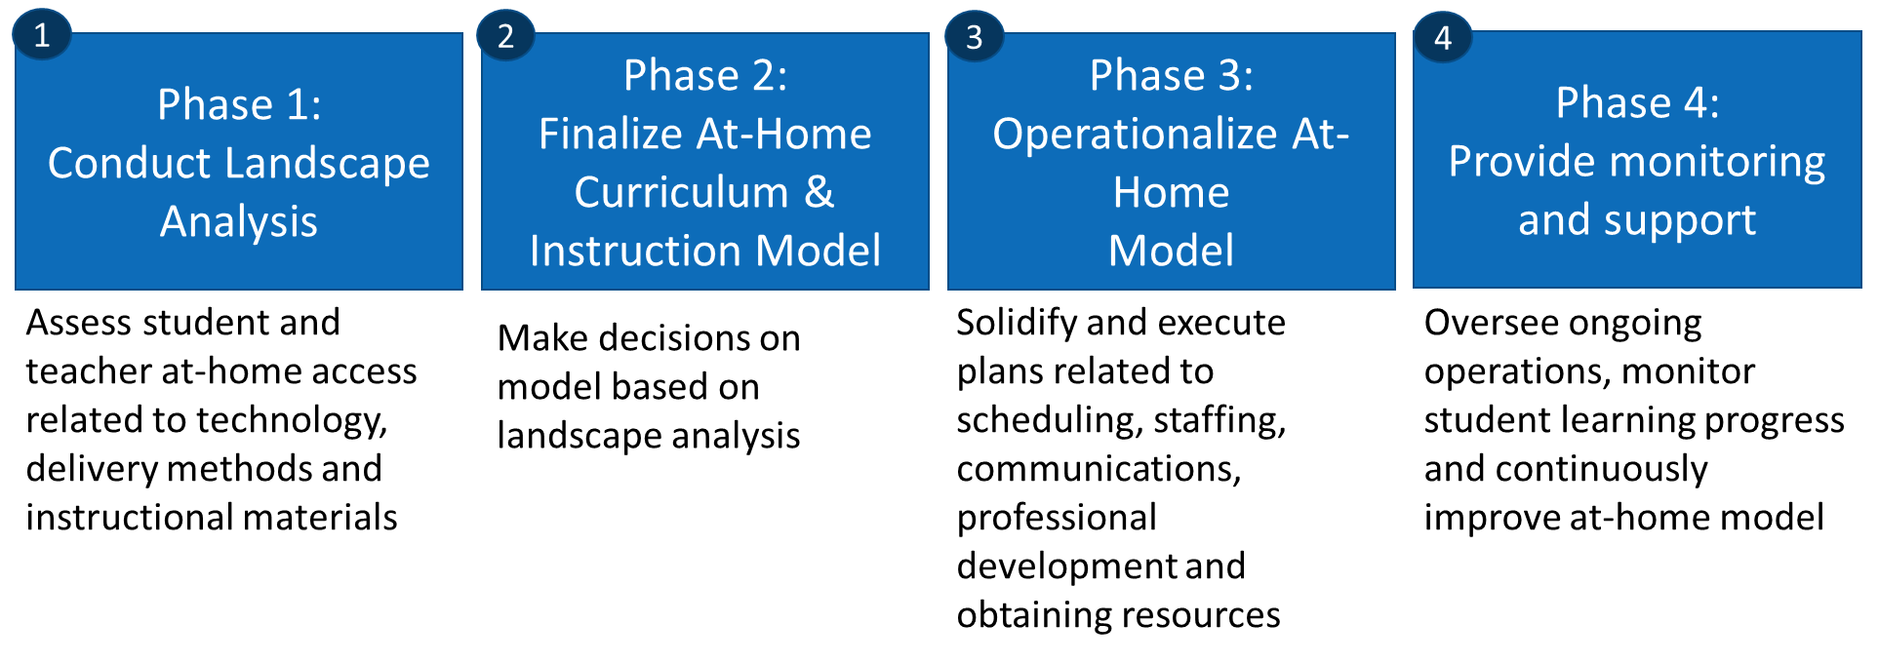

Instructional Continuity Recommended Check-list for Immediate Action
- Understand student access to at-home internet and devices
  - See next page for sample parent survey and communications that can be used if a district does not yet have this information
- Understand district’s access to learning platforms for students and teachers (e.g., google classroom, district learning management, system, etc.)
- Understand the available instructional materials that could be provided in at-home context by subject area and grade band
  - Note: Begin by determining if your district can use the materials that were already being used in the classroom prior to school closures to promote continuous learning
- Using the information above, develop your at-home curriculum and instruction model, including:
  - Instructional materials to be used by subject area and grade band
  - Instructional delivery method (e.g., digital, print materials or a combination)
  - Learning platform (e.g., google classroom)
- Create a daily and weekly short-term schedule based on the at-home model your district selects
- Develop a list of weekly activities teachers must complete to launch the online model
- Send communications to teachers, parents and students outlining the expectations and required activities for the at-home learning model

Understanding Technology Access
Student/Parent Survey Example

Overview of Survey Design
Technology Resource Survey Guidance: Districts may want to survey their students and teachers to understand access to at-home technology. There are two main factors in determining baseline readiness: internet and device access, both of which will help district’s select the learning platform and resources selected to launch an at-home learning model.

Internet Access Questions: When asking questions to understand connectivity, use descriptors that relate to online activities. While most people may not know what their actual bandwidth or other technical descriptors, they will be able to let you know specific activities they do using the internet at home (e.g., stream movies or music, play multiplayer games). These are all high bandwidth activities, so if they can do any of these though a residential or mobile connection, they have enough connectivity for online learning resources/activities.

Device Questions: When asking questions about devices please be sure to expand your definition of what a usable device is. This means including smartphones, Xbox One, PlayStation 4, and Amazon Fire TV devices. All the afore mentioned can utilize any content that is accessible through an internet browser. (See the Device/Hardware information below the sample communication templates for more information on how game systems and Fire TV devices can be utilized.)

Sample Parent/Guardian Communication

Dear Parents and Guardians,

In response to recent school closures we are gathering information about the ability of our students to continue learning at home using online materials and/or a virtual classroom. Please complete the following survey to help us understand the availability of internet and devices in your home. This will allow us to determine what supports we can provide our students to support continued learning at home. The survey can be accessed here. If possible, please complete it by Weekday, Month XX, 2020.

Sample Parent/Guardian Survey (Basic)

- How many students are within your household that attend our local district schools?

Grade Level Spans |  | Number
PK–5
6–8
9–12

- Do you have access to any of the following devices in the home that your student would be able to access for learning online? (Include all available devices)

Devices | Number
Computer (e.g. Desktop, Laptop, MacBook, Chromebook, etc.)
Mobile Device/Smartphone
Tablet (e.g. iPad, Kindle, Android tablet)
Gaming System with a browser (e.g. Xbox One or PS4)
Fire TV device (e.g. Stick, Box, or Smart TV with Fire TV built-in)
List others:

- Which of the following activities do you currently participate in online, using the internet, through any of the home device(s) you listed in the previous question?
- Watch movies
- Listen to music
- Play multiplayer games
- I am unable to do any of these activities online in my home or through any mobile device in my household(s)

Note: This question allows us to determine the bandwidth in your home which will inform the online instructional materials and learning opportunities that will be accessible by your student(s).

- Of the devices mentioned above, are any specifically dedicated to academic school work? (Include all that apply)

Devices | Number Dedicated to School Work
Computer (e.g. Desktop, Laptop, MacBook, Chromebook, etc.)
Mobile Device/Smartphone
Tablet (e.g. iPad, Kindle, Android tablet)
Gaming System with a browser (e.g. Xbox One or PS4)
Fire TV device (e.g. Stick, Box, or Smart TV with Fire TV built-in)
List others:

