The information included in this guidance is provided as a resource only.
This information is intended to assist in the delivery of educational resources in this time of public crisis.

Phase 4: Provide Monitoring and Support

Planning Category 4.2: Provide Ongoing Teacher Supports

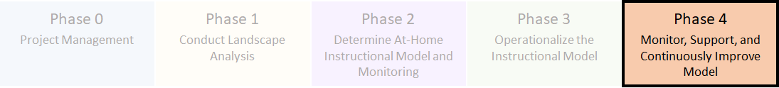

Planning Category Activities
- Design process for school leaders and coaches to check in with teachers for support.

- Develop check-in template, schedule, and execute teacher check-ins.

- Create professional development plan to provide ongoing support around use of materials and delivery method.

Planning Guidance
School districts should leverage existing systems and processes as a foundation of support to provide greater continuity and consistency.
- Design process for school leaders and coaches to check in with teachers for support.
- What processes and systems already exist for school leaders and coaches to check in with teachers? How can these systems be adjusted to a virtual setting?
- What new systems or processes need to be implemented to ensure that campus leaders and coaches have regular and frequent check-ins with teachers?
- What daily routines and expectations will need to be created or adjusted to check daily attendance or presence of teachers?
- How will systems be monitored and improved at the district level?
- What expectations will be mandatory across the district? What expectations will be determined by individual campus leaders or coaches?

- Develop check-in template, schedule, and execute teacher check-ins.
- What critical components do campus leaders or coaches need to check in about regularly with teachers to support at-home instruction?
- How will campus leaders or coaches conduct check-ins with teachers? What will be the expectations for pre- and post-work for check-ins?
- Where will check-in documents be located and how will they be shared?
- What is the expectation for preparing prior to the meeting?

- Create professional development plan to provide ongoing support around use of materials and delivery method.
- How will teacher training needs be identified? How will identified needs be shared with district leaders responsible for professional development support?
- Does a library of on-demand trainings exist to support differentiated teacher needs?
- What is the process for requesting additional training?
- Have individuals been identified as leads with certain programs or content to support teacher needs?
- What systems need to be adjusted or created to support coaches with their teacher check-ins? How will training for coaches be identified and provided for ongoing improvement, support, and accountability?
- Are there structures to support teacher collaboration and discussion for peer support?

Suggested Staff Support
The primary staff members who could be involved in this planning are district and campus leaders. As much as possible under current circumstances, leverage teacher input. Throughout the planning process, ensure that a clear owner is assigned to each task.
- District: establish guidelines for campus leaders and teachers regarding regular check-in expectations; develop process for identifying training needs and establishing system for requesting district-level support
- Campus: communicate expectations with staff and set schedule for check-ins; determine how teacher progress will be monitored and needs identified; share template for check-in and model use or adjustments to current process.
- Teachers: leverage check-ins as a system for raising concerns and requesting support; staff shares feedback to improve system to better meet individual needs

TEA Resources
Template Teacher Check-In Document: example of structure and guidance for campus leaders or coaches to conduct teacher check-ins

Additional Resources
Curriculum Support Guide Determine the Plan for Coaching: framework provided by Instructional Partners to guide the model and systems for coaching teachers

Find links to all Phase 4 resources on the TEA Instructional Continuity Framework website.

