For each of the social media posts, you can use the static image within this file or download and use the corresponding GIF directly from the TEA Public Health Campaign resources website.

Sat., April 4 Social Media Post #4
English
You can spread #COVID19 without knowing you have it. Whether you have symptoms or not, #StayHome. If you have to go out, wear a mask/bandana/scarf, regularly wash your hands, and stay 6 feet apart. We must stay #ApartTogether to slow coronavirus. https://tea.texas.gov/staywell
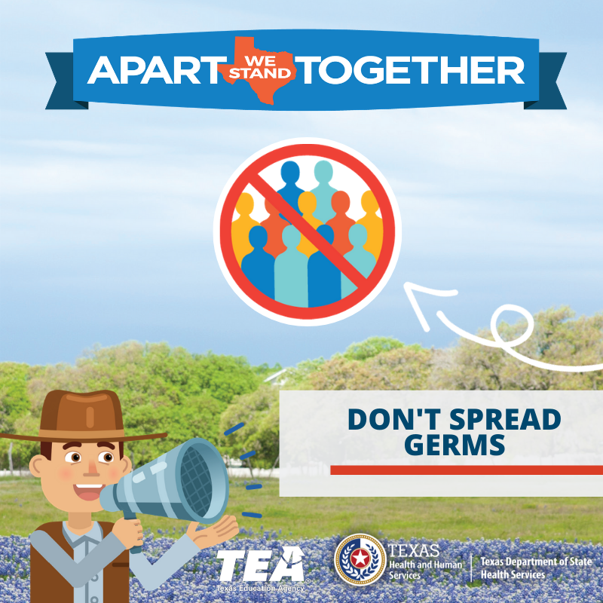

Spanish
Puede propagar #COVID19 sin saber que lo tiene.Ya sea que tenga síntomas o no, quedate en casa.Si tiene que salir, use una bandana/bufanda, lávese las manos regularmente y manténgase a 6 pies de distancia.Debemos permanecer separados #ApartTogether.tea.texas.gov/mantentebientejas
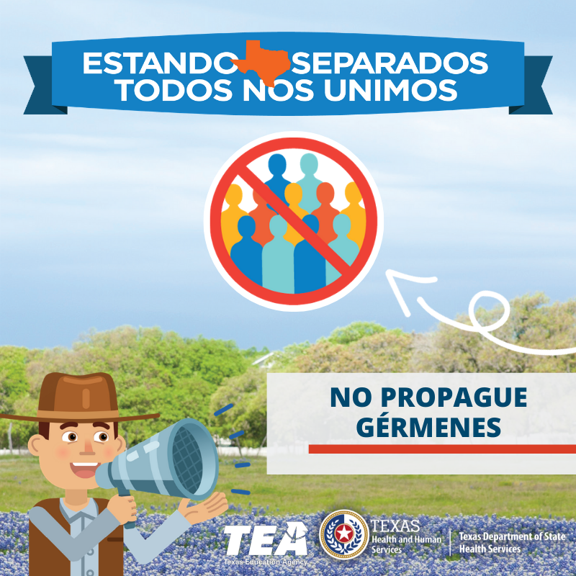

Sun., April 5 Social Media Post #5
English
Before social distancing, each person with #COVID19 spread the virus to 2.5 more people. At that pace, most would get it, and many more people would die. But we can slow the spread. That’s why we all #StayHome. #ApartTogether we slow coronavirus.
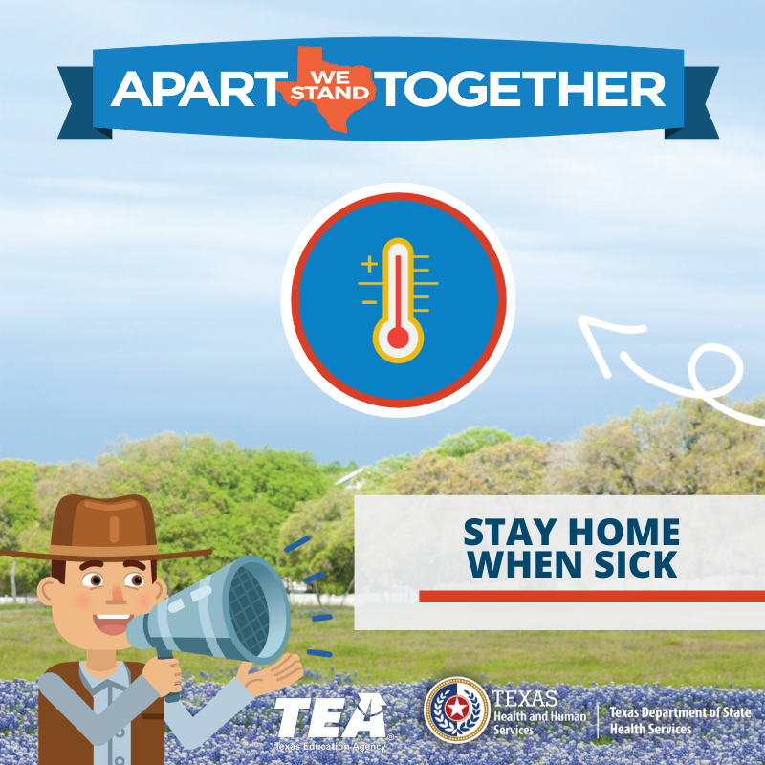

Spanish
Antes del distanciamiento social, cada persona con #COVID19 transmitió el virus a 2.5 personas.A ese ritmo, muchas personas se contagiarían, y muchas personas morirían.Pero podemos retrasar la propagación.Por eso todos quedemonos en casa y paremos el Coronavirus.#ApartTogether
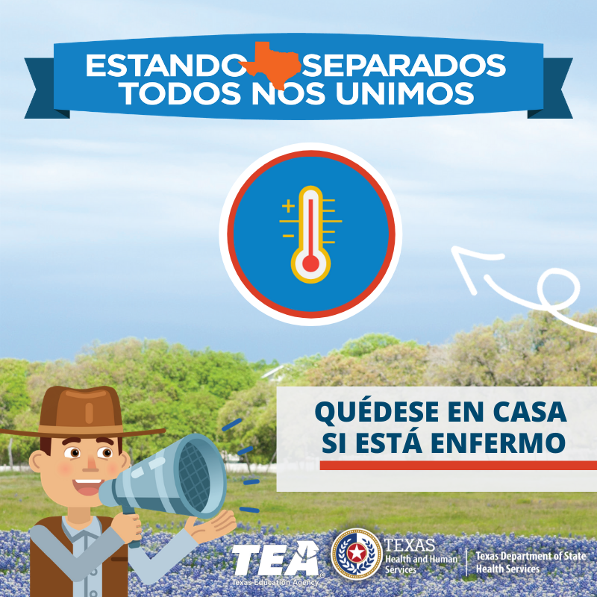

Mon., April 6 Social Media Post #6

English
Common symptoms of #COVID19 are fever, dry cough, & shortness of breath. If you have mild symptoms, call your doctor & #StayHome. If you develop serious symptoms, such as trouble breathing, pressure in the chest, or bluish lips or face, call your doctor & seek care immediately.

Spanish
Los síntomas comunes de #COVID19 son fiebre, tos seca y dificultad para respirar.Si tiene síntomas leves, llame a su médico y quedate en casa.Si desarrolla síntomas graves, como dificultad para respirar o presión en el pecho, busque atención médica de inmediato. #StayHome

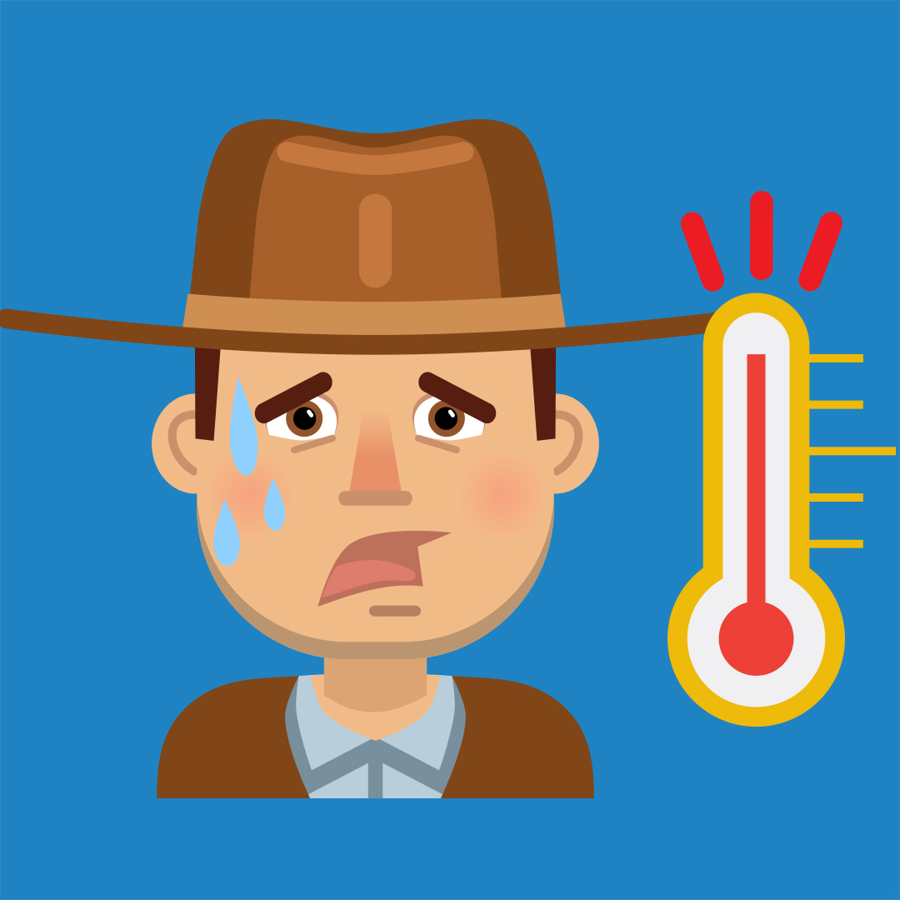

Tues., April 7 Social Media Post #7

English
#COVID19 lives on droplets in the lungs of people with the virus, even if they don’t have symptoms. When infected people breathe, the virus enters the air. If you can’t #StayHome, wear a mask/scarf/bandana, stay 6 feet apart, and wash your hands. #DontGoViral

Spanish:
#COVID19 vive de gotas en los pulmones de las personas con el virus incluso si no tienen síntomas.Cuando las personas contagiadas respiran, el virus entra al aire.Si no puedes quedarte en casa #StayHome, use una bufanda/pañuelo, manténgase a 6 pies de distancia y lávese las manos

Tues., April 7 Text Message #3

English
#COVID19 lives in the lungs of people with the virus, even if they don’t have symptoms. If you can’t stay home, wear a mask, stay 6 feet apart, and wash hands.

Spanish
#COVID19 vive en los pulmones de las personas con el virus, incluso si no tienen síntomas. Use una máscara, manténgase a 6 pies de distancia y lávese las manos.

