House Bill 3 College Preparation Assessments: Instructions for Requesting TSIA Reimbursement

I. Policy Overview
House Bill 3 (HB 3) college preparation assessment reimbursement, enacted by the 86th Legislature, permits the state to provide a one-time reimbursement to districts for the cost of administering one college preparation assessment (SAT, ACT or TSIA) per eligible student. Estimated funding is advanced to districts annually in the fall Foundation School Program (FSP) funding. Each year, TEA reconciles these funds for April settle-up.
More information about this policy is covered in depth in the HB 3 SAT, ACT, and TSIA Reimbursement FAQs. Importantly, for the 2021-2022 school year, eligible students are as follows:
- Seniors who take either the SAT, ACT, or TSIA from September 1, 2021 – July 31, 2022.
- Juniors who take either the SAT, ACT, or TSIA from January 1, 2022 – July 31, 2022.
Note: August 2022 test administrations will be submitted and considered in the 2022-2023 process.
SAT and ACT school day participants are automatically considered for reimbursement. TEA has a separate request process for districts who would like to request reimbursement for the SAT and ACT national day testing. If multiple records of a student are reported, TEA will reimburse the highest cost exam per eligible student. If multiple records of a student are reported from several districts, the first district will be considered.
If the TSIA is the highest cost exam for a student for which the district paid and would like reimbursement, then the district must request a reimbursement from the agency using the process outlined in this document.
A request for reimbursement does not guarantee a reimbursement will be administered. After receiving all requests for TSIA and SAT/ACT, TEA will validate requests and reconcile funding accordingly. TEA recommends that districts retain all back-up documentation on district policies, decisions, and payments in the event of an audit.
Only one file per district will be accepted. TEA will not accept individual campus requests.

II. Process Instructions

Step 1: Determine Eligible Students and Costs for TSIA Reimbursement
Districts should follow local policy when determining the students for which they would like reimbursement. The following is a list of eligibility criteria the district must consider when creating/following these local policies.
Student Eligibility:
- Student must have been in the eligible grade level at time of test administration (see above)
- Student must have been in the requesting district at time of test administration
- Student must have taken both the math and the reading administration at an approved TSIA testing center within the eligible time frames
Eligible Costs:
- TSIA2 ELAR assessment
- TSIA2 math assessment
- Proctor fees for administering an online assessment as a result of COVID-19, such as Examity and ProctorTrack
All other costs not described above are not eligible for reimbursement, including, but not limited to:
- The writing assessment
- Teacher salaries
- Licenses to purchase video chat services (Zoom, WebEx, GoToMeeting, etc.)

Step 2: Create TSIA Data File (File Template Provided for Reference)
Districts must provide all the data represented in the table below in a spreadsheet to the agency. TEA has created a template here for districts to utilize and/or replicate.
TEA has collaborated with the College Board to provide instructions on how TSIA administrators can create a custom report and query on the ACCUPLACER platform with the necessary TSIA data requested on the template. This allows those districts who are TSIA administrators or who have a data sharing agreement with an institute of higher education (IHE) an easier ability to find accurate data. Please go to section A of the appendix for more information.
Below is the required list of data elements in the template and its standards. For information on data types and pattern description definitions, please see sections B and C of the appendix.

Column | Data Element (As shown on template) | Definition (What it is) and Purpose (why it’s needed) | Source (Where to find it) | Length, Data Type, Pattern (How to enter it)
A | County-District-Campus (CDN) Number | The unique 6-digit number that identifies the county and district at which the student is enrolled. This also identifies the district that is requesting reimbursement.  To validate student attendance at district at time of testing | TSDS Element ID E0212 | 6, coded, ######  Example: 001902
B | Student 10-Digit TSDS Unique Student ID | The unique 10-digit number assigned to a student by the Texas Education Agency.  To validate the student | TSDS Element ID E1523 | 10, numeric, ##########  Example: 0123456789
C | First Name (Student) | The student’s legal first name  To validate TSIA2 test attendance | As entered on the TSIA ACCUPLACER platform; field is called “FIRSTNAME” | 20 characters, NameField (text), *…  Example: Xavier
D | Last Name (Student) | The student’s legal last name  To validate TSIA2 test attendance | As entered on the TSIA ACCUPLACER platform; field is called “LASTNAME” | 20 characters, NameField (text), *…  Example: Rodriguez, Jr.
E | Date of Birth (Student) | The student’s legal year, month, and day of birth  To validate TSIA2 test attendance | As entered on the TSIA ACCUPLACER platform; field is called “BIRTHDATE” | 8, coded, YYYYMMDD  Example: 20031231
F | Student ID  (Primary) | The student ID assigned by the TSIA2 ACCUPLACER.  To validate TSIA2 test attendance | As entered on the TSIA ACCUPLACER platform; field is called “ID#”  Can also be found on the Instructional Score Report (ISR) | 20, alphanumeric, *…  Example: 99999ABCDE
G | Supplemental Student ID | The supplemental student ID assigned by the TSIA2 ACCUPLACER.  To validate TSIA2 test attendance | As entered on the TSIA ACCUPLACER platform; field is called “ID#”  Can also be found on the Instructional Score Report (ISR) | 20, alphanumeric, *…  Example: 99999ABCDE
H | Test Start  (Date of TSIA Administration) | The start date of reading and/or math administration  To validate TSIA2 test attendance | TSIA ACCUPLACER platform; field is called “TESTSTART” | 8, coded, YYYYMMDD  Example: 20200131
I | EXNUM  (Session ID) | The examinee number generated and defined by the ACCUPLACER system  To validate TSIA2 test attendance | TSIA ACCUPLACER platform; field is called “EXNUM” | 9, numeric, #########  Example: 47949
J | Inst ID  (Location Administrative Site ID) | The 9-digit site number (10 characters when including the hyphen) generated and defined by the ACCUPLACER system  To validate TSIA2 test attendance | TSIA ACCUPLACER platform; field is called “SITEID” | 10, coded, ######-###  Example: 000466‐003
K | TSIA2 ELAR Placement Score, if applicable | The TSIA2 reading placement score for the reported test session.  For district record keeping and to validate TSIA2 reading administration attendance | Local records | 3, numeric, ###  Example: 940
L | TSIA2 Math Placement Score, if applicable | The TSIA2 math placement score for the reported test session.  For district record keeping and to validate TSIA2 math administration attendance | Local records | 3, numeric, ###  Example: 950
M | Cost of Administration(s) | a) If the student took the TSIA2 using district-purchased units either on campus or through video services such as Zoom or WebEx, the district will be reimbursed for the student record at a rate of $1.75 per unit. In the spreadsheet, districts must leave the cost field blank.  If not, TEA will override the reported cost.  b) If the student tested through Examity or ProctorTrack, either through units purchased by the district or an institute of higher education (IHE), the district will be reimbursed for the cost incurred by the district. In the spreadsheet, districts can report a valid cost. Districts must indicate whether or not the student tested using Examity or ProctorTrack in Column P.  c) If the student tested through an institute of higher education or other organization using units purchased by an entity other than district, the district will be reimbursed for the cost incurred by the district. In the spreadsheet, districts can report a valid cost.  Please keep in mind that the writing/essay and diagnostics on the TSIA2 are not eligible for reimbursement.  To ascertain TSIA2 administration cost for reimbursement | Local Records, Receipts, and/or Invoices | 5, numeric, ##.##  Example: 10.00
N | Did the student test through Examity or ProctorTrack?  (Y/N) | The indication that the student tested through Examity or ProctorTrack.  Should only to be filled as “Y” if reporting cost based on letter (b).  To accept the cost field as valid for those who tested using Examity or ProctorTrack. Otherwise, the cost may be overwritten. | Local records | 1, coded, Y/N  Example: Y

Step 3: Upload File to Qualtrics Form (Link Provided)
Once completed, save the file with the title “FY21TSIA_[insert CDN]” and as a comma-delimited list (comma separated value; .csv). No other file formats will not be accepted, including Excel files (.xlsx, .xls) or XML files (.xml). Remember, only one file per district will be accepted.
Open the link for submission of the spreadsheet and complete each required field. The link closes September 30, 2022. Late files will not be accepted, including those submissions that are late due to the platform being down or network connection problems. There is no appeals process.

1. Select the correct region and district based on the drop downs provided.
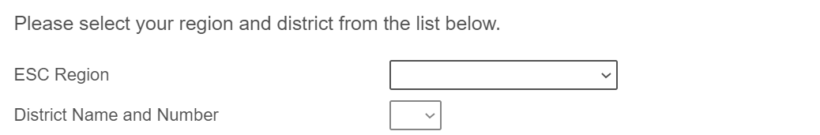
2. Enter the contact information for the person submitting the survey. This is the person the agency will contact if there are issues or errors in submission.
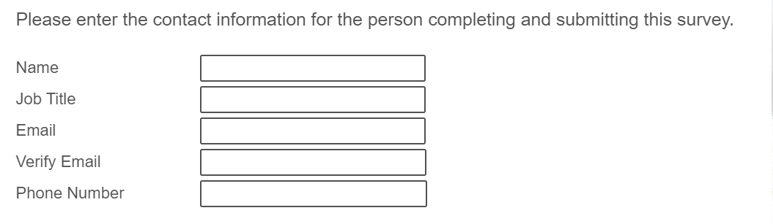
3. Enter the contact information for the district/LEA’s business office/accountant. This is the person the agency will contact if there are issues or errors in funding or calculations. Hit “Next” to go to the next page.
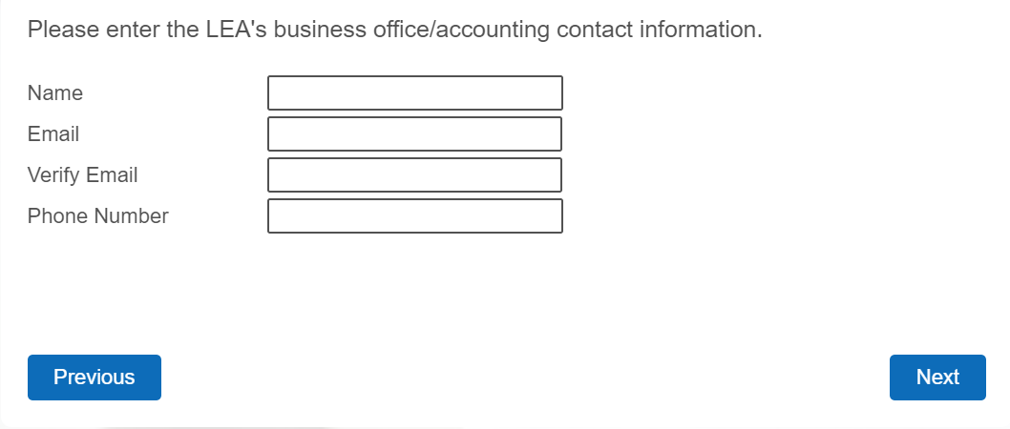
4. Download the template, complete the spreadsheet according to the instructions, title the spreadsheet FY22TSIA_[CDN], and save as a comma separated value (.csv). Acknowledge the cost reporting requirements. Hit “Next” to go to the next page.

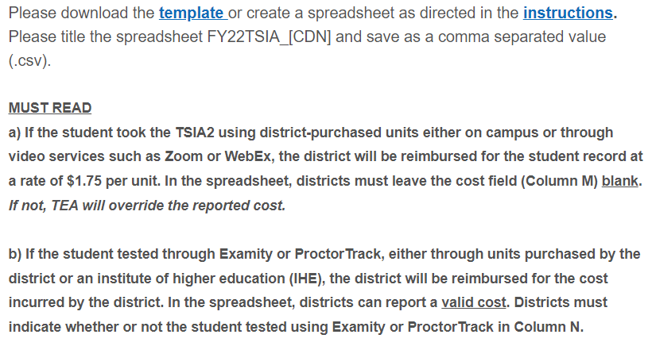
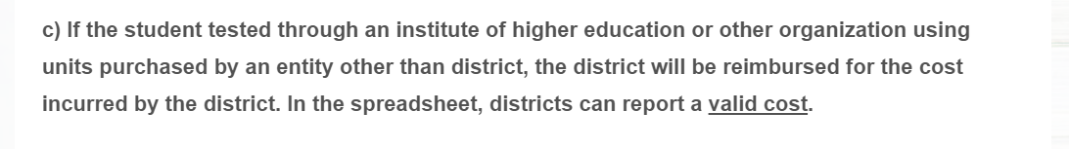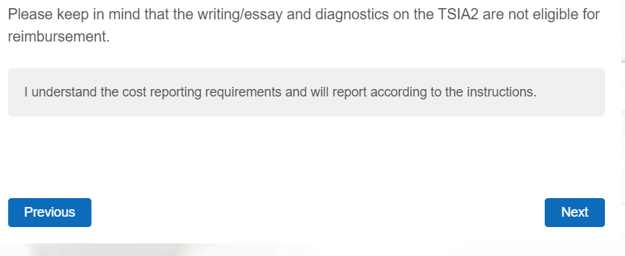
5. Upload the file. Hit “Next” to go to the next page.
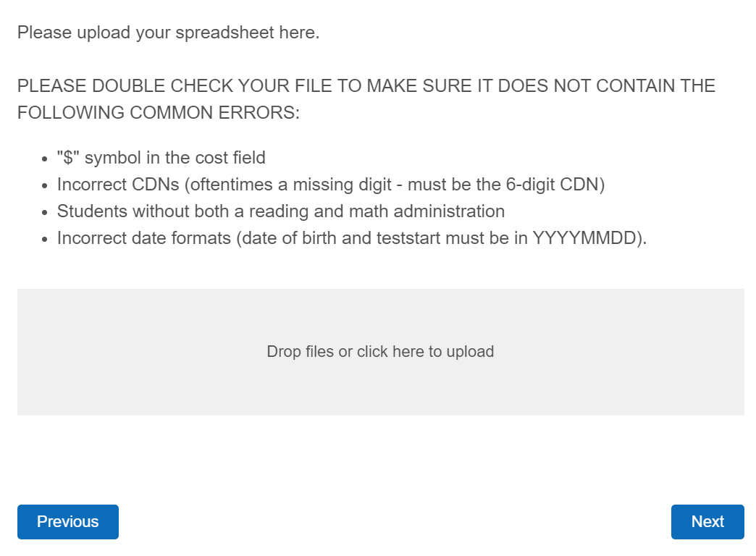
6. List the total number of students that are being submitted in the file.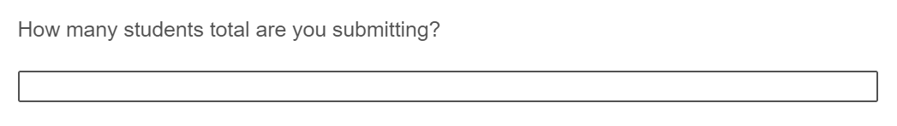
7. Provide the signature of the person submitting this form. This is verifying all information is correct and documentation can be provided to TEA in the event of an audit. Hit “Next” to submit the survey.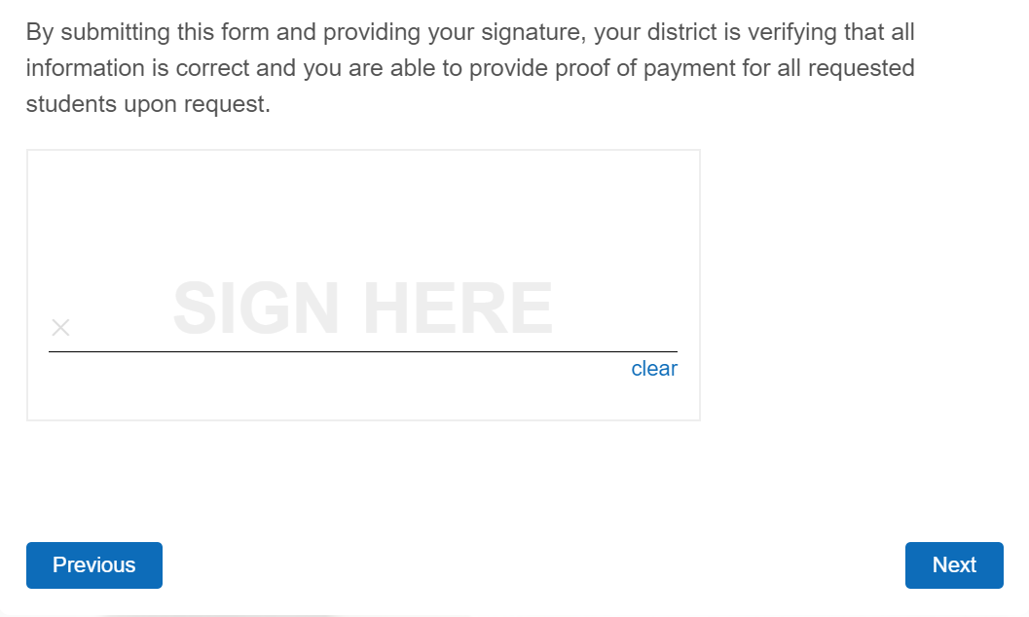
8. The form has been submitted. TEA will process the request and post final reimbursements on April 1, 2023 in the TEA Login (TEAL) Accountability application.
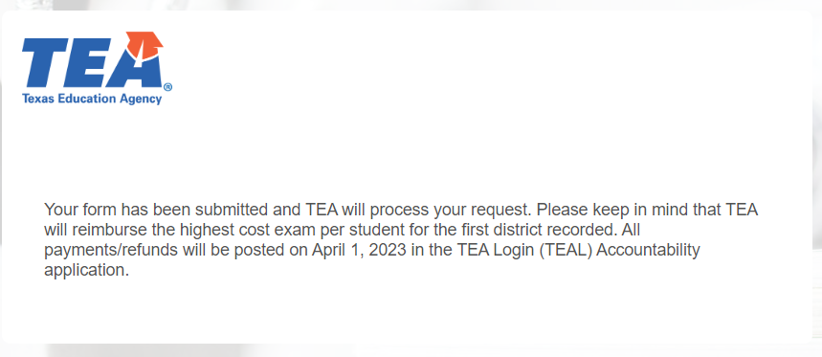

III. Appendix

A. College Board Instructions for TSIA Administrators Using the ACCUPLACER System
This information can be found when TSIA administrators log in to the ACCUPLACER system. There is an instruction document and voice recording.

B. Data Type Definitions
Coded
- A string of upper-case alphanumeric characters of fixed length
- If a value is present, it may not contain blanks
NameField
- Any of the following characters, in addition to the space character: ABCDEFGHIJKLMNOPQRSTUVWXYZ0123456789 ~ ! @ # $ % ^ & * ( ) - _ + = : ; " ' , . / < > ?
- Left justification is required
Numeric
- A string of numeric characters
- When the number is negative, a single dash precedes the number
- If decimal precision is required by the definition of a specific element, the decimal point must be present unless all digits to the right of the decimal are zero.
- Leading zeros are optional for numeric data types, even if displayed in the Domain of Values
String
- A string of alphanumeric characters
- attributes must start with a letter or underscore, and can only contain letters, digits (0-9), underscores ("_"), hyphens ("-"), and periods (".").

C. Pattern Description Definitions
*… Any character in name field accepted; no edit check for pattern
# Number; Digits 0 through 9 accepted.
MM Month (2-digit)
DD Day (2-digit)
YYYY Year (4-digit)

