DRAFT

**Texas Education Agency**

**Manual for Districts Subject to Wealth Equalization**

**2017–2018 School Year**

School Finance Department

Spring 2017

Texas Education Agency

Manual for Districts Subject to Wealth Equalization

**2017–2018 School Year**

**Contents**

Notes on This Manual 7

Significant Changes 9

Chapter 41 Calendar for School Year 2017–2018 11

Section 1: Background Information 17

What is Chapter 41? 17

How did Chapter 41 come about? 17

What is a Chapter 41 district? 17

What is weighted average daily attendance (WADA)? 18

What is the first equalized wealth level (EWL)? 18

What is the second EWL? 18

What is the third EWL? 19

Section 2: Administrative Procedures 21

What actions must our district take following preliminary notification of its Chapter 41 status in the spring? 21

What actions must our district take following official notification of its Chapter 41 status in the summer? 21

What procedures must our district follow in selecting a particular option? 23

When does the TEA provide estimates of the cost of recapture? 25

How does our district estimate the cost of recapture? 26

How does our district make its Chapter 41 payments if it does not qualify for the netting option and chooses to pay some or all recapture costs under Option 3? 26

What is settle-up? 27

Settle-Up: For Districts Exercising Option 3 or Option 3 in Combination with the Technology Consortium Form of Option 4 27

Settle-Up: For Districts Exercising Option 4 27

Section 3: Options for Reducing Wealth 31

What options are available to reduce wealth? 31

Which of these options require voter approval? 32

What special requirements apply in choosing Option 4? 32

How does our district participate in an Option 4 technology consortium? 33

What happens if our district does not make Chapter 41 payments? 33

What happens if the default is related to a prior school year? 34

What happens if the default is related to a current school year? 35

What happens if our district does not call an election? 37

What happens if our district calls an election but the voters don’t authorize an option to reduce wealth? 37

Section 4: Options for Reducing Costs 39

What options are available to reduce recapture costs? 39

Can our district receive a credit for submitting its agreement early? 39

Is our district eligible to receive a credit for tuition paid to another school district? 39

Is our district eligible to receive a CAD cost reduction? 40

What is the Chapter 41 hold harmless provision? 40

Is our district eligible for the hold harmless provision? 41

Section 5: Taxation 43

How does being a Chapter 41 district affect tax rate adoption? 43

What if our district experiences a decline in its tax base between the prior tax year and the current tax year? 43

Appendix A: Applicable Statutes 45

Appendix B: Forms 47

2017–2018 Chapter 41 District Intent/Choice Selection Form 49

2017–2018 Contracts 52

2017–2018 M&O Collections, WADA, CAD Cost, Tuition & Chapter 42 Partner Data 56

Appendix C: Sample Contracts 63

Agreement for the Purchase of Attendance Credits 65

Agreement for the Purchase of Attendance Credits (Netting Chapter 42 Funding) 67

Agreement for the Education of Nonresident Students 69

Optional Language to Be Inserted in the Agreement for the Education of Nonresident Students 71

Appendix D: Sample Ballot Proposition Language 73

Appendix E: Glossary 81

Index 83

*This page has been left blank intentionally.*

# Notes on This Manual

Although this manual provides information to anyone with an interest in Chapter 41 of the Texas Education Code, it is designed primarily for school districts that are subject to the provisions of   
Chapter 41 (“Chapter 41 districts”). It reflects the procedures the agency uses in administering   
Chapter 41’s provisions.

Unless stated otherwise, in this manual, *your district* refers to a Chapter 41 district.

The manual provides the following:

* an annual calendar with critical deadlines
* background information on Chapter 41
* the specific actions that your district must take to achieve wealth equalization
* information about tax-rate setting that is specific to Chapter 41 districts
* sample contracts that your district can use to achieve wealth equalization

The italicized terms in Sections 1 through 5 of the manual are defined in the glossary in Appendix E.

No school district official or any other person in your district has the authority, either implied or actual, to change any rules or requirements specified in this manual.

Your district will need to access the online Foundation School Program (FSP) System to comply with reporting requirements described in this manual. The FSP System is one of the applications in the Texas Education Agency Secure Environment (TEASE). Instructions on how to apply for access to the FSP System through the TEASE are available at <http://tea.texas.gov/About_TEA/Other_Services/Secure_Applications/TEA__Secure_Applications_Information/>.

*This page has been left blank intentionally.*

# Significant Changes

The following table briefly describes the significant changes from the 2016–2017 manual.The table does not include all changes made to the manual*.*

**Significant Changes in the   
*Manual for Districts Subject to Wealth Equalization 2017–2018 School Year***

|  |  |
| --- | --- |
| **Change** | **Section Affected** |
| The Chapter 41 Contract is automated via the Chapter 41 subsystem of the online FSP System. Beginning with the 2017–2018 school year, the letter approving the contract is located in a link at the bottom of the Contract Detail in the Chapter 41 subsystem of the online FSP System. | Chapter 41 Calendar for School Year 2017–2018, What actions must our district take following official notification of its Chapter 41 status in the summer?, |

*This page has been left blank intentionally.*

# Chapter 41 Calendar for School Year 2017–2018

If the calendar date falls on a weekend, federal or state holiday, the effective date is the business day preceding the weekend or holiday.

|  |  |  |
| --- | --- | --- |
| **May 1, 2017** | | May 1 is the approximate date the agency provides preliminary notification to districts tentatively identified as having Chapter 41 status for 2017-2018  This preliminary notification is informational only and does not require a response by the district unless the district needs to adopt its tax rate early. |
| **May 1, 2017** | | May 1 is the approximate date for preliminary 2017–2018 Cost of Recapture *Report*s to be made available through the <https://tea4avfawcett.tea.state.tx.us/fsp/Reports/ReportSelection.aspx> |
| **July 15, 2017** | | Certified property values for tax year 2016 are provided by the Texas Comptroller’s Property Tax Assistance Division (PTAD). |
| **July 15, 2017** | | The agency provides official notification to districts with property wealth above the equalized wealth level for the 2017­–2018 school year, as determined from the 2016 property values provided by the PTAD. |
| **August 21, 2017** | | **August 21 is the last date for a new Chapter 41 district to call an election for voter approval to purchase attendance credits from the state (Option 3), to contract for the education of nonresident students (Option 4), or to consolidate its tax base with another district**’**s (Option 5) if the district wishes to hold the election on November 7, 2017 (the uniform election date).** |
| **Important: A Chapter 41 district that is required to hold an election for voter approval of a selected option for reducing wealth is not required to hold the election on the uniform election date. The district may hold the election on any Tuesday or Saturday that is no more than 45 days after the date of the Chapter 41 contract. See Texas Education Code §§41.096, 41.112 and 13.003(d)-(g).** | | |
| **September 1, 2017** | | **District Intent/Choice Selection form deadline:** A Chapter 41 district must complete and submit the 2017–2018 Chapter 41 District Intent/Choice Selection form via the Chapter 41 subsystem of the online FSP System. A complete form must be in “submitted” or “approved” status by this deadline.  **Please note that according to the Texas Education Code, §41.004(c), a district notified of its Chapter 41 status may not adopt a tax rate for a tax year in which the district receives the notice until the Commissioner certifies that the district has equalized its wealth level. The agency will notify a school district by letter through the Chapter 41 subsystem once the district may proceed with tax rate adoption. The Office of the Attorney General requires this letter for any district seeking certification of a bond issuance.** | |
| **September 1, 2017** | | **Early agreement credit deadline:** A Chapter 41 district seeking an early agreement credit for Option 3 in 2017–2018 must complete and submit the *2017–2018 Option 3 Contract via the Chapter 41 subsystem of the online FSP System*. *A complete contract must be in “submitted” or “approved” status by this deadline* or submit an original signed Option 3 contract **that is postmarked by this deadline. For the district to receive this credit, the contract must be correct and complete.** | |
| **September 1, 2017** | | **If the commissioner determines that a school district will not be able to equalize wealth for the current year due to failing to call an election to authorize one or more options under Chapter 41, or does not provide the agency with notification of its intent to achieve wealth equalization, the commissioner may order the detachment of property under Chapter 41, Subchapter G or annexation under Subchapter H. The commissioner will notify the affected school districts and appraisal districts of this decision as soon as practicable after this date, but by May 31.**  See details in Section 3: Options for Reducing Wealth Equalization, “What happens if the default is related to a prior school year”, First Evaluation for possible actions regarding failure to achieve wealth equalization for a prior year. | |
| **September 15, 2017** | | Approximate date the agency notifies each Chapter 41 district with a balance due for the prior year as the result of updates to the *Cost of Recapture Report* made at near-final settle up. The balance due must be paid by October 1, 2017. | |
| **October 1, 2017** | | **Near-final balances are due** for recapture payments owed by Chapter 41 districts for the prior year based on updates to the *Cost of Recapture Report* made at near-final settle up.  See details in Section 3: Options for Reducing Wealth Equalization, “What happens if the default is related to a prior school year”, Second Evaluation for possible actions regarding failure to achieve wealth equalization for a prior year. | |
| **November 7, 2017** | | **November 7 is the date of the election to obtain voter approval for Option(s) 3, 4, and/or 5 if a district opted to hold the election on the uniform election date. Please refer to the Texas Secretary of State’s website at** <http://votetexas.gov/voting/when> **for uniform election deadlines and information (scroll to the bottom part of the page).**  **By November 7, if the commissioner determines that a school district will not be able to equalize wealth for the current year due to failing to call an election to authorize one or more options under Chapter 41, or that a district has not achieved wealth equalization for a prior year, the commissioner will order the detachment of property under Chapter 41, Subchapter G or annexation under Subchapter H, specifying the portion of the taxable value of the property to be detached or annexed. The commissioner will notify the affected school districts and appraisal districts of this decision as soon as practicable after this date, but by May 31.** | |
| **December 1, 2017** | | **December 1 is the deadline for reporting election results for a Chapter 41 district that held an election during fall 2017:** The district must notify the State Funding Division of the option(s) selected by voters by sending a certified copy of the school board minutes showing a canvass of election results. **The certified copy must be postmarked and mailed by this deadline.**  **The commissioner will order detachment under Chapter 41, Subchapter G or annexation under Subchapter H, for a Chapter 41 district whose election did not pass as soon as practicable after this date, but by May 31. The commissioner will begin analyses of parcel data to determine the method by which the commissioner will achieve equalization, specifying the portion of the taxable value of the property to be detached or annexed.** | |
| **January 15, 2018** | **January 15 is the contract deadline\*** for all other Chapter 41 contracts, including Option 3 contracts for districts not seeking an early agreement credit. **Contracts must be submitted *via the Chapter 41 subsystem of the online FSP System* or mailed and postmarked by this deadline.** | |
| **January 15, 2018** | **Supporting documentation deadline:** A Chapter 41 district must submit all other 2017–2018 supporting information, including the M&O Collections, WADA, CAD Cost, Tuition & Chapter 42 Partner Data, and Option 4 partner districts, **via the Chapter 41 subsystem of the online FSP System.** If a Chapter 41 district wants to receive a reduction in its recapture cost for county appraisal district (CAD) costs for 2017–2018, the district must report CAD costs in the M&O Collections, WADA, CAD Cost, Tuition & Chapter 42 Partner Data. A CAD cost reduction is granted automatically as long as a district submits CAD costs by the January 15 deadline. | |
| **\*Note: A contract submitted or mailed after the deadline of January 15, 2018, will be considered delinquent.** | | |
| **January 31, 2018** | January 31 is the approximate date for revised *Cost of Recapture* *Report*s for 2017–2018 to be available to Chapter 41 districts. | |
| **February 15, 2018** | The first payment for 2017–2018 is due from a Chapter 41 district to the state (Option 3) and/or to the partner district(s) (Option 4). | |
| **March 1, 2018** | A Chapter 41 district must submit any revised CAD costs for 2016–2017 by this date. A district that does not submit its 2016–2017 CAD costs by this date will not receive a CAD cost reduction for 2016–2017. | |
| **March 15, 2018** | The second payment for 2017–2018 is due from a Chapter 41 district to the state (Option 3) and/or to the partner district(s) (Option 4). | |
| **April 15, 2018** | The third payment for 2017–2018 is due from a Chapter 41 district to the state (Option 3) and/or to the partner district(s) (Option 4). | |
| **April 16, 2018** | April 16 is the approximate date for the 2016–2017 final *Summary of Finances* report to be made available through the TEA School District State Aid Reports web page at <https://tea4avfawcett.tea.state.tx.us/fsp/Reports/ReportSelection.aspx>. Chapter 41 districts with Option 4 contracts for 2016–2017 must submit changes to the number of prior-year (2016–2017) weighted average daily attendance (WADA) purchased via **the Chapter 41 subsystem of the online FSP System** within 30 days after the report is made available. Assuming the report is posted April 16, the projected due date for submitting changes is May 16, 2018. | |
| **May 1, 2018** | | The agency notifies each Chapter 41 district that is delinquent in recapture payments for a prior year as the result of updates to the *Cost of Recapture Report* made at final settle-up of the balance due. The balance due must be paid by May 15, 2018. |
| **May 15, 2018** | | **Balances are due** for recapture payments owed by Chapter 41 districts for a prior year based on the notices provided to districts May 1.  See details in Section 3: Options for Reducing Wealth Equalization, “What happens if the default is related to a prior school year”, Second Evaluation for possible actions regarding failure to achieve wealth equalization for a prior year. |
| **May 15, 2018** | | The fourth payment for 2017–2018 is due from a Chapter 41 district to the state (Option 3) and/or to the partner district(s) (Option 4). |
| **May 15, 2018** | | The agency notifies each Chapter 41 district that is delinquent in recapture payments for the current year as a result of data submitted through the FSP System of the balance due. The balance due must be paid by May 31, 2018. |
| **May 31, 2018** | | **Balances are due** for recapture payments owed by Chapter 41 districts for the current based on the notices provided to districts May 15.  See details in Section 3: Options for Reducing Wealth Equalization, “What happens if the default is related to the current school year”, What happens if the default is related to a current school year for possible actions regarding failure to achieve wealth equalization the current school year. |
| **June 15, 2018** | | The fifth payment for 2017–2018 is due from a Chapter 41 district to the state (Option 3) and/or to the partner district(s) (Option 4). |
| **July 1, 2018** | | July 1 is the effective date of the implementation of the commissioner’s actions under Chapter 41, Subchapter G. |
| **July 15, 2018** | | The sixth payment for 2017–2018 is due from a Chapter 41 district to the state (Option 3) and/or to the partner district(s) (Option 4). |
| **August 15, 2018** | | The last payment for 2017–2018 is due from a Chapter 41 district to the state (Option 3) and/or to the partner district(s) (Option 4). |
| **August 15, 2018** | | As soon as practicable after this date, but before August 31, the agency notifies any Chapter 41 district that is delinquent in recapture payments for the current year of the balance due, balances are due upon receipt of notification. |

*At his or her discretion, the commissioner may modify dates in this timeline to ensure the effective and efficient administration of Chapter 41, in accordance with TEC 41.006(b).This page has been left blank intentionally.*

# Section 1: Background Information

This section provides background information about Chapter 41 of the Texas Education Code (TEC) and how school districts are affected by this chapter.

## What is Chapter 41?

Chapter 41 of the TEC makes provisions for certain school districts to share their local tax revenue with other school districts. For the purposes of the school finance system in Texas, districts are designated as either Chapter 41 or Chapter 42 districts. The relative wealth of the school district is measured in terms of the taxable value of property that lies within the school district borders divided by the number of students in weighted average daily attendance (WADA). Chapter 41’s provisions are sometimes referred to as the “share the wealth” or “Robin Hood” plan because districts subject to Chapter 41 of the TEC are required to share their wealth with other school districts. The funds that are distributed by Chapter 41 districts are “recaptured” by the school finance system to assist with the financing of public education for all school districts.

## How did Chapter 41 come about?

The current provisions found in Chapter 41 reflect a long history of school finance litigation that has focused on the equity of public education funding. The debate has long centered on disparities in educational resources between school districts. In 1971, *Rodriguez v. San Antonio Independent School District* focused attention on inequalities in funding among districts. The *Rodriguez* case initiated a series of efforts at school finance reform that has continued to influence the development of school finance policy in Texas.

During the 1980s, equity litigation was strongly pursued by a group of school districts, led by the Edgewood Independent School District, resulting in four major state supreme court decisions. The Edgewood litigation prompted a number of attempts by the state legislature to address the equity problem. These included Senate Bill 1019 in 1989, Senate Bill 1 in 1990, and Senate Bill 351 in 1991; all were overturned by the courts as unconstitutional. In 1993, the Texas Legislature passed Senate Bill 7, which was based on the premise of providing all school districts with “substantially equal access to similar revenue per student at similar tax effort.” Providing districts with this equal access was achieved through a system that provides a guaranteed yield on each penny of M&O tax effort levied by districts and recaptures revenue on the tax collections of districts whose wealth per student exceeds the equalized wealth level. This system passed constitutional muster with the Texas Supreme Court, and its recapture provisions are found in the current version of the TEC, Chapter 41.

## What is a Chapter 41 district?

A “Chapter 41 district” is a district that is subject to the provisions of Chapter 41 of the TEC. The determination that a school district is subject to these provisions is based on the TEC, [§41.002](http://www.statutes.legis.state.tx.us/Docs/ED/htm/ED.41.htm#41.002), which establishes three equalized wealth levels. These equalized wealth levels represent the maximum property tax base that a school district is allowed to retain at various levels of tax effort, as described in the following paragraphs. A school district for which the wealth per WADA exceeds the lowest of the equalized wealth levels is subject to the provisions of Chapter 41.

**On or before approximately July 15 of each year, the TEA officially notifies school districts that will be subject to these provisions in the following school year**.

## What is weighted average daily attendance (WADA)?

The term *WADA* refers to a specialized calculation of the number of students that is used in calculations involving the Foundation School Program (FSP)[1]. In general, the number of WADA is calculated by summing a district’s Tier I allotments, making some adjustments, and dividing that sum by the amount of the basic allotment. The calculation of WADA is described in the TEC, [§42.302(a)](http://www.statutes.legis.state.tx.us/Docs/ED/htm/ED.42.htm#42.302), as follows:

“WADA” is the number of students in weighted average daily attendance, which is calculated by dividing the sum of the school district’s allotments under Subchapters B and C, less any allotment to the district for transportation, any allotment under Section 42.158 or 42.160, and 50 percent of the adjustment under Section 42.102, by the basic allotment for the applicable year.

In the context of Chapter 41, this calculation of WADA is referred to as *Chapter 42 WADA.* If a school district charges tuition to educate a nonresident student, this calculation is modified for Chapter 41 purposes to produce *Chapter 41 WADA.* In all other cases, Chapter 41 WADA is the same as Chapter 42 WADA.

Chapter 41 WADA = Chapter 42 WADA – WADA attributable to nonresident students

## What is the first equalized wealth level (EWL)?

The first EWL as defined in the general appropriations act is applied to the tax effort associated with a district’s compressed tax rate (CTR). A district’s CTR is its 2005 adopted M&O tax rate multiplied by the state compression rate. For 2017–2018, the state compression rate is 66.67 percent. The first EWL is indexed to the yield provided by the basic allotment.

## What is the second EWL?

The second EWL is determined by the funding provided to school districts for their tax effort that exceeds the CTR. If the state’s equalization program for school districts is funded to provide tax revenue equivalent to that raised by the Austin Independent School District on the first six pennies of tax effort that exceed the CTR, then Chapter 41 school districts are allowed to retain all the revenue on the equivalent tax effort.

## What is the third EWL?

The third EWL it is set in statute and it applies to any tax effort that exceeds the CTR plus six cents.

*Example:*

2005 M&O tax rate = $1.50

CTR = $1.50 × 66.67% = $1.00

2017 M&O tax rate = $1.17

|  |  |  |  |
| --- | --- | --- | --- |
|  | **Tax effort** |  | **2017–2018  Wealth per WADA** |
| 1st EWL | $1.00 |  | $514,000 |
| 2nd EWL | $0.06 |  | Unlimited[2] |
| 3rd EWL | $0.11 |  | $319,500 |
| Total tax effort | $1.17 |  |  |

Each year, **on or before approximately July 15**, the TEA notifies school districts in which property wealth per WADA meets or exceeds the third EWL. However, the final determination of whether a school district will be required to make recapture payments based on the third EWL is based on the district’s actual tax effort and the extent to which it exceeds the district’s CTR, and whether the district charges tuition to transfer students.

*This page has been left blank intentionally.*

# Section 2: Administrative Procedures

This section discusses administrative procedures that districts subject to the provisions of Chapter 41 must follow. **Please see the calendar at the beginning of this manual for dates associated with these procedures.**

Unless otherwise noted, your district refers to a Chapter 41 district.

## What actions must our district take following preliminary notification of its Chapter 41 status in the spring?

No action is required once your school district is notified in the spring (May) of its potential status as a district subject to the provisions of Chapter 41. The preliminary notification is for your district’s information only.

The TEA’s determination of your district’s potential Chapter 41 status is based on your district’s property value as provided by the Texas Comptroller’s PTAD and as described in the TEC, Section 41.001, your district will have to contact the PTAD to amend the value.

If your district needs to proceed with its tax ratification process early (before the official July 15 notification of Chapter 41 status), your district may treat its preliminary notification as its official notification and take the actions listed in the following subsection (“What actions must our district take following official notification of its Chapter 41 status in the summer?”). If your district does not need to proceed with its tax ratification process before the official July 15 notification of Chapter 41 status, no action is required, and any documentation your district submits that is dated before July 15 will be discarded.

## What actions must our district take following official notification of its Chapter 41 status in the summer?

Once your school district is notified in the summer (**on or before approximately July 15**) of its status as a district subject to the provisions of Chapter 41, it must take the following actions.

1. Complete and submit the 2017–2018 Chapter 41 District Intent/Choice Selection form via the Chapter 41 subsystem of the online FSP System to inform the state **a)** whether the district charges tuition to nonresident students **b)** which option the district intends to exercise to equalize its wealth level and **c)** whether your district is using the offset provision or will make payments to the state (please refer to the District Intent/Choice Selection form on page 45).

Your district must submit this information to proceed with its tax rate adoption process (please refer to the TEC, [§41.004(c)](http://www.statutes.legis.state.tx.us/Docs/ED/htm/ED.41.htm#41.004), and Section 5 of this manual for further information).

2. Complete and submit the contract via the Chapter 41 subsystem of the online FSP System that informs the state which option your district has chosen to equalize its wealth level or sign and mail a contract that informs the state which option your district has chosen to equalize its wealth level for the 2017–2018 school year.

**\*Note:** If your district chooses to submit the Option 3 Contract via the Chapter 41 subsystem, each year the district school board must delegate the authority to obligate the school district under chapter 41 to the superintendent. The following language is required to be recorded in the board minutes and the board minutes must be uploaded via the Chapter 41 subsystem of the online FSP System:

For the 2017–2018 school year, we delegated contractual authority to obligate the school district under Texas Education Code (TEC) §11.1511(c)(4) to the superintendent, solely for the purpose of obligating the district under TEC, Chapter 41, Subchapters A and D, and the rules adopted by the commissioner of education as authorized under TEC, 41.006. This included approval of the *Agreement for the Purchase of Attendance Credits* or the *Agreement for the Purchase of Attendance Credits (Netting Chapter 42 Funding)*.

If your school board chooses not to delegate contractual authority to the superintendent or if your board as designated the UserAdmin role in TEASE to someone other than the superintendent and your superintendent is not the district approver on behalf of your district, then your district must submit the contract in original paper form.

For those districts selecting Option 3, an early agreement credit is available (further details are available on page 39). A district seeking an early agreement credit for Option 3 must complete and submit the 2017–2018 Option 3 Contract via the Chapter 41 subsystem of the online FSP System. A complete contract must be in “submitted” or “approved” status by this deadline or

must mail its signed Option 3 contract by September 1, 2017. **All districts must mail their signed contracts to the TEA by January 15, 2018**.

**Please note that a contract submitted or mailed after the January 15, 2018, deadline will be considered delinquent.**

Generally, when a district is first notified of its status as a Chapter 41 district, this triggers the requirement to hold an election to authorize one or more options to achieve wealth equalization. Chapter 41 allows a district to forgo this requirement to conduct an election if the district received its first notification of Chapter 41 status in 2006–2007 or later and the district’s state aid under Chapter 42 for the school year exceeds the recapture costs for that same year (see the TEC, [§41.0041](http://www.statutes.legis.state.tx.us/Docs/ED/htm/ED.41.htm#41.0041)). These provisions allow an eligible district to offset its recapture costs against its Chapter 42 funds.

If your district qualifies to net its recapture against its state aid and your district intends to exercise Option 3 to equalize its wealth level, the district must execute the **Agreement for the Purchase of Attendance Credits (Netting Chapter 42 Funding)** contract on page 67. If your district qualifies to net its recapture against its state aid and your district intends to exercise Option 4 to equalize its wealth level for this school year, the district must sign the **Agreement for the Education of Nonresident Students** contract on page 69.

**If your district does not qualify for the offset provision and has not previously received voter authorization to exercise an option, your district must conduct an election**. Please see Appendix D, on election procedures, for detailed information about the election process. Your district needs to conduct this type of election only once. **If your district has conducted a Chapter 41 election in the past, it need not conduct additional elections upon subsequent notifications.** If your district does not qualify to net its recapture against its state aid or elects to pay its recapture separately, your district must sign the **Agreement for the Purchase of Attendance Credits** contract on page 65 or the **Agreement for the Education of Nonresident Students** contract on page 69.

3. Submit the remaining FSP System form (refer to Appendix B for more information):

M&O Collections, WADA, CAD Cost, Tuition & Chapter 42 Partner Data:

This form is used to submit estimated values for WADA, county appraisal district (CAD) costs, M&O collections at the compressed rate, and tuition charged or paid information.

## What procedures must our district follow in selecting a particular option?

Once your district is officially notified of its Chapter 41 status in the summer (on or before approximately July 15), it must abide by all fiscal, procedural, and administrative requirements adopted by the commissioner, which include taking the following steps:

* Complete and submit your district’s Chapter 41 District Intent/Choice Selection form via the Chapter 41 subsystem of the online FSP System. This form informs the state:
  + whether the district charges tuition to nonresident students and
  + which option the district intends to exercise to equalize its wealth.
  + whether you district is using the offset provision

• Choice 1—for a district that qualifies for the netting option, will have its

Chapter 42 funding reduced by the amount owed for recapture, and will not be

responsible for paying the seven installments from February 2018 through

August 2018.

• Choice 2—for a district that does not qualify for the netting option, will receive

full state funding under Chapter 42, and will be responsible for making recapture

payments from February 2018 through August 2018.

* Complete and submit the Option 3 Contract via the Chapter 41 subsystem of the online FSP System, or send only **one original** of each contract by **certified mail** to the address shown at the end of these requirements. **Do not send your district’s contract to the commissioner’s office or any other address**. **Do not send your contract by fax. Do not send duplicates.** The commissioner or his or her designee will approve or sign only one original of each contract. The signed contract will be available via a link at the bottom of the Contracts page of *the Chapter 41 subsystem of the online FSP System or* the agency will return a copy of the signed contract to your district if an original paper contract was sent.
* To the extent possible, submit multiple contracts (such as an Option 3 combined with the technology consortium form of Option 4) or arrangements with multiple partners **at the same time as one package**.

*Note: The Option 4 contracts are not submitted through the Chapter 41 subsystem online, the Option 4 contracts are mailed in original paper form.

* Ensure that corresponding contracts are submitted or **postmarked by the deadlines** specified in the calendar for the given year (see the **Chapter 41 Calendar for School Year 2017–2018**at the beginning of this manual).
* Submit all other data via the Chapter 41 subsystem of the online FSP System. Please be sure to edit and successfully submit the remaining required Chapter 41 subsystem forms: the M&O Collections, WADA, CAD Cost, Tuition & Chapter 42 Partner Data. **Contract deadlines apply regardless of actions in previous years or continuing arrangements.** The TEA encourages early submissions.
* Send all documents and correspondence pertaining to Chapter 41 to the following address. Note that this address does not include the name of the commissioner or any other specific individual.

Texas Education Agency

State Funding Division

**ATTENTION: Chapter 41 Actions**

1701 N. Congress Ave.

Austin, TX 78701-1494

Please direct questions about Chapter 41 to the Chapter 41 program director in the TEA State Funding Division at (512) 463-9238.

## When does the TEA provide estimates of the cost of recapture?

The TEA typically produces five estimates of the cost of recapture in five *Cost of Recapture Report*s during the course of the school year. These reports are referred to as the preliminary*,* payment*,* revised*,* near-final*,* and finalreports.

The TEA provides the **preliminary** *Cost of Recapture Report* in the early fall of the applicable year. If no information is available about your district’s choice of options when this report is produced, the TEA assumes that Option 3 will be exercised. Because current-year data are not yet available, the TEA may use prior-year data or estimates of current-year data for estimating Chapter 41 WADA and recapture costs. These data include M&O collections, enrollment, and Chapter 42 WADA.

The TEA provides the **payment** *Cost of Recapture Report* before the first payment due date in February. This version of the report reflects your district’s choice of option(s) and updated district data for M&O collections, Chapter 41 WADA, and CAD costs. If your district has not submitted appropriate documentation of its M&O tax collections or CAD costs, the report reflects the TEA estimate of your district’s M&O tax collections and no CAD costs. The TEA estimate of M&O tax collections is based on the parameters described in the General Appropriations Act that is applicable to the current budget year. (For more information, refer to the *School Finance 101* manual, which provides a thorough description of these parameters and is available at <http://tea.texas.gov/Finance_and_Grants/State_Funding/Manuals/School__Finance_Manuals/>.) Please note that documentation of M&O tax collections and CAD costs must be submitted via the Chapter 41 subsystem of the online FSP System.

The TEA may provide a **revised** *Cost of Recapture Report* in the spring, the summer, or both. This version of the report incorporates any corrections to district data and, if applicable, property values adjusted for declines using the preliminary values for the applicable tax year certified by the Texas Comptroller at the end of January. This version of the report incorporates current-year PEIMS data collected in the fall data submission, which are used to recompute recapture costs.

The TEA provides the **near-final** *Cost of Recapture* *Report* in the fall of the subsequent school year. For example, the agency will generate the 2017–2018 near-final *Cost of Recapture* *Report* in the fall of 2018. This version of the report incorporates the final calculation of Chapter 41 WADA and any other corrections or updates that are necessary, including the final Available School Fund allocation used in the calculation of the hold harmless tax base.

The TEA provides the **final** *Cost of Recapture Report* in April of the subsequent school year. For example, the agency will generate the 2017–2018 final *Cost of Recapture* *Report* in April 2019. This version of the report incorporates any necessary corrections to other data elements and your district’s M&O tax collections from the schedule of delinquent taxes receivable. Once the report becomes final by incorporating the tax collections, changes are limited to corrections of erroneous or inaccurate data elements that affect the cost of recapture. Districts that request changes to this report must provide sufficient documentation. Requests for changes to the report affecting any fiscal year that occurs more than five years after the end of the state fiscal year for which the change is requested will not be accepted.

## How does our district estimate the cost of recapture?

Your district can determine estimated recapture costs using a state aid Excel template provided by the Region XIII Education Service Center. The template is available at <http://www5.esc13.net/finance/index.html>. The TEA strongly encourages districts to compare their own estimates of recapture with those found in the *Cost of Recapture Report*. Your district can access the current *Cost of Recapture Report* on the TEA School District State Aid Reports web page at <https://tea4avfawcett.tea.state.tx.us/fsp/Reports/ReportSelection.aspx>.

## How does our district make its Chapter 41 payments if it does not qualify for the netting option and chooses to pay some or all recapture costs under Option 3?

If your district is exercising Option 3 or a combination of Options 3 and 4, it must make payments to the state in seven equal monthly installments (all districts paying the state the seven installments must sign an **Agreement for the Purchase of Attendance Credits**). Beginning in February of the applicable school year, payments are due by the fifteenth of each month (unless the fifteenth falls on a weekend or a banking holiday, in which case payment is due the prior business day). The last payment for 2017–2018 is due on August 15. Your district must make payments electronically from your district’s depository to the Texas Comptroller’s Funds Transfer Division, providing the depository with the following information:

Routing Number: 114900164

Fed Account Name: TX COMP AUSTIN

Account Number: 463600701

Account Name: CPA / Texas Education Agency

Reference: ([Name of District] ISD)

Attention: TEA Chapter 41 / WADA Sold

If your district is exercising Option 4, your districtmust begin payments to its partner district(s) in February. Your district may negotiate the payment schedule with its partner(s), as long as your district makes its last payment no later than August 15, 2018. Any differences between the estimated and actual costs of recapture will be handled in the settle-up process described in the following subsection.

Reductions in state aid payments to the partner districts that sell WADA to your district begin in February of each year. The state aid payment reductions occur with each payment received by the partner district in accordance with the FSP payment schedule, available at <https://tea4avfawcett.tea.state.tx.us/fsp/Reports/ReportSelection.aspx>.

## What is settle-up?

Settle-up is a process of reconciling your district’s estimated costs of recapture with its actual costs of recapture.

There are two rounds of settle-up, each associated with a *Cost of Recapture* *Report* (see **When does the TEA provide estimates of the cost of recapture?**).

The first round of settle-up is associated with the near-final *Cost of Recapture* *Report*. The TEA typically generates this report in September, following the school year that has just ended. At this “near-final” stage of settle-up, all data elements except final tax collections (from the schedule of delinquent taxes receivable) are incorporated in the near-final *Cost of Recapture* *Report*.

The second round of settle-up is associated with the final *Cost of Recapture* *Report*. The TEA generates this report in April of the following school year. This report incorporates the tax collections reported in the PEIMS submission that reflects data reported in the annual financial audit (as required by the TEC, [§44.008](http://www.statutes.legis.state.tx.us/Docs/ED/htm/ED.44.htm#44.008), and the *Financial Accountability System Resource Guide*) and any other updates that are available.

### Settle-Up: For Districts Exercising Option 3 or Option 3 in Combination with the Technology Consortium Form of Option 4

If your district exercises Option 3 or Option 3 in combination with the technology consortium form of Option 4, each *Cost of Recapture* *Report* will show your district’s near-final or final Option 3 cost compared to the amount your district paid. If your district’s near-final or final cost is more than the total amount paid, your district must pay the additional amount owed upon receipt of the report that shows the underpayment. Your district must make any payment owed electronically from your district’s depository to the Texas Comptroller’s Funds Transfer Division according to the instructions detailed in **How does our district make its Chapter 41 payments if it does not qualify for the netting option and chooses to pay some or all recapture costs under Option 3?** If your district’s near-final or final cost is less than the total amount paid, the TEA arranges for the overpayment to be refunded as soon as possible.

If your district still has a balance due as a result of final settle-up as of May 1, 2018, the TEA will notify your district of the balance, which must be paid by May 31, 2018. If your district does not pay the amount owed by May 31, 2018, the TEA will not provide the certification of wealth equalization necessary for the district to adopt a tax rate applicable to the upcoming school year and may take other actions as permitted by Chapter 41.

### Settle-Up: For Districts Exercising Option 4

If your district exercises Option 4, it is your district’s responsibility to settle up with its partner(s). This settle-up process includes paying any amount due to your district’s partner(s) and arranging for the payment of any amount due to your district from its partner(s). The near-final *Cost of Recapture* *Report*s will compare the near-final number of WADA needed to the number of WADA purchased. The final *Cost of Recapture* *Report*s will compare the final number of WADA needed to the number of WADA purchased. After receiving the near-final and final *Cost of Recapture* *Report*s, your district must update the information about the number of WADA purchased from each partner in the Chapter 41 subsystem of the online FSP System. Submitting updated information enables the TEA to make the appropriate adjustment to each partner’s state aid.

*This page has been left blank intentionally.*

# Section 3: Options for Reducing Wealth

This section discusses options for Chapter 41 districts to reduce property wealth per WADA.

Unless otherwise noted, your district refers to a Chapter 41 district.

## What options are available to reduce wealth?

Your district has five options available to reduce its property wealth per WADA. Your district may choose to:

1. Consolidate with another district (TEC, §§[41.031](http://www.statutes.legis.state.tx.us/Docs/ED/htm/ED.41.htm#41.031)– [41.034](http://www.statutes.legis.state.tx.us/Docs/ED/htm/ED.41.htm#41.034))
2. Detach property (TEC, §§[41.061](http://www.statutes.legis.state.tx.us/Docs/ED/htm/ED.41.htm#41.061)–[41.065](http://www.statutes.legis.state.tx.us/Docs/ED/htm/ED.41.htm#41.065))
3. Purchase attendance credits from the state (TEC, §§[41.091](http://www.statutes.legis.state.tx.us/Docs/ED/htm/ED.41.htm#41.091)–[41.099](http://www.statutes.legis.state.tx.us/Docs/ED/htm/ED.41.htm#41.099))
4. Contract to educate nonresident students from a partner district (TEC, §§[41.121](http://www.statutes.legis.state.tx.us/Docs/ED/htm/ED.41.htm#41.121)–[41.125](http://www.statutes.legis.state.tx.us/Docs/ED/htm/ED.41.htm#41.125))
5. Consolidate tax bases with another district (TEC, §§[41.151](http://www.statutes.legis.state.tx.us/Docs/ED/htm/ED.41.htm#41.151)–[41.160](http://www.statutes.legis.state.tx.us/Docs/ED/htm/ED.41.htm#41.160))

Your district may exercise these options singly or in combination. In the past, virtually all Chapter 41 districts have chosen Option 3 or Option 4, or both of these options. It is assumed that Chapter 41 districts will continue to use one or both of these options in the future, and the guidance in this manual is geared toward the administration of these two options. **If your district considers any other option, consult the Chapter 41 program director in the TEA State Funding Division at (512) 463-9238.**

If your district receives Chapter 42 funding in excess of recapture, it may select Option 3 and forgo the cost of holding an election by netting its recapture against its Chapter 42 funding. Otherwise, if your district selects Option 3, it will pay recapture to the state each month beginning in February 2018 (refer to the payment schedule found at the end of your district’s *Cost of Recapture Report*, available at <https://tea4avfawcett.tea.state.tx.us/fsp/Reports/ReportSelection.aspx>). The TEA advises your district to check its payment ledger, available at <https://tea4avfawcett.tea.state.tx.us/fsp/Reports/ReportSelection.aspx>, to verify payments and adjustments to its 2017–2018 recapture.

Option 4 requires your district to reduce its wealth by agreeing to educate students in one or more partner districts by sending money directly to those districts. The cost for your (the Chapter 41) district is based on the number of WADA your district pays to educate in order to achieve wealth equalization. The practice of paying for the education of students in other districts is referred to as the “purchase” of WADA. Partner districts that participate in these partnerships are described as “selling” WADA. The FSP (state aid) payments from the state to the partner districts are reduced to reflect the receipt of this revenue from your district.

The cost of recapture for a Chapter 41 district that is exercising Option 3 or 4 is based on the cost of an attendance credit. The cost of attendance credits is established by the TEC, [§41.093(a)](http://www.statutes.legis.state.tx.us/Docs/ED/htm/ED.41.htm#41.093), which states that:

the cost of each credit is an amount equal to the greater of:

1) the amount of the district’s maintenance and operations tax revenue per student in weighted average daily attendance for the school year for which the contract is executed; or

2) the amount of the statewide district average of maintenance and operations tax revenue per student in weighted average daily attendance for the school year preceding the school year for which the contract is executed.

For the 2017–2018 school year, the preliminary 2016–2017 statewide district average M&O tax revenue per WADA used to calculate recapture costs for the first EWL is calculated as data becomes available and is provided on the Cost of Recapture Report. The statewide average M&O revenue per WADA used to calculate recapture costs for the third EWL is calculated as data becomes available and is provided on the Cost of Recapture Report.

## Which of these options require voter approval?

Options 3, 4, and 5 require voter approval. You can find information about election procedures in Appendix D. Once authorized by voter approval, these options may be exercised at any time in the future.

## What special requirements apply in choosing Option 4?

If your district exercises Option 4 and receives any service or product from an entity that receives a portion of the gain from the Option 4 arrangement, your district must pay the fair market value for the service or product. For the purposes of this requirement, fair market value is defined as the price that would be paid by any other party had the gain from the Option 4 arrangement not been applied to reduce the cost.

If your district exercises Option 4, it must disclose to the commissioner any other contractual or financial arrangement between your district and its partner(s) or between your district and any other entity that directly benefits from the distribution of the gain (see the TEC, [§41.121](http://www.statutes.legis.state.tx.us/Docs/ED/htm/ED.41.htm#41.121)). Any business transaction between your district and other entities must be at a fair market price. Your district must be prepared to document that any product or service it provides as part of a financial arrangement with its partner(s) has an open marketplace that can establish a fair market price. For example, your district could document this by providing evidence of previous sales of the product or service to unrelated parties. Your district may not demand or negotiate a discounted purchase price from a partner district or other related entity for products or services provided to your district that is a lower price than would be paid by an unrelated party. Your district may not make an Option 4 partnership agreement subject to any separate financial agreement between the districts that is not contained in the Chapter 41 agreement.

The TEC, [§41.121](http://www.statutes.legis.state.tx.us/Docs/ED/htm/ED.41.htm#41.121), limits the number of WADA partner districts may sell. Specifically, a partner district must retain sufficient WADA so that its wealth per WADA remains below the equalized wealth level. A list of potential partner districts and the respective limits on the number of WADA they may sell is available at the TEA Chapter 41 Wealth Equalization page at <http://tea.texas.gov/Finance_and_Grants/State_Funding/Chapter_41_Wealth_Equalization/Chapter__41_Wealth_Equalization/>. Chapter 41 districts are responsible for ensuring that their partner districts do not exceed their limits in selling WADA. If the TEA determines that a partner district has sold WADA that exceeds the district’s limit, the partnering Chapter 41 district will be required to remedy the problem by modifying its contract(s) with its partner(s) to ensure that the limit is not exceeded.

## How does our district participate in an Option 4 technology consortium?

A technology consortium must be made up of at least three partner districts. Each partner district must be located, at least in part, in a county with a population of less than 40,000. Your district may be a member of the consortium, but it must pay full market value for all services received. The gain from the sale of WADA (for all partners combined) must be limited to 10 percent of your district’s cost of buying WADA. Your district must exercise the technology consortium form of Option 4 in combination with Option 3 in order to preserve the “hold harmless” status of your district (discussed in Section 4).

## What happens if our district does not make Chapter 41 payments?

If a Chapter 41 district fails to fully comply with all the requirements to achieve wealth reduction in accordance with a contract submitted to and approved by the commissioner for a school year in which wealth equalization is required, the commissioner is required to take steps to ensure that wealth equalization occurs. These steps are prescribed by the TEC, Chapter 41, Subchapter G or Subchapter H. They include the detachment of property and school district consolidation.

According to the TEC, [§41.203](http://www.statutes.legis.state.tx.us/Docs/ED/htm/ED.41.htm#41.203), the commissioner will analyze the parcel data related to taxable property in the school district to determine whether wealth equalization can be achieved through the detachment of the following types of property:

1. a mineral property;
2. real property used in the operation of a public utility, including a pipeline, pipeline gathering system, or railroad or other rail system; and
3. real property used primarily for industrial or other commercial purposes, other than property used primarily for agriculture or for residential purposes.

If a final judgment of a court determines that a mineral interest may not be annexed and detached without an attendant annexation and detachment of the surface estate or any other interest in the same land, the detachment and annexation of a mineral interest includes the surface estate and each other interest in the land covered by the mineral interest.

If detachment of these categories of taxable property would not achieve wealth equalization, then the commissioner must consolidate the school district with one or more school districts to achieve wealth equalization.

### What happens if the default is related to a prior school year?

The commissioner will evaluate the status of all recapture payments owed from prior school years two times annually. Districts with unpaid balances from prior school years will be considered delinquent.

#### First Evaluation

The first evaluation of the status of recapture payments owed from prior school years will occur in September of each year following near-final settle up calculations. The commissioner will notify delinquent districts of the amounts due on approximately September 15. A district that fails to make the recapture payments identified in this notice in full by October 1 will be considered to have defaulted on its recapture payments for a prior school year.

If a Chapter 41 school district is considered to be in default on its recapture payments as of October 1, the commissioner will notify the Chapter 41 school district that it has defaulted on its recapture payments and that the commissioner will not certify the Chapter 41 district to adopt a tax rate until wealth equalization has been achieved. The commissioner will also notify the Chapter 41 district in default of the commissioner’s authorization to achieve wealth equalization under the TEC, Chapter 41, [Subchapter G](http://www.statutes.legis.state.tx.us/Docs/ED/htm/ED.41.htm#41.201) or Subchapter H. The notice of default will be sent to each Chapter 41 district in default as soon as practicable but before the May 31 following the October 1 default. The agency also notifies the affected school districts and county appraisal districts in which the affected property is located of the determination.

Analyses of parcel data for Chapter 41 districts with delinquent balances due for recapture for a prior year will begin as soon as practicable following the October 1 default. The analyses will be used to determine the method by which the commissioner will achieve wealth equalization. The commissioner will first seek to achieve wealth equalization through the detachment of property from each Chapter 41 district that is in default. Detached property will be annexed to one or more districts that are not subject to Chapter 41 wealth equalization provisions. If wealth equalization cannot be achieved for a Chapter 41 district by detaching nonresidential property, then the district must be annexed to one or more districts to achieve wealth equalization. Property may not be annexed to another district if the annexation would result in a wealth per WADA in the receiving district that exceeds the third EWL.

Chapter 41 districts that are in default for a prior school year will be notified on or before May 31 of the action(s) the commissioner will take to achieve wealth equalization.

The commissioner’s action(s) to achieve wealth equalization will become effective July 1 of the current school year.

#### Second Evaluation

The second evaluation of the status of recapture payments owed from prior school years will occur in April of each year following final settle up calculations. The commissioner will notify delinquent districts of the amounts due no later than May 1. A district that fails to make the recapture payments identified in this notice in full by May 15 will be considered to have defaulted on its recapture payments for a prior school year.

If a Chapter 41 school district is considered to be in default on its recapture payments as of May 15, the commissioner will notify the Chapter 41 school district that it has defaulted on its recapture payments and that the commissioner will not certify the Chapter 41 district to adopt a tax rate for a subsequent school year until wealth equalization has been achieved. The commissioner will also notify the Chapter 41 district in default of the commissioner’s authorization to achieve wealth equalization under the TEC, Chapter 41, [Subchapter G](http://www.statutes.legis.state.tx.us/Docs/ED/htm/ED.41.htm#41.201) or Subchapter H. The notice of default will be sent to each Chapter 41 district in default as soon as practicable following the May 15 default. The agency also notifies the affected school districts and county appraisal districts in which the affected property is located of the determination.

Analyses of parcel data for Chapter 41 districts with delinquent balances due for recapture for a prior year will begin as soon as practicable following the May 15 default. The analyses will be used to determine the method by which the commissioner will achieve wealth equalization. The commissioner will first seek to achieve wealth equalization through the detachment of property from each Chapter 41 district that is in default. Detached property will be annexed to one or more districts that are not subject to Chapter 41 wealth equalization provisions. If wealth equalization cannot be achieved for a Chapter 41 district by detaching nonresidential property, then the district must be annexed to one or more districts to achieve wealth equalization. Property may not be annexed to another district if the annexation would result in a wealth per WADA in the receiving district that exceeds the third EWL.

Chapter 41 districts that are in default for a prior school year will be notified on or before May 31 of the action(s) the commissioner will take to achieve wealth equalization.

The commissioner’s action(s) to achieve wealth equalization will become effective July 1 of the current school year.

### What happens if the default is related to a current school year?

#### First Evaluation

During May of each year, the commissioner will evaluate the status of Chapter 41 districts for the current school year. Chapter 41 school districts that have not submitted the required documentation will be considered delinquent. Chapter 41 districts that have not complied with the payment schedules determined by statute, under Option 3, or determined by the Chapter 41 contract between partner districts under Option 4 will also be considered delinquent. The commissioner will notify delinquent districts of the amounts due no later than May 15 each year. A district that fails to make the minimum recapture payment identified in this notice in full by May 31 will be considered to have defaulted on its recapture payments for the current year.

If a Chapter 41 school district is considered to be in default on its recapture payments as of May 31, the commissioner will notify the Chapter 41 school district that it has defaulted on its recapture payments and that the commissioner will not certify the Chapter 41 district to adopt a tax rate until wealth equalization has been achieved. The commissioner will also notify the Chapter 41 district in default of the commissioner’s authorization to achieve wealth equalization under the TEC, Chapter 41, [Subchapter G](http://www.statutes.legis.state.tx.us/Docs/ED/htm/ED.41.htm#41.201) or Subchapter H. The notice of default will be sent to each Chapter 41 district in default on or before May 31. The agency also notifies the affected school districts and county appraisal districts in which the affected property is located of the determination.

Analyses of parcel data for Chapter 41 districts with delinquent balances due for recapture for the current year will begin no later than May 31. The analyses will be used to determine the method by which the commissioner will achieve wealth equalization. The commissioner will first seek to achieve wealth equalization through the detachment of property from each Chapter 41 district that is in default. Detached property will be annexed to one or more districts that are not subject to Chapter 41 wealth equalization provisions. If wealth equalization cannot be achieved for a Chapter 41 district by detaching nonresidential property, then the district must be annexed to one or more districts in order to achieve wealth equalization. Property may not be annexed to another district if the annexation would result in a wealth per WADA in the receiving district that exceeds the third EWL.

Chapter 41 districts that are in default for the current school year will be notified on or before May 31 of the action(s) the commissioner will take to achieve wealth equalization.

The commissioner’s action(s) to achieve wealth equalization will become effective July 1 of the same school year.

#### Second Evaluation

The second evaluation of the status of recapture payments owed from prior school years will occur in August. A district that fails to make the recapture payments in full by August 15 will be considered to have defaulted on its recapture payments for a current school year.

If a Chapter 41 school district is considered to be in default on its recapture payments as of the specified August date, the commissioner will notify the Chapter 41 school district that it has defaulted on its recapture payments and that the commissioner will not certify the Chapter 41 district to adopt a tax rate until wealth equalization has been achieved. The commissioner will also notify the Chapter 41 district in default of the commissioner’s authorization to achieve wealth equalization under the TEC, Chapter 41, [Subchapter G](http://www.statutes.legis.state.tx.us/Docs/ED/htm/ED.41.htm#41.201) or Subchapter H. The notice of default will be sent to each Chapter 41 district in default as soon as practicable but before May 31 following the August default. The agency also notifies the affected school districts and county appraisal districts in which the affected property is located of the determination.

Analyses of parcel data for Chapter 41 districts with delinquent balances due for recapture for a prior year will begin as soon as practicable following the August default. The analyses will be used to determine the method by which the commissioner will achieve wealth equalization. The commissioner will first seek to achieve wealth equalization through the detachment of property from each Chapter 41 district that is in default. Detached property will be annexed to one or more districts that are not subject to Chapter 41 wealth equalization provisions. If wealth equalization cannot be achieved for a Chapter 41 district by detaching nonresidential property, then the district must be annexed to one or more districts to achieve wealth equalization. Property may not be annexed to another district if the annexation would result in a wealth per WADA in the receiving district that exceeds the third EWL.

Chapter 41 districts that are in default for a prior school year will be notified as soon as practicable after the default but before May 31 of the action(s) the commissioner will take to achieve wealth equalization.

The commissioner’s action(s) to achieve wealth equalization will become effective July 1 of the current school year.

## What happens if our district does not call an election?

If by September 1, the commissioner determines that a school district will not be able to equalize wealth for the current year due to failing to call an election to authorize one or more options under Chapter 41, the commissioner will order the detachment of property under Chapter 41, Subchapter G or annexation under Subchapter H. The commissioner will notify the affected school districts and appraisal districts of this decision as soon as practicable, but by May 31.

## What happens if our district calls an election but the voters don’t authorize an option to reduce wealth?

If the commissioner determines that a school district will not be able to equalize wealth for the current year, because the voters did not authorize an option(s) to reduce wealth, the commissioner will order the detachment of property under Chapter 41, Subchapter G or annexation under Subchapter H, specifying the portion of the taxable value of the property to be detached or annexed. The commissioner will notify the affected school districts and appraisal districts of this decision as soon as practicable after receiving canvassed election results, but by May 31.

# Section 4: Options for Reducing Costs

This section discusses options for Chapter 41 districts to reduce recapture costs.

Unless otherwise noted, your district refers to a Chapter 41 district.

## What options are available to reduce recapture costs?

Several options are available to reduce recapture costs. Your district can take advantage of an early agreement credit, under certain conditions described below, as well as other methods of cost reduction.

## Can our district receive a credit for submitting its agreement early?

If your district is exercising Option 3, the purchase of attendance credits from the state, an early agreement credit is available (see the TEC, [§41.098](http://www.statutes.legis.state.tx.us/Docs/ED/htm/ED.41.htm#41.098)). To qualify, your district must submit a signed Option 3 agreement to the TEA State Funding Division that is correct and complete and is postmarked on or before the due date for early agreement credits. Typically, that deadline is September 1 of the applicable year. Check the **Chapter 41 Calendar for School Year 2017–2018** for the appropriate deadline.

The credit amount is equal to the lesser of 1) 4 percent of the cost or 2) $80 per credit purchased. To qualify for this credit, your district must exercise Option 3 or a combination of Options 3 and 4 that involves a technology consortium (information on technology consortiums is provided in **How does our district participate in an Option 4 technology consortium?**). If your district exercises a combination of Options 3 and 4 with a technology consortium, the credit applies only to the portion of the WADA purchased through Option 3. The early agreement credit is automatic if your district meets the deadline and all other requirements.

## Is our district eligible to receive a credit for tuition paid to another school district?

If your district pays tuition to another school district to educate a resident student, your district is eligible for a credit against the cost of recapture, as authorized in the TEC, [§41.124(a)](http://www.statutes.legis.state.tx.us/Docs/ED/htm/ED.41.htm#41.124). Your district must provide information about the number of students being transferred and the amount of tuition being paid per student in order to receive this credit. Your district should report this information in the Chapter 41 subsystem of the online FSP System. Your district should also maintain a list of the students being transferred in its permanent files for audit purposes; the list should not be submitted to the TEA.

The credit is computed in terms of a reduction in the number of WADA that your district must purchase to equalize its wealth:

(Total tuition paid) / (Cost per WADA) = Reduction in number of WADA for tuition paid

## Is our district eligible to receive a CAD cost reduction?

If your district exercises Option 3 or a combination of Options 3 and 4 and pays appraisal costs charged by a CAD, your district is eligible for a reduction in its recapture costs (“CAD cost reduction”), as authorized in the TEC, [§41.097](http://www.statutes.legis.state.tx.us/Docs/ED/htm/ED.41.htm#41.097). The reduction applies to appraisal costs **only**and not to costs that may be incurred for tax collections.

The cost reduction is based on your district’s CAD cost and a percentage of your district’s total M&O tax revenue:

CAD cost × {[Option 3 portion of recapture] / [Total M&O collections]} = Cost reduction

If your district is exercising Option 4, your district and your partner district can negotiate a credit. Your partner district may agree to give your district the same level of discount as in Option 3 by agreeing to pay that portion of your district’s CAD cost as part of the Option 4 agreement. If multiple partners are involved, each partner may agree to pay a share proportional to the number of WADA being purchased from the partner.

Your district reports CAD costs on the M&O Collections, WADA, CAD Cost, Tuition & Chapter 42 Partner Data, which is due January 15 of the current school year. The TEA will grant a CAD cost reduction automatically as long as your district submits its CAD costs by the January 15 deadline. Your district must submit any revisions to CAD costs for a given school year by March 1 (or the first business day of March if March 1 falls on a weekend) of the following school year (in other words, before final settle-up is completed for the relevant school year). See the **Chapter 41 Calendar for School Year 2017–2018** at the beginning of this manual for more information on these deadlines.

## What is the Chapter 41 hold harmless provision?

The Chapter 41 hold harmless provision allows a district to retain more wealth than it would otherwise keep at the EWL. A district is eligible for this provision if the revenue per WADA generated by applying a $1.17 rate to the tax base at the EWL is less than what the district’s revenue per WADA was in 1992–1993. This provision allows a district to keep a higher tax base, referred to as the hold harmless tax base, so that its 1992–1993 revenue per WADA is maintained.

The Chapter 41 hold harmless tax base is adjusted to reflect an increase in the EWL and factors in a Chapter 41 district’s actual M&O tax rate.

AWPS = WPS × {[(EWL / 280,000 – 1) × DTR / 1.17] + 1}

Where:

“AWPS” is the district’s wealth per student (adjusted by the hold harmless provision);

“WPS” is the district’s wealth per student determined under the TEC, [§41.002(e)](http://www.statutes.legis.state.tx.us/Docs/ED/htm/ED.41.htm#41.002);

“EWL” is the equalized wealth level; and

“DTR” is the district’s compressed M&O tax rate for the current school year.

## Is our district eligible for the hold harmless provision?

To be eligible for the hold harmless provision, your district must exercise Option 2 or 3, or Option 3 in combination with the technology consortium form of Option 4. If your district is exercising Option 3 in combination with the technology consortium form of Option 4, consult the Chapter 41 program director in the TEA State Funding Division at (512) 463-9238 for assistance with cost calculations (also, see Section 2, on administrative procedures, for more information).

*This page has been left blank intentionally.*

# Section 5: Taxation

This section discusses taxation as it relates to Chapter 41.

Unless otherwise noted, your district refers to a Chapter 41 district.

## How does being a Chapter 41 district affect tax rate adoption?

The TEC, [§41.004(c)](http://www.statutes.legis.state.tx.us/Docs/ED/htm/ED.41.htm#41.004), **prohibits a Chapter 41 district from adopting a tax rate until the commissioner has certified that wealth reduction has been achieved.** **Certification that wealth reduction has been achieved will take into account any outstanding balances from prior school years.** As a Chapter 41 district, your district is required to submit a District Intent/Choice Selection form via the Chapter 41 subsystem of the online FSP System before adopting a tax rate. This form indicates whether your district charges tuition to nonresident students and which option your district intends to use to reduce its property wealth per WADA. After receiving the District Intent/Choice Selection form, the commissioner provides a letter authorizing your district to proceed with adopting a tax rate. **Tax rate adoption may not proceed until your district has received the letter certifying that the district has achieved wealth equalization**. If your district is in default for recapture payments, the commissioner will not certify that wealth reduction has been achieved, and your district will not be permitted to adopt a tax rate. **The commissioner will begin analyses of parcel data to determine the method by which the commissioner will achieve equalization for a district that does not provide the Agency with notification of its intent to achieve wealth equalization.**

Your district must submit the Option 3 Contract via the Chapter 41 subsystem of the online FSP System or mail its signed contract by the January 15, 2018, deadline, or the contract will be considered delinquent. A request for approval of a delinquent contract will not be honored.

## What if our district experiences a decline in its tax base between the prior tax year and the current tax year?

The adjustment of taxable value for a rapid decline in a district’s tax base is dependent on appropriations or a surplus of funds in the foundation school program.

*This page has been left blank intentionally*

# Appendix A: Applicable Statutes

Texas Education Code, Chapter 41: <http://www.statutes.legis.state.tx.us/Docs/ED/htm/ED.41.htm>

*This page has been left blank intentionally.*

# Appendix B: Forms

This appendix includes information on the forms your district is required to submit. Your district should submit only those forms applicable to the option(s) it is exercising.

For the 2017–2018 school year, your district is required to mail in its contract or contracts with original signatures. All other information, including the Chapter 41 District Intent/Choice Selection Form, and the M&O Collections, WADA, CAD Cost, Tuition & Chapter 42 Partner Data, must be submitted online via the FSP System, which is accessed through the Texas Education Agency Secure Environment at <https://seguin.tea.state.tx.us/apps/logon.asp>. Instructions on how to apply for access to the online FSP System can be found at <http://tea.texas.gov/About_TEA/Other_Services/Secure_Applications/TEA__Secure_Applications_Information/>.

* **Forms to be submitted via the Chapter 41 subsystem of the online FSP System: District Intent/Choice Selection**: Use this form to indicate whether your district charges tuition to nonresident students and which option your district intends to use to reduce its property wealth per WADA, and whether your district is using the offset provision during the current school year
* M&O Collections, WADA, CAD Cost, Tuition & Chapter 42 Partner Data: Use this form to provide information on the option(s) chosen and associated contracts. This part of the Chapter 41 subsystem allows submission of CAD costs paid by your district and Option 4 districts and also allows for submission of records on WADA purchased from an Option 4 partner.

**Form to be submitted by mail only:**

* **Original Contract: Submit a signed Agreement for the Purchase of Attendance Credits for Option 3 and/or a signed Agreement for the Education of Nonresident Students for Option 4.**

Please see the **Chapter 41 Calendar for School Year 2017–2018** at the beginning of this manual for deadlines associated with these forms.

*This page has been left blank intentionally.*

## 2017–2018 Chapter 41 District Intent/Choice Selection Form

Use this form to indicate whether your district charges tuition to nonresident students, which option your district intends to use to reduce its property wealth per WADA, and whether your district is using the offset provision during the current school year. The form must be completed and submitted via the online FSP System. A screen shot of the form as it appears in the FSP System is shown on the following page.

#### Instructions and Notes

Your district may qualify to select Choice 1 if:

1. your district was notified of its Chapter 41 status for the first time in the 2006–2007 school year or later and

2. the cost of recapture is equal to or less than the district’s Chapter 42 funding for the same school year.

**If your district qualifies for the offset provision,** the district signs the **Agreement for the Purchase of Attendance Credits (Netting Chapter 42 Funding)** on page 67. The contract must be submitted by January 15, 2018.

**All other districts must select Choice 2** and sign the **Agreement for the Purchase of Attendance Credits** on page 65 or the **Agreement for the Education of Nonresident Students** on page 69. The contract must be submitted by January 15, 2018.

Screen shot of 2017–2018 Chapter 41 Choice SelectionDistrict Intent/Choice Selection form: For districts that were first designated Chapter 41 prior to 2006–2007









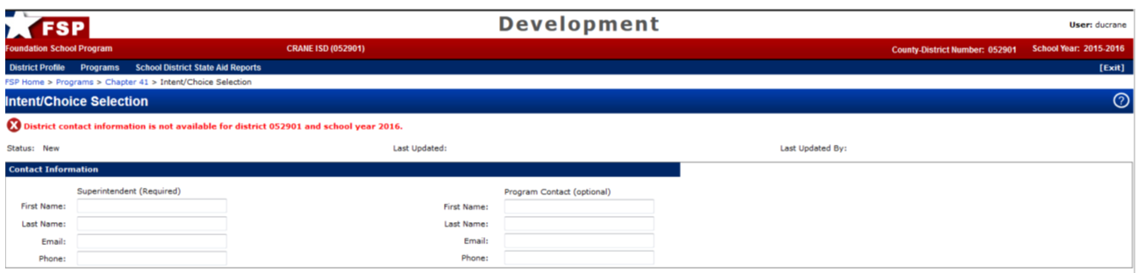



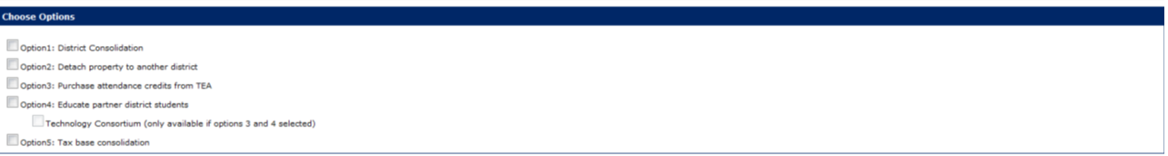

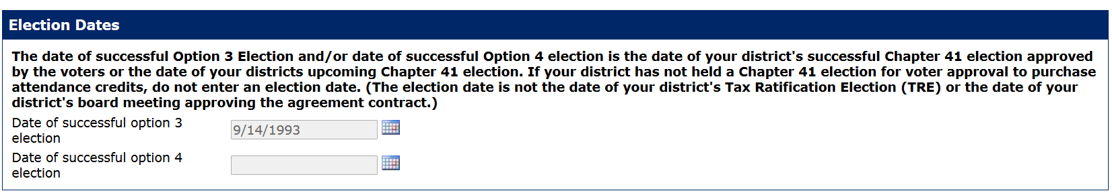



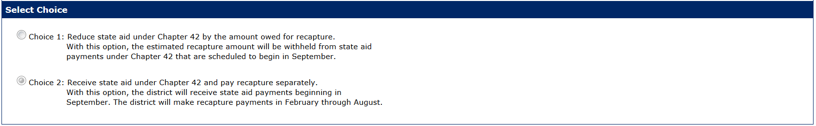

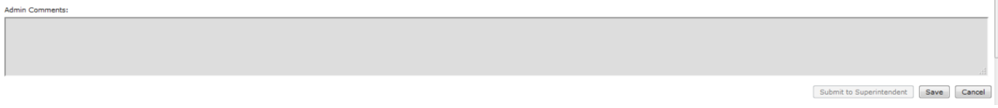

Screen shot of 2017–2018 District Intent/Choice Selection form: For districts that first designated Chapter 41 in 2006–2007 or later









The FSP System fills in your district’s estimated Chapter 42 funding and estimated cost of recapture automatically. If the cost of recapture exceeds the estimated Chapter 42 funding, your district is not eligible to select Choice 1 and must select Choice 2.

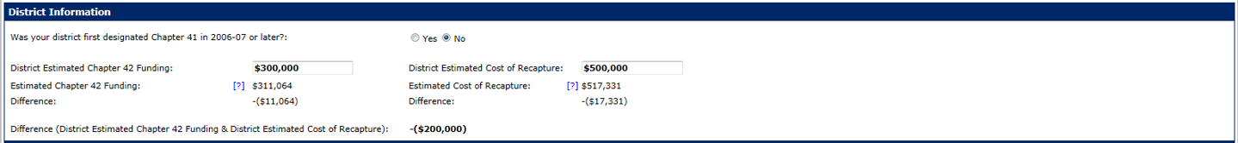



A district that is eligible to select Choice 1 and selects that choice must sign the **Agreement for the Purchase of Attendants Credits (Netting Chapter 42) contract**



## 2017–2018 Contracts

Use this form to inform the state which option your district has chosen to equalize its wealth level. The contract must be completed and submitted via the online FSP System. A screen shot of the contract as it appears in the FSP System is shown on the following page.

#### Instructions and Notes

If your district chooses to submit the Option 3 Contract via the Chapter 41 subsystem, each year the district school board must delegate the authority to obligate the school district under chapter 41 to the superintendent. The following language is required to be recorded in the board minutes and the board minutes must be uploaded via the Chapter 41 subsystem of the online FSP System:

For the 2017–2018 school year, we delegated contractual authority to obligate the school district under Texas Education Code (TEC) §11.1511(c)(4) to the superintendent, solely for the purpose of obligating the district under TEC, Chapter 41, Subchapters A and D, and the rules adopted by the commissioner of education as authorized under TEC, 41.006. This included approval of the *Agreement for the Purchase of Attendance Credits* or the *Agreement for the Purchase of Attendance Credits (Netting Chapter 42 Funding)*.

If your school board chooses not to delegate contractual authority to the superintendent or if your board as designated the UserAdmin role in TEASE to someone other than the superintendent and your superintendent is not the district approver on behalf of your district then your district must submit the contract in original paper form.

Screen shot of 2017–2018 Chapter 41 Contract Detail Information Section: 









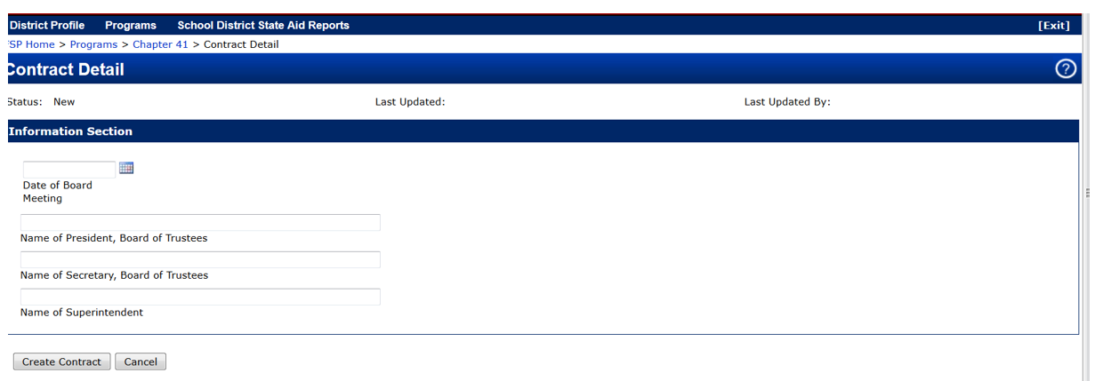

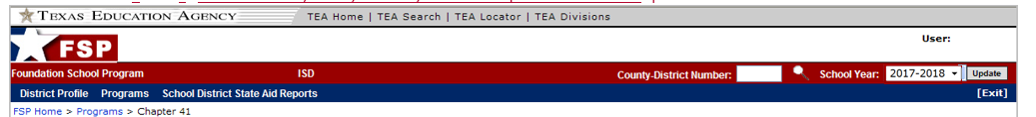Screen shot of 2017–2018 Contract Preview:

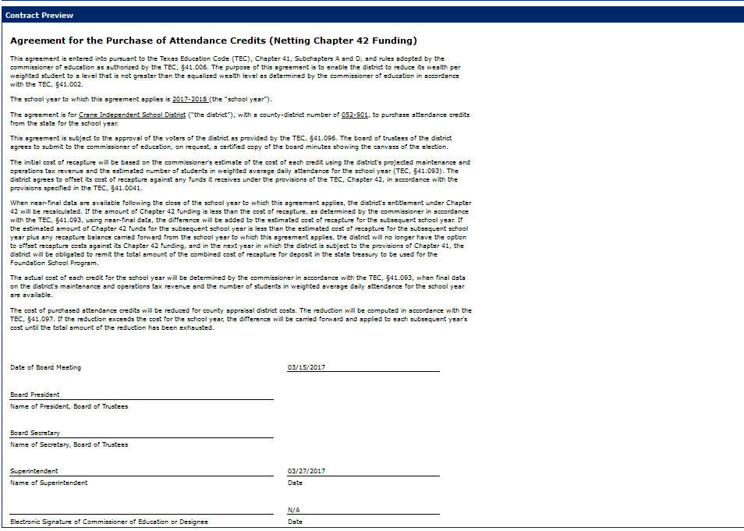

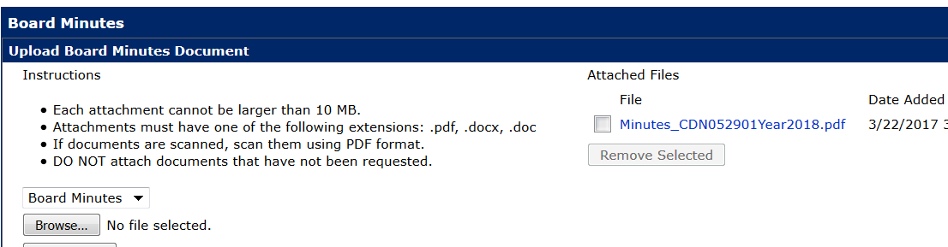Screen shot of 2017–2018 Contract Preview Board Minutes & Contract/Contract Letters:

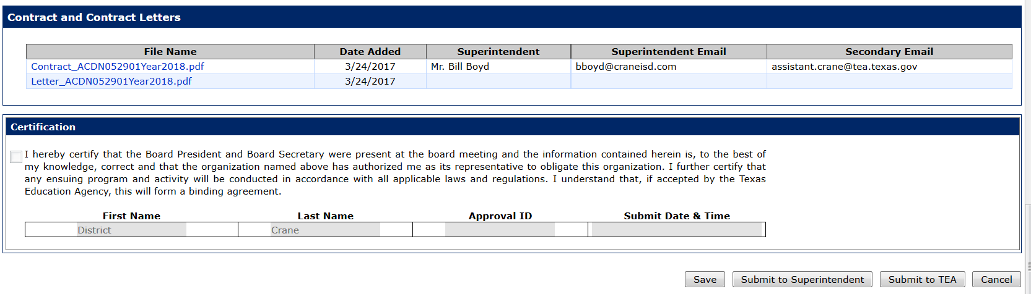

## 2017–2018 M&O Collections, WADA, CAD Cost, Tuition & Chapter 42 Partner Data

Use this form to provide information on the option(s) chosen and associated contracts. The form must be completed and submitted via the online FSP System. Screen shots of the form as it appears in the FSP System are shown on the following pages.

Screen shots of 2017–2018 M&O Collections, WADA, CAD Cost, Tuition & Chapter 42 Partner Data screens:

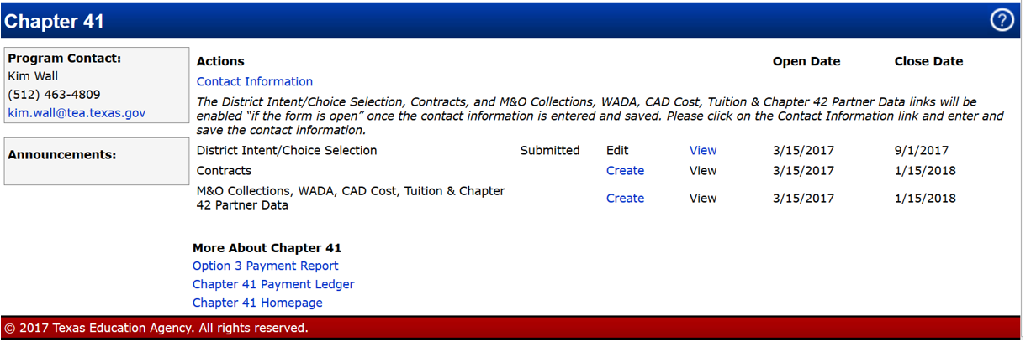

Screen shots of 2017–2018 M&O Collections, WADA, CAD Cost, Tuition & Chapter 42 Partner Data screens:

School Year field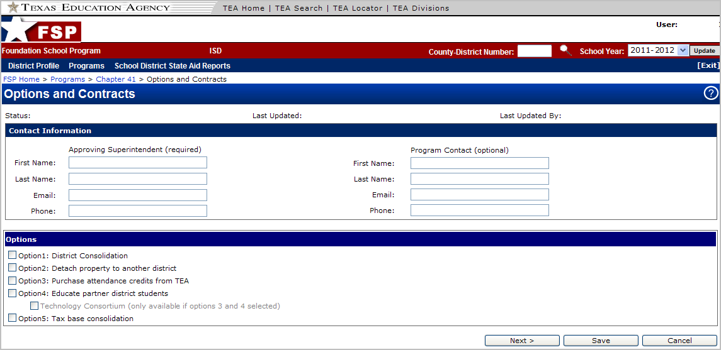

School Year field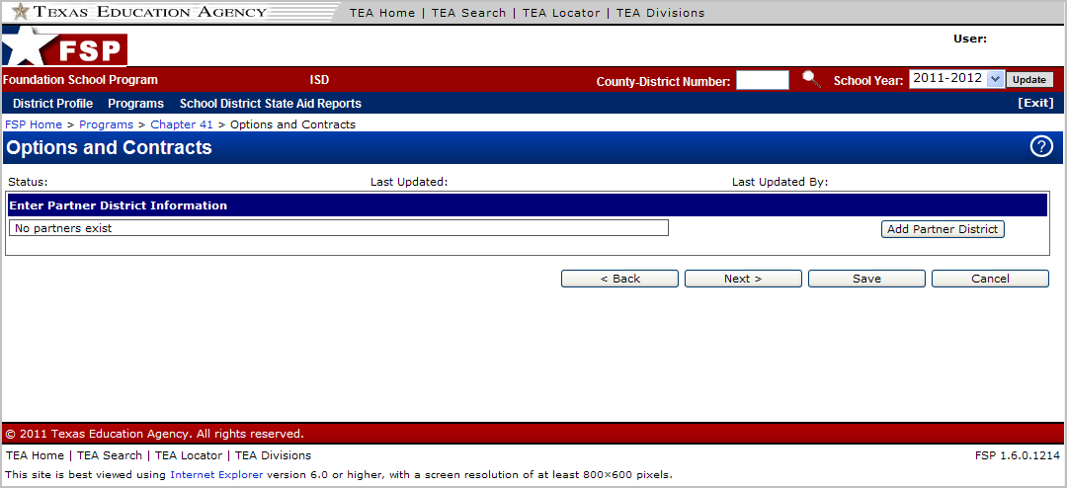

This screen is activated only if your district selected Option 4 on the preceding screen. It is used to enter partner district information.

If this screen applies to your district, click **Add Partner District** to add partner district information.

If this screen does not apply to your district, click **Next >**.

School Year field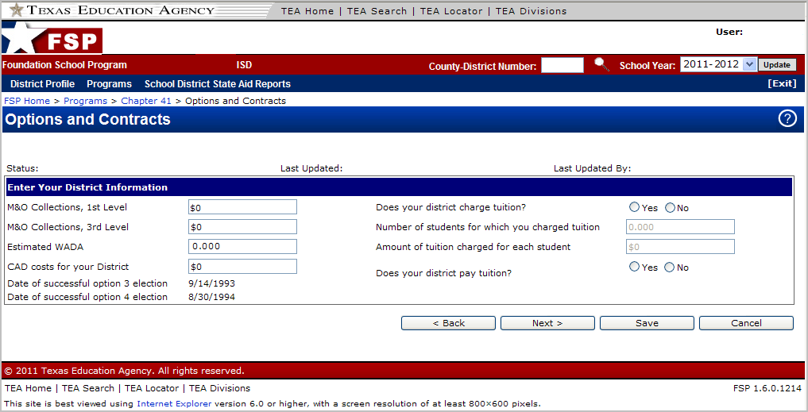

Enter the required information, and click **Next >**.

School Year fieldblank space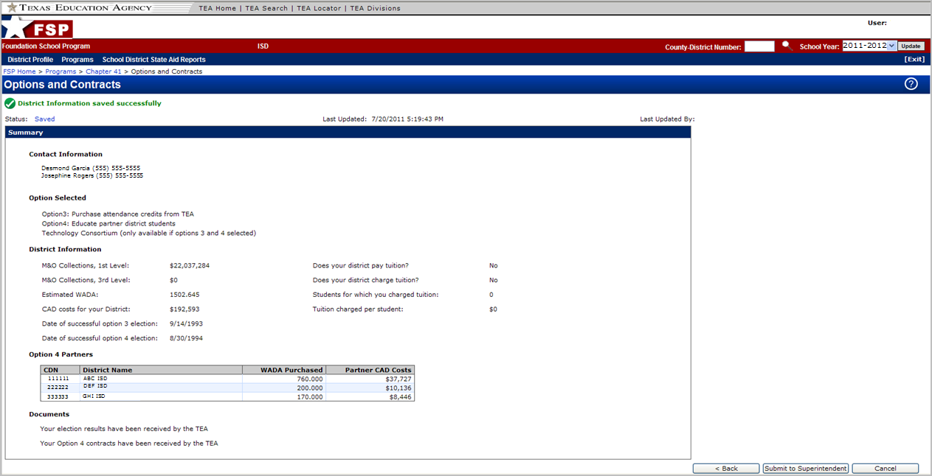

When this summary screen appears, review the information. If all information has been entered correctly, click **Submit to Superintendent**. Your district superintendent will then review the M&O Collections, WADA, CAD Cost, Tuition & Chapter 42 Partner Data information and submit the form to the TEA once (s)he has verified its accuracy.

# Appendix C: Sample Contracts

This appendix includes the following sample contracts and optional contract language:

Option 3:

* **Agreement for the Purchase of Attendance Credits**—for use if your district selected Choice 2 in the Choice Selection Form in the FSP System
* **Agreement for the Purchase of Attendance Credits (Netting Chapter 42 Funding)**—for use if your district selected Choice 1 in the District Intent/Choice Selection Form in the FSP System

Option 4:

* **Agreement for the Education of Nonresident Students**
* Optional language to be inserted in the **Agreement for the Education of Nonresident Students**

Please note that the sample contracts require the entry of the school year to which they apply.

**No school district official (or any other person in your district) has the authority, either implied or actual, to change or alter any rules, regulations, or reporting requirements specified in this manual.**

*This page has been left blank intentionally.*

## Agreement for the Purchase of Attendance Credits

This agreement is entered into pursuant to the Texas Education Code (TEC), Chapter 41, Subchapters A and D, and rules adopted by the commissioner of education as authorized by the TEC, §41.006. The purpose of this agreement is to enable the district to reduce its wealth per weighted student to a level that is not greater than the equalized wealth level as determined by the commissioner of education in accordance with the TEC, §41.002.

The school year to which this agreement applies is _____________________ (the “school year”).

The agreement is for ____________________________________________ School District (“the district”), with a county-district number of __________, to purchase attendance credits from the state for the school year.

This agreement is subject to the approval of the voters of the district as provided by the TEC, §41.096. The board of trustees of the district agrees to submit to the commissioner of education, on request, a certified copy of the board minutes showing the canvass of the election.

Initial payments will be based on the commissioner’s estimate of the cost of each credit using the district’s projected maintenance and operations tax revenue and the estimated number of students in weighted average daily attendance for the school year (TEC, §41.093). The district agrees to make the payments in accordance with the schedule specified in the TEC, §41.094.

The actual cost of each credit will be determined by the commissioner in accordance with the TEC, §41.093, when final data on the district’s maintenance and operations tax revenue and the number of students in weighted average daily attendance for the school year are available. If that amount is less than the amount paid by the district through August 15 of the school year, the difference will be refunded. If that amount is greater than the amount paid, the district shall remit an amount equal to the difference for deposit in the state treasury to be used for the Foundation School Program.

The cost of purchased attendance credits will be reduced for county appraisal district costs. The reduction will be computed in accordance with the TEC, §41.097. If the reduction exceeds the cost for the school year, the difference will be carried forward and applied to each subsequent year’s cost until the total amount of the reduction has been exhausted.

|  |  |  |
| --- | --- | --- |
|  | Date: |  |
| Signature of President, Board of Trustees |  |  |
|  |  |  |
|  |  |  |
|  |  |  |
|  | Date: |  |
| Signature of Secretary, Board of Trustees |  |  |
|  |  |  |
|  |  |  |
|  |  |  |
| Signature of Superintendent |  |  |
|  |  |  |
|  |  |  |
|  |  |  |
|  | Date: |  |
| Typed Name of Superintendent |  |  |
|  |  |  |
|  |  |  |
|  |  |  |
|  | Date: |  |
| Signature of Commissioner of Education or Designee |  |  |
|  |  |  |

## Agreement for the Purchase of Attendance Credits (Netting Chapter 42 Funding)

This agreement is entered into pursuant to the Texas Education Code (TEC), Chapter 41, Subchapters A and D, and rules adopted by the commissioner of education as authorized by the TEC, §41.006. The purpose of this agreement is to enable the district to reduce its wealth per weighted student to a level that is not greater than the equalized wealth level as determined by the commissioner of education in accordance with the TEC, §41.002.

The school year to which this agreement applies is _____________________ (the “school year”).

The agreement is for ____________________________________________ School District (“the district”), with a county-district number of __________, to purchase attendance credits from the state for the school year.

The initial cost of recapture will be based on the commissioner’s estimate of the cost of each credit using the district’s projected maintenance and operations tax revenue and the estimated number of students in weighted average daily attendance for the school year (TEC, §41.093). The district agrees to offset its cost of recapture against any funds it receives under the provisions of the TEC, Chapter 42, in accordance with the provisions specified in the TEC, §41.0041.

When near-final data are available following the close of the school year to which this agreement applies, the district’s entitlement under Chapter 42 will be recalculated. If the amount of Chapter 42 funding is less than the cost of recapture, as determined by the commissioner in accordance with the TEC, §41.093, using near-final data, the difference will be added to the estimated cost of recapture for the subsequent school year. If the estimated amount of Chapter 42 funds for the subsequent school year is less than the estimated cost of recapture for the subsequent school year plus any recapture balance carried forward from the school year to which this agreement applies, the district will no longer have the option to offset recapture costs against its Chapter 42 funding, and in the next year in which the district is subject to the provisions of Chapter 41, the district will be obligated to remit the total amount of the combined cost of recapture for deposit in the state treasury to be used for the Foundation School Program.

The actual cost of each credit for the school year will be determined by the commissioner in accordance with the TEC, §41.093, when final data on the district’s maintenance and operations tax revenue and the number of students in weighted average daily attendance for the school year are available.

The cost of purchased attendance credits will be reduced for county appraisal district costs. The reduction will be computed in accordance with the TEC, §41.097. If the reduction exceeds the cost for the school year, the difference will be carried forward and applied to each subsequent year’s cost until the total amount of the reduction has been exhausted.

|  |  |  |
| --- | --- | --- |
|  | Date: |  |
| Signature of President, Board of Trustees |  |  |
|  |  |  |
|  |  |  |
|  |  |  |
|  | Date: |  |
| Signature of Secretary, Board of Trustees |  |  |
|  |  |  |
|  |  |  |
|  |  |  |
|  |  |  |
| Signature of Superintendent |  |  |
|  |  |  |
|  |  |  |
|  |  |  |
|  | Date: |  |
| Typed Name of Superintendent |  |  |
|  |  |  |
|  |  |  |
|  |  |  |
|  | Date: |  |
| Signature of Commissioner of Education or Designee |  |  |
|  |  |  |

## Agreement for the Education of Nonresident Students

This agreement is entered into pursuant to the Texas Education Code (TEC), Chapter 41, Subchapters A, D, and E, and rules adopted by the commissioner of education as authorized by the TEC, §41.006. The purpose of this agreement is to enable the district to reduce its wealth per weighted student to a level not greater than the equalized wealth level for the school year in accordance with the TEC, §41.002.

The school year to which this agreement applies is _____________________ (the “school year”).

The agreement is for ______________________________________ School District (“the district”) to educate nonresident students for the school year from ______________________________________ School District (“the partner”). The district agrees to contract for the education of nonresident students by purchasing an estimated _______________ nonresident students in weighted average daily attendance (WADA) from the partner for the school year.

The estimated cost of the purchase will be determined by the commissioner in accordance with the provisions of the TEC, §41.093, using the district’s projected maintenance and operations tax revenue and the estimated number of WADA for the school year. The actual cost will be determined by the commissioner when final data on the district’s maintenance and operations tax revenue and the WADA count for the school year are available. The cost and number of contracted WADA in this agreement are subject to change according to the determinations of the commissioner so that the wealth per WADA of the district can be properly adjusted. The initial payment will be made no later than a date in February specified by the commissioner and the last no later than August 15 of the school year. The payment schedule will be negotiated by the two parties.

The partner will remain accountable for the educational performance of the students whose education is paid for by the district. For each WADA purchased by the district, state aid to the partner will be reduced by an amount equal to its state and local revenues per WADA for Tiers I and II for the school year. Any excess state allocations to the partner will be immediately refunded to the state if the excess cannot be recovered by reduced Foundation School Program payments. WADA purchased pursuant to this agreement are deducted from the partner’s total WADA count in determining the partner’s wealth per WADA for Chapter 41 purposes.

**The district must ensure that the partner or partners do not exceed their respective limits on the number of WADA that are available for purchase. If one or more partners sell WADA in excess of their limits, the district will not receive credit for the purchase of those WADA for the purposes of wealth equalization.**

[OPTIONAL: Insert here optional language on CAD costs, if applicable.]

This agreement is in effect for one year and becomes null and void at the close of the school year. This agreement is subject to the approval of the voters of the district as provided by the TEC, §41.122. The board of trustees of the district agrees to submit to the commissioner of education, on request, a certified copy of the board minutes showing the canvass of the election.

|  |  |  |  |  |  |  |  |  |  |  |
| --- | --- | --- | --- | --- | --- | --- | --- | --- | --- | --- |
| **The District** | | | |  | **The Partner** | | | | | |
|  | | | |  |  | | | | | |
| District: | |  | |  | District: | |  | | | |
|  | | | |  |  | | | | | |
| County-District No.: | | |  |  | County-District No.: | | |  | | |
|  | | | |  |  | | | | | |
| Signature of President, Board of Trustees | | | |  | Signature of President, Board of Trustees | | | | | |
|  | | | |  |  | | | | | |
| Date: |  | | |  | Date: |  | | | | | |
|  | | | |  |  | | | | | |
| Signature of Secretary, Board of Trustees | | | |  | Signature of Secretary, Board of Trustees | | | | | |
|  | | | |  |  | | | | | |
| Date: |  | | |  | Date: |  | | | | | |
|  | | | |  |  | | | | | |
| Signature of Superintendent | | | |  | Signature of Superintendent | | | | | |
|  | | | |  |  | | | | | |
| Typed Name of Superintendent | | | |  | Typed Name of Superintendent | | | | | |
|  | | | |  |  | | | | | |
| Date: |  | | |  | Date: |  | | | | | |
|  | | | |  |  | | | | | |
| Signature of Commissioner of Education | | | |  | **IF APPLICABLE**: Signature of Director, | | | | | |
| or Designee | | | |  | Education Service Center, Region | | | |  |  |
|  | | | |  |  | | | | | |
| Date: |  | | |  |  | | | | | |
|  | | | |  |  | | | | | |
|  | | | |  | **IF APPLICABLE**: Typed Name of Director | | | | | |
|  | | | |  |  | | | | | |
|  | | | |  | Date: |  | | | | | |

## Optional Language to Be Inserted in the Agreement for the Education of Nonresident Students

**Optional Language on CAD Costs**

The partner agrees to pay a prorated share of county appraisal district (CAD) costs incurred by the district as a result of funds raised by the district that are distributed to the partner. The share will be based on actual WADA purchased from the partner applied as a percentage to the total applicable CAD costs for the applicable year.

*This page has been left blank intentionally.*

# Appendix D: Sample Ballot Proposition Language

This appendix provides sample ballot proposition language that your district can use if it is conducting an election to obtain voter approval for exercising Option 3, 4, or 5.

So far, virtually all Chapter 41 districts have chosen Option 3 or 4 or both simultaneously. Therefore, it is assumed that all or most districts will use one or both of these options in the future. **If your district is considering any other option besides Option 3 or 4, please consult the Chapter 41 program director in the TEA State Funding Division at (512) 463-9238**.

Please direct questions about election procedures to the Elections Division of the Texas Secretary of State at 1-800-252-8683. **Please also contact this division for a calendar for special elections pertaining to Chapter 41.**

Following the US Supreme Court decision in *Shelby County v. Holder*, preclearance of an election under Section 5 of the Voting Rights Act may no longer be required. Your district should consult its legal counsel about compliance with state and federal voting requirements.

*This page has been left blank intentionally.*

BALLOT PROPOSITIONS

No. 0000

Special Election (Elección Especial)

________________ School District (Distrito Escolar De _______________)

Date (Fecha): ______________, 20XX

OFFICIAL BALLOT (BOLETA OFICIAL)

INSTRUCTION NOTE: (NOTA DE INSTRUCCION:)

Place an “X” in the square beside the statement indicating the way you wish to vote. (Marque con una “X” el cuadro a la ezquierda de la frase que indica la manera en que usted quiere votar.)

|  |
| --- |
| Ballot Proposition: Authorizing the board of trustees of __________ School District to purchase attendance credits from the state with local tax revenues.  (Propuesta Electoral: Autorizando a la junta directiva del Distrito Escolar de ___________ para adquirir créditos de asistencia estatales con ingresos de impuestos locales.) |
| **□**  FOR (A FAVOR DE) |
| **□**  AGAINST (EN CONTRA DE) |

*This page has been left blank intentionally.*

BALLOT PROPOSITIONS

No. 0000

Special Election (Elección Especial)

________________ School District (Distrito Escolar De _______________)

Date (Fecha): ______________, 20XX

OFFICIAL BALLOT (BOLETA OFICIAL)

INSTRUCTION NOTE: (NOTA DE INSTRUCCION:)

Place an “X” in the square beside the statement indicating the way you wish to vote. (Marque con una “X” el cuadro a la ezquierda de la frase que indica la manera en que usted quiere votar.)

|  |
| --- |
| Ballot Proposition: Authorizing the board of trustees of __________ School District to educate students of other school districts with local tax revenues.  (Propuesta Electoral: Autorizando a la junta directiva del Distrito Escolar de ___________ para educar estudiantes de otros distritos escolares con ingresos de impuestos locales.) |
| **□**  FOR (A FAVOR DE) |
| **□**  AGAINST (EN CONTRA DE) |

*This page has been left blank intentionally.*

BALLOT PROPOSITIONS

No. 0000

Special Election (Elección Especial)

________________ School District (Distrito Escolar De _______________)

Date (Fecha): ______________, 20XX

OFFICIAL BALLOT (BOLETA OFICIAL)

INSTRUCTION NOTE: (NOTA DE INSTRUCCION:)

Place an “X” in the square beside the statement indicating the way you wish to vote. (Marque con una “X” el cuadro a la ezquierda de la frase que indica la manera en que usted quiere votar.)

|  |
| --- |
| Ballot Proposition: Creation of a consolidated taxing district composed of the territory of __________ school districts, and authorizing the levy, assessment, and collection of annual ad valorem taxes for the maintenance of the public free schools within that taxing district at a rate not to exceed $________ on $100 valuation of taxable property  (Propuesta Electoral: Creación de un distrito impositivo consolidado compuesto del territorio de _____________ distritos escolares, y autorización a ejecución, tasación, y cobro de impuestos ad valorem anuales para el mantenimiento de escuelas públicas dentro de este distrito impositivo sin sobrepasar a una contribución de $________ por $100 de valoración de propiedad imponible) |
| **□**  FOR (A FAVOR DE) |
| **□**  AGAINST (EN CONTRA DE) |

*This page has been left blank intentionally.*

# Appendix E: Glossary

**appraisal costs:** Costs associated with the operation of county appraisal districts that school districts must pay. Chapter 41 districts are eligible for a credit for that portion of the costs resulting from the recaptured excess value.

**Chapter 41 hold harmless provision:** The Chapter 41 provision that allows certain eligible districts to keep more wealth than they would otherwise keep at the equalized wealth level.

**Chapter 41 WADA:** A modified calculation of Chapter 42 WADA that is made when a school district charges tuition to educate a nonresident student. Chapter 41 WADA is the sum of Chapter 42 WADA and WADA attributable to nonresident students.

**Chapter 42 WADA:** The weighted average daily attendance arrived at by summing a district’s Tier I allotments, making certain adjustments, and dividing that sum by the amount of the basic allotment.

**contract: Another term for the Agreement for the Purchase of Attendance Credits (Option 3) or the Agreement to Educate Nonresident Students (Option 4).**

**county appraisal district (CAD):** An entity that regularly makes a record of and assigns a value to all property within a county. After compiling this information, a CAD passes it on to a taxing entity.

**early agreement credit:** A credit available to a Chapter 41 district that is exercising Option 3 or a combination of Options 3 and 4 that involves a technology consortium. To qualify, a district must submit a signed Option 3 agreement to the TEA with a postmark on or before September 1 of the applicable year. The credit amount is equal to the lesser of 1) 4 percent of the cost or 2) $80 per credit purchased.

**equalized wealth level:** The wealth per student that a district may not exceed, or the maximum property tax base that a school district is allowed to retain at a certain level of tax effort.

**guaranteed yield:** A specified amount that a school district, no matter what its property wealth, is guaranteed per weighted student for each cent of tax effort over that required for the district’s local fund assignment. The guaranteed yield is made up of both state and local funds.

**wealth per student:** The taxable value of a district’s property divided by the number of students in weighted average daily attendance. For Chapter 41 purposes, the calculation of wealth per student is the ratio of a district’s tax base to its Chapter 41 WADA.

**weighted average daily attendance (WADA):** An adjusted count of the number of students in average daily attendance that gives greater weight to students who fall under certain categories, such as students who are enrolled in a gifted and talented program, and thus cost more to educate.

# Index

CAD cost reduction, 36

calendar, 11

Chapter 41

administrative procedures, 39

calendar, 11

definition, 17

district, defined, 17

forms, required, 43

history, 17

statutes related to, 41

taxation, 39

contracts (sample), 55

agreement for the education of nonresident students, 61

agreement for the purchase of attendance credits, 57, 59

optional language, 63

Cost of Recapture Report, 24

final, 25

near-final, 24

payment, 24

preliminary, 24

revised, 24

county appraisal district cost reduction, 36

credits, 35

early agreement credit, 35

for tuition paid to another district, 35

early agreement credit, 35

elections

procedures, 65

equalized wealth level

first, 18

second, 18

third, 19

forms, 43

District Intent/Choice Selection form, 47

M&O Collections, WADA, CAD Cost, Tuition & Chapter 42 Partner Data, 49

Foundation School Program (FSP)

short description, 18

guaranteed yield, 17

hold harmless provision, 36

eligibility, 37

Option 4, 29

special requirements, 30

technology consortium, 31

optional homestead exemption, 39

options for reducing wealth, 29

Option 3, defined, 29

Option 4 technology consortium, 31, 35

Option 4, defined, 29

options requiring voter approval, 30

Senate Bill 7 (1993), 17

settle-up, 26

first round, 26

Option 3 with technology consortium form of Option 4, special considerations, 26

Option 3, special considerations, 26

second round, 26

tax base, decline in, 39

tax rate, setting, 39

taxation, 39

Texas Education Agency

address, 24

phone number, State Funding, 24

WADA

Chapter 41 WADA, 18

Chapter 42 WADA, 18

estimating cost, 25

weighted average daily attendance (WADA)

Chapter 41 WADA, 18

Chapter 42 WADA, 18

estimating cost, 25



**Texas Education Agency**

**Austin, Texas**

**Spring 2017**

1. The FSP is the state program that establishes the amount of state and local funding due to school districts under Texas school finance law and that provides the state share of this funding to districts. The program is administered by the TEA.
2. Requires legislature to fund guaranteed yield on equivalent tax rate at same yield as Austin Independent School District