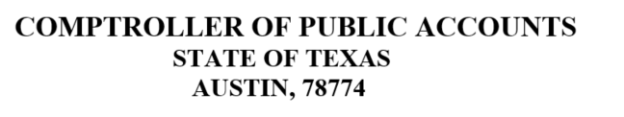


ACH CREDIT OPTION

TITLE OF DEPOSIT: RECAPTURE P
FINANCIAL INSTITUITION: WELLS FARGO BANK
ROUTING NUMBER: 121000248
ACCOUNT NUMBER: 83807011512100199
Addend Record: Include the DISTRICT NAME & COUNTY DISTRICT NUMBER

If you have questions specific to the amount of your recapture payment, please contact the Excess Local Revenue Analyst in the TEA State Funding, Forecasting and Fiscal Analysis Division at recapture@tea.texas.gov or 512-463-9238.

