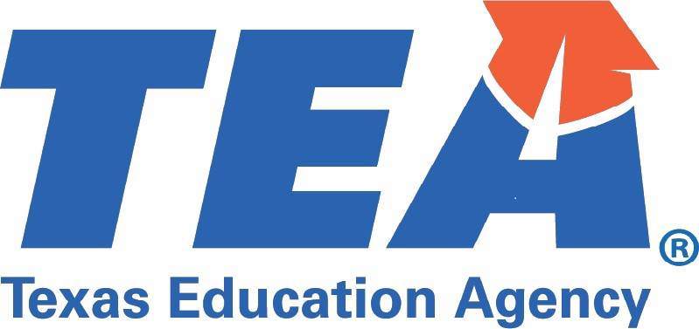
Verification of Accreditation Status for Test Exemptions
This form will not be returned or forwarded

Educator Information -To be completed by the educator as it appears in your TEA educator account (ECOS)
Last Name | First Name |  |  |  | Initial
Address | City |  |  | State |  | Zip code
Employment Information - To be completed by the employing school
The information requested below is needed to determine whether the experience may be claimed for certification and test exemptions.
Thank you for your assistance in completing this form.
Previous Employment From |  | Previous Employment To
Name of School

1. Was this school during the years indicated above operated by or under the jurisdiction of a governmental Yes unit in the state in which this institution is located?
No
If Yes, please provide the name of the governmental unit.

2. Was this school, during the years indicated above, accredited by a United States accrediting agency recognized Yes
by the U.S. Department of Education or by the state or national government in which this school is located?
No
If Yes, please provide the name of the accrediting agency or governmental unit.

3. Is this a public or private school? Public
Private
4. If the school is operated on the British system please indicate government or Government public school.
Public
Signature of authorized official |  |  | Title and Name of Authorized Official (print)

Stamp/Seal
The organization's official stamp must be included on the form if service from outside of the United States is reported. For public schools, the country's Department of Education is the organization official stamp.
Please Print, Sign, Scan, and Submit by Email to OSC75@tea.texas.gov
Please do not return this form to the educator. TEA will not accept forms directly from the educator.
Copyright© Texas Education Agency. All Rights Reserved. Revised (7/16/2025)

