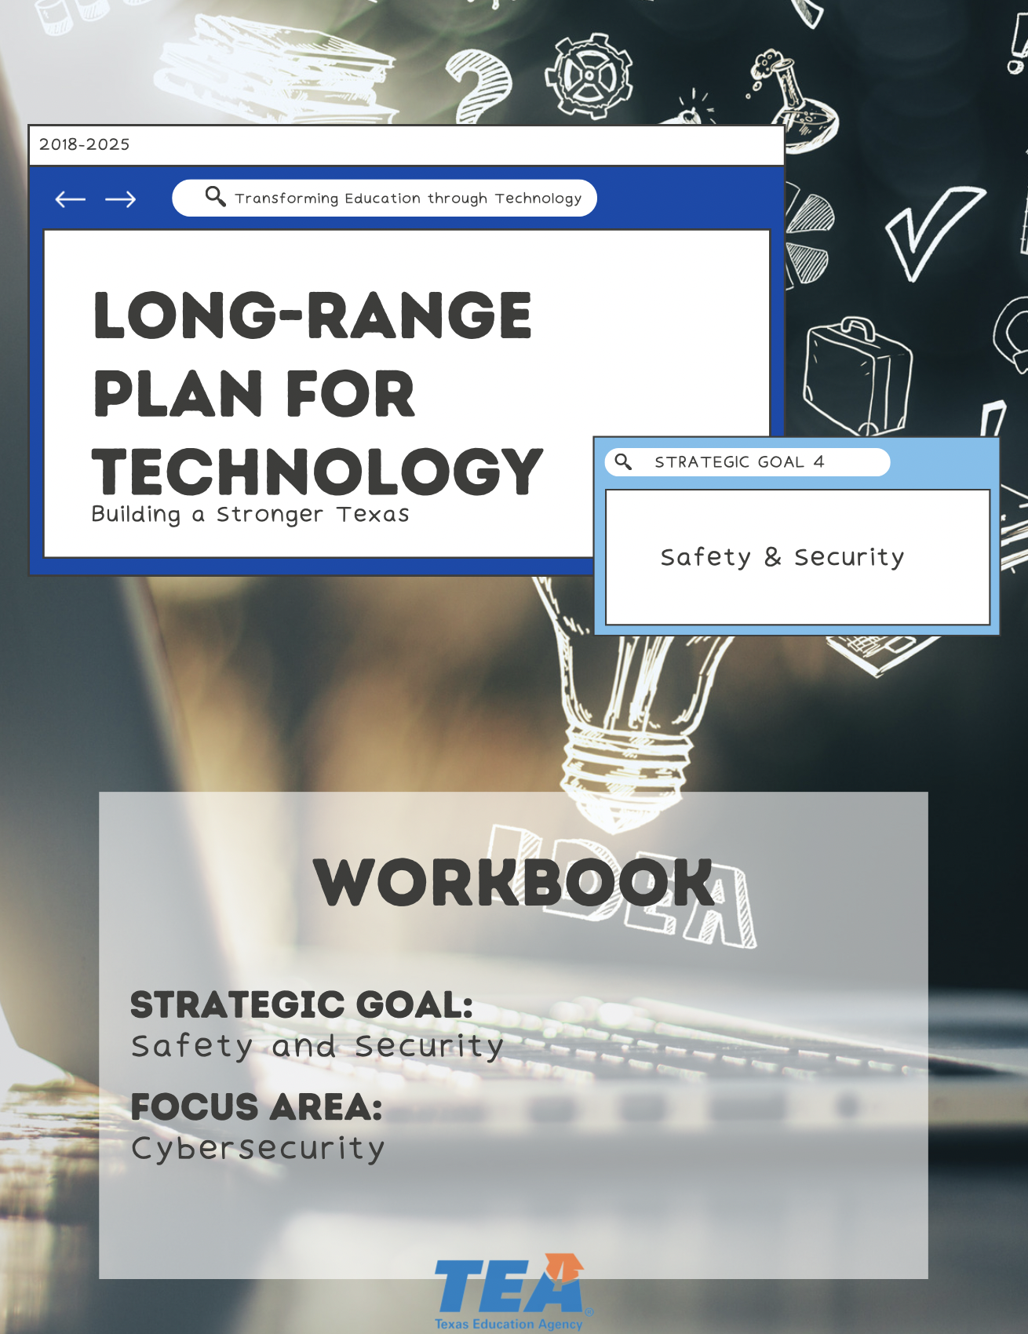



1. Take Note & Reflect:
Reflect on the resources your district has to promote cybersecurity. Would you describe your district's cybersecurity practices as 'strategic' and 'proactive'?

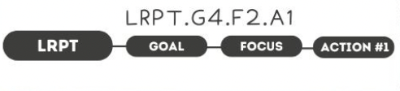

1. Take Note & Reflect:
Reflect on what your district's collaborative security team looks like. Does it meet the listed bullet points?

2. Take Note & Reflect:
Reflect on Who holds the role of Cybersecurity Coordinator in your district. Is this role clearly defined? How is your district prioritizing cybersecurity resources to address greatest risks?

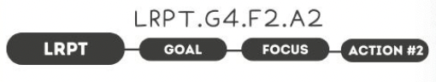

1. Take Note & Reflect:
Review your district's cybersecurity plan. What is included within it?

2. Take Note & Reflect:
How will you address what is missing and remain up-to-date on new threats and technology developments that would require addendums or adjustments to your plan?

3. Take Note & Reflect:
Reflect on how you will grow and develop your cybersecurity plan. How is your cybersecurity coordinator empowered to make changes as necessary?

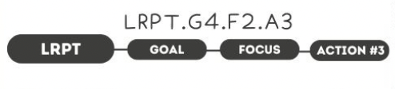

1. Take Note & Reflect:
How are staff members trained to ensure they are up to date on policies, signs of suspicious activities, and how to report incidents?

2. Take Note & Reflect:
Reflect on some of the processes that will be included in your training and what they entail.



1. Take Note & Reflect:
How are you are currently using your district's information security plan & security assessments?

2. Take Note & Reflect:
How will you remain aware of state and federal funding for cybersecurity? How will you advocate for a focus on cybersecurity?

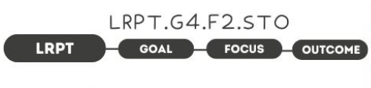

1. Take Note & Reflect:
How do your district's tools enhance the physical and cyber environments? How do they improve safety?

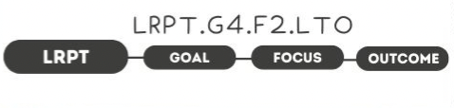

1. Take Note & Reflect:
How would you define a mature, risk-based security program for your district? How would your security team uphold this type of program in perpetuity?

2. Take Note & Reflect:
When a school campus or learning environment is free from risk or harm, what replaces the concern (creativity, autonomy, etc.)?

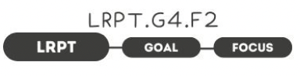

1. Take Note & Reflect:
Write a short summary statement for this focus area. How would you summarize what you've done and what you need to do for this focus area based on your work so far?

