Application for the School Transportation Allotment for Route Services

In this application, “school district,” and “district” mean a school district, county unit system, charter school, or other local education agency.

Use this application to request approval for your school district to submit route service information for transportation allotment purposes. The application must be completed before the first school year for which route service information will be reported.

Before completing this application, read the Texas Education Agency (TEA) School Transportation Allotment Handbook. The handbook prescribes requirements related to the transportation allotment and contains an explanation of the terms used in this application. It is available on the TEA School Transportation Funding web page.

Submit the completed application by mail, email, or fax to the following postal address, email address, or fax number:

Postal Address: School Transportation Unit
Office of School Finance
Texas Education Agency
1701 North Congress Avenue
Austin, TX 78751
Email Address: schtrans@tea.state.tx.us
Fax Number: 512-305-9165

Section 1: School District Information

Name of School District:
County-District Number:
First School Year for Which Route Service Information Will Be Reported:
Name of District Contact Person:
Phone Number of Contact Person:
Email Address of Contact Person:
Name of Contractor If School District Is Contracting Student Transportation:
Type “NA” if the school district is not contracting student transportation.

Section 2a: Regular Route Service: To and from School
If your district plans to provide regular route service to transport regular-program students to and from school, use the following table to provide information about each planned route.

Regular Route Service: To and from School (Home-to-School and School-to-Home)
 |  | Two-or-More-Mile Service Only |  |  |  |  | Two-or-More-Mile and Hazardous-Traffic-Area Service Combined
(1) |  | (2) | (3) | (4) | (5) |  | (6) | (7) | (8) | (9)
Route Identity |  | Daily Mileage | Days Operated | Annual Mileage  ([2] × [3]) | Average Daily Ridership |  | Daily Mileage | Days Operated | Annual Mileage  ([6] × [7]) | Average Daily Ridership
Totals

Example:

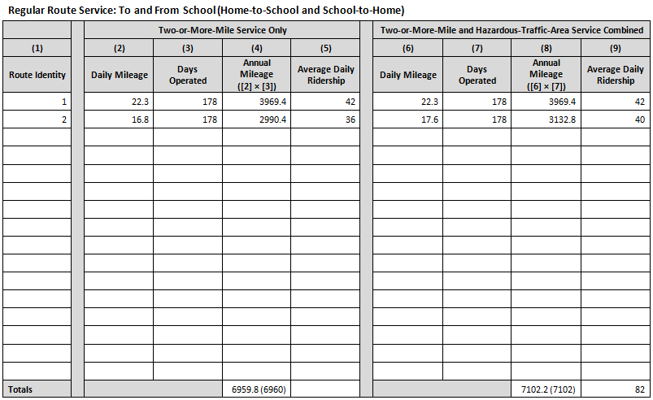

Section 2b: Regular Route Service: Transportation to and from Academic Courses
If your district plans to provide regular route service to transport regular-program students during the school day between the students’ campus of attendance and another instructional site for the students to attend required courses that are not available at the campus of attendance, use the following table to provide information about each planned route.

Regular Route Service: Transportation to and from Academic Courses
(1) | (2) | (3) | (4) | (5)
Route Identity | Daily Mileage | Days Operated | Annual Mileage  ([2] × [3]) | Daily Ridership
Totals

Section 3a: Special Route Service: Transportation to and from School
If your district plans to provide special route service to transport special-program students to and from school, use the following table to provide information about each planned route.

Special Route Service: Transportation to and from School (Home-to-School and School-to-Home)
(1) | (2) | (3) | (4) | (5)
Route Identity | Daily Mileage | Days Operated | Annual Mileage  ([2] × [3]) | Daily Ridership
Totals

Section 3b: Special Route Service: Transportation for Auxiliary or Extended School Year Services
If your district plans to provide special route service to transport special-program students to either prescribed services during the regular school year and school day or Extended School Year (ESY) services required by the students’ individualized education programs, use the following table to provide information about each planned route.

Special Route Service: Transportation for Auxiliary or ESY Services
(1) | (2) | (3) | (4) | (5)
Route Identity | Daily Mileage | Days Operated | Annual Mileage  ([2] × [3]) | Daily Ridership
Totals

Section 4: Career and Technical Education Route Service
If your district plans to provide career and technical education (CTE) route service, which is transportation of regular- or special-program students during the school day to TEA-approved CTE courses not available at the students’ campus of attendance, use the following table to provide information about each planned route.

CTE Route Service
(1) | (2) | (3) | (4) | (5)
Route Identity | Daily Mileage | Days Operated | Annual Mileage  ([2] × [3]) | Daily Ridership
Totals

Section 5: Private Route Service
If your district plans to have private route service, which is transportation of regular- or special-program students to and from school by privately owned or commercial transportation, use the following table to provide information about each planned route.

Private Route Service
(1) | (2) | (3) | (4) | (5)
Route Identity | Daily Mileage | Days Operated | Annual Mileage  ([2] × [3]) | Daily Ridership
Totals

Section 6: Certification

I certify that:
- I have read the TEA School Transportation Allotment Handbook,
- the school district will comply with all handbook requirements and applicable laws and regulations in providing student transportation or contracting for the provision of that transportation, and
- I understand that it is my school district’s responsibility to ensure that any contractor it employs to provide student transportation complies with all applicable requirements, laws, and regulations.

Printed Name of Superintendent:
Signature of Superintendent and Date of Signature:
Telephone Number:
Fax Number:
Email Address:

