Public Education Information Management System

PEIMS EDIT+
Administrator
Reference and
Training Guide



Texas Education Agency
FMY1112 Release
10/17/2011.1

Note: Please contact PEIMS Customer Support at peimscustomersupport@tea.state.tx.us
(or 512-463-9229) with any questions you may have about this document.

The images in this document are provided for illustration purposes only and do not contain real data.
This document is the property of the Texas Education Agency. All rights reserved.

© Texas Education Agency–PEIMS Division
Enterprise Data Management Group
1701 North Congress Avenue
Austin, Texas 78701

1st Edition - 17th Edition September 2001 – March 2011
18th Edition October 2011

Table of Contents
Introduction 9
Overview 9
Prerequisite Knowledge and Skills 9
Using the Admin Guide for Training 9
Customer Support 9
Chapter 1–The EDIT+ Environment 11
Overview 11
The EDIT+ Hierarchy 11
Hierarchical Security 11
Chapter 2–The EDIT+ User 13
Overview 13
Agent IDs and User Permissions 13
Setting Up a New EDIT+ User 14
Excluded Record Groups 17
Knowledge and Skill 19
Review Questions 19
Chapter 3–Maintaining EDIT+ User Profiles 21
Overview 21
EDIT+ User Administration 21
Editing an EDIT+ User Profile 21
Deleting an EDIT+ User Profile 22
Viewing an EDIT+ User Profile 23
Monitoring User Login/Logoff Activity 23
Knowledge and Skill 24
Review Questions 24
Exercise 3.1–Edit a User Profile 24
Exercise 3.2–Delete User Profile 24
Chapter 4–Posting Broadcast Messages 25
Overview 25
Posting an ESC Broadcast Message 25
Removing an ESC Broadcast Message 27
Knowledge and Skill 27
Review Questions 27
Exercise 4.1–Post a Broadcast Message 27
Exercise 4.2–Remove a Broadcast Message 27
Chapter 5–Purging PEIMS Data Files 29
Overview 29
Purging a Data File 29
Knowledge and Skill 30
Review Questions 30
Exercise 5.1–Send/Purge Files 30
Chapter 6–Setting Up Audit Reports 31
Overview 31
Selecting Major Funds 31
Knowledge and Skill 32
Exercise 6.1–Select a Major Fund 32
Chapter 7–Region-Wide Reports and Table Downloads 33
Overview 33
Region-Wide Reports 33
Accessing Standard Region-Wide Reports 33
Accessing DCMS Region-Wide Reports 34
Region-Wide Table Downloads 35
Knowledge and Skill 36
Review Questions 36
Chapter 8–The SAF Process 37
Overview 37
SAF Authorization 37
SAF Access 37
SAF User Roles and Permissions 38
SAF Administration–Email Notification 39
Districts and the SAF Process 40
District Superintendent–SAF Approval 40
District Superintendent–SAF Disapproval 41
ESCs and the SAF Process 42
ESC–District File Accepted After SAF Approval 42
ESC–District File Accepted Prior to SAF Approval 43
ESC–District File Rejected Prior to SAF Approval 44
ESC–District File Rejected After SAF Approval 44
SAF and File Status Override 45
SAF Process and First Submission/Resubmission 45
SAF Process and Approved Collections 45
Knowledge and Skill 46
Review Questions 46
Chapter 9–The PET Process 47
Overview 47
Setting Up PET 48
User Roles and the PET Process 48
Establishing PET Access Permissions 48
Accessing PET 49
EDIT+ User with PET Access Permissions 49
User with PET-Only Access Permissions 49
User with PET-View Only Access Permissions 50
PET Home Page 51
Select School Year Button 51
Accessing Open School Years 51
Accessing Closed School Years 52
PET Processes 53
Process #1: Performing a PET Search in PID 54
Process #2: Viewing a PET Event History 55
Using EDIT+ PID Detail to View PET Event History 57
Process #3: Maintaining a PET Event 57
Logically Deleting a PET Event 58
Process #4: Adding a PET Event 59
Process #5: Creating a PET Student Record in PID 60
Process #6: Transferring a PET File to TEA 61
Requirements for Transferring a PET File 61
Transferring a PET File 62
The Key to Accurate PET Data 64
Process #7: Validating and Loading PET Event Records 65
Verifying the Student in PID 65
Validating and Loading PET Events 65
Process #8: Retrieving a PET File 66
Process #9: Generating a PET Report 67
Generating File-Based (PET Error) Reports 67
Generating School Year-Based Reports 70
Generating Monitoring Reports 72
Parameter-Driven PET Reports (My PET Report Requests) 73
PET File Processing Status 76
PET Status 76
PET File History 76
PET Version History 77
Knowledge and Skill 77
Review Questions 77
Chapter 10–PID Maintenance 79
Overview 79
PID Maintenance Access 79
PID Maintenance User Roles and Permissions 79
User with EDIT+, PET, and PID Maintenance Permissions 79
User with PET and PID Maintenance Permissions 80
User with PID Maintenance Only Permissions 80
PID Maintenance Administration 80
PID Maintenance Guidelines 81
Maintaining PID Records Online 82
PID Maintenance Search 82
PID Maintenance Detail 84
PID View 85
Knowledge and Skill 86
Review Questions 86
Exercise 10.1–Conducting a PID Maintenance Search 86
Chapter 11–Using a Working Collection for Training New Users 87
Overview 87
Properly Using EDIT+ for Training 87
Creating Test Files 87
Training Scenarios 88

Notes:

Table of Figures
Figure 1. EDIT+ Hierarchical Security 11
Figure 2. Relationship of Agent ID to Hierarchy Structure 13
Figure 3. User Administration Page 14
Figure 4. Add New User–User Information 15
Figure 5. Add New User–Address and Contact Information 16
Figure 6. Add New User–General Access Permissions 16
Figure 7. Add New User–Special Access Permissions 17
Figure 8. Exclude Record Groups Button–User Profile 18
Figure 9. Exclude Record Groups Page–Options 18
Figure 10. Edit User Profile–User Administration Page 22
Figure 11. Edit User Profile–Last Updated Fields 22
Figure 12. Delete User Profile–User Administration Page 23
Figure 13. Users Activity Page 23
Figure 14. Post Message to ESCs, Districts, and Campuses 25
Figure 15. Post Message–Message Start and End Dates 26
Figure 16. Active Posted Messages–Message Displayed 26
Figure 17. EDIT+ Home Page–Message Posted by ESC 26
Figure 18. Active Posted Messages Page–Remove Button 27
Figure 19. Collection Status Page–Purge Checked Files 29
Figure 20. Administration Page–Audit Report Setup Link 31
Figure 21. Audit Report Setup Page–Major Funds Drop-Down Lists 32
Figure 22. Audit Report Setup Page–Choose a Major Fund 32
Figure 23. View Reports Page–Link to Region-Wide Reports 33
Figure 24. Region-Wide Reports and Table Downloads Page 34
Figure 25. Region-Wide Standard Reports–All Districts Not Accepted 34
Figure 26. Region-Wide Standard Reports–All Districts Accepted 34
Figure 27. Region-Wide Table Downloads–Select Download Table 35
Figure 28. egion-Wide Table Downloads–Select District(s) 35
Figure 29. Region-Wide Table Downloads–Download Complete 36
Figure 30. SAF Administration Page–Completed SAF Email Distribution List 39
Figure 31. District File Approve-Disapprove Buttons 40
Figure 32. District File Approved and SAF Form Available for Viewing 41
Figure 33. District File Disapproved and File Rejected 41
Figure 34. ESC View of District File Accept-Reject Buttons After SAF Approval 42
Figure 35. ESC View of District File Accept-Reject Buttons Prior to SAF Approval 43
Figure 36. District File Accepted by ESC–SAF Not Yet Processed 43
Figure 37. District File Accepted by ESC–SAF Subsequently Processed 43
Figure 38. District File Rejected by ESC–Prior to SAF Approval 44
Figure 39. District File Rejected by ESC–After SAF Approval 44
Figure 40. EDIT+ Home Page with PID Subapp Link 49
Figure 41. District-Level User with PET-Only Access 50
Figure 42. Campus-Level User with PET-Only Access 50
Figure 43. PET Home Page for PET-View Only User 51
Figure 44. Select School Year Button 52
Figure 45. Perform a PID Search Using PET 54
Figure 46. PET Search PID Results 54
Figure 47. View a PET Event History–PET Search PID Results 55
Figure 48. PET Event History for [Name] 55
Figure 49. PET Event History Link on PID Detail Page 57
Figure 50. PET Event History–Event Date Link 57
Figure 51. PET Event Maintenance for [Name] Page 58
Figure 52. PET Add Event Button 59
Figure 53. PET Event Add for [Name] 59
Figure 54. PET Student Add 60
Figure 55. PET Student Add–Error Message 60
Figure 56. PET File Transfer Page 62
Figure 57. PET Status Page–User-Controlled Abort Button 63
Figure 58. XML Schema Definition (XSD) Validation Results 64
Figure 59. PET Retrieve Data Page 66
Figure 60. PET Error Reports–View Button for District-level PET User 67
Figure 61. PET Error Reports Page 68
Figure 62. PET Error Reports by Campus Page 68
Figure 63. PET Error Reports–View Button for Campus-level PET User 69
Figure 64. Campus-Level PET Error Reports–On Demand Button 69
Figure 65. Campus-Level PET Error Reports–Processing Complete 69
Figure 66. PET Reports Page 70
Figure 67. PET Report Available for Viewing 70
Figure 68. PET Reports by Campus–Generate Reports on Demand 71
Figure 69. Parameter Page for PET4D001 72
Figure 70. Create Report Request–Sample 73
Figure 71. My PET Report Requests–List of Requested Reports 75
Figure 72. PET File History Page 76
Figure 73. PET Status–PET Version History 77
Figure 74. PID Maintenance Permissions–User Administration 80
Figure 75. PID Maintenance Permissions–User Directory 80
Figure 76. PID Home Page–PID Maintenance Only User 82
Figure 77. PID SubApp Home Page–EDIT+, PET, and PID Maintenance User 83
Figure 78. PID Maintenance Search Page 83
Figure 79. ID Maintenance Search Results 83
Figure 80. PID Maintenance Detail–Update Mode 84
Figure 81. PID Maintenance Detail–Person Link for Student/Staff ID Conflict 85
Figure 82. PID View–Student/Staff ID in Conflict 86

Introduction

Overview
Welcome to the PEIMS EDIT+ Administrator Guide. This Guide provides the EDIT+ user who has Administrator-level permissions with guidance for using the EDIT+ software application. Topics discussed include maintaining user profiles as well as higher level processes such as SAF (Superintendent Approval Form), PET (PID Enrollment Tracking), and PID Maintenance.

Prerequisite Knowledge and Skills
Before using this Guide, EDIT+ Administrators should have a working understanding of:
- PEIMS and the PEIMS data collection process
- EDIT+ and its application features
You may find it helpful to review the PEIMS EDIT+ User Guide before proceeding.

Using the Admin Guide for Training
In addition to providing reference information for the Administrator-level user regarding EDIT+ features and functionality, this Guide can also serve as a training tool for ESC, district, and campus PEIMS Coordinators. Working through the Guide’s chapters and step-by-step procedures in a training setting helps introduce your Administrator-level users to the features and functionality available to them. Additionally, the final chapter, Using a Working Collection for Training New Users, provides sample training scenarios and proper use of the EDIT+ application for training purposes.

Customer Support
The EDIT+ Project Team is staffed with Customer Support to assist with questions you may have about the application, its features, and functionality. Customer Support can be contacted via phone, email, or Customer Support Request (CSR) submitted within the application.
For any questions about this document or the features and functionality contained herein, please contact EDIT+ Customer Support at editplus@tea.state.tx.us or (512) 463-9229.
For more information about how to submit a CSR, see the Getting Started chapter in the PEIMS EDIT+ User Reference and Training Guide.

Notes:

Chapter 1–The EDIT+ Environment

Overview
The EDIT+ environment is designed for multi-user access. When users log on to the system and supply a valid password, they have access and permissions to EDIT+ as granted by TEA through the design of the application.

A multi-user setup allows:
- Many different users at one or more computers
- Many user accessing the EDIT+ application at the same time
- Shared or secure data, as required

The EDIT+ Hierarchy
Because there are hundreds of users accessing EDIT+ at the same time, a hierarchical approach is implemented for the task of managing the various levels of users. The Texas School Directory database (AskTED) is linked to the EDIT+ application to create the hierarchical environment. Users within a particular hierarchical group have predetermined access privileges. These privileges are initially established when the TEASE Login ID is created, but they can be modified by TEA and EDIT+ Administrators who have Administration rights.

Hierarchical Security
The hierarchical environment provides EDIT+ users with secure data access. For example, users with the role of ESC have access to all of their regional PEIMS data status information. Similarly, district users have access to their district information but not the information of peer districts unless they are given the rights via an alternate ID. Likewise, campus users have access to their campus information, but not the information of peer campuses unless they are given rights.
Figure 1. EDIT+ Hierarchical Security

Campus A1
PEIMS Staff
Campus A2
PEIMS Staff
Campus A3
PEIMS Staff
District A
PEIMS Staff
District B
PEIMS Staff
District C
PEIMS Staff
Regional PEIMS Staff
Flow of Data Access Rights Using Hierarchical Security

Notes:

Chapter 2–The EDIT+ User

Overview
EDIT+ is secured using multiple levels of system and application-design to protect the privacy of student and staff education records. To access EDIT+, the following requirements must be met:
Access Form–The first step in establishing access to EDIT+ is the TEASE Request for Access form. A link to the form can be found in the top menu of the EDIT+ External wesite at http://www.tea.state.tx.us/index4.aspx?id=3024.
- EDIT+ Profile–During the process of completing the TEASE Request for Access form, an EDIT+ Administrator (district or ESC, as applicable) establishes the new user profile and general access permissions. Any special permissions requested on the form are set up after the form is submitted to TEA or by an Administrator-level user with a current MOU-Memorandum of Understanding (questions regarding MOUs should be directed to the Enterprise Data Management group within the PEIMS Division). The TEASE Request for Access form must be properly completed, signed, and the user profile established before it is submitted to TEA. The completed form is then processed through the Enterprise Data Management group.
- TEASE Account–After the Enterprise Data Management group completes their processing of the TEASE Request for Access form, TEA Security proceeds with establishing a TEASE account, TEASE Login ID, TEASE password, and link to EDIT+, all conforming to TEA Security standards. These elements can only be established by TEA Security. Once all access requirements are complete, requestors are notified by TEA Security email that their TEASE account, TEASE Login ID, TEASE password, and EDIT+ access link are ready for them to begin using the EDIT+ application.
Agent IDs and User Permissions
EDIT+ creates Agent IDs for its users based on the hierarchical relationship table in the Texas School Directory. The hierarchical order for EDIT+ Agent IDs is as follows:
- TEA
- ESC
- ESC-Only
- District
- Campus-Only
A user’s TEASE Login ID is associated with a hierarchical Agent ID, Agent Type, and Agent Name. The Agent ID is the numeric identification of the campus, district, or ESC; the Agent Type is the role (campus, district, or ESC), and the Agent Name is the alpha name.
Figure 2. Relationship of Agent ID to Hierarchy Structure
User | TEASE Login ID | Agent ID | Agent Type | Agent Name
A | Assigned by TEA | 999950 | ESC/ESC Only | Education Service Center XCXI
B | Assigned by TEA | 999999 | District | Learning ISD
C | Assigned by TEA | 999999001 | Campus/Campus Only | Learning High School
User permissions are established when a user profile is created based on the Agent ID (e.g., ESC, district, campus). For example, a TEASE Login ID created with an Agent ID for a campus only has campus user authority. Campus-only users may view only campus data contained in district files and approved databases.
Additional permissions such as User Administration, ESC User Only, Complete/Accept File, PET, PID Maintenance, among others, can be added to a user profile by selecting the appropriate check box(es) within the profile.

Setting Up a New EDIT+ User
You must have User Administration permissions to add a new user to EDIT+. If you have this authority, Administration appears as a selection in the Contents list on the EDIT+ home page.
To create/add a new EDIT+ user:
- Select Administration in the Contents list. The Administration page displays.
- Select Maintain Users. The User Administration page displays.
Note: Verify that the correct county/district for the individual you are adding displays in the for Agent ID field. If not, delete the existing Agent ID and type in the correct ID for the individual you are adding. Select Go to display the User Administration page. A list of current users displays for that Agent ID.
Figure 3. User Administration Page
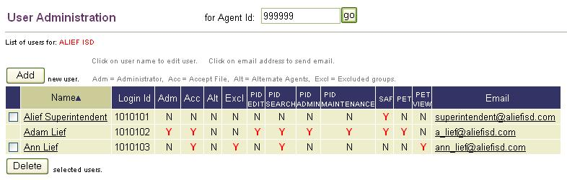
Note: A checkbox does not display next to the name of the person who is setting up the user profiles.

- Select the Add button to display the Add New User page. You are ready to enter the profile information. The Add New User page is divided into four sections:
- User Information
- Address and Contact Information
- General Access Permissions
- Special Access Permissions
User Profile–User Information
The first section, User Information, provides fields for you to enter the new user’s TEASE Login ID, first name, last name, and email. An asterisk (*) indicates a required field.
Figure 4. Add New User–User Information
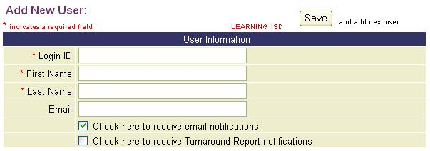
- Login ID–Enter the user’s TEASE Login ID as provided by TEA Security.
- First Name, Last Name-Enter the user’s first name and last name.
- Email–Enter current and valid email address. This address is used for email notifications and by TEA to contact users. Please keep email addresses up-to-date.
Note: The system checks to determine if an email address is present in this field but does not check the validity of the email address.
- Email Notification–The Check Here to Receive Email Notifications checkbox is selected by default. If the user does not need to receive email notifications, uncheck the box. If the user does want to receive email notifications, a valid email address must be entered.
Note: Email notification is a method used by the EDIT+ system to advise users about various EDIT+ processes. There are two types of EDIT+ email notification: Automatic Email Notification and User-Controlled Email Notification. See the EDIT+ User Reference and Training Guide chapter entitled, Email Notification, for details.
- Turnaround Reports–The Check Here to Receive Turnaround Report Notifications checkbox is not selected by default. Only certain EDIT+ users (e.g., Superintendents) need Turnaround Reports email notification. Select this checkbox if the user should be automatically notified when Turnaround Reports are available for viewing and printing.
- Save and add next user–Complete the remaining fields or simply select the Save and Add Next User button (at the top of the page) to create additional users for this Agent ID.
Note: If you do not complete the remaining sections at this time, you must return later to complete the profile before the user has full EDIT+ privileges. See the chapter entitled, Maintaining EDIT+ User Profiles, for more information.
User Profile–Address and Contact Information
The next section of the Add New User page provides fields for address, phone, and fax information. Please keep this information current. It is used regularly by TEA.
Figure 5. Add New User–Address and Contact Information
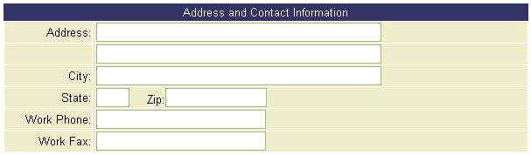
User Profile–General Access Permissions
The next section, General Access Permissions, lists the setup options for general access usage within EDIT+. These permission selections are available for the District-level Administrator to establish general permissions for the new user.
Figure 6. Add New User–General Access Permissions
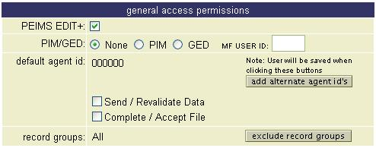
- PEIMS EDIT+–By default, each new user has general access privileges to PEIMS EDIT+.
- PIM/GED–Certain users can be granted additional general access permissions (visible only to TEA, ESCs, or Administrator-level users with an MOU).
- Default Agent ID-Represents the Agent ID to which the user’s profile is associated.
- Send/Revalidate Data–Gives users the authority to send files, run reports, and revalidate files (i.e., perform edits against a data file that has previously been sent to the EDIT+ server).
Note: Do not check the Send/Revalidate option if you want to set up a user who can view only reports and collection status (i.e., one who does not send files, generate reports, or revalidate files),
- Complete/Accept File– Gives users the authority to complete files for review at the next hierarchy level; also for users to accept files from the hierarchy level directly below.
- User Administration–Grants permission to add, maintain, and delete user profiles. Care should be given when granting User Administration since users granted this permission have broad access to user profiles within their hierarchy.
- Add Alternate Agent IDs–See the Alternate Agent IDs section of this chapter for details about this feature and how to set an Alternate Agent ID.
- Exclude Record Groups–See the Excluded Record Groups section of this chapter for details about this feature and how to exclude various record groups.
User Profile–Special Access Permissions
The final section, Special Access Permissions, grants the user permission to work with certain special features within the EDIT+ database. The permissions in this section are available for TEA or ESC-level administrators to establish for the new user. District-level administrators do not have authority to establish special permissions.
Note: Permissions that restricted because of user role are protected (shaded) to render them viewable but not accessible. Permissions previously granted display with a checkmark.
Figure 7. Add New User–Special Access Permissions
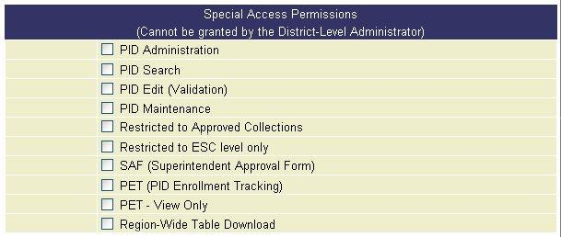

IMPORTANT! Regarding certain special access permissions:
- Access to PID–A user must have pre-approved access to PID (via completing and submitting a TEASE Request for Access form to TEA) to be granted PID Search, PID Edit (Validation), and/or PID Maintenance.
- PID Search / PID Edit / PET and PET View Only–A user must have PID Administration permissions to grant PID Search, PID Edit (Validation), PET, and PET View Only.
- PID Administration–Only granted to TEA-level users and ESC users who have executed a Memorandum of Understanding (MOU) with TEA.
- Region-Wide Table Download–Only granted to TEA, ESCs, or Administrator-level users whose region has executed a Memorandum of Understanding (MOU) with TEA. ESC-level Only users cannot be granted this permission.

Excluded Record Groups
Excluded record groups are the records that do not display on the Select Validation Options page when a file is transferred for validation processing.
The EDIT+ default authorizes users to work with all record groups associated with a user role. Users with excluded record groups are able to complete the files, view their file submission, as well as the file submission of other users in their agent ID, except files related to the record groups for which they have been excluded.
Excluding Record Groups in the User Profile
To exclude record groups in the user profile:
- From the EDIT+ Contents list, select Administration and then select Maintain Users. The User Administration page displays.
- Select the Add button. The Add New User page displays.
- Within the General Access Permissions section of the Add New User page, select the Exclude Record Groups button.
Note: If you determine that a user with excluded record groups should also have permission to complete and accept files, select the Complete/Accept File checkbox at this time.
Figure 8. Exclude Record Groups Button–User Profile
- On the Exclude Record Groups page, select corresponding checkbox(es) to exclude the user from accessing specific record groups.
Figure 9. Exclude Record Groups Page–Options
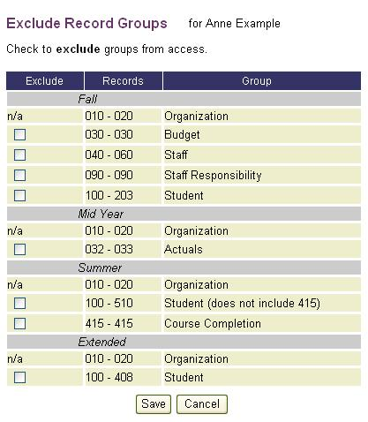
- Select Save to save the changes.
- The User Administration page for the default Agent ID of the user displays a Y in the Excl column for users with excluded record groups.

Knowledge and Skill
This section provides review questions and exercises to assess the knowledge and skill you have acquired from reading through the chapter.

Review Questions
- List several reasons an EDIT+ Administrator might want to update an existing user’s profile.
- If an Administrator wants to view (in a single location) all current permissions for several users, where is this information found?
- In which of the four user profile sections would an Administrator add the user’s email address? Record groups? The user’s work phone number? PID Maintenance? Which of these actions is not possible for a District-level Administrator?
Notes:

Chapter 3–Maintaining EDIT+ User Profiles

Overview
Once EDIT+ User accounts are established they need to be maintained. EDIT+ User Administration provides a means of managing user accounts. User accounts can be edited, deleted, and user activity can be reviewed and monitored. The EDIT+ Administrator performs User Accounts maintenance through the Administration link within the Contents bar on the EDIT+ home page.
User Administration is used by an EDIT+ Administrator to:
- Add or remove general permissions to an existing ID
- Add or remove special permissions to an existing ID (for ESC-level EDIT+ Administrators only)
- Change record group access
- Change Alternate IDs
- Review/monitor individual user activity within EDIT+

EDIT+ User Administration
EDIT+ user profiles are managed by User Administration. Once profiles are established, the PEIMS Coordinators at each Education Service Center (region) handle the management of EDIT+ User Administration. The ESCs know when it is appropriate for user administration to be handled at the district level and when it is not.
There are two operational scenarios:
- ESC PEIMS personnel coordinate User Administration for the districts; each district has a primary PEIMS Coordinator handling user administration for that district. Additional users may have administration authority; however, one central person is the key contact.
- ESC PEIMS personnel handle all User Administration activities.

Editing an EDIT+ User Profile
You can edit an existing EDIT+ user profile within your hierarchy by following steps similar to setting up a new EDIT+ user.
To edit an EDIT+ user profile:
- Verify that the correct Agent ID for the individual you are editing displays in the For Agent ID field. If not, delete the existing Agent ID and enter the correct Agent ID. Select Go.
- Select Administration from the EDIT+ Contents list then select Maintain Users. The User Administration page displays with a list of current users for the Agent ID specified.

Figure 10. Edit User Profile–User Administration Page
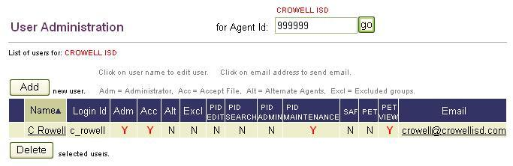
Note: Whenever you are logged in as yourself, a checkbox does not display next to your name indicating you are not authorized to delete your own user profile. However, if you have User Administration permissions you can modify your own profile including, for example, adding/removing excluded record groups and removing alternate agent IDs. Caution: You are able to remove your own User Administration permission however, once done, you cannot re-grant this permission; it can only be re-granted by TEA.
- Select the name hyperlink for the user profile you want to update. The Edit User page displays.
- The User Information section of the Edit User page contains a Last Updated date field and a Last Updated By name field. These two fields enable the Administrator to track who has made the most recent update to a user’s profile including the date and time of the update.
Figure 11. Edit User Profile–Last Updated Fields
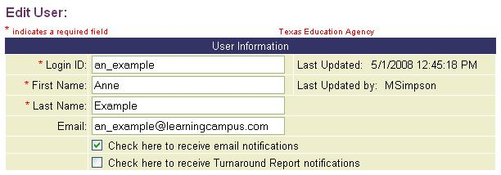
- Modifications can be made in the General Access permissions section of the profile if you are a District-level Administrator or higher. Modifications to the Special Access permissions can only be made at the ESC-level or TEA-level.
- Once you have completed updating the information, select Save.

Deleting an EDIT+ User Profile
Former EDIT+ users should be removed from the system to protect the confidentiality of PEIMS data, especially, if they leave your campus/office or if their job responsibilities change.
To delete an EDIT+ user profile:
- Select Administration from the EDIT+ Contents list, then select Maintain Users. The User Administration page displays.
- In the for Agent ID field, enter the Agent ID associated with the TEASE Login ID you need to delete. When the list of users displays, notice the checkbox to the left of the names.

Figure 12. Delete User Profile–User Administration Page
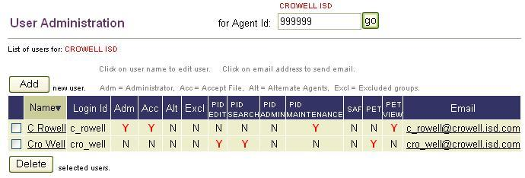
- Select the checkbox next to the person’s name you want to delete from EDIT+ system, then select the Delete button. A pop-up message prompts you to confirm the delete.
- Verify your selection then select OK. Once a TEASE Login ID is removed, it cannot be recreated for use in EDIT+. If you choose Cancel, you are returned to the User Administration page and your selection remains with no checkmark in the checkbox.
- After selecting the OK button, return to the User Administration page. Notice the selected user is deleted. The TEASE Login ID is now deleted from the User Administration page. All activities performed by that TEASE Login ID remain in the database to maintain an accurate audit trail for data accountability.
Note: To delete multiple users, place a checkmark next to all user names you plan to delete. Select the Delete button. If you are satisfied with your selections, confirm the delete.

Viewing an EDIT+ User Profile
EDIT+ enables you to update your own name, email address, physical mailing address, and phone information. To view/update your user profile, select My User Profile from the EDIT+ Contents list. Fields that are shaded are not editable. After you have completed all updates, select Save.

Monitoring User Login/Logoff Activity
An EDIT+ user with User Administration permissions, can view user Login and Logoff activity.
To monitor a user’s Login and Logoff activity:
- From the EDIT+ Contents list, select Administration then select User Login Activity. The Users Activity page displays. The page displays the same list of names as the User Administration page. Columns are sortable in ascending or descending order.
Figure 13. Users Activity Page
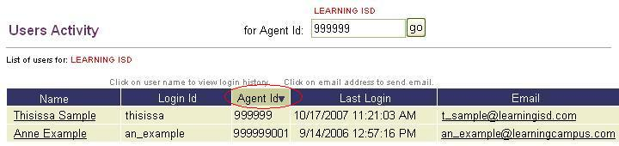
- If an email address is present, it serves as an email link to the user. The user’s underlined name serves as a link to an individual User Activity page, listing details of the user’s EDIT+ Login and Logoff activity.
Knowledge and Skill
This section provides review questions and exercises to assess the knowledge and skill you have acquired from reading through the chapter.

Review Questions
- How do you modify a user’s access permissions?
- How do you remove an EDIT+ user profile?
- How do you review a user’s Login and Logoff activity?

Exercise 3.1–Edit a User Profile
- Give Administration authority to a user you created in previous test exercise.
- Change a test user’s email address.
- Change a test user’s PID Search permission.

Exercise 3.2–Delete User Profile
- Delete a user you created.
- Verify the user is deleted.

Chapter 4–Posting Broadcast Messages

Overview
Broadcast messages can be posted to the EDIT+ home page and display as System Messages, TEA Messages, or ESC Messages. System messages always relate to the availability of the EDIT+ application. For example, if the EDIT+ application is unavailable due to maintenance, a message is posted here. TEA messages always relate to TEA-related activities, for example, due dates for first submissions and other important TEA-related events. Both system and TEA messages are displayed for all EDIT+ users, (region, district, and campus users).

Posting an ESC Broadcast Message
Posting a broadcast message is an excellent way for ESCs to communicate with their EDIT+ users about important events, for example, reminding districts and campuses of submission due dates. Messages can be posted for any length of time and can be any length of text, although, it is recommended they be as brief as possible. Messages may be displayed in all current collections or in a specific collection. ESCs may also post messages for other ESCs to view.
To post an ESC message:
- Within an open collection, select Messages in the EDIT+ Contents list.
- On the Active Posted Message page, select Post. The Post Message page displays.
- Select the down arrow in the To field to determine the audience for your message. ESCs can post messages that display for their districts only, or for districts and campuses, or for other ESCs. Messages can be displayed in a specific collection or all current collections.
Figure 14. Post Message to ESCs, Districts, and Campuses
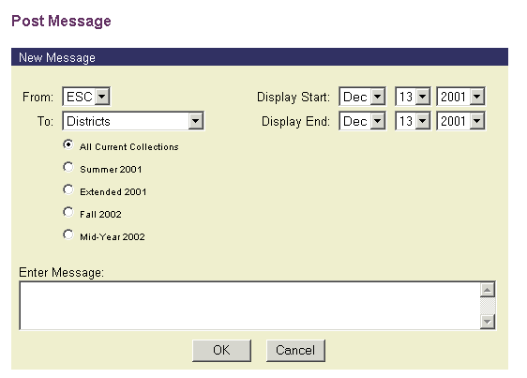
- Choose the message start and end dates by selecting the down arrows in the Display Start field and the Display End field. You can choose the month, day and year from the appropriate drop down boxes to indicate when you want the message display to start and when the message display should end.

- Choose the collection that you wish to post the message to from the list of available collections. By default, All Current Collections is selected. To choose a different collection, select the radio button next to the collection in which you want your message displayed. In this example, the message is posted to all current collections.
Figure 15. Post Message–Message Start and End Dates
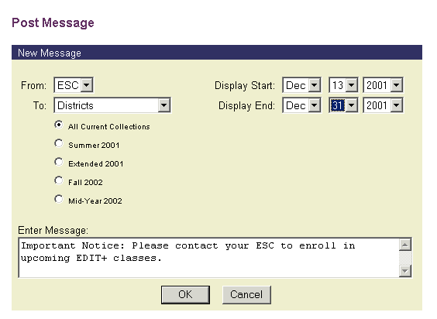
- Select inside the Enter Message box to position your cursor and type your message. The text automatically wraps as you type. No special formatting (bold or underlined text) is allowed in the message box.
- Select OK to save your text and post the message.
Figure 16. Active Posted Messages–Message Displayed
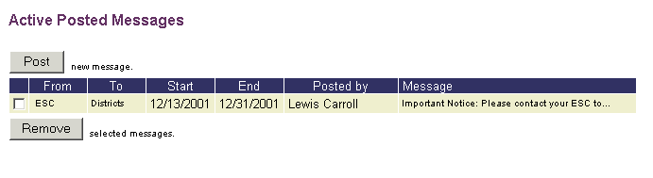
- The Active Posted Messages page displays only the beginning of your message.
Figure 17. EDIT+ Home Page–Message Posted by ESC
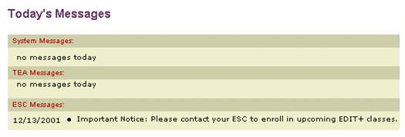
- Your full message is displayed on the EDIT+ home page.
Removing an ESC Broadcast Message
To remove an ESC message:
- Select Messages in the EDIT+ Contents list.
- On the Active Posted Messages page, you see your current message displayed. Select the checkbox next to the message you wish to remove. Select the Remove button to delete the message.
Figure 18. Active Posted Messages Page–Remove Button
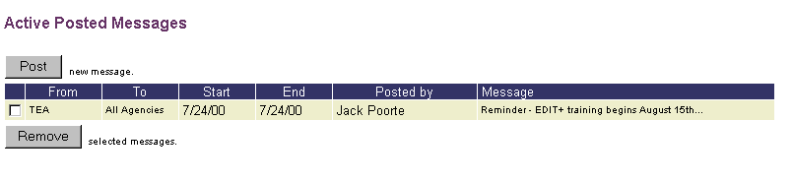
- The message is not displayed when you return to the home page.

Knowledge and Skill
This section provides review questions and exercises to assess the knowledge and skill you have acquired from reading through the chapter.

Review Questions
- What is the difference between a System message and a TEA message?
- How long does a message remain posted?
- How can you post a message for districts only?

Exercise 4.1–Post a Broadcast Message
- Post the following ESC message: “Good Morning!” on the EDIT+ home page.
- Post the following District-only message on the EDIT+ home page: “Please submit your files today.”

Exercise 4.2–Remove a Broadcast Message
- Remove all messages posted in the preceding exercise.
- Verify all messages posted are removed.

Notes:

Chapter 5–Purging PEIMS Data Files

Overview
EDIT+ offers the capability to purge partial data files from the system. The purge function serves two purposes:
- Allows EDIT+ Administrators to clean up the Collection Status page by deleting partial files.
- Improves the speed of loading data files onto the EDIT+ server.
Note: Only partial files can be purged. An eight-digit district file cannot be purged. An eleven-digit campus file also cannot be purged.
Purging is final. There is no recovery option. If you think you might need partial files after the collection closes, you should save them locally prior to the collection close date.

Purging a Data File
Only EDIT+ Administrators have the ability to purge data files. The Purge function is accessed from the Collection Status page. A checkbox next to a file name indicates that the file can be purged. Multiple files can be purged by selecting multiple checkboxes.
To purge a file:
- Select Collection Status from the EDIT+ Contents list. The Collection Status page displays.
Figure 19. Collection Status Page–Purge Checked Files
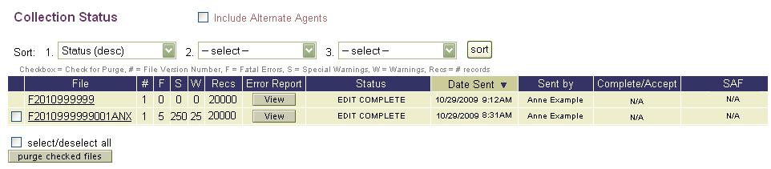
- Click the checkbox next to the file you want to purge and then select the Purge Checked Files button.
- The Purge Confirmation page displays. Select the OK button to confirm your purge request. Select the Cancel button to cancel your purge request.

Knowledge and Skill
This section provides review questions and exercises to assess the knowledge and skill you have acquired from reading through the chapter.

Review Questions
- What types of files can be purged?
- Which of the following files can be purged?
F2010123456000ANX
F2010123456
F2010123456000
F2010123456101000
F2010123456101
- Can you recover files once they have been purged?

Exercise 5.1–Send/Purge Files
- Submit several partial files and one district file.
- Purge all unwanted files from your Collection Status.

Chapter 6–Setting Up Audit Reports

Overview
EDIT+ Administrators have the ability to select up to four Major Funds to display as columns in some Mid-Year audit reports. Changes to Major Funds can be made at any time, but whenever changes are made to the Audit Reports Setup any previously generated reports are reset for the current collection year. For example, if you generate PRF9D010 and PRF9D011 in the morning and then select different Major Fund groups in the afternoon, the previously-generated reports are removed and the On Demand button is available.
Note: Major Fund selections are not saved from one collection year to the next. EDIT+ Administrators should select Major Funds at the beginning of each new Mid-Year collection year.
Other items to know about Audit Report Setup:
- Only EDIT+ Administrators can access Audit Report Setup.
- Audit Report Setup is available only in the Mid-Year collection.
- GASB 34 allows groups of fund codes to be defined for a major fund, but selection of fund groups is not supported in EDIT+.
- When the Save button is selected after making changes on the Audit Report Setup page, previously generated versions of reports PRF9D010 and PRF9D011 are reset for the current collection year.
- If no Major Funds are selected, PRF9D010 and PRF9D011 display an empty column heading, with zeros under the heading bar.

Selecting Major Funds
To select Major Funds:
- From the EDIT+ home page, select Administration from the EDIT+ Contents list.
- From the Administration page, select Audit Report Setup.
Figure 20. Administration Page–Audit Report Setup Link
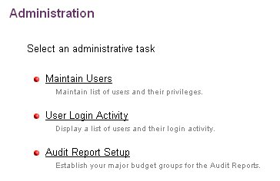
- The Audit Report Setup page displays four Major Fund fields where selections.
Figure 21. Audit Report Setup Page–Major Funds Drop-Down Lists
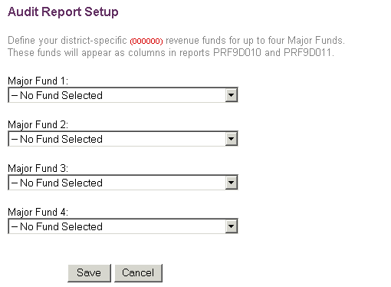
- To choose a Major Fund, select the down arrow in the Major Fund 1 field to display a popup menu. Repeat this step to choose other Major Funds. Save your selections.
Figure 22. Audit Report Setup Page–Choose a Major Fund
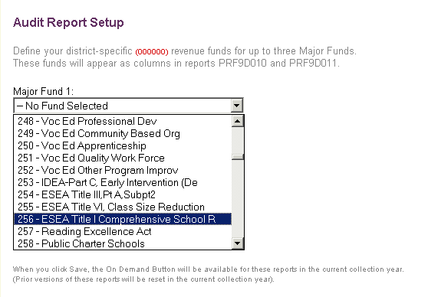
Note: When the Save button is selected, previous version of reports PRF9D010 and PRF9D011 are reset for the current collection year..
- After Major Funds are chosen, they are displayed on the Audit Report Setup Complete page.
- Use the Click Here link to return to the EDIT+ home page.

Knowledge and Skill
This section provides review questions and exercises to assess the knowledge and skill you have acquired from reading through the chapter.

Exercise 6.1–Select a Major Fund
- Submit a Mid-Year file. Use the On Demand button to generate reports PRF9D010 and PRF9D011. What is displayed in the Major Fund columns?
- Use Audit Report Setup to select two or more of the Major Funds. Go to Standard Reports. Use the On Demand button regenerate PRF9D010 and PRF9D011. What is displayed in the Major Fund columns now?
- Repeat all steps in #2 selecting two or more Major Funds different than those used.

Chapter 7–Region-Wide Reports
and Table Downloads

Overview
EDIT+ offers the capability for ESCs to run their own region-wide reports and access their own region-wide table downloads. The term region-wide encompasses all data from all districts within the region. Only users with ESC privileges are able to view and use region-wide functionality. For some region-wide features, special permissions must be granted.

Region-Wide Reports
Currently, Region-Wide Reports are generated within the following two report groups:
- Standard Region-Wide Reports
- Data Collection Monitoring System (DCMS) Reports
Note: Standard Region-Wide Reports can be generated only once and only when all district files have reached Turnaround status. DCMS Region-Wide reports can be generated as often as needed.

Accessing Standard Region-Wide Reports
Standard Region-Wide Reports are accessed from the Region-Wide Reports and Table Downloads page. The reports are available: (1) when all districts within an ESC have reached Turnaround status, or (2) from an Approved database.
To access Standard Region-Wide Reports:
- On the View Reports page, as an ESC user, select the Region-Wide Reports and Table Downloads link.
Figure 23. View Reports Page–Link to Region-Wide Reports
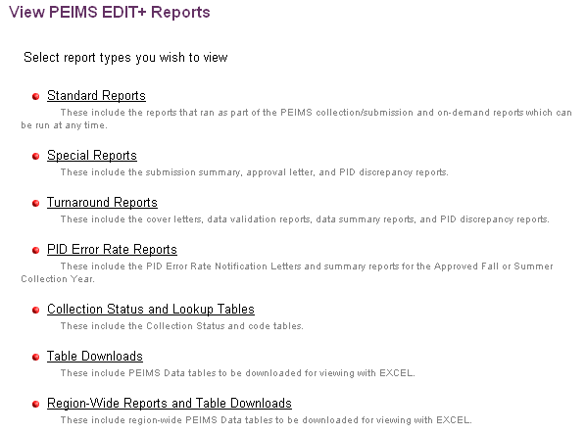
- Once the Region-Wide Reports and Table Downloads link is selected, the ESC user is presented with several options. Select Standard Reports.
Figure 24. Region-Wide Reports and Table Downloads Page
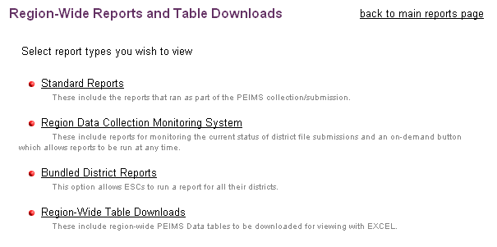
- If all district files have not been accepted, the user sees the following page and message.
Figure 25. Region-Wide Standard Reports–All Districts Not Accepted
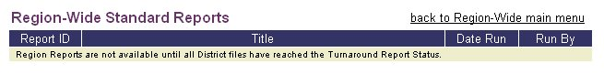
- If all district files have been accepted and reached Turnaround Status, the
Region-Wide Standard Reports page displays a list of Standard Region-Wide Reports. An On Demand button can be selected to generate any report not yet run.
Figure 26. Region-Wide Standard Reports–All Districts Accepted
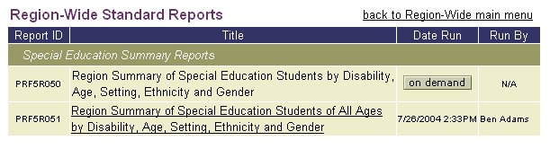
- The reports are arranged in functional groups. Currently, the only Region-Wide Standard Reports available are Special Education Summary Reports.

Accessing DCMS Region-Wide Reports
Although DCMS reports are generally TEA-level reports, DCMS region-wide reports are available to ESCs at all times without restriction (subject to Accepted file or report status). The reports are accessed differently than Standard Region-Wide Reports.
To access DCMS Region-Wide reports:
- From the View Reports page, select Region-Wide Reports and Table Downloads, then select Region Data Collection Monitoring System.
- A list of DCMS reports displays for the ESC user.
- Selecting the On Demand button generates the DCMS report or replaces a prior version of the report.

Region-Wide Table Downloads
Region-Wide Table Download functionality enables ESC users to select a specific table download for districts within their region whose files have reached Turnaround Status as of the date of the download. This feature is granted as a special permission within the ESC user’s profile. See the chapter entitled, The EDIT+ User, for details regarding setting up user profiles.
Note: To request this permission, submit a fully completed and signed TEASE Request for Access form to the Enterprise Data Management group within the PEIMS Division. A link to the form can be found in the top menu of the EDIT+ External wesite at http://www.tea.state.tx.us/index4.aspx?id=3024.
To download region-wide tables within your ESC:
- From the View Reports page, select Region-Wide Reports and Table Downloads, then select the Region-Wide Table Downloads link. The Region-Wide Table Downloads page displays with a list of collection-specific table downloads.
- Select the On Demand button corresponding to the desired table download.
Figure 27. Region-Wide Table Downloads–Select Download Table
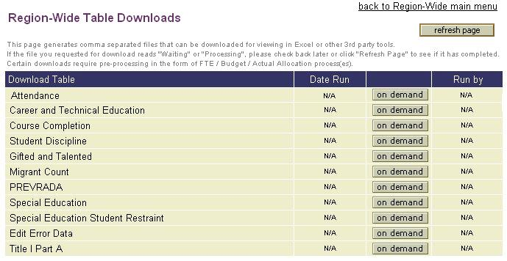
- When the On Demand button is selected, the Select Districts for Table Download page displays with a list of all districts within the ESC that have submitted a file for the collection.
Figure 28. Region-Wide Table Downloads–Select Districts
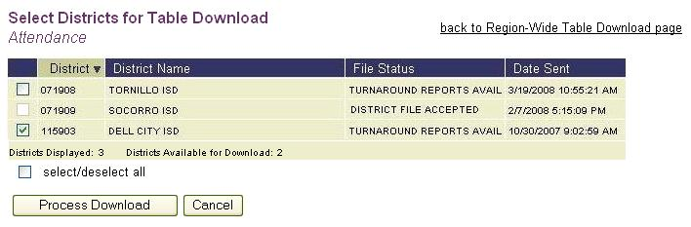
- If a district file has reached Turnaround Reports Available, it is available for download by selecting the checkbox to the left of the District ID. The checkbox is grayed-out for files that have not reached Turnaround Reports Available status. The Districts Displayed count and Districts Available for Download count are helpful FYI, especially for large districts.
- Select the Process Download button to begin the download. The Cancel button cancels any selection(s) and returns you automatically to the Region-Wide Table Downloads page.
- After selecting Process Download, you are returned to the Region-Wide Table Downloads page where you can view the download progress by selecting the Refresh Page button.
Figure 29. Region-Wide Table Downloads–Download Complete
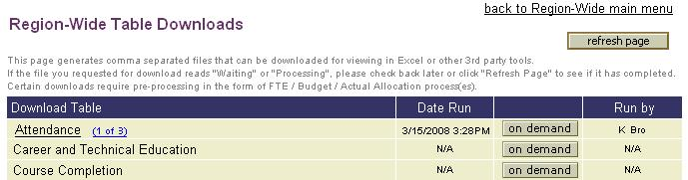
- When processing is complete, the download name displays as a link. Selecting the link displays a File Download dialog box with an option to Open or Save the download file. It is recommended you save the download to your hard drive so that it can be viewed at the time of the download and any future date.
Note: Table downloads are generated as .zip files that can be extracted as text files. Double-clicking the extracted text file displays the download data within Notepad® in a comma-separated format. Excel® can also be used to view the download.
- Each table download that is generated for at least one district displays a table count link in parentheses to the right of the download name. Selecting the table count link displays the Districts for Table Download page along with all districts within the ESC for which the download has processed to date.
Note: The PEIMS EDIT+ Tables Reference provides detailed information regarding the database tables used within the EDIT+ application. It includes the data source for each of the tables, data relationships, and table organization.

Knowledge and Skill
This section provides review questions and exercises to assess the knowledge and skill you have acquired from reading through the chapter.

Review Questions
- How often can Standard Region-wide Reports be generated? How many districts must send in data files in order to generate these reports? What must the file status be to generate these reports?
- How often can DCMS Region-Wide Reports be generated? Is there a required file status to generate these reports?
- Who is authorized to access Region-Wide Table Downloads? How is the Region-Wide Table Downloads page accessed?
- What status must a district file reach before table download data is available?
- What is the significance of the table count link on the Region-Wide Table Downloads page?

Chapter 8–The SAF Process

Overview
The SAF (Superintendent Approval Form) process is an automated process within EDIT+ that enables districts and ESCs to approve their PEIMS data file submissions and electronically sign their respective file approval forms. Originally designed for district files (thus the name, Superintendent Approval Form process), the SAF process has been expanded to encompass ESC file submission as well. For districts, the Superintendent (or Charter School Director) electronically approves and signs the district file submission. For ESCs, the ESC Executive Director electronically approves and signs the ESC file submission.
Prior to the implementation of the SAF process, the District PEIMS Coordinator was required to print EDIT+ report PRF0A003-Superintendent’s Statement of Approval of Summary Report and Error Listing, obtain the Superintendent’s physical signature, and fax the signed form to the ESC PEIMS Coordinator. After review, the ESC PEIMS Coordinator then faxed the form to TEA. The receipt of the form at TEA was recorded in the Data Collection Monitoring System (DCMS) and the document was filed. This entire series of procedures has been automated and a new Superintendent Approval Form (SAF0A001) has replaced the former report-generated letter.

SAF Authorization
In the SAF process, the physical signature once required for Superintendent approval has been replaced by an electronic signature displayed on a PDF version of the Superintendent Approval Form (SAF0A001). The electronic signature is not a duplicate of the SAF Requestor’s physical signature, but a typed script font of the SAF Requestor’s name, representing an authorized electronic representation of the signature.

SAF Access
Access to the SAF process is secured through a combination of required measures:
- A TEASE Request for Access form completed, submitted to, and approved by TEA.
- A TEASE account, TEASE Login ID, and TEASE password established by TEA with access to EDIT+.
- An EDIT+ user profile and user permissions set up for each user role in the SAF process.
TEASE Access Request Form
To establish authorization for the SAF process, an SAF Requestor (i.e., a Superintendent, Charter School Director, or ESC Executive Director) must complete, sign, and submit a TEASE Request for Access form. The form is processed through the Enterprise Data Management group within the PEIMS Division and then TEA Security. It is filed at TEA, thus becoming the legal authorization for the electronic signature on the SAF.
Note: The TEASE Request for Access form must be completed and signed by every Superintendent regardless of district size. Hand-stamped signatures and substitute signatures are not acceptable. A link to the form can be found in the top menu of the EDIT+ External wesite at http://www.tea.state.tx.us/index4.aspx?id=3024.
SAF User Roles and Permissions
TEASE and EDIT+ access requirements, in combination with required EDIT+ user roles and permissions, combine to provide secure access and use of the SAF process. Each user role requires that specific permissions be established in the EDIT+ user profile. The following sections detail how to set up each user profile.
District PEIMS Coordinator User Role
The District PEIMS Coordinator has the role of accepting (completing) or rejecting the district’s data file, therefore must have:
- A district-level Agent ID
- All required record groups
- Send/Validate and Complete/Accept File general permissions
Note: The Send/Revalidate and Complete/Accept File permissions give the District PEIMS Coordinator the required functionality to accept (i.e., complete) a district file.
Superintendent User Role
The Superintendent has the role of approving or disapproving the district’s data submission, therefore must have:
- A district-level Agent ID
- SAF special permissions
- Charter Schools–With regard to the SAF district file submission process, a charter school Executive Director functions in the same capacity as a Superintendent therefore follows the same user role set up and functionality.
Note: A Superintendent does not send or complete files in the SAF process, therefore those permissions are not granted in their user profile.
ESC PEIMS Coordinator User Role
The ESC PEIMS Coordinator has the role of accepting (completing) or rejecting the both a district’s data file and their ESC file (in the ESC process), therefore must have:
- An ESC-level Agent ID
- All required records groups
- Send/Validate and Complete/Accept File general permissions
ESC Executive Director User Role
Similar to the Superintendent’s user role for a district, the ESC Executive Director has the role of approving or disapproving an ESC’s file submission, therefore must have:
- An ESC-level Agent ID
- SAF special permissions

SAF Administration–Email Notification
SAF Administration manages the email notification function which communicates the status of a submission file. It is maintained for the district file submission process by the District PEIMS Coordinator and by the ESC PEIMS Coordinator for the ESC file submission process. Alternatively, any EDIT+ user with Administration privileges can also maintain SAF Administration.
Note: An ESC can view a district SAF email distribution list by entering the County/District number in the For Agent ID field and selecting the Go button.
To access SAF Administration:
- Select the Administration link from the Contents list on the EDIT+ home page, then select the SAF Administration link.
- The SAF Administration page displays fields for District Superintendent, District PEIMS Coordinator, and ESC PEIMS Coordinator for the selected Agent ID.
Figure 30. SAF Administration Page–Completed SAF Email Distribution List
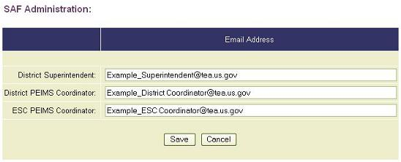
- Enter one email address for each field. The SAF process requires that all three fields be completed. Check entries carefully (there is no email verification feature).
- Dual Roles–If there are dual roles, for example, the Superintendent is the same person as the District PEIMS Coordinator, enter their email address in both fields.
- Multiple Recipients–There must be a single valid email address for each SAF user role field. To send an email to multiple recipients, enter a single valid distribution list address in any of the fields.
- ESC Executive Director–For ESC level entries only. Since the ESC Executive Director is the functional equivalent of a Superintendent, use the Superintendent field to enter the Director’s email address for status regarding ESC data files. Also, enter the ESC PEIMS Coordinator email address in both Coordinator fields.
- When all fields have been properly completed, select Save to save your entries and return to the SAF Administration main page.
Districts and the SAF Process
The SAF process is conducted through the Collection Status page. Using an Approve or Disapprove button in the SAF column, a Superintendent with SAF permissions can:
- Approve a district’s data file submission, initiating an auto-generated Superintendent Approval Form (SAF0A001).
- Disapprove a district’s data file submission, rejecting the file for the district to resolve errors and resend the file.
Note: The data file must be fatal free with all required record groups and have reached Edit Complete status in order to be eligible for the SAF process. Partial files cannot be submitted for approval or disapproval via the SAF process.

District Superintendent–SAF Approval
To approve a district file using the SAF process:
- From the Collection Status page, the Superintendent approves the submission by selecting the Approve button from the SAF column.
Figure 31. District File Approve-Disapprove Buttons
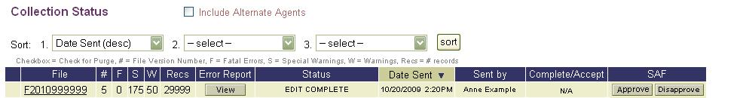
Note: In the above illustration, an N/A displays in the Complete/Accept column because the Superintendent has only been granted Approve/Disapprove permissions (i.e., does not have Complete/Accept permissions for sending data files). See the chapter entitled, PEIMS Data Acceptance, in the EDIT+ User Guide for details regarding sending data files.
- When the Approve button is selected, a form displays with a Sign Approval Form button. The Superintendent has the option to sign or cancel the form. Selecting the Cancel button returns the Superintendent to the Collection Status page where the Approve and Disapprove buttons remain available.
IMPORTANT! Because the electronic signature is the equivalent of the Superintendent’s written signature and approval, prior to electronically signing the form, the Superintendent should verify the name and title displayed. If the information is incorrect, select the Cancel button and notify the TEA AskTED Administrator immediately, providing the correct/current information. The Superintendent can then return to the SAF process after the information is corrected.
- Selecting the Sign Approval Form button:
- Initiates the processing of the Superintendent Approval Form (SAF0A001).
- Indicates the Superintendent’s intention to sign the form and acknowledges that the electronic signature has the same force and effect as the use of a written signature.
- Records the Superintendent’s approval in DCMS.
- Displays a Confirmation of Superintendent Approval page with a list of the email recipients who receive a secure PDF of the Superintendent Approval Form (SAF0A001).
Note: If the SAF email distribution list is not complete (see SAF Administration–Email Notification section of this chapter), the Confirmation of Superintendent Approval page displays an error message. At this point in the process, it is not possible to add an email recipient. Make note to return to the SAF Administration page at another time and verify all email field(s) are complete to ensure receipt of notification in future SAF processes.
- The Superintendent can return to the EDIT+ home page or the Collection Status page by selecting the links provided on the Confirmation of Superintendent Approval page.
- When the Superintendent Approval Form (SAF0A001) completes processing, a View button displays in the SAF column of the Collection Status page for both the District PEIMS Coordinator and Superintendent. Selecting the View button displays a PDF of SAF0A001. The PDF can be printed or saved.
Figure 32. District File Approved and SAF Form Available for Viewing
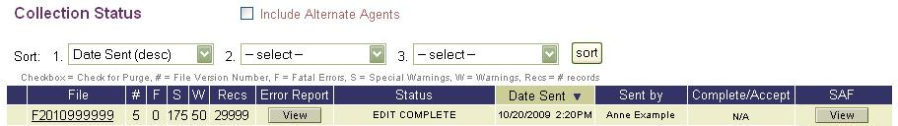
Note: For illustration purposes, the Edit Complete file status is used; however, a Superintendent can approve a file at the District File Completed and Turnaround Reports Available file statuses also.

District Superintendent–SAF Disapproval
When a district file reaches Edit Complete status, the Superintendent has an option to disapprove the file. This option is available only until the ESC accepts the district’s submission. Once the ESC accepts a district file, a file status of Turnaround Reports Available is assigned and it is no longer possible for the Superintendent to disapprove the submission.

To disapprove a district file using the SAF process:
- From the Collection Status page, the Superintendent selects the Disapprove button in the SAF column. The district file is rejected and a Confirmation of Superintendent Disapproval page displays.
- The Superintendent can return either to the EDIT+ home page or the Collection Status page via links at the bottom of the Confirmation page.
- Upon returning to the Collection Status page, District File Rejected displays in the Status column and Disapproved displays in the SAF column.
Figure 33. District File Disapproved and File Rejected
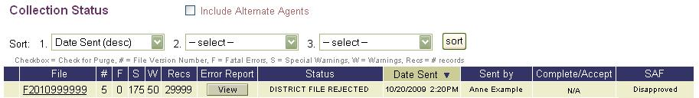
Note: Disapproved displays in the SAF column until the file is resubmitted, at which time the Superintendent views N/A in the SAF column. Once the resubmitted file status reaches Edit Complete, the Superintendent once again views the Approve/Disapprove buttons on the Collection Status page.
ESCs and the SAF Process
ESCs interface with the SAF process in two instances:
- Approving or disapproving an ESC data file submission (Fall and Mid-Year only).
- Accepting or rejecting a district data file submission.
ESCs and the Submission of ESC Data Files
ESCs send data files to TEA twice each collection year (Fall and Mid-Year). The ESC data file SAF process is the functional equivalent of the district data file SAF process; however, for ESC data files, the ESC Executive Director approves the submission whereas, for district data files, the Superintendent performs that function.
ESCs and the Submission of District Data Files
Although an ESC is not able to approve or disapprove a district’s SAF, an ESC can affect the flow of the process based on when it accepts or rejects the district’s data file submission.
An ESC can:
- Accept the district file after the district’s SAF approval.
- Accept the district file prior to the district’s SAF approval.
- Reject the district file prior to the district’s SAF approval.
- Reject the district file after the district’s SAF approval.

ESC–District File Accepted After SAF Approval
The most common sequence in the SAF process is when the ESC accepts a district’s submission after the Superintendent has approved the district file.

- When a Superintendent approves a district file, the ESC receives an email notification that the file has been approved.
- Upon receipt of the email, if the ESC PEIMS Coordinator views the Collection Status page, the page displays a file status of District File Completed with Accept/Reject buttons in the Complete/Accept column and a View button in the SAF column.
Figure 34. ESC View of District File Accept-Reject Buttons After SAF Approval
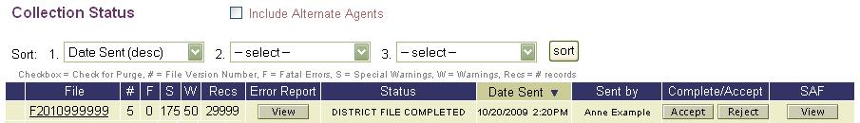
- The SAF View button is available because the Superintendent has approved the district submission. Selecting the View button displays a PDF file of the Superintendent Approval Form (SAF0A001). The file can be printed or saved to a local hard drive.
- When the ESC PEIMS Coordinator selects the Accept button, the district file is accepted and the file transitions to Turnaround Reports Available.

ESC–District File Accepted Prior to SAF Approval
The SAF process is independent of the ESC’s file Accept/Reject options, therefore it is possible, although not likely, that an ESC could accept a district’s submission before the Superintendent approves the file.
- Once a file reaches a status of District File Completed, the ESC PEIMS Coordinator can accept the file prior to the Superintendent’s approval by selecting Accept in the Complete/Accept column.
Figure 35. ESC View of District File Accept-Reject Buttons Prior to SAF Approval
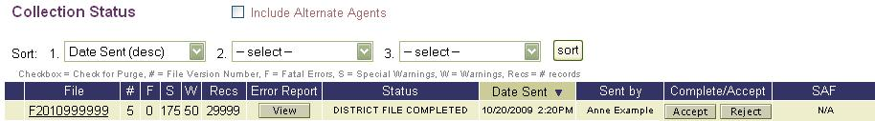
Note: The ESC PEIMS Coordinator views an N/A in the SAF column which indicates the Superintendent has not yet approved the file. If the file had been approved, a View button would display in the SAF column.
- After the ESC PEIMS Coordinator selects the Accept button, the Collection Status page displays a status of Turnaround Reports Available with N/A in the Complete/Accept column.
Note: When the Superintendent views the Collection Status page, the SAF column displays only an Approve button. The Superintendent cannot Disapprove a submission once the ESC has accepted the file.
Figure 36. District File Accepted by ESC–SAF Not Yet Processed
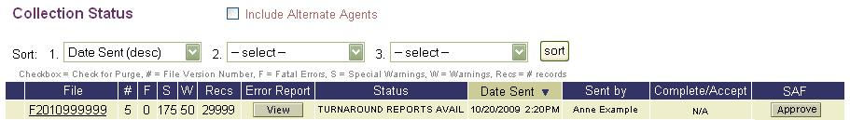
- If the Superintendent subsequently approves the submission, a View button displays in the SAF column indicating that a PDF of the Superintendent Approval Form (SAF0A001) is available for viewing, printing, and saving to your hard drive.
Figure 37. District File Accepted by ESC–SAF Subsequently Processed
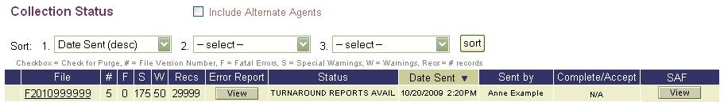

ESC–District File Rejected Prior to SAF Approval
EDIT+ allows the ESC PEIMS Coordinator to reject a district’s completed data file prior to the district’s SAF approval process.
- The ESC PEIMS Coordinator rejects the district’s data file by selecting the Reject button in the Complete/Accept column of the Collection Status page.
- Once the ESC rejects the file, an email is sent informing the District PEIMS Coordinator that the file has been rejected.
- Returning to the Collection Status page, the file status displays District File Rejected with N/A in both the Complete/Accept and SAF columns.
Figure 38. District File Rejected by ESC–Prior to SAF Approval
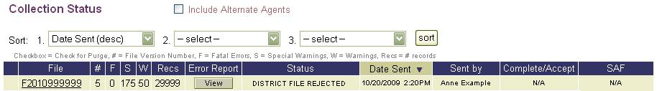
- The district file can be resent once all corrections required by the ESC are made.

ESC–District File Rejected After SAF Approval
EDIT+ also allows the ESC PEIMS Coordinator to reject the district’s submission even after the Superintendent has approved the submission.
- In the SAF column, the View button indicates the Superintendent has approved the district file and a PDF of the Superintendent Approval Form (SAF0A001) is available.
Figure 39. District File Rejected by ESC–After SAF Approval
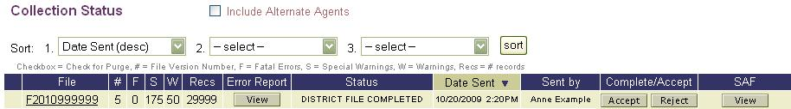
- By selecting the Reject button in the Complete/Accept column, the ESC PEIMS Coordinator can reject the district file.
- When the ESC PEIMS Coordinator rejects the district submission after the Superintendent has approved the file, the following occurs:
- Email notification is sent to the Superintendent and the District PEIMS Coordinator informing them of the file rejection by the ESC.
- The PDF file of the Superintendent Approval Form (SAF0A001) is deleted from the system; the View button on the Collection Status page is replaced with N/A.
- DCMS is updated removing the Letter Received Date.
- Returning to the Collection Status page, the file status displays District File Rejected and N/A displays in both the Complete/Accept and SAF columns.
- The district file can be resent and the SAF process repeated once all corrections required by the ESC are made.

SAF and File Status Override
EDIT+ Customer Support can override the status of any data file including any ESC or district files that have progressed through the SAF process. When a file status is overridden, the changes that take place in the system are conditioned upon whether the file has been approved or disapproved.
- If an ESC file has been disapproved and is subsequently overridden:
- The file transitions to an override status (ESC FILE DISAPPRV-OVRRIDE).
- Notification is sent to ESC Executive Director (designated in SAF email notification list).
- If an ESC file has been approved and is subsequently overridden:
- The file transitions to an override status (ESC FILE APPRV-OVRRIDE).
- Notification is sent to ESC Executive Director (designated in SAF email notification list).
- The PDF of SAF0A001 is deleted from the system and DCMS is updated removing the Letter Received Date.
- If the district file has been disapproved and is subsequently overridden:
- The file transitions to an override status (DISTRICT FILE DISAPPRV-OVRRIDE).
- Notification is sent to the Superintendent (designated in SAF email notification list).
- If the district file has been approved and is subsequently overridden:
- The file status transitions to an override status (DISTRICT FILE APPRV-OVRRIDE).
- Notification is sent to the Superintendent (designated in SAF email notification list).
- The PDF of SAF0A001 is deleted from the system and DCMS is updated removing the Letter Received Date.
Note: When a file is overridden and resent, the data has been revised; therefore, the file needs to be resent and reapproved through the SAF process.

SAF Process and First Submission/Resubmission
The Superintendent Approval Form (SAF0A001) is coupled with the submission of a specific district file. If a file is resubmitted, the Superintendent must approve the resubmitted file in order to obtain a Superintendent Approval Form that is consistent with the resubmitted file.

SAF Process and Approved Collections
The Superintendent Approval Form (SAF0A001) remains available in an Approved collection (via the View button in the SAF column on the Collection Status page) until the collection is archived.

Knowledge and Skill
This section provides review questions and exercises to assess the knowledge and skill you have acquired from reading through the chapter.

Review Questions
- What is the general purpose of the SAF process?
- Who has the role of accepting or rejecting a district’s data file? Approving or disapproving a district’s data submission?
- Who has the role of accepting or rejecting an ESC’s data file? Approving or disapproving an ESC’s data submission?
- What is the purpose of including email addresses in the SAF process? Where are the email addresses maintained? To whom are the email notifications sent?
- What status does a file need to reach before it is eligible for the SAF process?
- What does a district need to do if their file is rejected and, therefore, cannot advance through the SAF process?
- If a file is resubmitted, does the Superintendent need to approve the resubmitted file?
- What is the report number for the SAF form?
- How does a Superintendent (or ESC Executive Director) obtain permissions for and access to the SAF process?

Chapter 9–The PET Process

Overview
The Texas public school population is mobile with students moving and enrolling in multiple districts within the state throughout their academic career. This mobility creates record-keeping challenges for the districts and campuses. The PID Enrollment Tracking (PET) process provides districts and open-enrollment charter schools with the functionality to dynamically maintain student enrollment information at TEA for students matriculating within the state of Texas.
Student data is submitted to TEA semiannually during Fall and Summer PEIMS data collections. Fall enrollment data is submitted in late January and released at the beginning of March. Attendance data is submitted in late July and released at the beginning of October.
First available for the 2005-2006 school year, the PET Process helps meet TEA’s business process needs with regard to the semiannual PEIMS submission and release of enrollment and attendance data. The process is designed as an extension to PID (Person Identification Database) and offers an efficient and reliable way to dynamically track public school student enrollments and withdrawals.
The objectives of the PET process are to:
- provide up-to-date records for students in grades PK-12.
- improve leaver reporting by eliminating the reporting of district-to-district moves on leaver records by:
- reducing the time school districts devote to searching for students who have enrolled in other Texas public school districts.
- allowing school districts to devote more resources to students who have dropped out of school.
- enable districts to find students who have left and enrolled in other districts within the Texas public education system.
- enable districts to identify the previous Texas districts of enrollment for students newly enrolled in their district.
TEA requires the submission of PET files. The submission requirements, including a submission schedule and timelines, are published by TEA and posted to the TEA website.
For more information about the PEIMS guidelines for PID Enrollment Tracking (PET), including PET context edits, PET edits (validation), and PET PID edits (validation), please refer to Appendix G of the PEIMS Data Standards.
Setting Up PET
Access to PET process is secured using multiple levels of system and application-level security to protect the privacy of student education records. These security levels include:
- A TEASE Request for Access form completed, submitted to, and approved by TEA.
- A TEASE account, TEASE Login ID, and TEASE password established by TEA with access to the EDIT+ application.
- An EDIT+ user profile with applicable PET user permissions.
- A link to the form can be found in the top menu of the EDIT+ External wesite at http://www.tea.state.tx.us/index4.aspx?id=3024.

User Roles and the PET Process
PET user roles extend authorized PET functions to the user. There are three user roles in the PET process:
- An EDIT+ user with PET access permissions (user accesses EDIT+ through TEASE then accesses PET from the EDIT+ home page).
- A user with PET-only access permissions (user accesses PET directly through TEASE; does not have permissions or access to EDIT+).
- A user with PET-View Only access permissions (user accesses PET directly through TEASE; does not have access to EDIT+ and is only allowed to links to PET Search PID, PET Event History, and PET Reports).

Establishing PET Access Permissions
The Special Access Permissions section within the EDIT+ user profile establishes access to PET.
Note: Setting the PET special access permission is the equivalent of granting PID Search or PID Edit (validation) within EDIT+. Granting these privileges is a TEA-level responsibility unless the ESC has executed a Memorandum of Understanding (MOU) with TEA.
To establish user access permissions to PET:
- Select the Administration link from the Contents list on the EDIT+ home page
to display the Administration page then select the Maintain Users link. The User Administration page displays.
- From the User Administration page, select the user name hyperlink to display the user’s profile page. Scroll to the Special Access Permissions section to determine if either of the PET access permissions (PET or PET-View Only) is checked.
- Select the checkbox next to the appropriate PET access permission. PET View is automatically included in the PET access permission so it is not necessary (or possible) to select both PET and PET View-Only.
Note: If a user is set up for PET-only or PET-View Only access, the PEIMS EDIT+ checkbox in the General Access Permissions section of the user’s profile must be unchecked.

Accessing PET
PET is accessed differently depending upon the user profile established and the special access permissions granted.

EDIT+ User with PET Access Permissions
A link located within the Contents list of the EDIT+ home page allows the EDIT+ user who has PET special access permissions to access PET. Access for PET-only users (i.e., users who do not have access to EDIT+ but do have access to PET) is discussed further in this section of the chapter.
To access PET from EDIT+:
- Select the PID Subapp link from the EDIT+ Contents list.
Figure 40. EDIT+ Home Page with PID Subapp Link
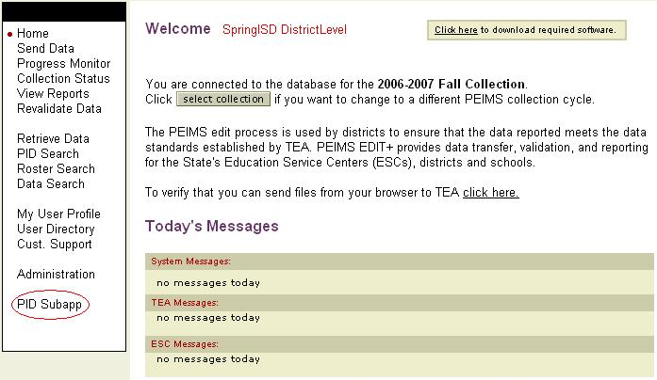
Note: EDIT+ users with PET access permissions must be connected to the current year EDIT+ collection to view and access the PID Subapp link.
- When the PID Subapp link is selected, the PET home page displays. The Contents list on the PET home page varies based upon the hierarchy level of the user. Any links that are shaded are functions not available to the user.

User with PET-Only Access Permissions
Some users may not have a link to EDIT+ but need access to PET. Once TEASE access is established and PET special access permissions are set, the user can log on to PET.
To access PET as a PET-only user:
- Log on to the TEASE startup page at http://seguin.tea.state.tx.us/apps/logon.asp.
- Enter the TEASE Login ID and TEASE password provided by TEA Security.
- Select Continue. A TEASE Application List page displays.
- Although the user is a PET-only user, for Launch purposes only, the user selects the PEIMS EDIT+ Production link.
- The PET home page displays.

Figure 41. District-Level User with PET-Only Access
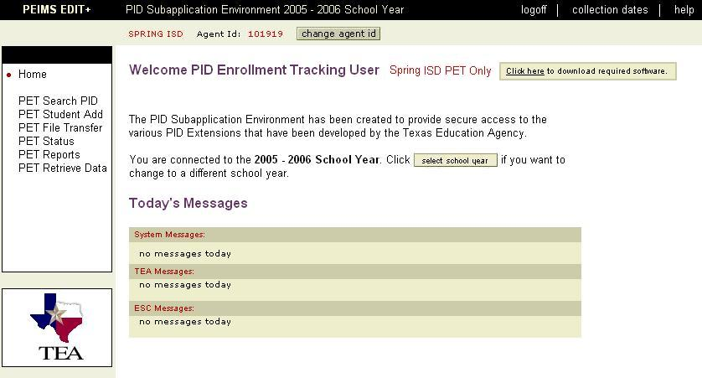
Note: For a campus-level user with PET-only access, notice the PET File Transfer link is shaded because the campus-level user is not able to send a PET file.
Figure 42. Campus-Level User with PET-Only Access
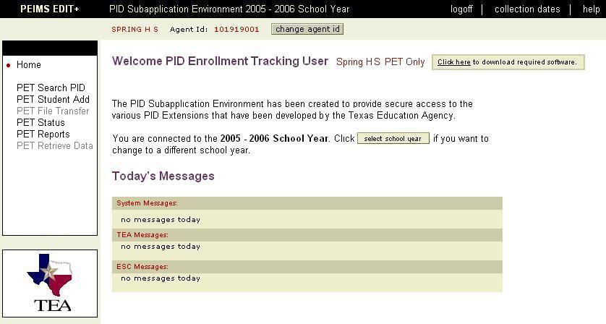

User with PET-View Only Access Permissions
Some users may not have access to EDIT+ or PET functionality but need view-only access to PET. Once TEASE access is established and PET-View Only special access permissions are set in the user profile, the user can log on to PET with links to PET Search PID, PET Event History, and PET Reports.
To access PET as a PET-View Only user:
- Log on to the TEASE startup page at http://seguin.tea.state.tx.us/apps/logon.asp.
- Enter the TEASE Login ID and TEASE password provided by TEA Security.
- Select Continue. A TEASE Application List page displays.
- Although the user is a PET-View Only user, for Launch purposes only, the user selects the PEIMS EDIT+ Production link.
- The PET home page displays.

Figure 43. PET Home Page for PET-View Only User
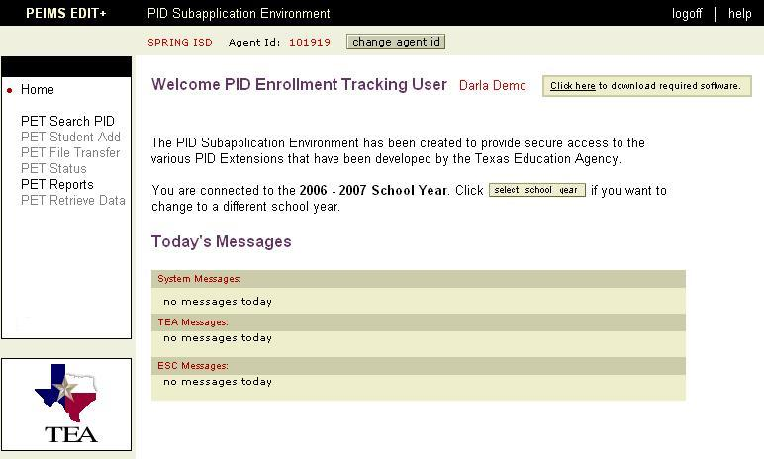
Note: PET Student Add, PET File Transfer, PET Status, and PET Retrieve Data are shaded because the PET-View Only user does not have access to those PET features.

PET Home Page
EDIT+ users will find the PET home page has a similar appearance to the EDIT+ home page. The Contents list on the left side of the page provides access to PET functionality. The Welcome message displays the school year selection and a link to download required software. The lower section of the page lists Today’s Messages that are identical in content to the messages displayed on the EDIT+ home page.
There are two functionality buttons of importance on the PET home page:
- the Change Agent ID button which allows the user to filter to a deeper level in the user hierarchy, and
- the Select School Year button which enables the user to select a specific school year for accessing PET events and specific PET processes.

Select School Year Button
The PET school year is a 15-month period, beginning June 1 of any given year and ending August 31 of the following year (e.g., June 1, 2009 through August 31, 2010). This 15-month period accommodates both traditional academic calendars and year round school calendars. The Select School Year button offers PET users the ability to manage PET data and PET Reports within specific school years. PET users can access open or closed school years.

Accessing Open School Years
By default, PET is set to the current open school year. However, there is a period of several months during the calendar year when one school year has not ended before another school year begins. During this time frame, two school year selection choices are displayed on the Select School Year page.

To access a different open school year:
- On the PET home page, click the Select School Year button to display the page.
Figure 44. Select School Year Button
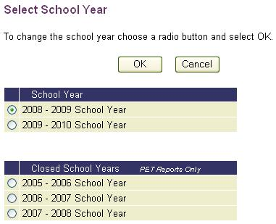
- Choose a different open school year by selecting the radio button corresponding to the school year in which you want to work. Select OK.
- You are returned to the PET home page. The school year you chose displays in the page banner at the top of the page and in the Welcome message.
- When you exit PET and then return, the system retains the open school year you selected.
- Once all schools have closed statewide for a school year, that school year moves to a Closed School Years section on the Select School Year page.

Accessing Closed School Years
District and campus-level PET users can select a closed school year for the purpose of accessing and generating prior year school year-based PET Reports. Please refer to the section of this chapter entitled, Prior School Year-Based PET Reports, for procedures and important details regarding the generation of these reports.
To access a closed school year:
- On the PET home page, click the Select School Year button to display the page.
- Choose a closed school year by selecting the radio button corresponding to the school year in which you want to generate prior year reports. Select OK.
- Notice the school year displays in the banner at the top of the page and in the Welcome message. When you exit PET and return, the system resets to the current open school year.

PET Processes
The PID Enrollment Tracking (PET) system provides several processes to assist PET users in their ability to dynamically track public school student enrollment and withdrawals.

Note: The following processes are presented in a helpful learning order but not a required functional order.

- Performing a PET Search in PID
This process parallels the process for performing a PID Search within EDIT+ with the additional capability of providing access to a student’s PET Event History.

- Viewing a PET Event History
This screen displays a view of the student’s PET Event History. A PET Event is an individual student’s enrollment to or withdrawal from a Campus ID of Enrollment tightly coupled with the date the event took place. A student’s PET Event History is the complete set of all events.

- Maintaining a PET Event
This process provides the capability to maintain an existing PET event.

- Adding a PET Event
This process provides the capability to create a new PET event.

- Creating a PET Student Record in PID
This process provides the capability to add a new student record to PID.

- Transferring a PET File to TEA
This process provides the capability to transfer a PET file to TEA using a method that parallels the process for sending a PEIMS data file. This process performs a client-side validation of the PET file against the PET XML Schema Definition (XSD).

- Validating and Loading PET Event Records
This process validates the information contained within the PET file and if the events are determined to be valid, loads the PET events into the database.

- Retrieving a PET File
This process enables the PET user to retrieve a PET file similar to the EDIT+ file retrieval process.

- Generating a PET Report
This process provides access to the PET Report Library.
Process #1: Performing a PET Search in PID
The PET Search PID page enables the PET user to search PID for a student's PET Event History. Search results display only students with a current PET enrollment record for a campus within the district (if a District ID is entered) or a specific campus (if a Campus ID is entered).
Note: The procedure for performing a PID Search using functionality within PET is the same as the procedure for performing a PID Search within EDIT+. Searches can be conducted on 9-digit SSNs as well as Student IDs with a single leading alpha character plus 8 digits. Accepted alpha characters are: S (state-assigned ID), G (GED-assigned ID), or T (temporarily-assigned ID made by the Enterprise Data Management group within the PEIMS Division).

To perform a PET Search in PID:
- Select PET Search PID from the Contents list on the PET home page. The PET Search PID page displays.
- Enter the search criteria into the search fields. Select Reset to clear all fields from any erroneous entries or previous searches. Select Search to display search results.
- At least one required field marked with an asterisk (*) must contain data.
- Any one field can be used to conduct a search (except the First Name field).
- Partial name searches can be done using a wildcard character search (e.g., smit*).
- Any combination of fields can be entered to narrow the search.
Figure 45. Perform a PID Search Using PET
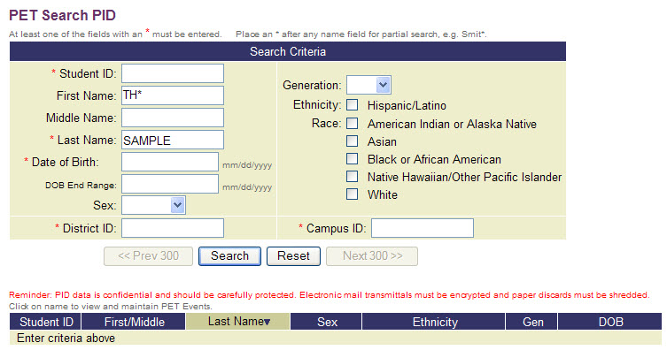
- PET Search PID can be performed using either District ID or Campus ID (not both). Search results display only students with a current PET enrollment record for a campus within the district (if a District ID is entered) or a specific campus (if a Campus ID is entered).
- PET Search PID results display on the lower half of the page. Results can be sorted in ascending or descending order. The triangle symbol next to the column header identifies the current sort column and order of the sort.
Figure 46. PET Search PID Results

Process #2: Viewing a PET Event History
The Pet Event History page displays the history of a student’s PET events. The 2005-2006 school year is the first year listed for all students.
The following conditions apply when using the PET Event History page:
- A district-level user has maintenance access to an event listed in a student’s PET Event History only if the event was created by a campus in their district.
- A campus-level user has maintenance access to an event listed in a student’s PET Event History only if the event was created by their campus.

To view a student’s PET Event History:
- Select the PET Search PID link on the PET home page. The PET Search PID page displays.
- Enter data that is specific to the student in one or more data fields. At least one required field marked with an asterisk (*) must be entered. The PET Search results display at the bottom of the page.
Figure 47. View a PET Event History–PET Search PID Results
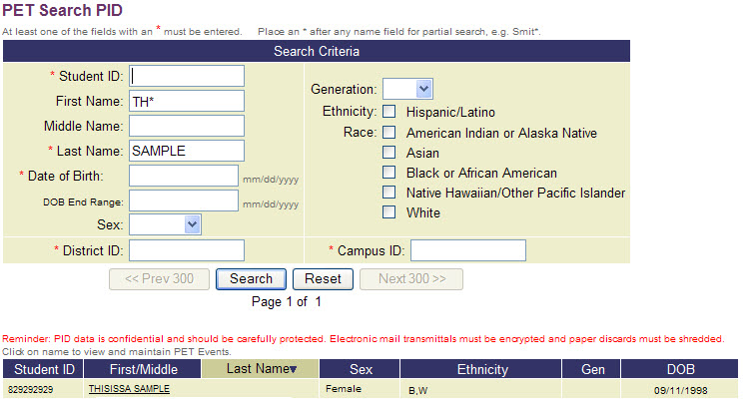
- Select the name link for a student. The PET Event History for [Name] page displays. When selecting column headers, same-date withdrawals and enrollments are displayed in Event Type order with withdrawals first, then enrollments.
Figure 48. PET Event History for [Name]
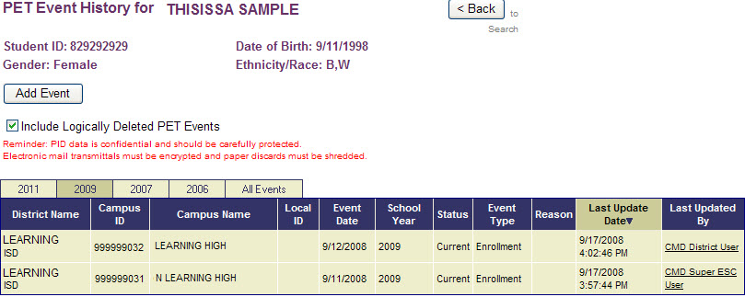
Note: The default sort for PET Event History is Last Update Date in descending order. If you leave the PET Event History page and return within the same logon session, the sort is displayed in the last sort you performed.
- School Year Tabs–The page is designed to display tabs for the current school year, prior school year(s), and All Events. For each tab selection, a student’s history is displayed with or without logically deleted events by checking/unchecking the Include Logically Deleted PET Events checkbox. If there are no events for a student for a particular school year, no tab displays for that school year.
- District Name, Campus ID, Campus Name, Local ID–These columns represent standard Agent Names and Agent IDs used in the EDIT+ application and sub-applications.
- Event Date–Selecting the Event Date link on the PET Event History page displays the PET Event Maintenance page for that event (see the section, Process: Maintaining a PET Event, for further information). An Event Date link does not display if a student has never enrolled in a campus in the user’s hierarchy.
- School Year–The school year associated with the PET event.
- Status–This column identifies the status of the campus associated with the event. The values are school year specific.
Note: Possible values for the Status column are Last (last enrolled campus) and Current (current enrolled campus). If the enrollment event for a campus displays Last, the associated withdrawal event also displays Last.
- Event Type–Enrollment or Withdrawal.
- Reason–The Event Reason column assists with the identification and verification of dual event dates. Possible values for are C-Calendar (indicating dual events have been confirmed by the school year calendar) and V-Verified (indicating dual events have been verified by other means of documentation).
- Last Update Date–This date represents the last date the PET event was updated.
- Last Updated By– Selecting the name link in the Last Updated By column displays a PET Event Inquiry Email which allows the user to contact the district person who last updated a student’s PET event. The email includes standard text to which additional text can be added. The email also includes the Campus ID associated with the PET event in question.
Note: Because the content of the email is confidential, TEA’s PGP Encrypted Email functionality is utilized. Once the initial email is sent, the key to successfully using this functionality is for both the sender and receiver to select Reply All when responding to all emails in the email chain.
The name link does not display if the person listed:
► has an inactive user profile
► has an invalid email address or no email address in their user profile
► has an Agent ID that no longer matches the District ID associated with the event
Note: If District File displays in the Last Updated By column, when selected, a message displays referring the user to the AskTED website to obtain the most current district contact information.
Using EDIT+ PID Detail to View PET Event History
The EDIT+ PID Detail page allows the EDIT+ user with PID Search privileges to display historical data stored in the student’s PET Event History.
To use PID Detail to View a student’s PET Event History:
- Select the PID Search link in the EDIT+ Contents list. The PID Search page displays.
- Enter the search criteria and select Search. The search results display.
- Select the Name hyperlink to display the student’s PID Detail.
Figure 49. PET Event History Link on PID Detail Page
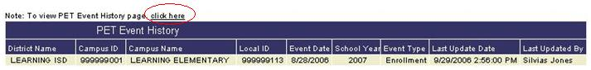
- The student’s PET Event History displays at the bottom of the PID Detail page as the last section of data. A Click Here link takes the user to the PET Event History page. The records are not available for edit; however, view-only capability is provided.
Note: An EDIT+ user with PID Search privileges is able to view the PET Event History through the PID Detail page without being granted access to PET.

Process #3: Maintaining a PET Event
The PET Event Maintenance page displays information about a PET event and enables the user to update the information. This screen also allows the districts to modify incorrectly submitted data rather than deleting and resubmitting the enrollment/withdrawal records.
While any user who has access to PET is able to view a student’s PET Event History, requirements exist that restrict a user’s ability to manually add a PET event, maintain an existing PET event, or add student records to the PID.
- A district-level user is only able to manually create a PET event for a student who attends a campus in their district.
- A campus-level user can only add a PET event for a student who attends their campus.

To maintain a PET event:
- From the PET Event History for [Name] page, select the Event Date link.
Figure 50. PET Event History–Event Date Link
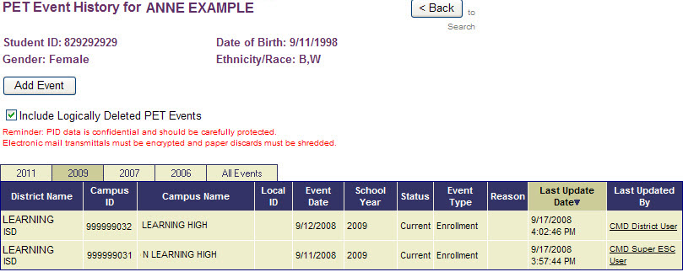
- The PET Event Maintenance for [Name] page displays. The Campus ID of Enrollment field is auto-filled.
Figure 51. PET Event Maintenance for [Name] Page
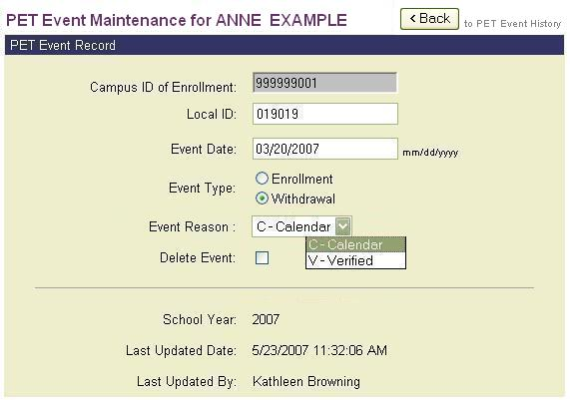
- Enter the student’s Local ID. This is required if one has been assigned. The system checks to determine if the campus has a Local ID for the student. If one exists and is not entered, an error message displays.
- If applicable, enter a revised Event Date into the data field. Select the radio button next to the applicable Event Type (enrollment, withdrawal).
- Select an Event Reason. This field assists with the identification and verification of dual event dates. Possible values for are C-Calendar (indicating dual events have been confirmed by the school year calendar) and V-Verified (indicating dual events have been verified by other means of documentation).
Note: Do not select the Delete Event checkbox when maintaining a PET event unless you intend to logically delete the event (see section that follows). The Delete Event checkbox does not cancel or reset.
- Select Submit to update the PET event or select Cancel to cancel the changes.

Logically Deleting a PET Event
The term logical delete indicates that the event is not physically deleted from the permanently stored database data but is marked as being deleted using a data field.
To logically delete a PET event:
- From the PET Event Maintenance page, select the Delete Event checkbox.
- Once the Delete Event box is checked, a message displays prompting the user to confirm the delete. Select OK and then Submit. The message: Change(s) Applied Successfully displays.
- Select the Back button to return to the PET Event History for [Name] page.
- Logically deleted events continue to display in a student’s PET Event History appearing in a shaded format with a strike through the font.
- To show/hide logically deleted events, check/uncheck (respectively) the Include Logically Deleted PET Events checkbox. The page refreshes automatically.
Process #4: Adding a PET Event
The PET Event Add function provides the user with the ability to add a new PET event (enrollment, withdrawal). While most users add PET events by extracting them from their Student Information Systems (SIS), some districts and open-enrollment charter schools do not have access to an SIS; therefore, PET Event Add provides that function.
If the requirements for adding a PET event are met, the system adds the PET event.
- A district-level user is only able to manually create a PET event for a student who attends a campus in their district.
- A campus-level user can only add a PET event for a student who attends their campus.

To add a PET event to a student record:
- From the PET Event History page, select the Add Event button.
Figure 52. PET Add Event Button
- The PET Event Add for [Name] page displays.
Figure 53. PET Event Add for [Name]
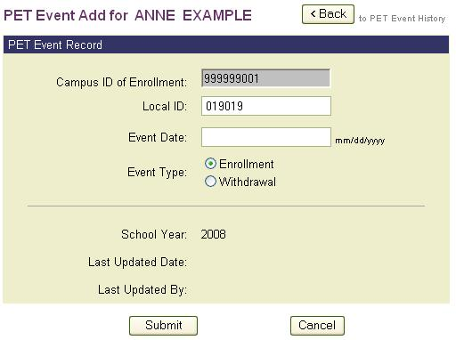
- Enter the Campus ID of Enrollment and Event Date into the data fields.
- Select the radio button next to the applicable Event Type.
- Click Submit to add the PET event.

Process #5: Creating a PET Student Record in PID
A student must exist in PID before a PET event can be added. To access the PET Event Add process, conduct a PET Search PID to identify and select the student. If the student does not exist in PID, they can be added using the PET Student Add page.
To create (add) a new PET student record in PID:
- Select PET Student Add from the Contents list on the PET home page. The PET Student Add page displays.
Figure 54. PET Student Add
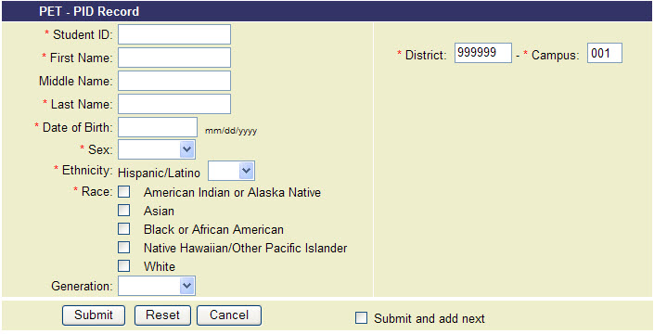
- Enter all required data elements as indicated by the asterisks (*).
- Select the Submit button to create (add) the new student record. If you are adding multiple records, select the Submit and add next check box then select Submit. The record is added and a new PET Student Add page displays.
- The system validates that each required data element has been provided and a success/fail message displays to let the user know if the record is added.
- If the PET Student Add action is successful, a New record successfully added message displays in the upper right section of the page. If the student record is not added, an error message displays.
Figure 55. PET Student Add–Error Message
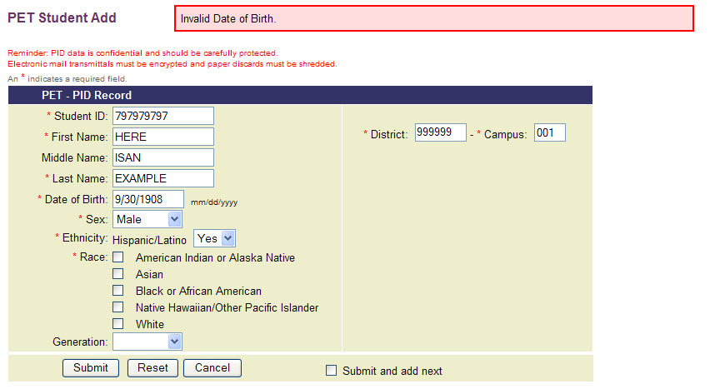

Process #6: Transferring a PET File to TEA
PET files are submitted to TEA in an eXtensible Markup Language (XML) file. This file is created through a vendor or district-supported process that extracts the required information from the district’s student information system (SIS) and stores the data in an XML-based file consistent with the PET XML Schema Definition (XSD). The system verifies the structure of the file against the PET XSD and the contents of the file against data types and restrictions defined with the PET XSD for each element type.
Note: The PET XSD is updated by TEA annually in Appendix G of the PEIMS Data Standards. SIS vendors need to support all updates to the PET XSD.

Requirements for Transferring a PET File
Before successfully transferring a PET file to TEA, several requirements must be met:
- Required software
- Required PET file format
- Required PET file naming convention

Required Software
Transferring a PET file to TEA requires the installation of Microsoft© .NET Framework software. If your computer does not have .NET installed, you can download the software by selecting the Click Here to Download Required Software link on the PET home page (or the EDIT+ home page for EDIT+ PET users).
Note: Before installing the .NET Framework or any software on your computer, it is recommended that you first check with the Technical Support staff at your campus, district, or region and that you read the Technical Tips document, .NET Installation and Usage, located at the Tech Tips link of the EDIT+ external website. After doing so, if you have further questions, please contact EDIT+ Customer Support.

Required PET File Format
TEA requires all PET files follow an XML Schema Definition (XSD), including the data element sequence, as published in Appendix G of the PEIMS Data Standards.

Required PET File Naming Convention
EDIT+ file naming conventions do not apply to PET files. The PET file name is constructed as follows:
- Position 1: The letter P indicating the file is a PET file.
- Positions 2-5: All four digits of the current school year, e.g., 2010.
- Positions 6-11: The six-digit county-district number (i.e., Agent ID).
- Positions 12-14: An optional file extension of .XML is allowed, e.g., P2010999999.xml.
Transferring a PET File
The procedures for transferring a PET file to TEA are similar to those for sending a PEIMS data file through EDIT+ with a few major differences:
- PET files are transferred one at a time. A file must reach PET Complete status or Aborted status before a subsequent file can be sent.
- The PET process performs a client-side PET XSD validation before the transfer process begins. If there are file errors on the client side, the file does not transfer.
Note: PET is a live production environment. DO NOT send test files through PET.

To begin the PET file transfer process:
- Select the PET File Transfer link from the Contents list on the PET home page.
The PET File Transfer page displays.
Figure 56. PET File Transfer Page
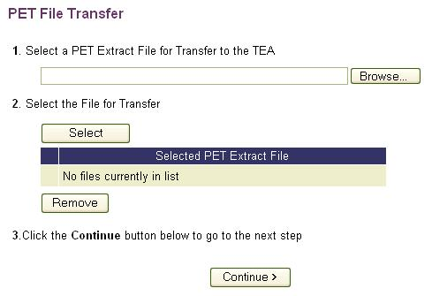
- To select a PET file for transfer, type the full path and file name into the field on the page, or select the Browse button to locate the file on your hard drive or network drive using the Choose File window.
- In the Choose File window, locate the file. Select Open. The file is placed in the field for Select a PET Extract File for Transfer to the TEA.
- Choose the Select button to move the file to the Selected PET Extract File list. If you need to remove a file from the list, select the checkbox next to the file name, then select the Remove button.
- Choose the Continue button to proceed to the next step. The system validates the name of the file against the PET file naming convention. If the naming convention is correct, the Initiate File Transfer page displays.
- Select the Transfer to TEA button to begin the file transfer. Selecting the Back button returns the user to the PET File Transfer page.
Note: If a PET file has been sent previously, a warning message displays that the file is about to be overwritten. PET files can be overwritten; however, PET event records cannot be overwritten.
- The file transfer process performs an XSD validation from your computer (i.e., client-side validation) before the file is actually transferred to TEA.
Note: If the XSD validation is not successful, the file does not transfer and an XML Schema Definition (XSD) Validation Results page displays (see the section entitled PET XSD Validation Errors for more details). If the XSD validation is successful, the Transferring Files page displays. The transfer process usually takes only a few minutes.
- For the file to transfer successfully, you must not log off the Transferring Files page; however, it is possible to open another browser window without interrupting the file transfer if you should need to conduct other activities on your computer.
Note: If there are system or user function errors encountered during the file transfer process, a PET File Transfer Error page displays and the file does not transfer. Some of the most common reasons a file transfer errors occur are incorrect page sequencing, double-clicking, or timing out.
- When the transfer finishes, the PET File Transfer Complete page displays and any auto-generated PET Reports begin processing.

User-Controlled Abort Button
PET users can manually abort a processing PET file by selecting the file’s Abort button from the PET Status page. The button is located in the far right column of the page.
Figure 57. PET Status Page–User-Controlled Abort Button
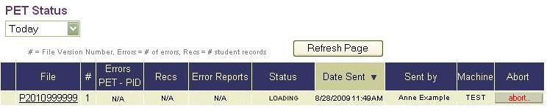
When the Abort button is selected, a confirmation message displays with a Click Here option to return to the PET Status page.
Note: A file can be aborted at any time prior to XSD Validation Error status or PET Complete status.

PET XSD Validation Errors
Before a PET file transfers to TEA, the file runs through validation. Errors result if the PET file is not formatted consistently with the PET XML Schema Definition or if there are certain data quality issues.
To view PET XSD validation errors:
- If there are XSD errors detected in the PET file submission, the XML Schema Definition Validation Results page automatically displays.
Figure 58. XML Schema Definition (XSD) Validation Results
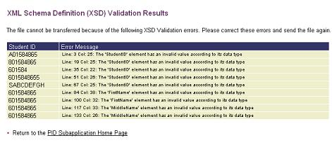
- The page provides a listing of the first 250 errors, displaying the Student ID and Error Message associated with the ID.
Note: In cases where the system has detected a missing Student ID in the .XML file, the Student ID column displays a MISSING message. The line and column references in the Error Message column assist in locating the PET record that contains the error.
- Users can view a complete list of the file’s validation errors in PET report (PET1D002-PET XSD Validation Error Report). After the XML Schema Definition Validation Results page displays, the report automatically generates and is available from the PET Reports link in the PET Contents list.
- Once the XSD validation errors are corrected, the file can be resent.

The Key to Accurate PET Data
The key to achieving accurate PET data is accurately maintaining your local enrollment-withdrawal tracking system. By keeping your local system up-to-date and then uploading your PET file to TEA on a weekly basis, you are following a process that ensures TEA is getting accurate information and allows both systems (your local system and TEA) to be in synch.
PET data becomes corrupt when you submit a PET file and then attempt to manually correct or update the information online. Remember, PET only inserts records, it does not update records. Therefore, by sending a file and trying to make online corrections, you are providing the system with two different sets of information for a student, i.e., the file you sent and the online update. Unless you are classified as an online district, you should never make PET updates online.
Note: Once you have submitted a PET file, you do not have to wait until the following week to submit another file. If a data correction is made directly to the PET file, when the file is sent subsequently, the PET process uploads any corrected data.

Process #7: Validating and Loading PET Event Records
Once the system begins to process a PET file, record processing occurs in two stages:
- Verifying the student in PID
- Validating and loading the PET events

Verifying the Student in PID
Before PET event records can be validated and loaded, the system verifies that the student record and all required demographics exist in PID. If they exist, PET proceeds to the next stage in the process. If demographics do not exist, the system must determine if the student is new to the Texas Public Education System and should be added to PID.
If the PID Verify process determines the student does exist in PID, the PET context edits are applied to the incoming PET event data. If any PET context edits are violated, the PET student event record is not loaded and the error is captured for error reporting on PET1D001 PET Extract File Error Report. If no PET context edits are violated, the system loads the student’s PET event.
If the PID Verify process determines the student does not exist in PID, the PET context edits are applied to the Student ID and the three major demographics (First Name, Last Name, and Date of Birth) on the incoming PET event data. If any PET context edits are violated, the PET student event record is not loaded and the error is captured for error reporting on PET1D001 PET Extract File Error Report.

Validating and Loading PET Events
If no PET context edits are violated, then the PET PID edits (validation) are applied to the incoming Student ID and the three major demographics (First Name, Last Name, and Date of Birth). If any PET PID edits are violated, a PID error results, the student is not added to PID, and the error is captured in PET2D001 PET PID Statement of Discrepancies.
Note: Any PET PID edit errors received during processing of a PET file do not affect the district’s PID Error Rate. The PID Error Rate standard does not apply to PET.
If no PET PID edits are violated, the system adds the student to PID and processes the remaining PET context edits. If any of the remaining PET context edits are violated, the PET student event record is not loaded and the error is captured for error reporting on PET1D001 PET Extract File Error Report. If no PET context edits are violated, the system loads the student’s PET event.
Note: Guidelines for PET context edits, PET edits, and PET PID edits are available in Appendix G of the PEIMS Data Standards.
Process #8: Retrieving a PET File
The procedure for retrieving a PET file is the same as the procedure for retrieving a data file within EDIT+.
The following requirements apply when retrieving a PET file:
- ESC-level PET users are able to retrieve the most current PET files within their region.
- District-level PET users are able to retrieve the most current PET files within their district.
- Campus-level PET users do not send campus PET files nor have the capability to retrieve PET files within their district.

To retrieve a PET file:

- Select PET Retrieve Data from the Contents list on the PET home page. The PET Retrieve Data page displays.
Figure 59. PET Retrieve Data Page
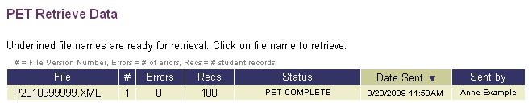
- From the file list on the PET Retrieve Data page, select the file hyperlink (underlined file name) for the file you want to retrieve.
Note: Notice that the rows are sorted in descending order by date sent. All columns are sortable and selecting column headings displays a different sort order.
- The Retrieving PET File page displays the progress of the file retrieval.
- When the Save As dialog box displays, specify the location to which you would like to save the file.
Note: Select Yes if a Security Warning dialog box appears, allowing the file retrieval process to continue.
- When the file retrieval process is finished, the Retrieving PET File page displays the status of complete and you are returned to the PET Retrieve Data page.
Process #9: Generating a PET Report
The PET Report process generates reports that provide districts and campuses with detailed information regarding PET events. PET Reports are available only through the PET home page link; no PET Reports are available through EDIT+ reports pages. PET Reports are school year-specific whereas EDIT+ reports are collection-specific.
There are three types of PET Reports:
- File-based–PET Reports based on a district’s PET file submission. All PET Error Reports are file-based.
- School Year-based–PET Reports based on PET events (enrollment, withdrawal).
- Monitoring–PET Reports that assist ESCs with monitoring PET file submissions for districts within their region. The reports are generated based on criteria provided by the user when the report is run. PET4D001-PET Missing Submission Report is an example of a monitoring report.
Note: PET ReportsHelp contains detailed descriptions and report samples for all PET reports. It is available within the PET subapplication by selecting the purple book icon next to any PET report name.

Generating File-Based (PET Error) Reports
File-based PET reports are based on a district’s PET file submission. District-level file-based PET reports are auto-generated; campus-level file-based reports are generated on demand. All PET Error Reports are file-based.
Note: File-based PET reports cannot be regenerated until a subsequent file is submitted.

District-Level PET Error Reports
District-level PET Error reports are automatically generated by the system every time a district successfully transfers its PET file to TEA. Once the reports are generated, they can be viewed.

To view an auto-generated district-level PET Error report:

- First determine you are in the school year for which you want to view the report. The school year is displayed in the black banner at the top of each PET page. Change the year by choosing the Select School Year button on the PET home page.
- Once you have determined you are in the correct school year, select the PET Status link from the Contents list on the PET home page. The PET Status page displays.
- From the Error Reports column on the PET Status page, select the View button. The PET Error Reports page displays.
Figure 60. PET Error Reports–View Button for District-level PET User
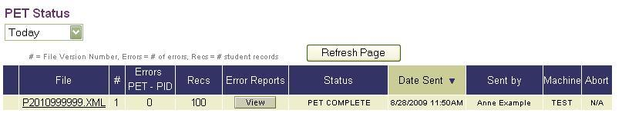
Note: Selecting the hyperlink in the File column takes you to the File History.
Figure 61. PET Error Reports Page
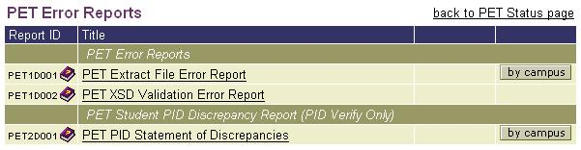
- On the PET Error Reports page, select the report name link for the report you want to view. You can open the report for immediate viewing and printing or you can save a copy of the report to your hard drive for viewing and printing at a later time.

District-Level PET Error Reports by Campus
To run a district-level PET Error Report by campus:
- First determine you are in the school year for which you want to run the report. The school year is displayed in the black banner at the top of each PET page. For a window of time during the summer months, the school year can be changed by choosing the Select School Year button from the PET home page.
- Once you have determined you are in the correct school year, from the PET Error Reports page (which displays when the View button is selected from the PET Reports page), select the By Campus button for the report you want to view. The PET Error Reports by Campus page displays.
Figure 62. PET Error Reports by Campus Page
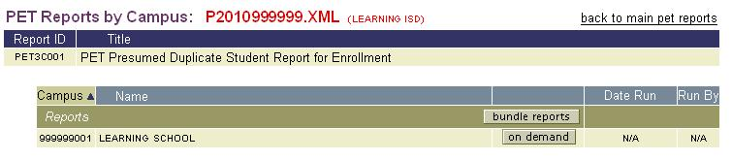
- You can generate a campus report individually by selecting the On Demand button next to the campus name or you can generate a bundle of all campuses in the district by selecting the Bundle Reports button.
- When you select the On Demand button, a Processing Report window opens. If you prefer not to wait for the report to process, closing the window returns you to the PET Error Reports by Campus page.
- Periodically refreshing the PET Error Reports by Campus page displays the progress of your report. When report processing is complete, the report name appears as a link and a report window opens to display the report.
- When the Bundle Reports button is selected, the Campus Reports Request page displays to confirm the bundle request.
- Selecting the Click Here link returns you to the PET Error Reports by Campus page. The bundle feature creates a zip file that can be saved to your hard drive by selecting the Download link located below the Date Run column header.

Campus-Level PET Error Reports
Campus-level PET users can run campus-level PET Error Reports if their district’s file has reached PET Complete status. The district’s file status displays on the PET Status page for the campus.
To run a campus-level PET Error Report:
- First determine you are in the school year for which you want to run the report. The school year is displayed in the black banner at the top of each PET page. For a window of time during the summer months, the school year can be changed by choosing the Select School Year button from the PET home page.
- Once you have determined you are in the correct school year, select PET Status from the Contents list. The PET Status page displays. Select the View button.
Note: The View button displays only if the district’s PET file has reached PET Complete status. If there is no button displayed, the reports are not yet available for viewing.
Figure 63. PET Error Reports–View Button for Campus-level PET User
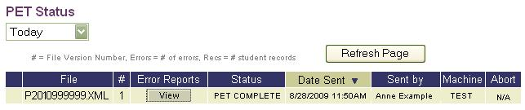
- The PET Error Reports page displays. Select the On Demand button for the report you want to generate.
Figure 64. Campus-Level PET Error Reports–On Demand Button
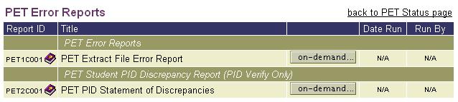
- When you select the On Demand button, a Processing Report window opens. If you prefer not to wait for the report to process, closing the window returns you to the PET Error Reports page.
- Periodically refreshing the PET Error Reports page displays the progress of your report. When report processing is complete, the On Demand button no longer displays and the report name appears as a link. Select the report name link to display the report.
Figure 65. Campus-Level PET Error Reports–Processing Complete
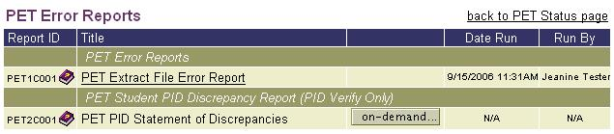
Generating School Year-Based Reports
School year-based PET reports are based on PET events. The reports are generated on demand from the PET Reports page. Since school year-based reports are based on PET events, they can be regenerated at any time.

District-Level School Year-Based District Reports
To run a district-level school year-based district report:
- First determine you are in the school year for which you want to run the report. The school year is displayed in the black banner at the top of each PET page. For a window of time during the summer months, the school year can be changed by choosing the Select School Year button from the PET home page.
- Once you have determined you are in the correct school year, select the PET Reports link from the Contents list on the PET home page. The PET Reports page displays.
Figure 66. PET Reports Page
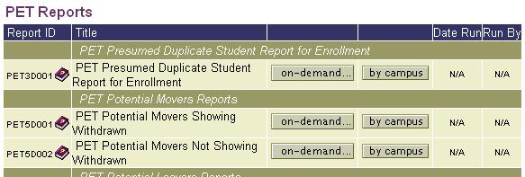
Note: Notice that prior to running a report, N/A displays in the Date Run and Run By columns.
- Select the On Demand button located to the right of the report name to run the report. A pop-up window displays indicating the report is processing.
Note: If you prefer not to wait for the report to finish, you can close the report processing window and refresh the PET Reports page periodically with your browser to determine if processing is complete.
- When the report finishes processing, a pop-up window displays, enabling you to Open (view) or Save the report to your hard drive.
- Refreshing the PET Reports page displays the report name as a link. The Date Run and Run By columns display a time/date stamp and the name of the user who ran the report.
Figure 67. PET Report Available for Viewing
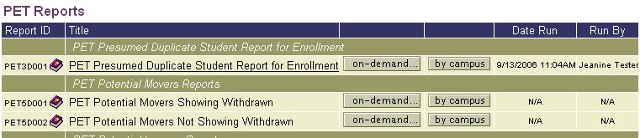
Note: Because school year-based reports process PET events and not a PET files, the On Demand button remains available for regenerating the reports at any time.

District-Level School Year-Based Reports by Campus
To run a district-level school year-based report by campus:
- First determine you are in the school year for which you want to run the report. The school year is displayed in the black banner at the top of each PET page. For a window of time during the summer months, the school year can be changed by choosing the Select School Year button from the PET home page.
- From the PET Reports page, select the By Campus button for the report you want to view. The PET Reports by Campus page displays.
Figure 68. PET Reports by Campus–Generate Reports on Demand
- You can generate a campus report individually by selecting the On Demand button next to the campus name or you can generate a bundle of all campuses in the district by selecting the Bundle Reports button.
- The bundle feature then creates a zip file that can be saved to your hard drive by selecting the Download link located below the Run By column header.
- When the PET Reports by Campus page is refreshed, the bundle reports and On Demand buttons redisplay on the page. This is because school year-based reports generated on demand are based on PET events and can be regenerated at any time unlike reports that are file-based and dependent upon PET file submissions.

Prior School Year-Based PET Reports
District and campus-level users can generate and access prior school year-based reports.
To generate and access a prior school year-based report:
- First determine you are in the school year for which you want to run the report. The school year is displayed in the black banner at the top of each PET page.
- Prior year reports are generated from closed school years. Change to a closed school year by choosing the Select School Year button from the PET home page. You are directed to the Select School Year page. Choose the closed school year from which you want to generate reports.
- Once a closed school year is selected, you are returned to the PET home page where the PET Reports link is enabled.
- Selecting the PET Reports link takes you to the PET Reports page where reports can be generated (if they have not been previously run) or accessed via the report name link (if they have been previously generated.
IMPORTANT! Because the content of school year-based PET reports is dependent upon PET events submitted by all districts, over time a district’s reports could change even though the district itself has not changed its PET event data. For this reason, it is recommended that following the close of a school year, districts regenerate their school year-based PET reports.

Generating Monitoring Reports
PET Monitoring Reports are neither PET file-based nor school year-based. These reports are generated after the user provides selection criteria when prompted by the system (for example, a date range). The purpose of monitoring reports is to assist ESCs monitor the PET data submissions of districts within their region.

Monitoring Report PET4D001
An example of a PET Monitoring Report is the ESC-level PET4D001-PET Missing Submission Report, available only to ESC users. The report displays a list of districts that have not submitted a PET file within a specified time frame (determined by the Enterprise Data Management group within the PEIMS Division).
ESCs have the option to generate this report for:
- Missing submission of PET files only (i.e., exclude districts with successfully submitted batch PET files and all PET online districts).
- Missing submission of PET online districts only (i.e., exclude districts with successfully submitted PET online transactions).
- Missing submission of PET files and PET online districts (i.e., exclude districts with successfully submitted batch PET files and districts with successfully submitted PET online transactions).
IMPORTANT! Districts must send a PET file that reaches PET COMPLETE status within a specified time frame (as determined by the Enterprise Data Management group within the PEIMS Division) to be considered compliant. Districts that are not compliant are sent PET File Delinquency emails from PEIMS Customer Support. First and second delinquency emails are sent to the district user who last submitted a PET file and the ESC. Third and subsequent delinquency emails are sent to the district user who last submitted a PET file, the ESC, and the Superintendent. Once the delinquent PET file is submitted and reaches PET complete status, the delinquency sequence resets.

To generate the PET4D001 report:
- From the PET home page, select PET Reports. The PET Reports page displays.
- Select the On Demand button. The PET4D001 parameter page displays.
Figure 69. Parameter Page for PET4D001
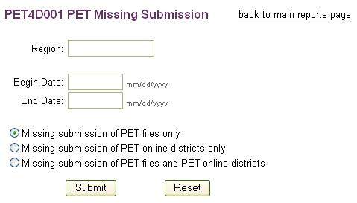
- On the report parameter page, enter your ESC Agent ID in the Region field.
- Enter a Begin Date and an End Date.
- Select the radio button next to the option for the report results you want to generate. Click the Submit button. Selecting the Reset button clears your entries.
- As the report generates, a Processing Report window opens. If you prefer not to wait for the report to process, closing the window returns you to the PET Reports page. Periodically refreshing the PET Reports page displays the progress of your report.
- When report processing is complete, the report name appears as a link. Select the link to display the report. Notice that the On Demand button continues to display on the PET Reports page indicating the report is available to run again.

Parameter-Driven PET Reports (My PET Report Requests)
The My PET Report Requests feature enables PET users to create custom PET reports by selecting pre-determined parameters from various pre-approved reports. Users can generate a specific report, then save or download the report results to their local hard drive.
If a user has access to certain reports on the PET Reports page (based on Agent ID and permissions), those same reports are accessible in My PET Report Requests. Reports are generated and saved based on TEASE Login ID, therefore visible only to the requestor.

Requesting a Parameter-Driven Report
To request, create, and generate a parameter-driven report:
- Determine you are in the school year for which you want to generate the report.
- Select My PET Report Requests from the PET home page.
- The My PET Report Requests page displays. The first time a request is made during a school year, the page displays with no reports listed.
- Select the Create Report Request button. The Create Report Request page displays enabling you to create your first request.
- The Create Report Request page defaults to the first available group of reports. Selecting a different group from the available drop-down list displays additional reports. Select the radio button next to the report name to request the report.
Note: Not all reports are parameter-driven therefore not every report group is listed. Only current school-year based reports (i.e., reports based on PET events) are available.
Figure 70. Create Report Request–Sample
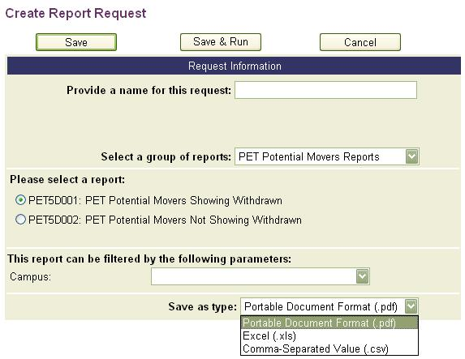
Notice the selection criteria on the page:
- Provide a name for this request–This name identifies the specific request. It should be descriptive enough to identify the report and its contents.
- Select a group of reports–The report group selection parallels the selection on the PET Reports page for the Agent ID in context.
- Select a report–The reports displayed are based on individual report design and pre-approved by TEA.
- Parameter filters–Available parameters are based on individual report design and pre-approved by TEA. If the page displays a report with no filter selections, then the only parameter for the report is the export (Save As Type) option.
- Save as type–Select from three possible formats: Portable Document Format (.pdf), Excel® (.xls), or comma-separated value (.csv). Available formats are based on individual report design; therefore, not all formats are available for all parameter-driven reports.
- Review each of the selection criteria, completing the desired parameters for your request.
- Select the Save button to save your parameters and generate the report at a later time. A confirmation message displays. Select OK to return to the My PET Report Request page. Generate the report at any time by selecting the arrow button in the Generate column for the specific request.
- Select the Save & Run button to save your parameters and immediately generate the report. A confirmation message displays. Select OK to return to the My PET Report Request page where you can monitor report processing.
- If you select the Cancel button you are asked to confirm your request. Selecting OK returns you to the My PET Report Request page.

Tracking a Parameter-Driven Report
To track a parameter-driven report:
- When processing starts, details of the request display on the My PET Report Request page:
- Request ID–The Request ID is unique for each request and sequentially assigned based on requests generated system-wide. By default, the most recent request displays at the top of the list.
- Request Name–The Request Name is the unique name entered on the Create Report Request page.
- Agent ID–The Agent ID identifies the district associated with the file.
- School Year–The School Year column identifies the school year the request is run against.
- Date of Request–The Date of Request is a date and time stamp identifying when the original request is made.
- Last Run–The Last Run column displays a date and time stamp identifying when the request was last generated.
- Status–The Status column displays the processing status of the request. The most common values are: Submitted, Processing, and Completed. Once the status reaches Completed, the date and time stamp display in Last Run column.
- View–When the request successfully reaches Completed status, the View column displays an icon based on the type of file format selected on the Create Report Request.
- Generate–Once a request is created and the user selects the Save button, the Generate button displays on the My PET Report Requests page indicating the request is ready to generate. If the user leaves this page and returns at a later time, the Generate button remains until the request is generated. After a request is generated, the Generate button no longer displays.
- Edit–If the user wants to generate the same report with different parameters, the Edit button is used to select the new parameters.
- Delete–Select the Delete button to delete any request. A confirmation message displays asking the user to confirm the delete. If you are certain, select OK. Once deleted, the request cannot be restored.
- As a request is processing, the My PET Report Requests page automatically refreshes every 5 seconds. If no reports are processing, the page refreshes every 5 minutes. Each page displays up to 10 reports. If there is more than one page of requests, page number tabs at the bottom of each page enable you to toggle between pages.
- When report processing is complete, an icon representing the output format displays in the View column. Depending on the output format chosen, selecting the icon either opens a report for immediate viewing or provides an option to save the report to your hard drive.
Figure 71. My PET Report Requests–List of Requested Reports
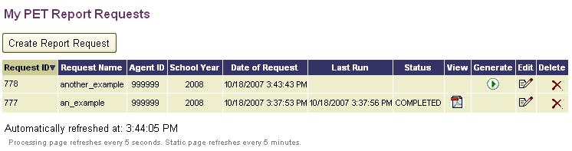
Note: Due to inherent limitations regarding the maximum quantity of rows in Excel®, if it is anticipated that an export will generate greater than 65,000 rows of information, users must: (1) select .csv as their output type, (2) save the report results to their local hard drive, and (3) open the file with a text editor such as WordPad® or Notepad®.

Generating a Previously Requested Report Using Different Parameters
Report requests remain on the user’s My PET Report Requests page until deleted; therefore, a request can be regenerated by editing the original parameters. This process provides a quick and convenient method for easily regenerating a previously requested report using different parameter selections.
Note: Regenerating a report overwrites the results from a previously run report. To retain original parameters, create a new request with a new name for the different parameters.

To generate a previously requested report using different parameters:
- From the My PET Report Requests page, select the Edit button for the specific report.
- The Edit Report Request page displays. Notice that the list boxes are populated with values from the previously saved request.
- Choose the new parameters with which you want to generate the report and select Save or Save & Run, as applicable.

PET File Processing Status
The PET Status, PET File History, and PET Version History pages are used to check the status and processing details of PET files and certain PET reports.

PET Status
The PET Status page provides information about each submitted PET file such as name, version number, errors, record count (i.e., student count, not event count), file status, date sent, sent by, and the machine name from which the file is sent. For users familiar with EDIT+, the PET Status page is similar to the EDIT+ Collection Status page.

To view the PET Status page:
- Select the PET Status link from the Contents list on the PET home page.
- By default, the PET Status page displays a list of the current (Today) files and the following features:
- District/Campus Filter–District and campus users can filter PET file results for the current day or over the last 10, 15, 30, or 60 days. Results are for their district only.
- ESC Filter–ESC users can filter PET file results for the current day or over the last 10, 15, 30, or 60 days. Additionally, ESC users can filter PET files by district or by selecting 0-ALL to view PET files for the entire region.
- File History Link–The file name link in the File column displays the complete PET File History for that file. This link is not available for campus-level users.
- Errors Detail–The Errors column displays results for both PET context errors (PET) and PET PID errors (PID).
- Access to PET Error Reports–Selecting the View button in the Error Reports column displays the PET Error Reports page and reports associated with the file.

PET File History
The PET File History page provides a listing of each version of the PET file displaying errors, records, status, date sent, and the person who sent the file.
To view the PET File History page:
- Select the file name link in the File column of the PET Status page. The PET File History page displays.
Figure 72. PET File History Page
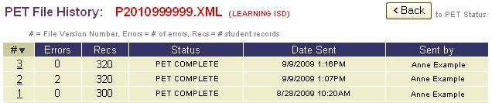
- Select the version number link in the # column to display PET Version History page.
- To return to the PET Status page, select the Back button.

PET Version History
The PET Version History page is divided into two sections:
- PET File Info–Detailed information about each version of a PET file (similar to the information recorded on the PET Status and PET Version History pages).
- PET File Process History–Historical time and date stamp tracking data recorded as the file is processing.
To view the PET Version History page:
- Select the PET file version number link on the PET File History page. The PET File Version History page displays.
Figure 73. PET Status–PET Version History
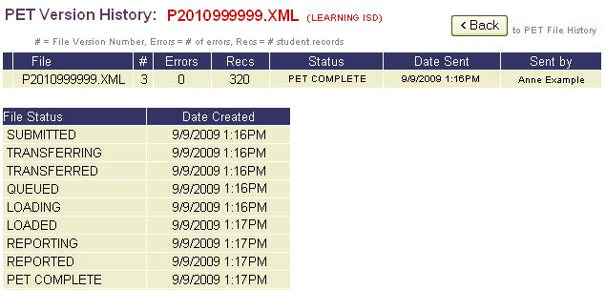
- The Errors column provides a sum of the count of PET context edit errors and PET PID errors. The PET Status page provides a detail of the two types.
- To return to the PET File History page, select the Back button.

Knowledge and Skill
This section provides review questions and exercises to assess the knowledge and skill you have acquired from reading through the chapter.
Review Questions
- Can anyone who has EDIT+ access navigate to the PET home page?
- How do you add a PET Event?
- How do you view a PET Event History?
- Are PET Error Reports file-based or event based?
- Which PET report is for ESCs only to be used as a monitoring report? Is this report file-based or event based?
- What is an example of a school-year based PET report?
- What is the PET File History and how do you access it?
- What is the PET Version History and how do you access it?
Notes:

Chapter 10–PID Maintenance

Overview
PID Maintenance is a manual process for updating PID records online within the EDIT+ PID Subapp environment in EDIT+. It is a powerful tool, designed to assist districts with a convenient method for maintaining demographic information in student/staff PID records. It is not designed, however, to be used as a method to resolve issues in PID records. Should there be a need for resolution of demographic information in a student or staff record, please contact the PID Coordinator in the Enterprise Data Management group within the PEIMS Division.

PID Maintenance Access
Only district-level users are authorized to use PID Maintenance; however, no existing district user is automatically granted access.
Note: New users must first have a TEASE account, TEASE Login ID, and TEASE password with an access link to the EDIT+ application in order to establish PID Maintenance.
To establish PID Maintenance in an existing user profile:
- A TEASE Request for Access form must be fully completed with the PID Maintenance special permissions option selected.
- The form is processed through the Enterprise Data Management group within the PEIMS Division and then TEA Security. It is approved (or returned to the district for additional information and resubmitted for approval) and kept on file at TEA, thus serving as authorization for the user to maintain PID records online.
- An EDIT+ user profile with special permissions for PID Maintenance is then granted by TEA.
A link to the TEASE Request for Access form can be found in the top menu of the EDIT+ External wesite at http://www.tea.state.tx.us/index4.aspx?id=3024.

PID Maintenance User Roles and Permissions
Access requirements, in combination with the establishment of the required EDIT+ user roles and permissions, combine to provide secure access and use of PID Maintenance. Setting up a user profile is contingent upon the intended user role and permissions.

User with EDIT+, PET, and PID Maintenance Permissions
Each district-level user granted access to EDIT+, PET, and PID Maintenance must have:
- A district-level Agent ID.
- Applicable EDIT+ permissions selected in the general and special access permissions of their user profile.
- PET (PID Enrollment Tracking) permissions selected in the special access permissions of their user profile.
- PID Maintenance permissions selected in the special access permissions section of their user profile. This permission is granted by TEA only.

User with PET and PID Maintenance Permissions
Each district-level user who is granted access to both PET and PID Maintenance must have:
- A district-level Agent ID.
- PET (PID Enrollment Tracking) permissions selected in the special access permissions of their user profile.
- PID Maintenance permissions selected in the special access permissions section of their user profile. This permission is granted by TEA only.

User with PID Maintenance Only Permissions
Each district-level user who is granted access only to PID Maintenance (no EDIT+ and no PET) must have:
- A district-level Agent ID.
- PID Maintenance permissions selected in the special access permissions section of their user profile. This permission is granted by TEA only.
Note: It is not necessary to have the PID Search and PID Edit (Validation) permissions (both used within EDIT+) for a PID Maintenance Only user.

PID Maintenance Administration
PID Maintenance special permissions are reflected on both the User Administration page and the User Directory page.
Figure 74. PID Maintenance Permissions–User Administration
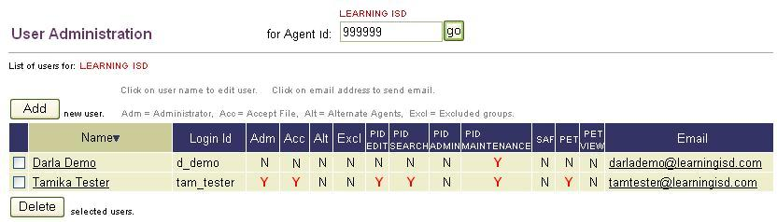

Figure 75. PID Maintenance Permissions–User Directory
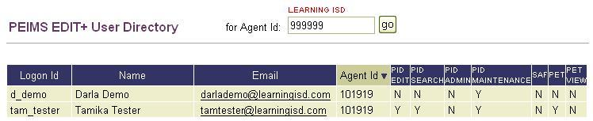

PID Maintenance Guidelines
Before proceeding with PID Maintenance features and functionality, it is important to be aware of system requirements and guidelines.
Time Constraints on Updates
Manual updates to existing PID records are not allowed until 14 days have elapsed since the most recent update. Likewise, no updates to new PID records are allowed until 14 days after the record is inserted into the database. If an attempt is made to manually update a new or existing record prior to the expiration of the change time frame, a message displays informing the user of the date the record is available for update.
Required Student/Staff Information
For consistency with EDIT+ and PET, required student/staff information includes the following:
- Student/Staff ID
- First Name
- Middle Name (if one exists)
- Last Name
- Date of Birth
- Sex
- Ethnicity
- District and Campus IDs
PID Transaction Codes
PID transaction codes are displayed in the PID Record section of the PID Maintenance Detail page. The code identifies the type of transaction performed to the PID record. This code also displays in the PID Change Log section of PID Maintenance Detail page as well as on the PID Detail page within EDIT+.
PID Context Edits for Student/Staff
PID context edits for student/staff used in PID Maintenance are consistent with the context edits used in the PET process. Applicable context edits are found in Appendix G of the PEIMS Data Standards.
PID Edits
PID edits used in PID Maintenance are consistent with the PID edits used in the EDIT+ PID process. Applicable PID edits are found in Appendix G of the PEIMS Data Standards.
APL Value
The APL value identifies the last application making a change to PID. Within the domain of APL values, a value of ONL identifies the PID Maintenance subapplication. Although this value does not display on the PID Maintenance Search or Detail pages, it does display in all PID-related reports (both EDIT+ and PET).

Maintaining PID Records Online
PID records are maintained online using the following features:
- PID Maintenance Search
- PID Maintenance Detail
- PID View

PID Maintenance Search
Prior to updating a PID record online, the database must be searched to determine if the record already exists in PID. The PID Maintenance Search feature provides immediate response for student/staff lookup searches via the PID Maintenance Search page.
Note: Searches can be conducted on 9-digit SSNs as well as Student/Staff IDs with a single leading alpha character plus 8 digits. Accepted alpha characters are: S (state-assigned ID); G (GED-assigned ID); or T (temporarily-assigned ID made by PEIMS).

To access PID Maintenance Search:
- For PID Maintenance Only users: For log on purposes only, select the EDIT+ application link on the TEASE Log On page. The PID home page displays with a link for PID Maintenance. Notice there are no links to EDIT+ or any other PID subapplications from this page.
Figure 76. PID Home Page–PID Maintenance Only User
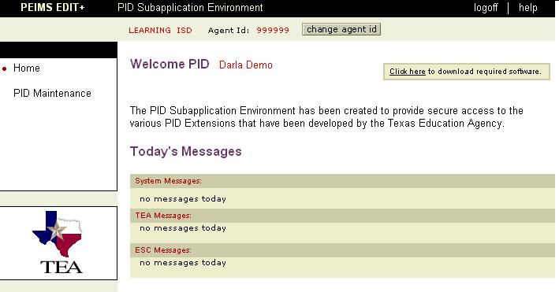
- For EDIT+ and PET users (with PID Maintenance special permissions): After linking to EDIT+ through the TEASE Log On page, select the PID Subapp link on the EDIT+ home page. Selecting this link displays the PID Enrollment Tracking User home page with a link for PID Maintenance.

Figure 77. PID SubApp Home Page–EDIT+, PET, and PID Maintenance User
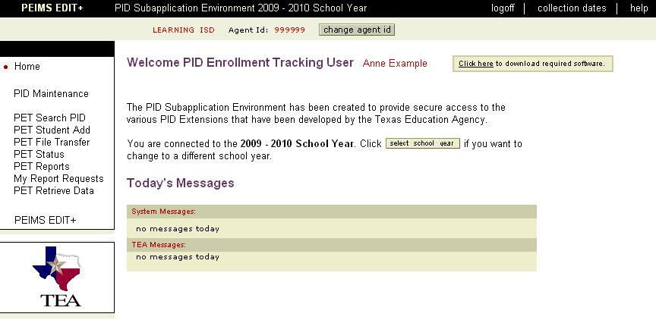
- Select the PID Maintenance link. The PID Maintenance Search page displays.
Figure 78. PID Maintenance Search Page
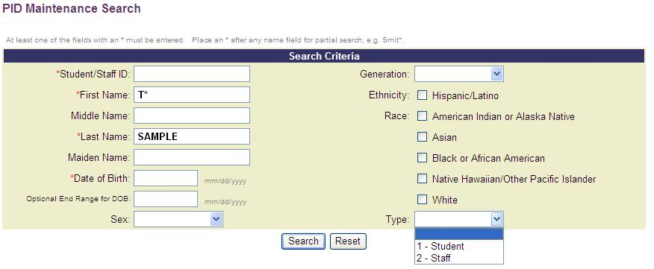
- Enter your search criteria and select the Search button. You can refine searches by entering more specific criteria in the field boxes and making selections from the drop-down menus. Partial name searches can be done using a wildcard character search (*). Selecting Reset clears all fields from any erroneous entries or previous searches.
Figure 79. PID Maintenance Search Results
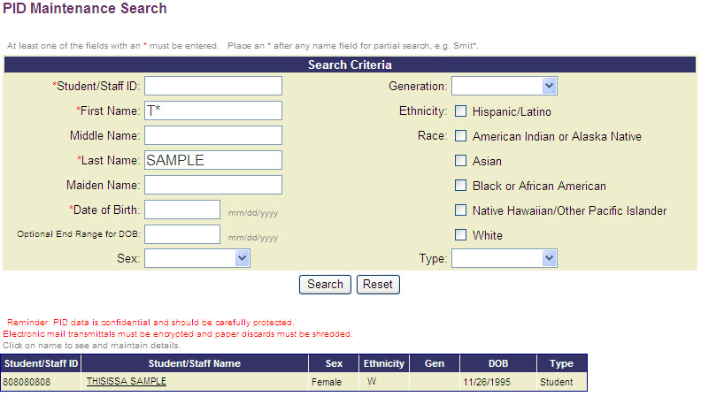
- To display individual PID Maintenance Search details, select any Student/Staff Name link at the bottom of the page. The PID Maintenance Detail page displays for that person.

PID Maintenance Detail
The PID Maintenance Detail page is used to manually update PID records online. The page consists of the same four sections as the EDIT+ PID Detail page: PID Record, Submitting District(s), PID Change Log, and PET Event History.
Note: Every PID Maintenance update is logged by the system, including the person making the update, and the date and time of the update.

To access the PID Maintenance Detail page and enter an online update:
- After conducting a PID Maintenance search, select the Student/Staff Name link on the PID Maintenance Search page.
- The PID Maintenance Detail page displays in one of two modes:
- Static Text Mode–The student/staff member’s PID Maintenance Detail page displays in a static text mode if it is not available for update, i.e., 14 days have not elapsed since the previous update (or entry). The demographic fields are not editable and a message displays informing the user of the first date the record is available for update.
- Update Mode–The student/staff member’s PID Maintenance Detail page displays in the update mode if it is available for update, i.e., the 14-day time constraint has expired. The major demographic fields are editable, the minor demographics display drop-down lists, and the Submit/Reset/Cancel buttons are visible.
Figure 80. PID Maintenance Detail–Update Mode
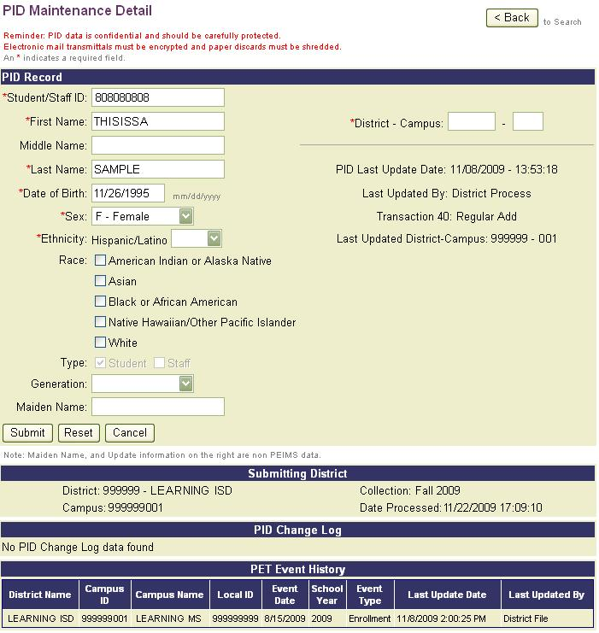
- For each eligible PID record, the following fields can be updated during a single update transaction:
- Student/Staff ID
- and/or 1 of the 3 major demographics (First Name, Last Name, or Date of Birth)
- and/or any of minor demographics (Sex, Ethnicity, Generation, Maiden Name).
Note: Two major demographics cannot be updated at the same time. Additionally, previously entered minor demographics cannot be reset to a blank field.
- Enter the change information and complete the District-Campus ID. The District ID you enter must match your Agent ID and the Campus ID must be a valid campus within your district. Campus ID is not a required field for staff or student/staff updates.
- Select the Submit button. You are prompted to confirm the update. If you are certain of the update, select OK. If the request passes validation rules, the record updates. If you select Cancel (within the confirmation message), you remain on the PID Maintenance Detail page and can continue your update.
- If the record updates, a message indicates that the record has updated successfully and the PID Maintenance Detail page displays in the static text mode.
Note: The Last Updated By field displays the user who last updated the record manually online or who last submitted a PEIMS data file. If a named user did not last update the record, TEA Online or District Process displays in the field.
- The page remains in the static text mode until it available for update. A message confirms when the record is once again available for update.
PID View
PID View is used to view existing PID records that are in conflict with your update request. For example, in the process of updating a Student/Staff ID, if the system detects that the ID is in an existing PID record, an error message displays. Selecting a link within the error message takes the user to the PID View page.
Note: For help with error messages returned on Date of Birth updates, see Appendix G of the PEIMS Data Standards for verification of student/staff date ranges.
To use PID View:
- On the PID Maintenance Detail page, select the Person link that displays within the error message.
Figure 81. PID Maintenance Detail–Person Link for Student/Staff ID Conflict
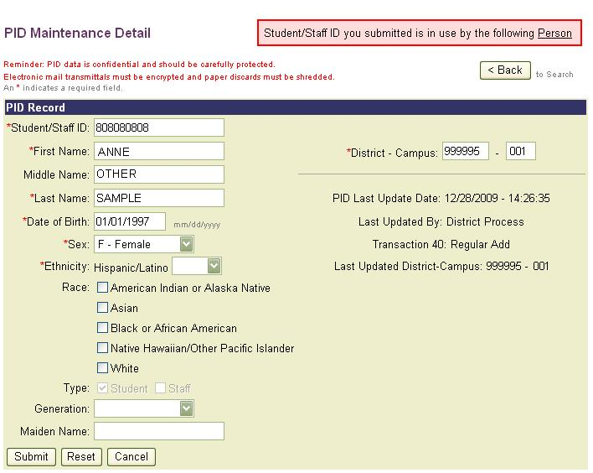
- The PID View page displays the PID record of the person whose existing record is in conflict with the update(s) entered.
Figure 82. PID View–Student/Staff ID in Conflict
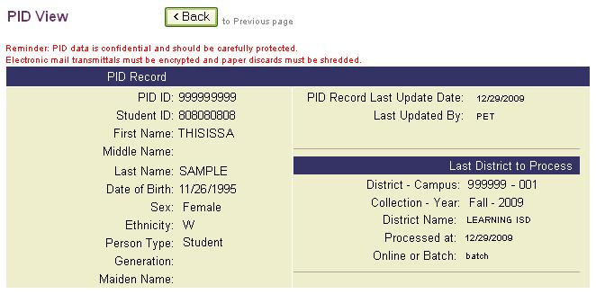
- Similarly, in the process of updating a major demographic (for example, Date of Birth), if the system detects that all three major demographics submitted are in use by another person with a different Student/Staff ID, an error message displays.
- Selecting the Person link displays the PID View page for the person whose record is in conflict with the update(s) entered.

Knowledge and Skill
This section provides review questions and exercises to assess the knowledge and skill you have acquired from reading through the chapter.

SPECIAL NOTE: Do not use PID Maintenance to update actual PID records in any training exercises!

Review Questions
- Who has access to PID Maintenance? How is PID Maintenance accessed?
- What time restraints exist for updating PID records using PID Maintenance?
- What other EDIT+ search feature does PID Maintenance resemble?

Exercise 10.1–Conducting a PID Maintenance Search
- Access the PID Maintenance Search page.
- Enter search criteria.
- From the search results, display the PID information for a specific student/staff member.

Chapter 11–Using a Working Collection for Training New Users

Overview
When training users on the EDIT+ application, it is possible to use a Working collection within the EDIT+ live production site. This chapter provides methods for safely using the EDIT+ application for training new users.
Note: This chapter applies to using the production site for EDIT+ files only. DO NOT UNDER ANY CIRCUMSTANCES send PET test files through production!

Properly Using EDIT+ for Training
Users log in to EDIT+ production using their actual User ID. Listed below are guidelines for the proper use of the EDIT+ production environment:
- Use only Working collections from prior school years to practice sending files.
- Use appropriate file names (see Creating Test Files section below).
- The File Retrieve functionality is useful in obtaining files to use for testing and training. For sending purposes, a file from a prior year collection can be retrieved and renamed.
- Training or test files should be removed from the system, using the Purge Files button on the Collection Status page.
- If you would like to train users affiliated with a newly created campus, please contact EDIT+ Customer Support at editplus@tea.state.tx.us.

Creating Test Files
An EDIT+ trainer can create test files for purposes of conducting EDIT+ training. In this case, test files are defined as fictitious data created by the instructor in the format required in the PEIMS Data Standards. The test file is named using the training district or campus Agent ID plus an additional extension predetermined by the instructor to indicate the file is a test file. All trainees should use the same file extension.
The test file extension is vital to differentiate the training files from a district’s real PEIMS data. Training files should never be allowed to reach completed status. All training files should be purged after class.
- Examples of appropriate file names (for this example, district = 123456):
F2010123456000TST, S2010123456001ANX
- Examples of inappropriate file names (for this example, district = 123456):
F2010123456, S2010123456
These file names are inappropriate because they use the file naming convention for real data.

Note: It is not possible for TEA to create test Agent IDs for use in EDIT+ production due to technical restrictions concerning security.

Training Scenarios
Depending on the training setting and knowledge level of the attendees, training sessions may need to vary. This section provides several scenarios and suggestions for training the new user.

Scenario #1: Instructor Demo Training
This scenario is by instruction demonstration only. There are no hands-on activities for the attendees. The EDIT+ trainer uses a district or campus file to demonstrate:
- Sending data files
- Re-sending files to demonstrate how the previous version of the file is over-written
- Renaming the file and resending it named as a partial file
- Viewing the Progress Monitor, Collection Status, and File History for a file
- Introducing the Change Alternate Agent ID button (if appropriate) to either change to another Agent ID or to drill down to a lower level in the hierarchy
- Introducing Complete/Accept concepts using fatal free files
- Demonstrating how to refresh and view reports associated with the file

Scenario #2: Instructor-Led Hands-On Practice
Attendees log on to a Working collection and use either test data or actual data contained in a partial file name. After logging on, the EDIT+ trainer guides the attendees through selected EDIT+ features and functionality. All training files are purged by the instructor after class ends.
Users log on using their actual EDIT+ User ID to practice:
- Accessing EDIT+
- Exiting EDIT+
- Selecting Collections and viewing Collection Status
- Viewing Reports
- Viewing User Directory and User Profile
- Accessing Customer Support and sending a CSR
- Retrieving Data
- Viewing PID Search (if user has appropriate permissions)
- Viewing Data Search (if user has appropriate permissions)
- Viewing PET, SAF, and PID Maintenance (if user has appropriate permissions)
- Accessing and viewing the two online help systems (ReportsHelp and UserHelp)
- Accessing and reviewing the EDIT+ external website including user support pages, reference materials, and user documents
Scenario #3: Instructor-Supervised Hands-On Practice
Users log on using either test data or actual data contained in a partial file name. After logging on, the EDIT+ trainer provides time for unguided practice using training files. All training files are purged by the instructor after class ends.
Users log on using their actual EDIT+ User ID to practice:
- Sending Data (use partial file naming standard only)
- Checking the Progress Monitor
- Checking Collection Status (notice the status of the file sent in the prior activity)
- Viewing all Reports for the file the users just sent
- Revalidating Data
- Retrieving Data
- Viewing/Using Data Search (if appropriate for the user)

© Texas Education Agency–PEIMS Division
Enterprise Data Management Group
1701 North Congress Avenue
Austin, Texas 78701

