2011-2012 PEIMS Data Standards
Section 7:
XML Diagrams

diagram | 
complexType FallDistrict  diagram | 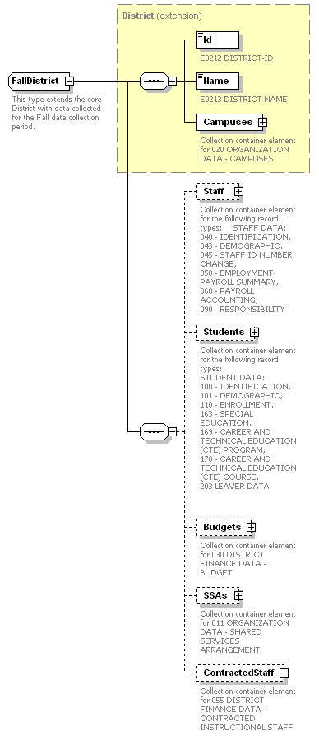

complexType CampusList
diagram | 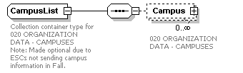

complexType Campus
diagram | 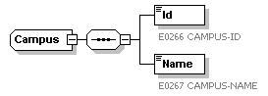

complexType StaffMemberList
diagram | 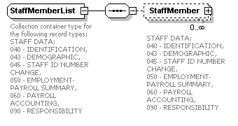

complexType FallStaffMember  diagram | 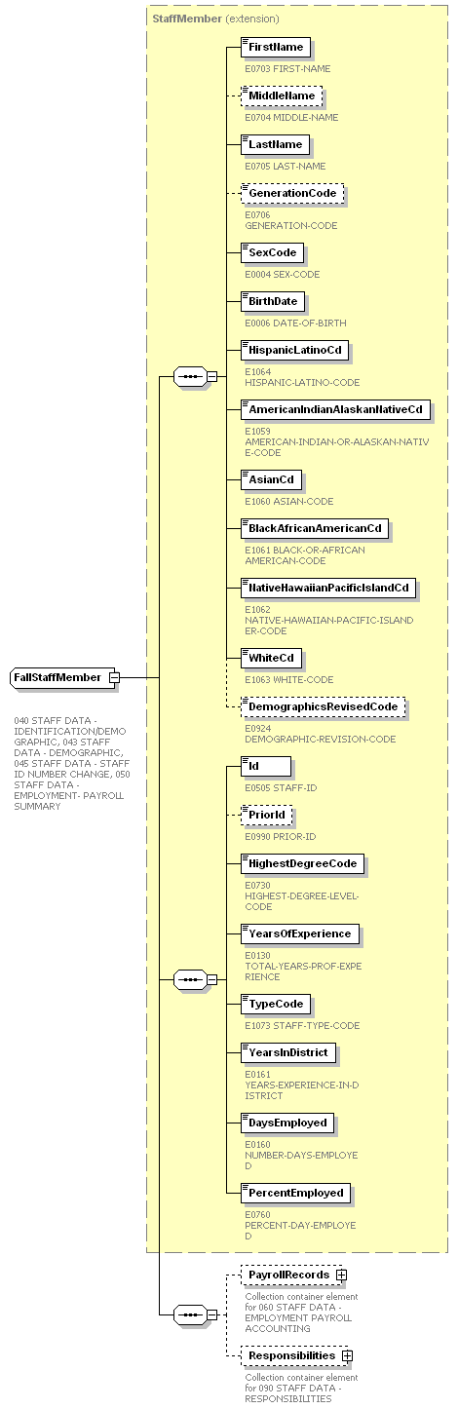

complexType PayrollEntryList
diagram | 

complexType PayrollFinancialData
diagram | 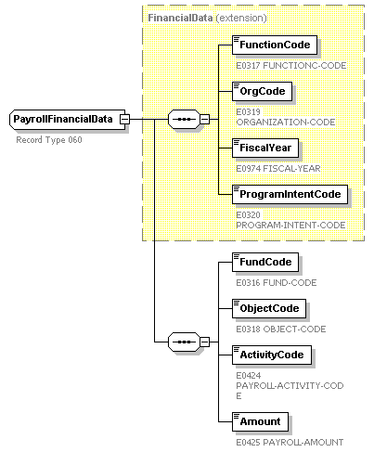

complexType StaffResponsibilityList
diagram | 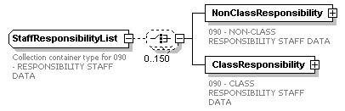

complexType StaffResponsibility
diagram | 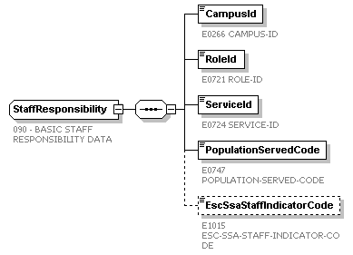

complexType StaffClassResponsibility
diagram | 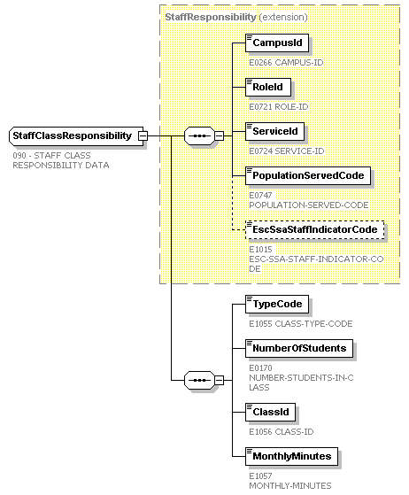

complexType StudentList
diagram | 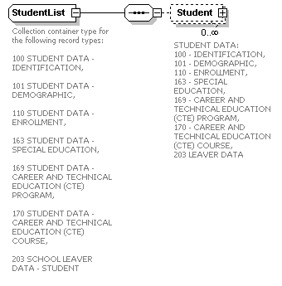
complexType FallStudent  diagram |  | 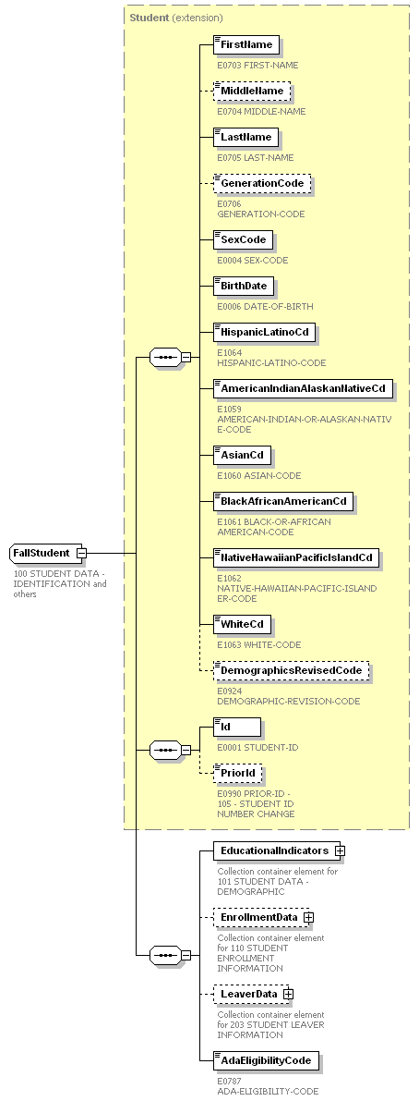

complexType EducationalIndicators
diagram | 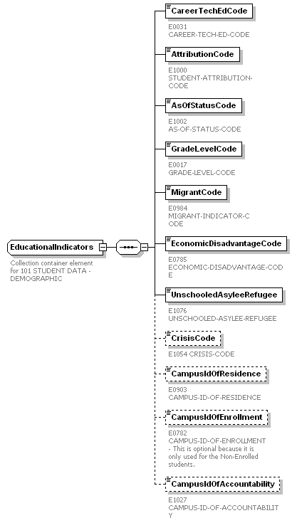
complexType Enrollment diagram | 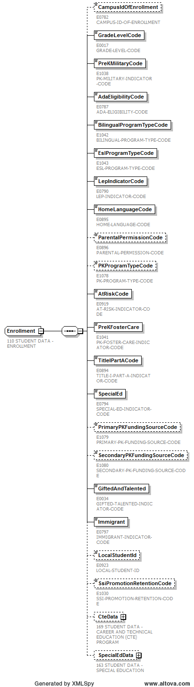

complexType CareerAndTechnicalEducation
diagram | 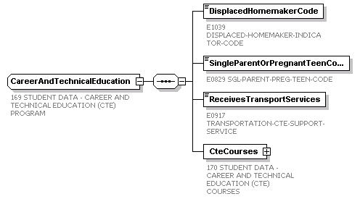

complexType ServiceList
diagram | 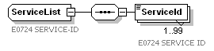

complexType SpecialEducation
diagram | 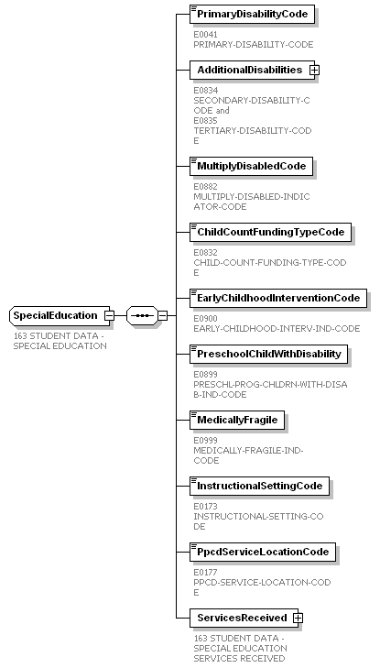

complexType DisabilityList
diagram | 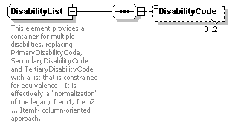

complexType SpecialEducationServices  diagram | 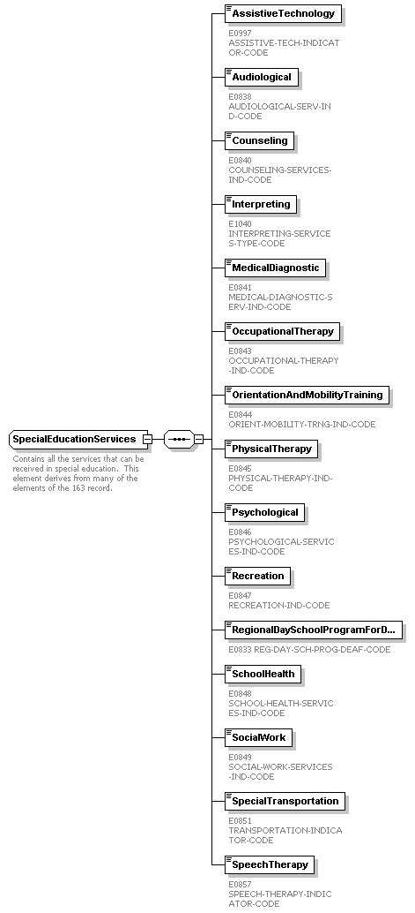
complexType Leaver
diagram | 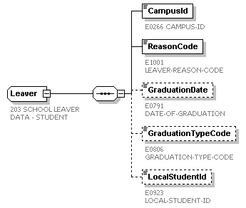

complexType BudgetList
diagram | 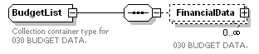

complexType BudgetFinancialData
diagram | 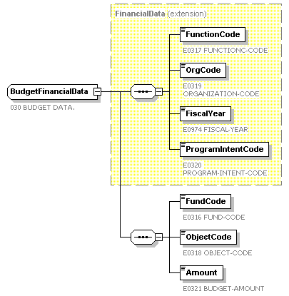

complexType SharedServiceArrangementList
diagram | 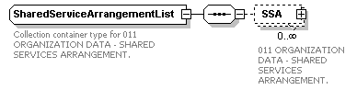

complexType SharedServiceArrangement
diagram | 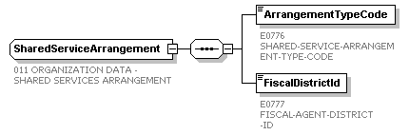

complexType FteSummaryList
diagram | 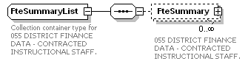

complexType FteSummary
diagram | 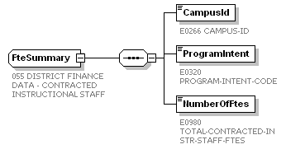

This page is intentionally left blank.
element MidyearDataSubmission
diagram | 

complexType MidyearDistrict
diagram | 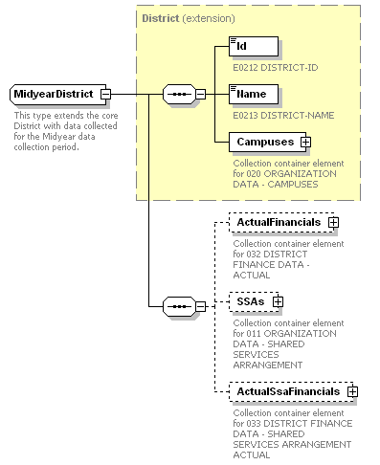

complexType CampusList
diagram

complexType Campus
diagram

complexType ActualFinancialDataList
diagram | 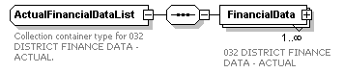

complexType ActualFinancialData
diagram | 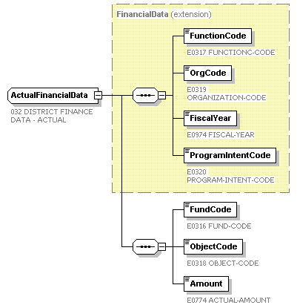

complexType SharedServiceArrangementList
diagram

complexType SharedServiceArrangement
diagram

complexType SsaFinancialDataList
diagram | 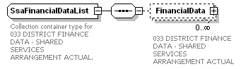

complexType SsaFinancialData
diagram | 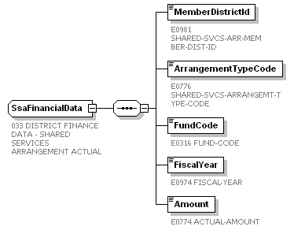

This page is intentionally left blank.
element SummerDataSubmission
diagram | 

complexType SummerDistrict  diagram | 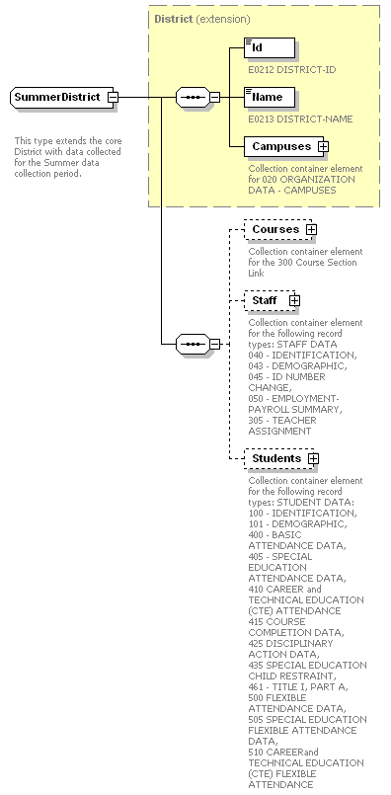

complexType CampusList
- diagram

complexType Campus
diagram

complexType CourseList
diagram | 

complexType Course
diagram | 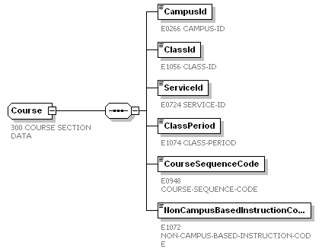

complexType StaffMemberList
diagram | 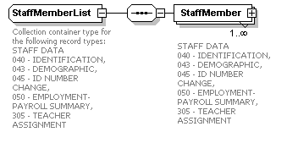

complexType SummerStaffMember  diagram | 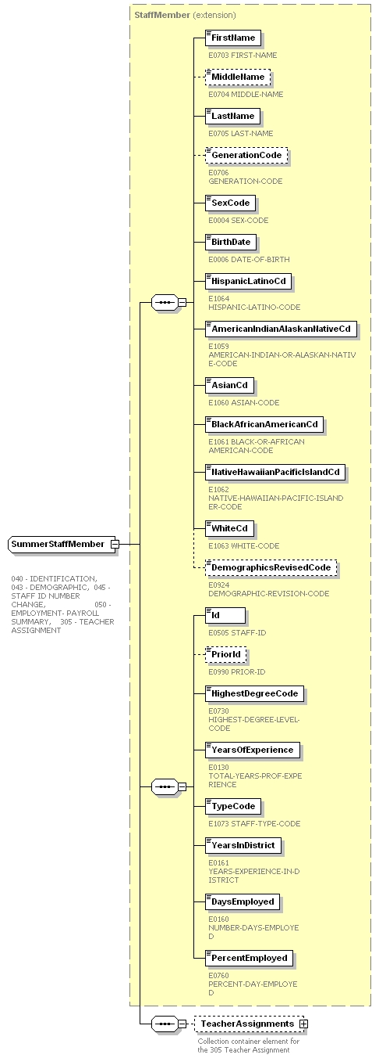

complexType TeacherAssignmentList
diagram | 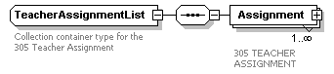

complexType TeacherAssignment
diagram | 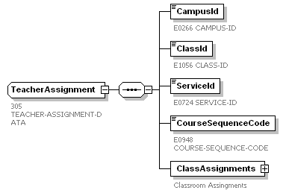

complexType ClassAssignmentList
diagram | 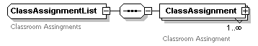

complexType ClassAssignment
diagram | 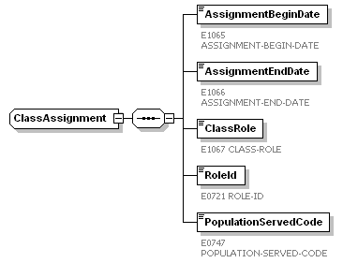

complexType StudentList
diagram | 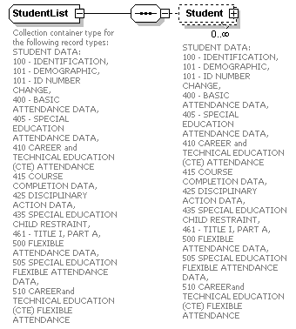

complexType SummerStudent  diagram | 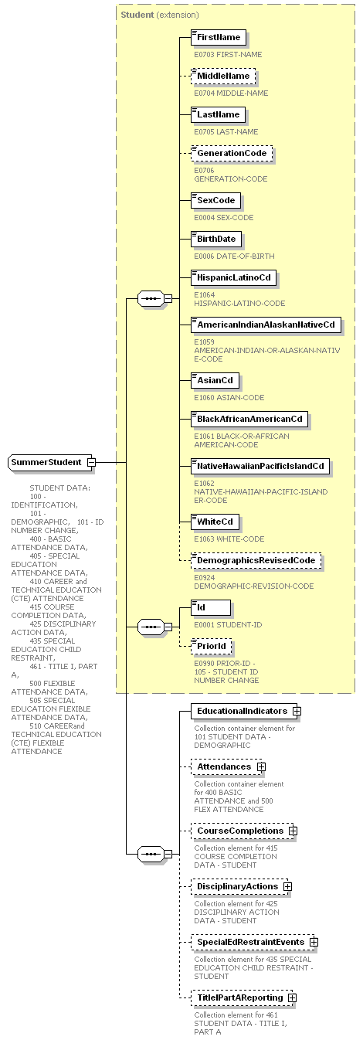

complexType EducationalIndicators
diagram | 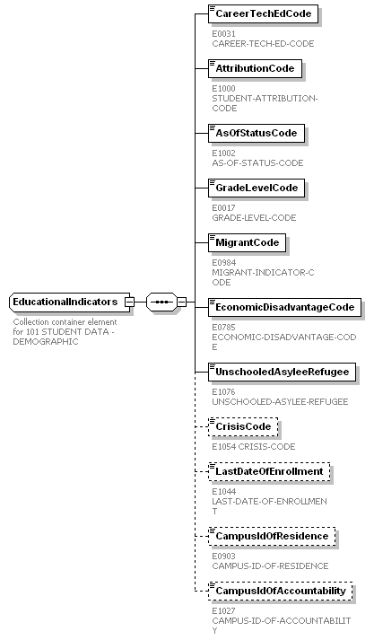

complexType AttendanceList
diagram | 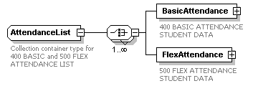

complexType BasicAttendance  diagram | 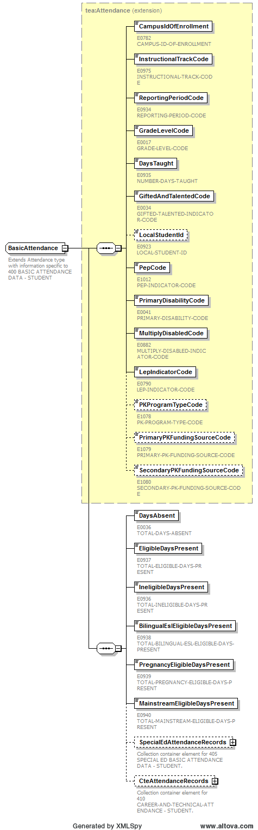

complexType SpecialEdBasicAttendanceList
diagram | 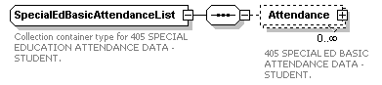

complexType SpecialEdBasicAttendance
diagram | 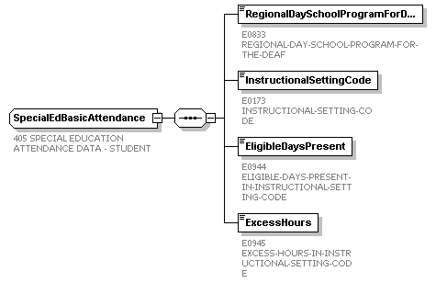

complexType CteAttendanceList
diagram | 

complexType CteAttendance
diagram | 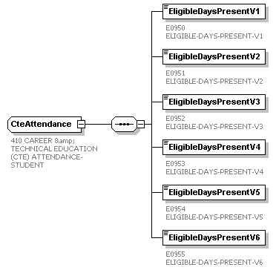

complexType FlexibleAttendance  diagram | 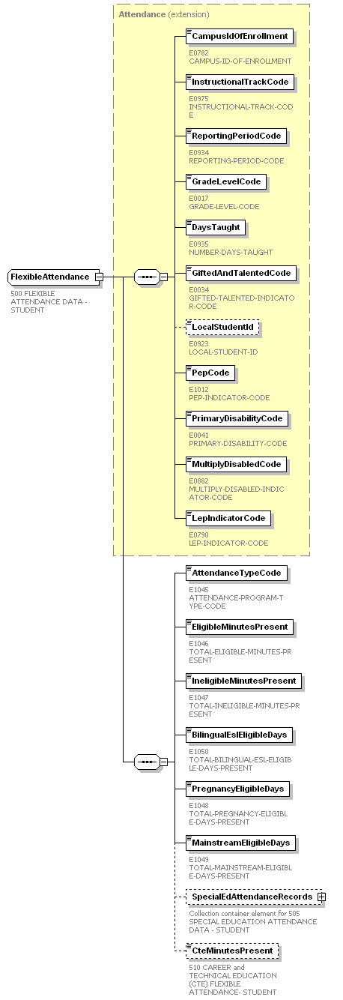

complexType SpecialEdFlexibleAttendanceList
diagram | 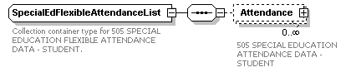

complexType SpecialEdFlexibleAttendance
diagram | 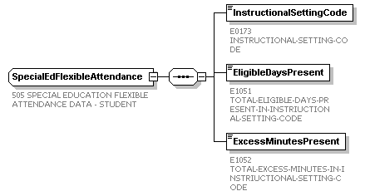

complexType CourseCompletionList
diagram | 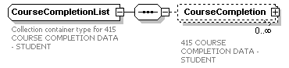

complexType CourseCompletion
diagram | 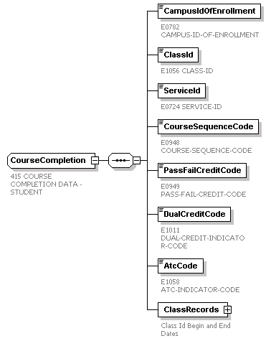

complexType StudentClassList
diagram | 

complexType StudentClass
diagram | 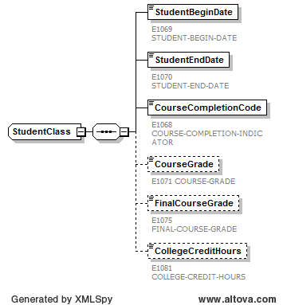

complexType DisciplinaryActionList
diagram | 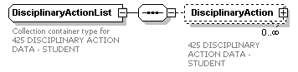
complexType DisciplinaryAction  diagram | 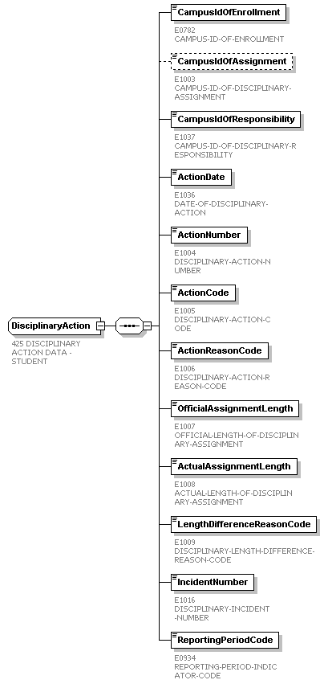

complexType SpecialEdRestraintEventList
diagram | 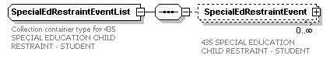

complexType SpecialEdRestraintEvent
diagram | 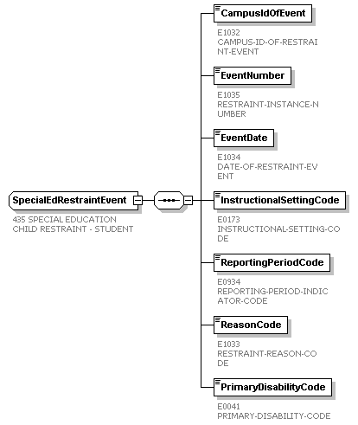

complexType TitleIPartAList
diagram | 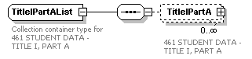

complexType TitleIPartA
diagram | 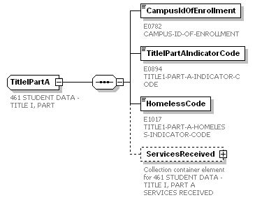

complexType TitleIPartAServices
diagram | 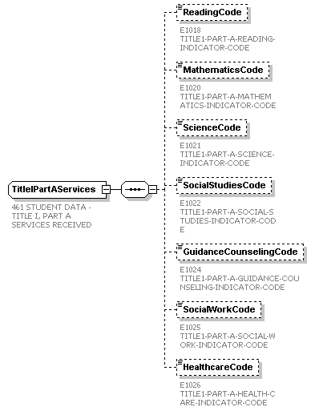

This page is intentionally left blank.
element ExtendedYearDataSubmission
diagram | 

complexType ExtendedYearDistrict
diagram | 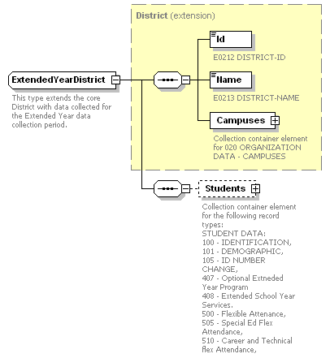

complexType CampusList
- diagram

complexType Campus
diagram

complexType StudentList
diagram | 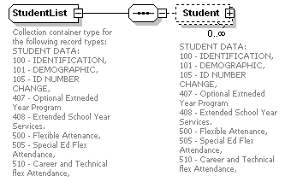
complexType ExtendedYearStudent  diagram |  | 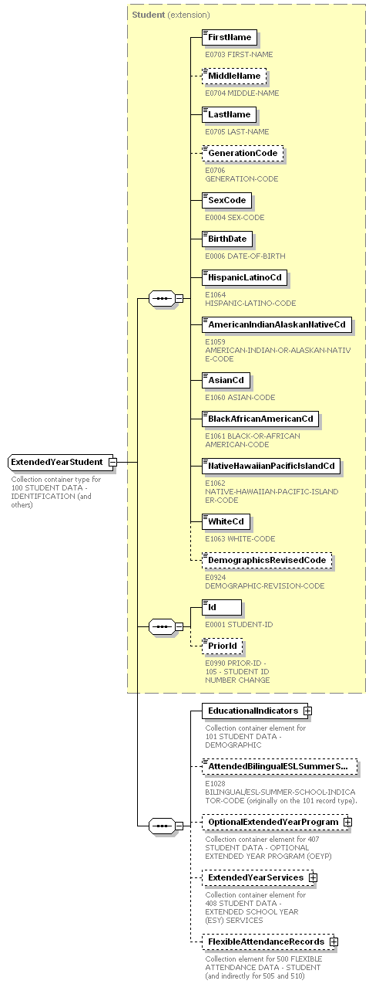
complexType EducationalIndicators
diagram | 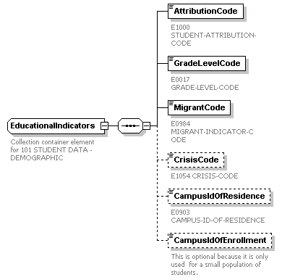

complexType OptionalExtendedYearProgram
diagram | 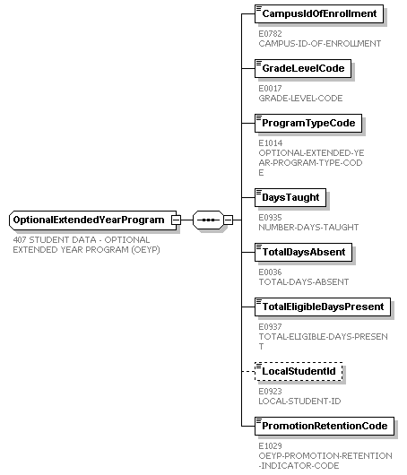

complexType ExtendedYearServiceList
diagram | 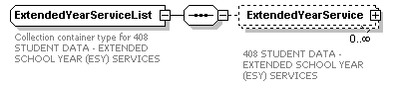

complexType ExtendedYearService
diagram | 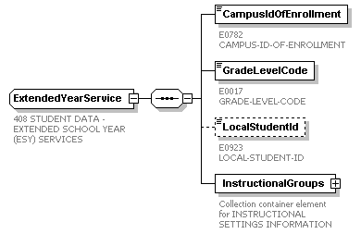

complexType InstructionalGroupList
diagram | 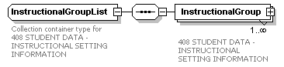

complexType InstructionalGroup
diagram | 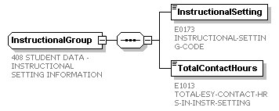

complexType FlexibleAttendanceList
diagram | 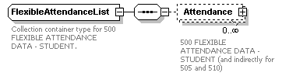

complexType FlexibleAttendance

diagram

complexType SpecialEdFlexibleAttendanceList
diagram | 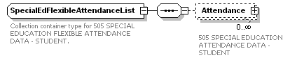

diagram

diagram

diagram

diagram

diagram

