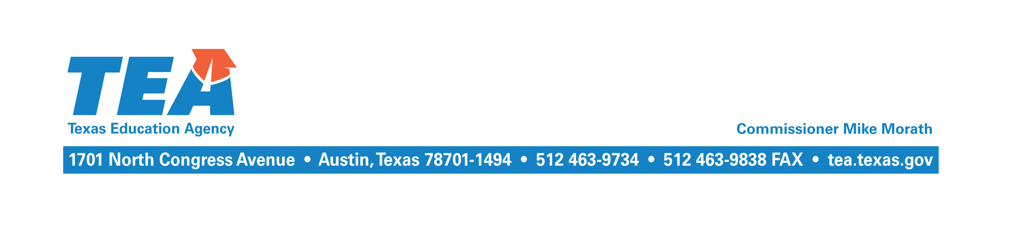

September 19, 2018

To the Adminstrator Addressed:

Subject: 2017–2018 Near-Final Chapter 41 Recapture

The Near-Final Cost of Recapture (COR) report and other related reports for the 2017–2018 school year have been updated and are available at the School District State Aid Reports website at https://tealprod.tea.state.tx.us/fsp/Reports/ReportSelection.aspx. The Near-Final COR report incorporates the final calculation of Chapter 41 weighted average daily attendance (WADA) that reflects the student attendance data submitted by your district through the Public Education Information Management System (PEIMS) in summer 2018 for the 2017–2018 school year, and any other corrections or updates that are necessary.

Districts that experienced losses in average daily attendance (ADA) due to Hurricane Harvey and are eligible for an ADA adjustment were held harmless to a projected ADA number calculated using a three-year average trend from the 2014–2015 through the 2016–2017 school years or the 2017–2018 legislative payment estimate (LPE) projection for the 2017–2018 school year. This is a one-time adjustment that will only be made for the 2017–2018 school year.
More details about the Commissioner’s adjustments to ADA for school districts experiencing declines in enrollment because of Hurricane Harvey can be found at the following link: https://tea.texas.gov/About_TEA/News_and_Multimedia/Correspondence/TAA_Letters/Commissioner_s_adjustment_to_average_daily_attendance_(ADA)_for_school_districts_and_charter_schools_experiencing_declines_in_enrollment_because_of_Hurricane_Harvey_for_the_2017%E2%80%932018_school_year_/.

The maintenance and operations (M&O) tax collections your district reported through the Tax Information Survey subsystem of the Foundation School Program (FSP) System in summer 2018 have also been used. If your district did not complete the survey, then budgeted tax collections for the 2017–2018 school year as reported through the PEIMS will continue to be used until tax collections reported in the J-1 schedule of the 2017−2018 annual financial report are incorporated at Final settle up in April 2019.

If your district has a balance due for the 2017–2018 school year, please remit the balance on or before October 15, 2018. Enter your district’s name or county district number and select school year 2017–2018 from the drop down menu at the following link to view your outstanding balance: https://tealprod.tea.state.tx.us/fsp/Reports/ReportSelection.aspx. The payment should be made electronically using the standard wiring instructions or the ACH receiver services instructions. Please indicate the district name/county district number and the appropriate school year on the reference line.

If you have any questions about this letter, please contact Kim Wall by email at kim.wall@tea.texas.gov or by phone at (512) 463-4809.

Sincerely,

Al McKenzie
Director of State Funding

AM/kw

