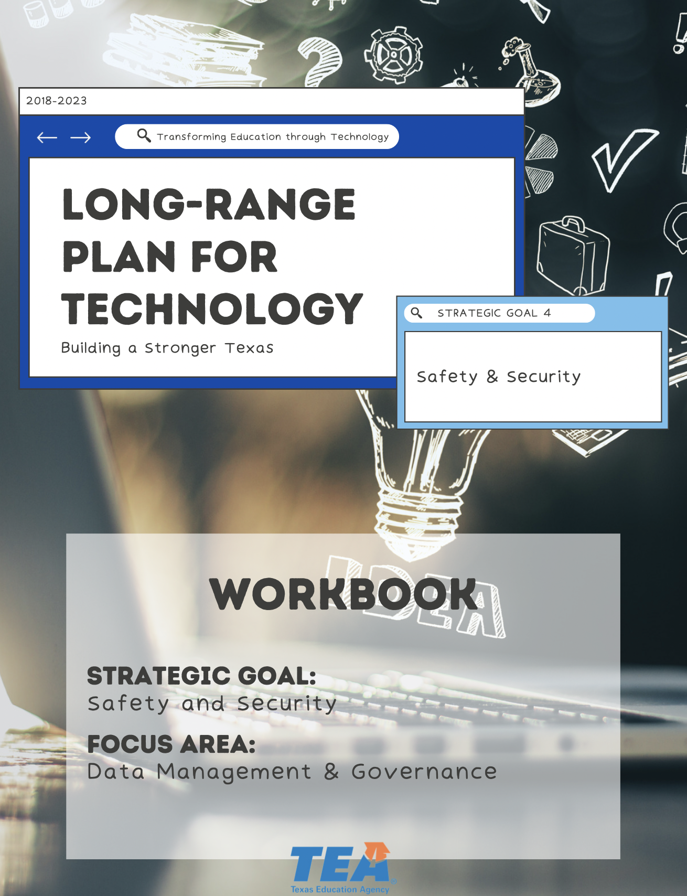

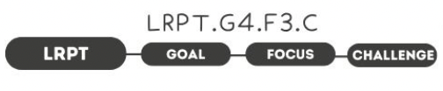

1. Take Note & Reflect:
Where does data exist in your district?

2. Take Note & Reflect:
Reflect on how your district's data is retained and stored. What are your current data management practices?

3. Take Note & Reflect:
Reflect on how your district uses and stores data. Has there been an instance when data presented a significant threat?

4. Take Note & Reflect:
Does your district have a complete picture of your existing data? What are your current data management practices?

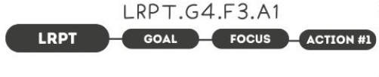

1. Take Note & Reflect:
What data collaborative governance groups are in place in your district?

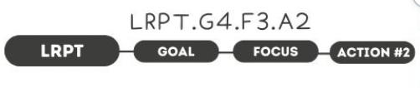

1. Take Note & Reflect:
What is an example of data being classified by risk? Reflect on how your district classifies data by risk.

2. Take Note & Reflect:
What protections are in place for ensuring student data privacy?

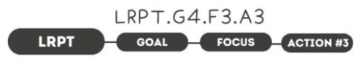

1. Take Note & Reflect:
What individual is (or should be) appointed to managing and maintaining the data and ongoing data governance decision-making process?

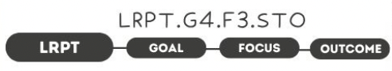

1. Take Note & Reflect:
How would you measure "better" understanding of type, location, volume, and ownership of data for your district?

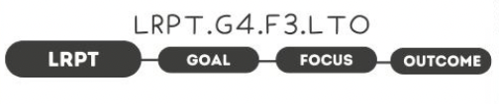

1. Take Note & Reflect:
What are examples of improved business decisions that could be made from better data management?

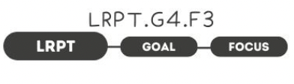

1. Take Note & Reflect:
Write a short summary statement for this focus area. How would you summarize what you've done and what you need to do for this focus area based on your work so far?

