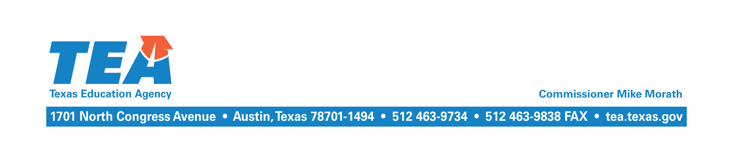
April 22, 2016

Re: 2014–2015 Final Cost of Recapture Report

To the Administrator Addressed:

Your district’s final Cost of Recapture Report and other related reports for the 2014–2015 school year are available online on the School District State Aid Reports web page. Your district’s “final” cost of purchasing weighted students in average daily attendance (WADA) was based on the following:

- Chapter 42 WADA: Chapter 42 WADA is the WADA that was computed on the “final”
2014–2015 Summary of Finances (SOF) that reflects the final student attendance data submitted by your district through the Public Education Information Management System (PEIMS) in July for the 2014–2015 school year.

- Chapter 41 WADA: If your district charged tuition to educate nonresident students, the WADA of those transfer students was subtracted from the Chapter 42 WADA to arrive at Chapter 41 WADA.

- Maintenance and Operations (M&O) Tax Collections: The M&O tax collections that appear on the “final” 2014–2015 SOF were used to calculate the final cost of purchasing WADA. The SOF uses tax collections as reported in the J-1 Schedule of your district’s annual financial and compliance report for the 2015 fiscal year.

Option 3 Districts

If your district exercised Option 3 (or partial Option 3), please review your district’s Chapter 41 payment ledger in the Foundation School Program (FSP) System. All FSP ledgers are available on the system’s Payment Ledger page. The ledger shows the monthly payments that your district made through August 2015 and any transactions related to near-final settle-up, the final amount owed, and the remaining balance.

If the “final” balance shown is a positive number, your district owes that amount as the “final” settle-up. Payment is due by May 31, 2016, and should be made electronically using the standard wiring instructions. If the “final” balance shown is a negative number, your district was due a refund for that amount, and payment was sent in April 2016.

Option 4 Districts

If your district exercised Option 4, a report that compares the number of WADA purchased to the “final” number of WADA needed to equalize wealth, titled Comparison of WADA Acquired to WADA Needed, is available at the end of your district’s final Cost of Recapture Report. If the difference shown is a positive number, your district bought more WADA than was necessary. If the difference is a negative number, your district did not purchase enough WADA to sufficiently reduce its wealth, and additional WADA must be purchased.

It is your district’s responsibility to “settle up” with its partner(s). Please make any necessary changes to the WADA purchased number in the Chapter 41 Options and Contracts form via the Chapter 41 subsystem of the online FSP System so that the number of WADA bought matches the number of WADA needed, and submit the changes to the Texas Education Agency by May 31, 2016. We will then make appropriate changes to the WADA information for your district’s partner(s).

Technology Consortium Districts

If your district exercised Option 3 in combination with the technology consortium form of
Option 4, a report that compares the total gain for all partners to the 10 percent limit, titled Final Calculation of Gain to Partners for a Chapter 41 District Exercising Option 3 Combined with the Technology Consortium Form of Option 4, is available at the end of your district’s final Cost of Recapture Report. If the gain for all partners exceeds the limit, your district must reduce the number of WADA being bought from its partners so that the limit is not exceeded. If the gain is less than the limit, your district may purchase additional WADA from its partners, so long as the limit is not exceeded. Please make any necessary changes in the Chapter 41 District Intent/Choice Selection form via the Chapter 41 subsystem of the online FSP System, and submit the changes as soon as possible. We will then make appropriate changes to the information for your district’s partner(s).

The Chapter 41 payment ledger is available in the FSP System on the Payment Ledger page. If the “final” balance shown on the ledger is a positive number, your district owes that amount as the “final” settle-up. Payment is due by May 31, 2016, and should be made electronically using the standard wiring instructions. If the “final” balance shown is a negative number, your district is due a refund for that amount. The refund will be made in the near future. Please keep in mind that changes made to the number of WADA being purchased through Option 4 will change the amount overpaid or underpaid through Option 3.

Option 3 and Option 4 Districts

If your district exercised both Option 3 and Option 4, please review your district’s Chapter 41 payment ledger, available in the FSP System on the Payment Ledger page. If your district does not change the number of WADA being bought through Option 4, your district should follow the instructions above for Option 3–only districts. If your district chooses to buy additional WADA from its partner(s), your district should change the number of WADA purchased by updating the district’s Options and Contracts form in the FSP System Chapter 41 subsystem accordingly. Please submit these changes upon receipt of this letter. Because the Cost of Recapture Report assumes that any necessary WADA not purchased under Option 4 will be purchased under Option 3, a change to Option 4 purchases will result in a change to Option 3 WADA.

If you have any questions, please contact Kim Wall by email at kim.wall@tea.texas.gov or by phone at (512) 463-4809.
Sincerely,

Amanda Brownson
Director of State Funding

AB/kw

