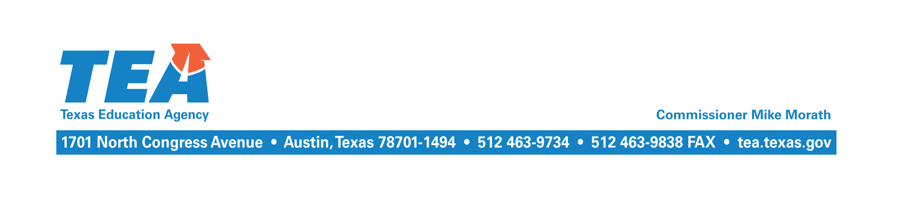

September 19, 2017

To the Administrator Addressed:

Subject: 2016–2017 Near-Final Chapter 41 Recapture

The Near-Final Cost of Recapture (COR) report and other related reports for the 2016–2017 school year have been updated and are available at the School District State Aid Reports website at https://tea4avfawcett.tea.state.tx.us/fsp/Reports/ReportSelection.aspx. The Near-Final COR report incorporates the final calculation of Chapter 41 WADA that reflects the student attendance data submitted by your district through the Texas Student Data System (TSDS) in summer 2017 for the 2016–2017 school year, and any other corrections or updates that are necessary.

The maintenance and operations (M&O) tax collections your district reported through the Tax Information Survey subsystem of the Foundation School Program (FSP) System will also be used. Any data submitted before September 6 will be included when the agency publishes the 2016–2017 near-final COR in mid-September. If your district did not complete the survey, then budgeted tax collections for the 2016-2017 school year as reported through the TSDS will continue to be used. In early October, another near-final SOF will be published that will incorporate data submitted after September 6. After September 30, tax collections reported in the J-1 schedule of the 2016-2017 annual financial report will be incorporated at Final settle-up in April 2018.

If your district has a recapture balance due for the 2016–2017 school year, please remit the balance on or before October 1, 2017. Enter your district’s name or county district number and select school year 2016–2017 from the drop down menu at the following link to view your outstanding balance: https://tea4avfawcett.tea.state.tx.us/fsp/Payments/Ledger.aspx. The payment should be made electronically using the standard wiring instructions. Please indicate the district name and the appropriate school year on the reference line.

If you have any questions about this letter, please contact Kim Wall by email at kim.wall@tea.texas.gov or by phone at (512) 463-4809.

Sincerely,

Al McKenzie
Director of State Funding

AM/kw

