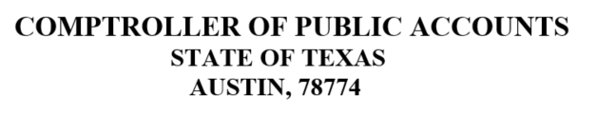

WIRING INSTRUCTIONS FOR COMPTROLLER FED ACCOUNT ROUTING NUMBER: 114900164
FED ACCOUNT NAME: TX COMP AUSTIN ACCOUNT NUMBER: 463600701
ACCOUNT NAME: CPA / TEXAS EDUCATION AGENCY REFERENCE: NAME OF DISTRICT
ATTENTION: TEA RECAPTURE

Be sure to indicate TEA, or the funds may be sent to another state agency. If you have any banking questions, please contact the State Comptroller Treasury Division at 512.463.5905.

If you have questions specific to the amount of your recapture payment, please contact the Excess Local Revenue Analyst in the TEA State Funding Division at 512.463.9238.
.

