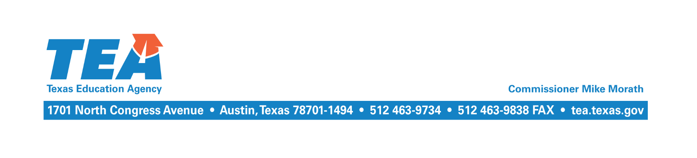

September 20, 2020

Subject: 2019–2020 Near-final Excess Local Revenue (Recapture)

The near-final Cost of Recapture (COR) report and other related reports for the 2019–2020 school year have been updated and are available at the School District State Aid Reports website at https://tealprod.tea.state.tx.us/fsp/Reports/ReportSelection.aspx. The near-final COR report incorporates the district’s final enrollment, entitlement and local share under Texas Education Code, Chapter 48, final state certified property values for tax year 2019, adopted maintenance and operations (M&O) tax rate for tax year 2019, M&O taxes collected by your district in 2019–2020, and any other corrections or updates that are necessary.

The M&O tax collections your district reported through the Tax Information Survey subsystem of the Foundation School Program (FSP) System in summer 2020 have also been used. If your district did not complete the survey, then budgeted tax collections for the 2019–2020 school year as reported through the PEIMS will continue to be used until tax collections reported in the J-1 schedule of the 2019−2020 annual financial report are incorporated at final settle up in April 2021.

If your district has a balance due for the 2019–2020 school year, please remit the balance on or before October 15, 2020. To view your district’s remaining balance, select Payment Ledgers from the drop down menu at the following link, enter your district’s name or county district number, and select school year 2019–2020: https://tealprod.tea.state.tx.us/fsp/Reports/ReportSelection.aspx. Please make the payment electronically via wire transfer or ACH using the respective payment instructions posted to the Excess Local Revenue web page under Payment Instructions at https://tea.texas.gov/finance-and-grants/state-funding/excess-local-revenue. Provide the district name and county district number on the reference line for a wire transfer and in the addenda record for an ACH payment. According to the instructions, be sure to also indicate the TEA as the recipient and that the transaction is a recapture payment. Once payment is received, the amount will be credited to your Recapture payment ledger.

If you have any questions about this letter, please email recapture@tea.texas.gov or contact Kim Wall by phone at (512) 463-4809.

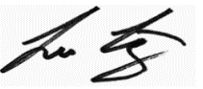
Sincerely,

Leo Lopez, RTSBA
Associate Commissioner for School Finance
& Chief School Finance Officer

